Supplementary A
Fitting data from the discrimination task. Probe slants were selected adaptively using the minimum expected entropy method. For each viewing condition, participants' trial-by-trial responses {$S_{k}{, R}_{k}$} were analyzed using a generalized linear mixed-effects model implemented in MATLAB's fitglme function with a probit link and Laplace approximation. Psychophysical thresholds were estimated as the reciprocal of the fitted slope parameter.
Cue weights analysis in Exp.1. To assess the contribution of texture to slant perception, texture cue weights were calculated for each base slant and viewing distance condition. In the slant discrimination task, generalized linear models were fitted separately for each participant and condition to characterize the relationship between responses and slant differences. For cue-consistent conditions, the model was defined as follows:
$Φ^{-1}\left(P\left(Y=1\right)\right)=$ ß₀ + ß_{consistent}*Δ_{slant} [1]
where Δ_{s} denotes the slant difference between the probe and reference stimuli, and (Y = 1) or (Y = 0) indicates that the probe or reference stimulus, respectively, was selected on a given trial. For the cue-conflict conditions, the model was modified as follows:
$Φ^{-1}\left(P\left(Y=1\right)\right)=$ ß₀ + ß_{inconsistent}*Δ_{slant} + ß_{sc}*SC [2]
where SC refers the slant conflict (i.e., ±5°) in a specific trial. The cue weights were then computed by -ß_{sc}/ß_{consistent} as a measure of the independent contribution of texture in slant discrimination.
For each subject and each based slant condition (i.e., 30° and 60°) in the slant estimation task, we first fit a linear function to the slant estimates in conditions with stereo slant of S and texture slants of S-5°, S, and S+5° to estimate the slope of this line, ß_{texture}. Then we computed another slope ß_{combined} representing the effect of changing texture and stereo cues together. The ratio, ß_{texture}/ß_{combined,} was treated as measure of the texture cue weight as in the discrimination task. Additionally, to ensure the computed cue weights remained within the range [-1, 1], we imposed a constraint whereby values exceeding 1 were capped at 1, and values below -1 were set to -1.
Cue weights analysis in Exp.2. Considering the introduction of the viewing distance in the discrimination task, we modified the models for cue weighting analysis as described below:
$Φ^{-1}\left(P\left(Y=1\right)\right)=$ ß₀ + ß_{consistent}*Δ_{slant} + ß_{distance}*Δ_{distance} [3]
$Φ^{-1}\left(P\left(Y=1\right)\right)=$ ß₀ + ß_{conflict}*Δ_{slant} + ß_{sc}*SC + ß_{distance}*Δ_{distance} [4]
in which Δ_{distance} refers the distance shift difference between the probe and reference stimuli. This new component was treated as a control variable to control for any potential influence of absolute surface distance on slant perception. Other analyses followed the same procedures as in Experiment 1.

Supplementary B
Cue weighting results in Exp.1: Cue weights were computed to quantify the relative influence of stereo and texture information on slant perception. The results are shown in Fig. S1. In the estimation task, texture cue weights increased significantly with viewing distance at the high slant (t (24) = 4.254, p < 0.001, Cohen’s d = 0.503) but not at low slants (t (24) = 1.218, p = 0.235, Cohen’s d = 0.270). In contrast, viewing distance did not significantly affect cue weights in the discrimination task (t (24) < 1.6, p > 0.09, Cohen’s d < 0.8).
A 3-way repeated-measures ANOVA revealed a significant main effect of slant (F (1,24) = 41.177, p < 0.001, η_{p}² = 0.632), and the interactions task × slant (F (1,24) = 4.517, p = 0.044, η_{p}² = 0.158). Post hoc tests revealed significant slant effects in both tasks, but the effect was larger in the discrimination task (estimation: t (24) > 2.223, p < 0.036, Cohen’s d > 0.445; Discrimination: t (24) > 3.148, p < 0.004, Cohen’s d > 0.630).
Cue weighting results in Exp.2: Paired t-tests revealed no significant effect of viewing distance in either the estimation task or the discrimination task (t (31) < 1.0, p > 0.28, Cohen’s d < 0.5). A repeated measures ANOVA found that none of other main effects or interactions reached significance (F (1,31) < 2.0, p > 0.66, η_{p}² < 0.30). These results are shown in Fig. S1.
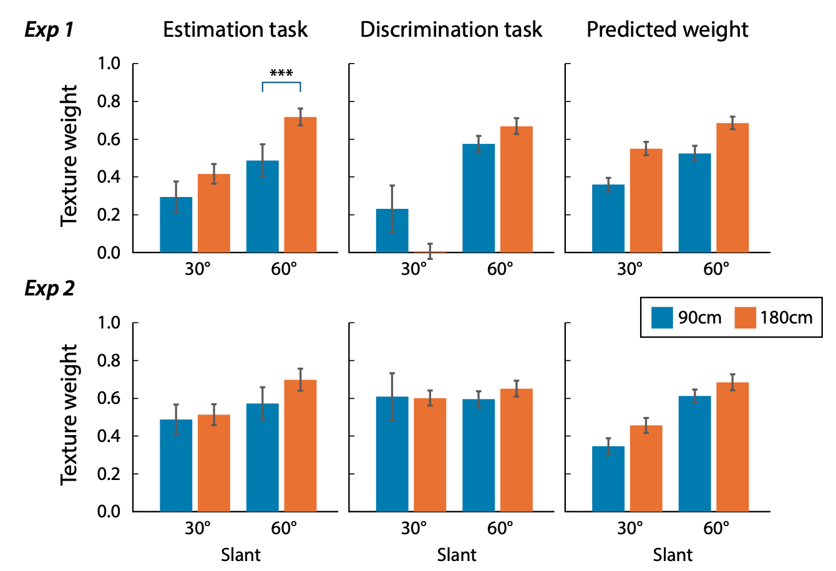
Figure. S1. Means of texture weights measured by the estimation task (left) and by the slant discrimination task (middle) and predicted by the Bayesian model in Experiment 1 (upper) and Experiment 2, respectively. Error bars represent standard error.

Supplementary C
The parameter $σ_{0}$. The parameter $σ_{0}$in Equation [6] was estimated from the behavioral data by identifying the value that best accounted for the relationship between observers' psychophysical thresholds and perceptual gains. Specifically, candidate values ranging from $1^{∘}$to ${50}^{∘}$were evaluated. For each candidate value, Bayesian-predicted gains were computed according to Equation [6], and a linear mixed-effects model was used to assess the correspondence between predicted and observed perceptual gains, with participant included as a random effect. Model fit was evaluated using Akaike's Information Criterion (AIC), and the value yielding the lowest AIC was selected. The resulting estimates were $σ_{0}={21.29}^{∘}$in Experiment 1 and $σ_{0}={22.78}^{∘}$in Experiment 2. These results are shown in Fig. S2. Given the close agreement between experiments, a value of $σ_{0}={20}^{∘}$was adopted for all model simulations and predictions reported in the main text. This value corresponds to a prior uncertainty that is comparable in magnitude to the sensory uncertainties observed in the experiment, implying approximately equal weighting of prior and sensory information when sensory uncertainty is near ${20}^{∘}$.

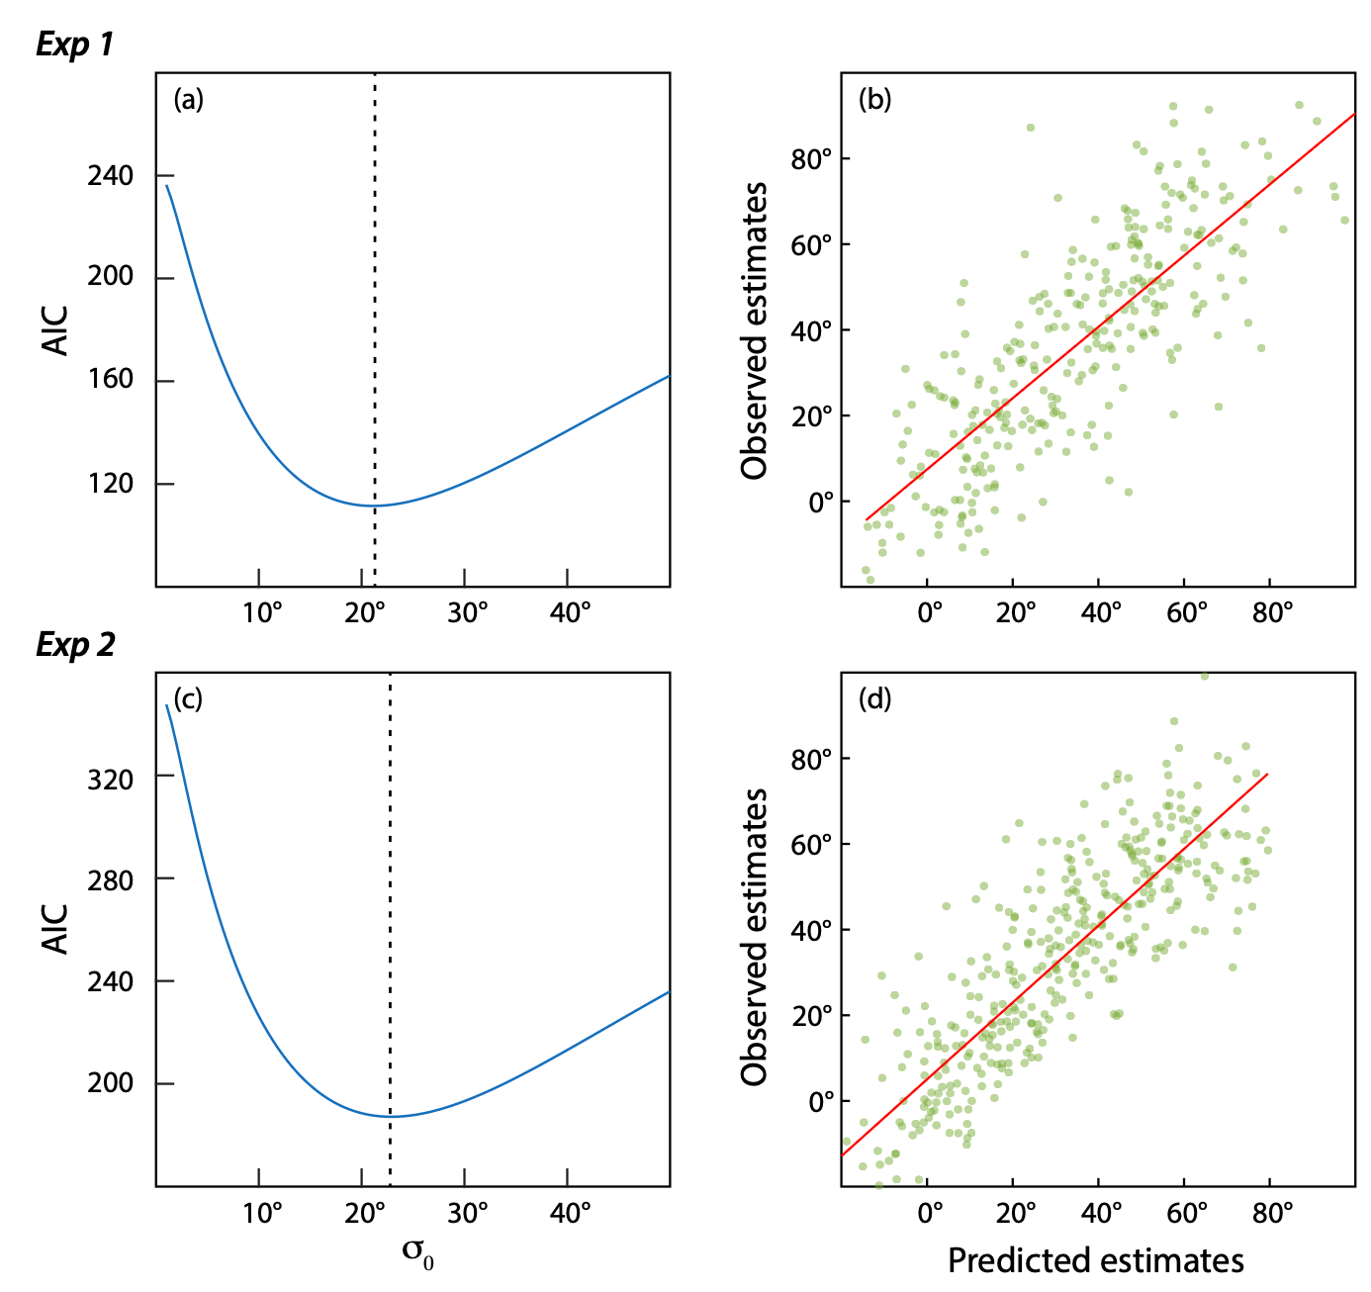
Figure S2. Estimation and validation of the Bayesian prior uncertainty parameter ($σ_{0}$). (a,c) AIC profiles for Exp.1 (a) and Exp.2 (c) as a function of $σ_{0}$. Dashed lines indicate the best-fitting values. (b,d) Observed versus model-predicted slant estimates using the fitted $σ_{0}$values for Exp.1 (b) and Exp.2 (d). Red lines show least-squares regression fits.

