Database Schema of kd-photomap

FLICKR_DE_WEST_TABLE

Store the information of photos

"LONGITUDE" FLOAT(126),
"LATITUDE" FLOAT(126),
"DT" DATE,
"PERSON" VARCHAR2(255),
"PHOTO_ID" PK NUMBER,
"VIEWED" NUMBER,
"TITLE" VARCHAR2(255),
"RAWTAGS" VARCHAR2(1000),
"SMALLURL" VARCHAR2(100),

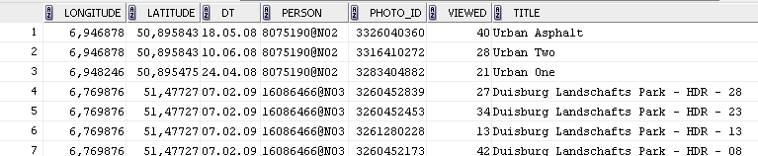

FLICKR_DE_WEST_TABLE _5000
FLICKR_DE_WEST_TABLE _10000
FLICKR_DE_WEST_TABLE _20000
FLICKR_DE_WEST_TABLE _40000
FLICKR_DE_WEST_TABLE _80000

Store the information of the polygons with different radius

"ID" PK NUMBER, -polygon id
"NAME" VARCHAR2(10 CHAR), -polygon name
"NUMBER_OF_EVENTS" NUMBE, -total number of photos
"GEOM" "MDSYS"."SDO_GEOMETRY", -polygon geo-coordinates

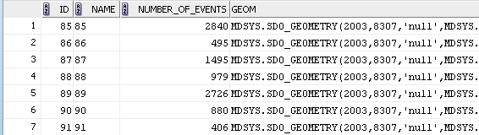
FLICKR_DE_WEST_TABLE _COUNT

Store the number of photos information for all polygons and persons

"ID" Composite PK NUMBER, - polygon id
"RADIUS" Composite PK NUMBER, -polygon radius

"PERSON" CLOB, -number of photos taken by different persons
Format: personid_1:numbers;personid_2:numbers;……

"HOUR" CLOB, -number of photos taken within different hours
Format: yyyy-MM-dd@HH24:numbers; yyyy-MM-dd@HH24:numbers;…...

"DAY" CLOB, -number of photos taken within different hours
Format: yyyy-MM-dd:numbers; yyyy-MM-dd:numbers;…

"MONTH" CLOB, -number of photos taken within different months
Format: yyyy-MM:numbers; yyyy-MM:numbers;……

"YEAR" CLOB, -number of photos taken within different years
Format: yyyy:numbers; yyyy:numbers;……

"TOTAL" NUMBER, -total number of photos

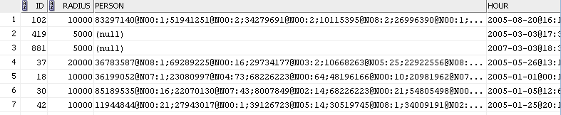

FLICKR_DE_WEST_TABLE _GEOM

Store the location of the all photos

"PHOTO_ID" PK NUMBER, -photo id (FK from FLICKR_DE_WEST_TABLE)

"CLUSTER_R5000_ID" NUMBER, -id of 5000km radius polygon, where the photo is located
"CLUSTER_R10000_ID" NUMBER, -id of 10000km radius polygon, where the photo is located
"CLUSTER_R20000_ID" NUMBER, -id of 20000km radius polygon, where the photo is located
"CLUSTER_R40000_ID" NUMBER, -id of 40000km radius polygon, where the photo is located
"CLUSTER_R80000_ID" NUMBER, -id of 80000km radius polygon, where the photo is located

