**What Are the Solutions to Climate Change**

1. Introduction

Up to the 21st century, climate change has become the most vital challenge on the earth. The earth emerges numerous disasters like rising global temperatures, extreme weather events, reduction of biodiversity, melting polar ice caps and rising sea levels due to extreme climate change. These serious threats to biodiversity, economies, and human well-being have been triggered by rapid climate change, which has an adverse impact on human life. Under this circumstance, how to deal with extreme climate change is essential to alleviate harmful influence on human life.

1. Transition to Renewable Energy

Nowadays, fossil fuels including coal, oil, and natural gas play an important role in the development of industry. Fossil fuels account for 80% of global energy consumption. The burning of fossil fuels releases a large amount of greenhouse gas, like carbon dioxide and methane. The emission of these greenhouse gases destroys the ozone layer makes the X-ray radiate on the earth directly. So, the temperature increases significantly. Accordingly, lots of countries invest a great deal of money in

renewable energy transition, such as solar energy, wind energy, geothermal energy and unclear energy. For example, Denmark is the most successful country in energy transition all over the world. Denmark has already generated over **50% of its electricity from wind turbines and they plan to** reach **100% renewable electricity before 2030**. Since, the Danish government introduced **subsidies, tax incentives** to support wind and solar energy development and replacement of fossil fuels.

1. Improving Energy Efficiency

Despite renewable energy transition, improving energy efficiency and recycling is also indispensable. Sustainable transportation contributes to reducing carbon emissions, which can significantly mitigate extremely climate change. Under such conditions, it is vital to replace gasoline-powered cars with electric vehicles. Therefore, governments should invest in electric vehicle **charging networks**, expand **car-free urban designs and provide tax incentives for electric vehicle users to encourage citizens to purchase e**lectric vehicles. As the development of AI technology, **AI-powered vehicle operation** systems make **e**lectric vehicles more competitive compared to gasoline-powered cars. If scientists are able to overcome the battery limitation and extend the range of electric vehicles, the electric vehicles will eventually replace gasoline-powered cars.

1. Recycling

Recycling is a key component of avoiding extreme climate change because it significantly lowers greenhouse gas emissions by reducing mining and production and landfill processes. For instance, **recycling aluminum requires 95% less energy** than producing it from raw materials. Thus, enhancing the efficiency of recycling processes is crucial for sustainability. Not only does it save the cost of recycling but also motivate people to participate in recycling. A notable example of advanced recycling system is **Germany’s Pfand system. In this system, consumers need to pay a small amount of deposit when purchasing bottled drinks, so they are motivated to return plastic bottles to the designated machine. And consumers also get lucky draw opportunities to win coupons, if they insist on collecting plastic bottles. In this circumstance, the efficiency of recycling will be significantly improved.**

1. Summary

**To sum up, tackling climate change requires approaches integrating energy transition, recycling and improving energy efficiency. Meanwhile, government and residents have to collaborate to prevent extreme climate change.**

1. AI Statement

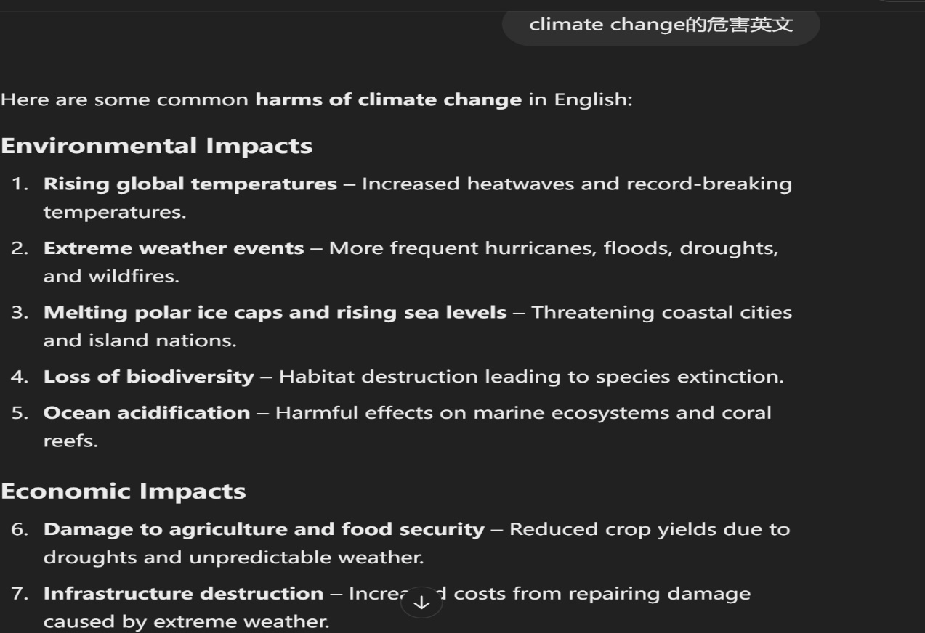

图形用户界面, 文本

AI 生成的内容可能不正确。

文本

AI 生成的内容可能不正确。

文本

AI 生成的内容可能不正确。

