Essay 2: What are the solutions to climate change?

Climate has natural variability over long timescales, but human activities have now become the dominant driver of climate change (Trenberth, 2018). Since the Industrial Revolution, greenhouse gases such as carbon dioxide (CO₂), methane (CH₄), and nitrous oxide (N₂O) have steadily increased in atmospheric concentration, intensifying global climate change and leading to widespread and far-reaching impacts. Since the signing of the Paris Agreement, although many countries have implemented emission reduction measures, global greenhouse gas emissions have continued to rise annually, and the world’s energy structure has yet to undergo substantial transformation (Santos, 2022). In some OECD countries, declining renewable energy costs and rising public concern about climate issues are gradually driving structural changes in the energy sector (Santos, 2022). However, in non-OECD countries, emissions from fossil fuel consumption continue to grow. While the scientific community has repeatedly warned of the severe risks of future climate change, how to reverse current emission trends and trigger effective policy shifts remains an open challenge.

At the policy level, both international cooperation and national climate strategies are critical. The 2023 United Nations Climate Change Conference (COP28) called for a “just, orderly, and equitable” transition away from fossil fuels and proposed tripling global renewable energy capacity by 2030 (UNFCCC, 2023). In China, the government has integrated climate response into its national development agenda, committing to peak carbon emissions before 2030 and achieve carbon neutrality by 2060. Efforts also include the development of green finance, emissions trading systems, and energy structure reform (The State Council Information Office of China, 2021). These policy directions offer institutional guarantees for long-term climate action, but how to effectively reverse emissions trends and implement truly impactful policy remains a major global challenge.

Technological innovation plays an irreplaceable role in mitigating climate change. According to the IPCC Sixth Assessment Report (2022), shifting the current energy structure through the adoption of renewable energy is one of the most effective strategies. Solar and wind power have become the lowest-cost sources of new electricity generation in many regions, and their scalability makes them key to decarbonizing the power sector. However, to address intermittency challenges, widespread deployment of advanced battery storage and smart grid technologies is essential. In sectors that are difficult to electrify, such as heavy industry, aviation, and shipping, carbon capture, utilization and storage (CCUS), hydrogen fuel, and synthetic alternatives offer feasible decarbonization pathways. In the building sector, low-carbon construction and energy-efficient design are also critical, including passive architecture, green insulation materials, and digital control systems. In agriculture and land use, soil management, afforestation, and dietary shifts can help enhance carbon sinks. Many of these technologies are already available or rapidly emerging, but achieving the 1.5°C target requires urgent scaling and integrated implementation across regions.

However, no single solution is sufficient to address climate change at the global scale. Technological innovation often faces barriers such as high costs, limited energy storage capacity, and slow deployment speed. Politically, inadequate long-term investment and delayed policy effectiveness hinder progress. Socially, resistance to behavioral change and unequal access to green alternatives further limit the impact of individual and collective action (Advances in Climate Change Research, 2022). Therefore, integration becomes essential: policies can accelerate the adoption of technology, while public participation can help shape market demand for sustainable solutions. An integrated response is not optional—it is essential for meaningful and effective climate action.

Reference：

Advances in Climate Change Research. (2022). Demand-side mitigation pathways, potentials, and policies for well-being and equity. Advances in Climate Change Research, 18(5), 546–556. <https://www.climatechange.cn/article/2022/1673-1719/1673-1719-18-5-546.shtml>

Intergovernmental Panel on Climate Change (IPCC). (2022). Climate Change 2022: Mitigation of Climate Change. Contribution of Working Group III to the Sixth Assessment Report of the Intergovernmental Panel on Climate Change. Cambridge University Press. <https://www.ipcc.ch/report/ar6/wg3/>

Santos, J. A. (2022). Climate change and the energy transition: The role of energy policies in achieving carbon neutrality. Energy Policy, 161, 112747. <https://doi.org/10.1016/j.enpol.2021.112747>

The State Council Information Office of China. (2021). Responding to Climate Change: China’s Policies and Actions. <http://www.scio.gov.cn/zfbps/32832/Document/1716934/1716934.htm>

Trenberth, K. E. (2018). Climate change caused by human activities is happening and it already has major consequences. Journal of Energy & Natural Resources Law, 36(4), 463–481. <https://doi.org/10.1080/02646811.2018.1450895>

United Nations Framework Convention on Climate Change (UNFCCC). (2023). Draft decision -/CP.28: Conference of the Parties, twenty-eighth session. <https://unfccc.int/documents/635130>



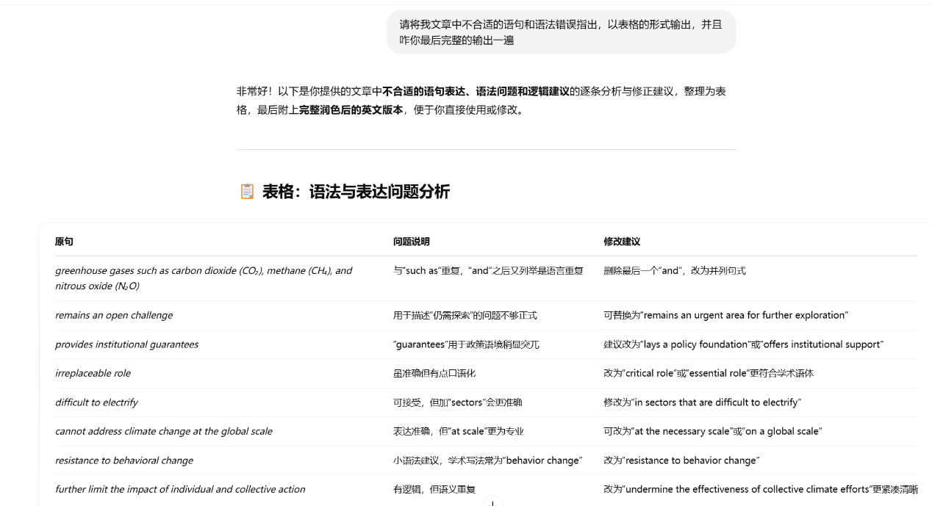

图形用户界面, 文本, 应用程序, 电子邮件

AI 生成的内容可能不正确。