**What are the solutions to climate change**

1. **Climate status and causes[1]**

Observational evidence demonstrates that anthropogenic drivers—predominantly the persistent release of greenhouse gases—have unequivocally triggered planetary warming. Between 2011 and 2020, the global mean surface temperature surpassed pre-industrial levels (1850–1900 baseline) by 1.1°C, in tandem with accelerating emissions **(Fig. 1)**. This climatic upheaval results from diverse contributions across spatial and temporal scales, rooted in unsustainable energy infrastructures, transformative land-use systems, and uneven consumption-production paradigms. These disparities span regions, nations, and social strata (high confidence).

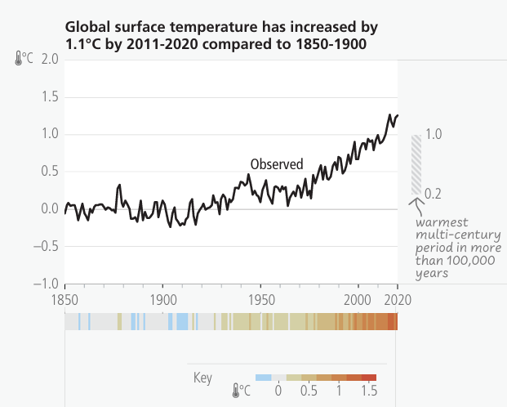 图表, 箱线图

AI 生成的内容可能不正确。

Fig. 1: Global temperature changes since 1850

Three interlocking mechanisms underpin this destabilization. First, atmospheric CO₂ concentrations have surged past 410 ppm **(Fig. 2)**—a 50% increase since the Industrial Revolution—trapping solar radiation through the greenhouse effect. Fossil fuel combustion contributes 75% of these emissions, with coal-fired power plants alone emitting 15 billion tons annually.

Second, industrialized agriculture accounts for 25% of global methane emissions, primarily from livestock and rice paddies. Methane is 84 times more potent than CO₂ over a 20-year timeframe, fueling a feedback loop as thawing permafrost releases ancient methane reserves.

Third, deforestation persists at an alarming pace, with 10 million hectares of carbon-sequestering forests lost each year—equivalent to 27 soccer fields per minute. This delivers a triple blow: eliminating carbon sinks, eroding biodiversity, and disrupting regional precipitation cycles.

图形用户界面, 应用程序

AI 生成的内容可能不正确。

Fig. 2: Changes in greenhouse gas concentrations since 1850

The climate crisis is not the product of natural variability but the result of humanity’s thermodynamic assault on ecological equilibrium. Since 1850, human activities have released approximately 2,500 billion tons of CO₂ into the atmosphere, overriding solar and volcanic influences that once drove minor climate fluctuations. Without a 50% reduction in global emissions by 2030, models forecast irreversible tipping points: the collapse of ocean currents, Amazon basin desertification, and ice-free Arctic summers. This is not a projection—it is an ongoing diagnosis.

1. **How to mitigate climate change[1]**

Tackling climate change requires a multifaceted strategy encompassing energy system transformation, ecological restoration, market-based policies, and urban reform. Each plays a pivotal role in curbing emissions and advancing sustainable development.

* 1. **Energy System Decarbonization**

Transitioning from fossil fuels to renewable energy is fundamental to reducing carbon emissions. Historically reliant on coal, oil, and gas, global energy systems must shift toward wind, solar, and hydroelectric sources. The Intergovernmental Panel on Climate Change (IPCC) stresses that limiting warming to 2°C or below demands a rapid phaseout of unabated coal by 2050—including canceling new projects and retiring existing plants. Enhancing energy efficiency and deploying smart grid technologies are also essential to manage the intermittency of renewables while maintaining grid stability.​

* 1. **Ecological restoration**

Restoring natural ecosystems offers a highly effective carbon sink. Forests, wetlands, and grasslands absorb atmospheric CO₂ and provide co-benefits such as biodiversity enhancement and soil regeneration. The IPCC’s *Special Report on Climate Change and Land* highlights the critical role of reforestation, afforestation, and soil carbon management in both mitigation and adaptation. Protecting and rehabilitating ecosystems amplifies their capacity to sequester carbon and withstand climate stressors.

* 1. **Deployment of market-based climate policies**

Carbon pricing—through taxes or emissions trading systems (ETS)—incentivizes emissions reductions by assigning a financial cost to carbon output. These mechanisms drive innovation and encourage cleaner production practices. According to the IPCC, effective carbon pricing fosters a systemic transition to low-emission technologies. Moreover, revenue generated can be reinvested into green infrastructure, social equity programs, and climate resilience initiatives, multiplying their positive impact.

* 1. **Green urban development and low-emission mobility**

Urban and transport reforms are vital for reducing emissions, as cities are major contributors to global CO₂ output. Strategic planning—promoting compact, mixed-use cities and public transit—can dramatically lower car dependency. The IPCC projects that such changes could reduce urban transport emissions by 25% by 2050 under an ambitious scenario. Investments in cycling and walking infrastructure, as well as electric vehicle deployment, further support a shift toward sustainable urban mobility.

**Reference:**

[1] IPCC, 2023: Sections. In: Climate Change 2023: Synthesis Report. Contribution of Working Groups I, II and III to the Sixth Assessment Report of the Intergovernmental Panel on Climate Change [Core Writing Team, H. Lee and J. Romero (eds.)]. IPCC, Geneva, Switzerland, pp. 35-115, doi: 10.59327/IPCC/AR6-9789291691647

**AI Statement**

文本

AI 生成的内容可能不正确。

图形用户界面, 文本

AI 生成的内容可能不正确。