**Solutions to Climate Change: A Multifaceted Approach**

1. **Introduction**

Climate change is one of the most pressing challenges of our time, threatening ecosystems, economies, and human well-being[1-3]. Addressing it requires a combination of natural, technological, policy-driven, and community-based solutions[4, 5]. Below, this essay explores key strategies to mitigate and adapt to climate change, emphasizing the need for integrated efforts across sectors.

1. **Natural Climate Solutions**

Nature itself offers powerful tools to combat climate change. Forests, wetlands, and oceans act as carbon sinks, absorbing CO₂ from the atmosphere[6]. Protecting and restoring these ecosystems can store billions of tons of carbon annually. For instance, The Nature Conservancy aims to reduce or store 3 billion metric tons of CO₂ yearly by 2030 through reforestation, regenerative agriculture, and wetland conservation[7]. Similarly, sustainably managed working forests, such as those managed by Weyerhaeuser, sequester carbon through tree growth and long-term storage in wood products like buildings, which retain carbon for decades[8].

However, natural solutions must be implemented carefully. For example, planting trees in inappropriate areas, such as carbon-rich wetlands, can release stored emissions and harm biodiversity[9, 10]. Thus, prioritizing existing ecosystems over artificial interventions is critical for maximizing benefits.

1. **Technological Innovations and Clean Energy**

Transitioning to renewable energy and advancing green technologies are essential to reducing emissions. The Elsevier Foundation’s Chemistry for Climate Action Challenge highlights innovative projects, such as biodegradable packaging made from agricultural waste in the Philippines and biogas production from fruit waste and cow manure in Somalia[11]. These solutions not only reduce emissions but also empower local communities economically.

Governments and industries must also invest in clean energy infrastructure. The Nature Conservancy advocates for policies that expand solar, wind, and battery storage technologies, while modernizing electric grids to support renewable integration[12]. Carbon capture and storage (CCS) technologies, though controversial, are being explored by companies like Weyerhaeuser to offset residual emissions[13, 14].

1. **Policy and Market Mechanisms**

Strong climate policies are indispensable. The U.S. Environmental Protection Agency (EPA) emphasizes regulations to limit greenhouse gas emissions, such as the Inflation Reduction Act, which funds clean energy projects and climate resilience programs[15]. International agreements, like the Paris Agreement, provide frameworks for global cooperation, though challenges persist. For example, WWF’s 2007 critique of U.S. obstruction during the Bali Roadmap negotiations underscores the need for political will[16, 17].

Market-based approaches, such as carbon pricing and carbon credits, also play a role. Weyerhaeuser’s forest carbon projects in Maine demonstrate how carbon markets can incentivize sustainable land management[18]. However, transparency and accountability are vital to avoid “greenwashing” and ensure these mechanisms deliver real environmental benefits.

1. **Community Engagement and Equity**

Local communities, especially vulnerable populations, must be central to climate action. Initiatives like Path to Positive Communities train leaders to implement localized solutions, such as coastal mangrove restoration to buffer against storms[19]. Gender equity is equally critical, as women often bear disproportionate climate impacts[20]. The Elsevier Foundation’s winning projects in Somalia and the Philippines actively involve women in biogas production and sustainable packaging, fostering inclusive development[21].

Education and youth empowerment are equally vital. Programs like the Youth Climate Action Toolkit, co-developed by The Nature Conservancy, equip young people with skills to advocate for policy changes and drive grassroots movements[22].

1. **Overcoming Challenges and Integrated Approaches**

Some climate solutions inadvertently harm biodiversity or communities. For example, hydroelectric dams disrupt fish migration, while wind turbines may endanger birds[23]. To avoid such trade-offs, experts recommend “nature-based solutions” that address both climate and biodiversity goals. A 2023 study in Nature found that protecting existing forests is more effective than reforestation efforts[24].

Integrated strategies are key. The IPCC and IPBES stress that solving climate change and biodiversity loss requires breaking down silos between sectors[25]. For instance, climate-smart agriculture can enhance soil health (storing carbon) while improving crop resilience to extreme weather.

1. **Conclusion**

Climate change demands a multifaceted response combining natural stewardship, technological innovation, robust policies, and community-driven action. While no single solution is sufficient, synergies between approaches—such as aligning renewable energy expansion with biodiversity protection—can amplify impact. As emphasized by scientists, “breaking down silos is the only way forward that won’t cause more problems than it solves”. By prioritizing equity, transparency, and science, humanity can forge a sustainable path toward a climate-resilient future.

1. **References**

1. Morisetti, N. and J.J. Blackstock, *Impact of a changing climate on global stability, wellbeing, and planetary health.* The Lancet Planetary Health, 2017. **1**(1): p. e10-e11.

2. Sillmann, J., et al., *Understanding, modeling and predicting weather and climate extremes: Challenges and opportunities.* Weather and Climate Extremes, 2017. **18**: p. 65-74.

3. Markowitz, E.M. and M.L. Guckian, *3 - Climate change communication: Challenges, insights, and opportunities*, in *Psychology and Climate Change*, S. Clayton and C. Manning, Editors. 2018, Academic Press. p. 35-63.

4. Davies, C. and R. Lafortezza, *Transitional path to the adoption of nature-based solutions.* Land Use Policy, 2019. **80**: p. 406-409.

5. Shiferaw, B., et al., *Managing vulnerability to drought and enhancing livelihood resilience in sub-Saharan Africa: Technological, institutional and policy options.* Weather and Climate Extremes, 2014. **3**: p. 67-79.

6. Gibbs, N.H.D. *Forests Absorb Twice As Much Carbon As They Emit Each Year*. January 21, 2021; Available from: <https://www.wri.org/insights/forests-absorb-twice-much-carbon-they-emit-each-year>.

7. Conservancy, T.N. *What We Do Our Goals for 2030*. Available from: <https://www.nature.org/en-us/what-we-do/our-priorities/>.

8. Weyerhaeuser. Available from: <https://www.weyerhaeuser.com/sustainability/3by30/climate-change-solutions/>.

9. Cox, E., et al., *Carbon removal beyond the trees.* Communications Earth & Environment, 2025. **6**(1): p. 253.

10. Palmer, L., *How trees and forests reduce risks from climate change.* Nature Climate Change, 2021. **11**(5): p. 374-377.

11. Clear, R. *Chemistry for Climate Action winners develop biodegradable packaging and green energy for cooking and irrigation*. 2023; Available from: <https://www.elsevier.com/connect/chemistry-for-climate-action-winners-2023>.

12. Belgium, B. *SolarPower Europe and The Nature Conservancy Release Landmark Policy Paper on Nature-Inclusive Solar*. 2024; Available from: <https://www.nature.org/en-us/newsroom/nature-inclusive-solar-parks-europe/>.

13. Araújo, O.d.Q.F. and J.L. de Medeiros, *Carbon capture and storage technologies: present scenario and drivers of innovation.* Current Opinion in Chemical Engineering, 2017. **17**: p. 22-34.

14. Katie Lebling, A.G., Karl Hausker and Zachary Byrum, *7 Things to Know About Carbon Capture, Utilization and Sequestration.* 2023.

15. Agency, U.S.E.P. *Climate Change Regulatory Actions and Initiatives*. Available from: <https://www.epa.gov/climate-change/climate-change-regulatory-actions-and-initiatives>.

16. Gunfaus, M.T. and H. Waisman, *Assessing the adequacy of the global response to the Paris Agreement: Toward a full appraisal of climate ambition and action.* Earth System Governance, 2021. **8**: p. 100102.

17. UNFCCC. *Key aspects of the Paris Agreement*. Available from: <https://unfccc.int/most-requested/key-aspects-of-the-paris-agreement>.

18. Weyerhaeuser, *Removing and storing carbon dioxide from the atmosphere.*

19. pathtopositive. Available from: <https://pathtopositive.org/>.

20. WOMEN, U. *Explainer: How gender inequality and climate change are interconnected*. 2022; Available from: <https://www.unwomen.org/en/news-stories/explainer/2022/02/explainer-how-gender-inequality-and-climate-change-are-interconnected>.

21. *2024 Elsevier Foundation Chemistry for Climate Action Challenge*. 2024; Available from: <https://elsevierfoundation.org/partnerships/research-in-developing-countries/greenchem/our-winners/>.

22. Conservancy, T.N. *Educating Youth for Climate Action*. 2024; Available from: <https://www.nature.org/en-us/about-us/who-we-are/how-we-work/youth-engagement/educating-for-climate-action/>.

23. Wu, H., et al., *Effects of dam construction on biodiversity: A review.* Journal of Cleaner Production, 2019. **221**: p. 480-489.

24. Heinrich, V.H.A., et al., *The carbon sink of secondary and degraded humid tropical forests.* Nature, 2023. **615**(7952): p. 436-442.

25. Scholes, P.B., *IPBES-IPCC CO-SPONSORED WORKSHOP BIODIVERSITY AND CLIMATE CHANGE WORKSHOP REPORT*. 2021.

1. **Statement of AI use**

I mainly used AI to help me collect some examples and modify the structure and sentence structure of the article. This is shown in the figure below.

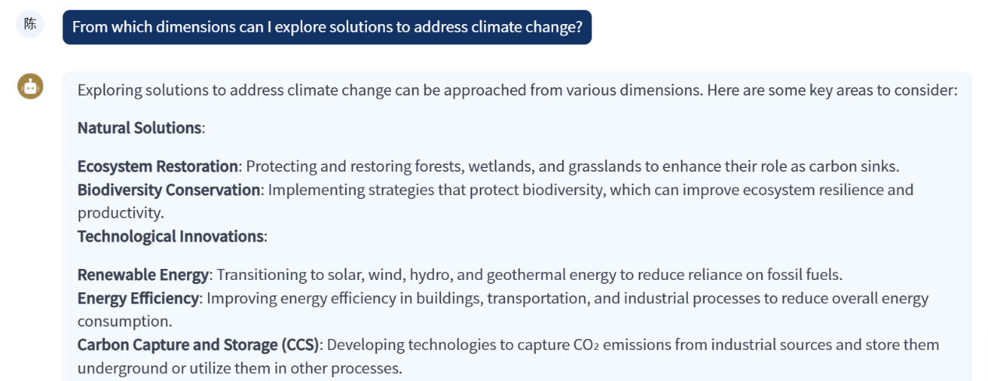

Fig. 1

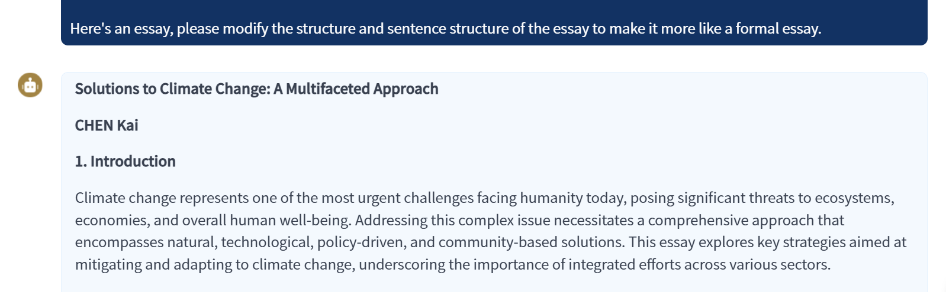

Fig. 2