The reason why climate change is a global crisis lies in its widespread negative effects on the environment and human society. ‌ Climate change not only affects natural ecosystems, but also poses a serious threat to global economy, social stability and human health. First, climate change has a serious impact on natural ecosystems. Global warming is causing more extreme weather events, rising sea levels, melting glaciers, declining biodiversity and other problems. These changes not only disrupt the ecological balance, but also threaten the survival of many species. Second, climate change poses challenges to global economic and social stability. Extreme weather events such as floods, droughts and heat waves is to reduce agricultural production and damage infrastructure, affecting food security and economic development. In addition, climate change exacerbates poverty and inequality, especially in developing countries. Third, climate change is a threat to human health. Environmental pollution caused by extreme weather events and climate change can increase the risk of infectious diseases and affect human health. Addition, climate change may also lead to water shortage and air quality decline, further affecting human quality of life‌.

In the face of the challenges posed by global warming, the international community needs to take urgent action. First, reducing greenhouse gas emissions is key. Countries should strengthen environmental protection policies and promote the shift to renewable energy and low-carbon economic models. By reducing dependence on fossil fuels, we can reduce greenhouse gas emissions and slow the rate of global warming. haring, technology transfer and resource allocation to jointly promote sustainable development. It is also cring and to provide a scientific basis for decision-making.

Addressing the economic problems caused by climate change faces multiple difficulties and requires a comprehensive approach:

‌ 1.differences in emission reduction targets ‌ : Countries differ in economic level, historical emission responsibilities, and emission reduction targets, so it is necessary to balance the interests of all countries.

‌ Fund and technology gap ‌ : developing countries are faced with the high cost of energy transformation, lack of financial and technical support, and conflict with the goal of poverty eradication.

‌ 2.Cooperation challenges ‌ : Developed countries have not fully honored their commitments, and some countries have imposed unilateral climate sanctions, violating the principle of common area and undermining cooperation.

‌ 3.geopolitical risks ‌ : Geopolitical risks threaten the process of global decarbonization and call for enhanced cooperation among major powers.

‌ 4.policy misunderstanding ‌ : Misunderstanding in policy design hinders the realization of maximum emission reduction effect. Public awareness needs to be improved to avoid misunderstanding.

To cope with these difficulties, the international community needs to strengthen cooperation, and developed countries should honor their commitments and provide financial and technical support. At the same time, strengthen the innovation and application of green technology to promote green and low-carbon transformation; In addition, it is also necessary to improve public awareness and understanding of climate policies, and form a good atmosphere for the whole society to respond.

Addressing human health issues caused by climate change faces the following difficulties:

‌ 1.Extreme weather affects health ‌ : Extreme weather such as heat waves and floods occurs frequently, causing respiratory and circulatory diseases, and increasing health risks such as infectious diseases and nutritional deficiencies. ‌

‌ 2.Sensitive groups most affected ‌ : The elderly, children and other sensitive groups are more sensitive to climate change, cardiovascular system, respiratory system and other vulnerable. ‌

‌ 3.Mental health issues highlighted ‌ : Stress and insecurity caused by climate change are increasing mental health problems such as anxiety and depression. ‌

‌ 4.measures need to be integrated ‌ : Both mitigation and adaptation measures need to be put in place, involving adjustments in energy, industry and natural ecosystems, as well as strengthening monitoring, early warning, prevention and control of climate-sensitive diseases. ‌

To address these challenges, international cooperation is needed to develop and implement effective strategies, raise public awareness and jointly address the health challenges posed by climate change.

Addressing global warming, economic problems and health problems caused by climate change requires a comprehensive approach:

‌ 1.Tackling global warming ‌ :

‌ Reduce greenhouse gas emissions ‌ : Promote green and low-carbon development, improve energy efficiency and reduce the use of fossil fuels.

‌ Protecting and restoring ecosystems ‌ : Enhancing natural carbon sinks, such as afforestation and wetland conservation.

‌ 2.To fix the economy ‌ :

‌ green technology innovation ‌ : We will encourage research and development of low-carbon technologies to reduce the cost of emission reduction and promote economic transformation.

‌ International cooperation ‌ : Jointly respond to climate change, share technology and experience, and jointly advance global climate governance.

‌ Coping with health issues ‌ :

‌ Strengthen monitoring and early warning ‌ : Establish a monitoring and early warning system for climate-sensitive diseases to respond to extreme weather events in a timely manner.

‌ 3.Raise public health awareness ‌ : popularize the knowledge of the impact of climate change on health and advocate a healthy lifestyle.

To sum up, addressing the global warming, economic problems and health problems brought about by climate change requires concerted global efforts and comprehensive measures to achieve sustainable development.

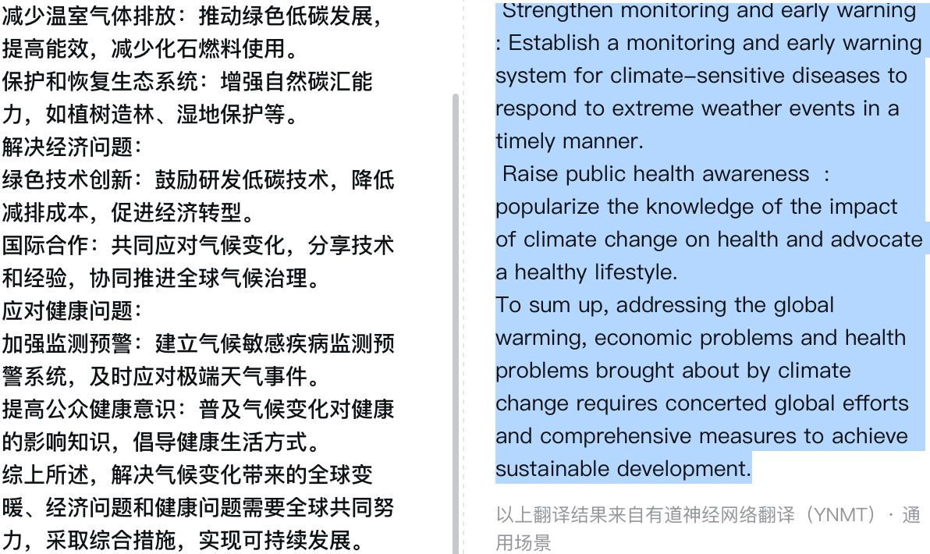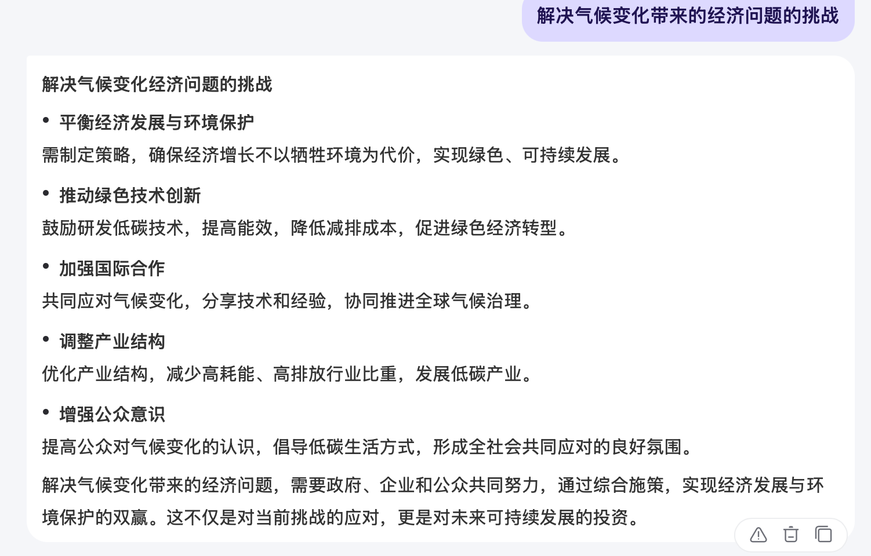

Since I am not a student of this major, there is a lot to learn and understand about such issues, so I use artificial intelligence Q&A to help me answer professional questions in the field, and use translation software to translate terms and test grammar.‌