TWO-DIMENSIONAL ARRAY ANTENNA PATTERNS
(Note: some details slightly outdated for version 1.4 – see online Help)

Introduction

According to the principle of pattern multiplication, the radiation pattern of an array of identical elements (i.e., identical element patterns) can be written as the product (phasor quantities)

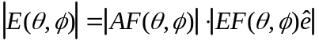

where 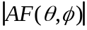 is the array factor and 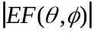 is the element factor. The unit vector denotes the polarization of the element. The array factor depends only on the geometrical arrangement of the elements and their excitation conditions. The element factor depends only on the type of element. The coordinate system is shown below. If the x-y plane corresponds to the earth’s surface and the z axis the zenith, the angles and are the azimuth and elevation angles, respectively.
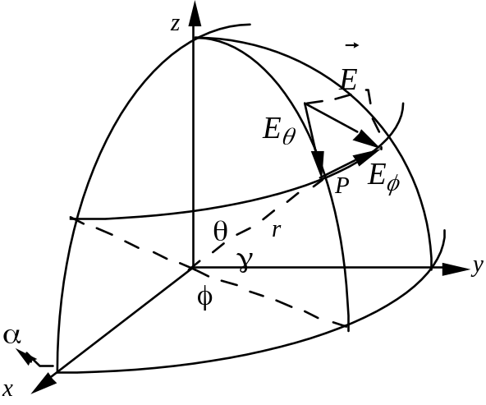

For a periodic array of elements that are laid out on a rectangular lattice in the x-y plane, the array factor can be expressed as the sum

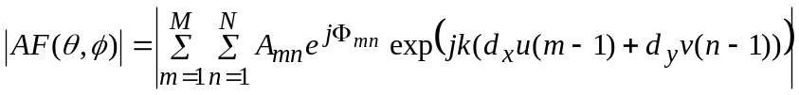

where 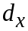 and 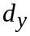 are the spacings along the x and y axes, 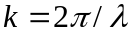, and the x and y direction cosines are
.

The amplitude and phase excitation coefficients for element (m,n) are 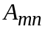 and 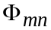, which are controlled by the method of feeding the element. An example of a two-dimensional array of dipoles is shown on the next page. Note that the above formula is written for element m=n=1 located at the origin, x=y=0. However, the diagram shows the center of the array at the origin. The shifting of the reference merely adds a phase factor (exponential factor) to the array factor, which does not affect the magnitude of the array factor. Also note that if the number of elements is large, then the array dimensions are approximately

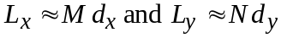.

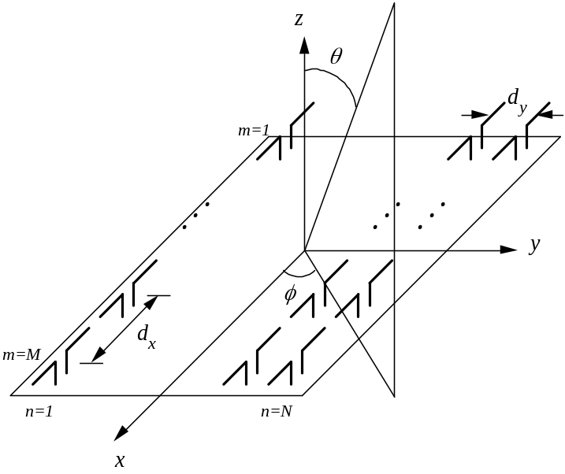

The amplitude and phase coefficients are used to scan the beam, control the sidelobe level and, in some cases, shape the radiation pattern. Some common amplitude distributions for controlling sidelobes are tabulated:

Distribution | First sidelobe or parameters
Uniform (Reference) | -13.2 dB
Cosine on a pedestal | 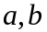: 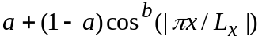
Taylor (sum beam) | SLL,
Bayliss (difference beam) | SLL,

In the past, the majority of antenna applications required only a single focussed beam. Modern radars and communications may require multiple simultaneous beams from a common aperture.

Two-dimensional Array Patterns: array2d.m

The array factor for a two-dimensional array is computed by array2d.m. The user can select from several types of amplitude distributions. Also, phase shifter roundoff algorithms can be selected to observe the effects of digital phase shifters on the beam position, gain and sidelobe level. array2d.m may call several functions, depending upon the calculations requested by the user. They include taylor, bayliss, and cosine which compute aperture distributions, and tuncate and rro which execute phase shifter roundoff algorithms. Introductory comments from the code follow:

% array factor of a planar array with a specified amplitude and
% phase distribution. phase quantization can be included if desired.
% this program requires the functions
% taylor, bayliss, cosine, tuncate, rro
% array in xy plane, number of elements Nx and Ny, spacings dx and dy
% theta and phi are standard spherical coordinates
% aperture efficiency (taper efficiency) eta is computed

The user will be asked to input the range of angles for the pattern calculation. If the start and stop values for are identical, then a pattern cut for that value of is generated. Similarly, if the start and stop values for are identical, then a pattern cut for that value of is generated. If a range of both and are given, then a two-dimensional contour, mesh, or both is plotted in direction cosine space. The range of u and v will correspond to the given range of and .

The input sequence is as follows:

% Enter pattern loop values
disp('enter phi pattern values')
disp('same value for stop and start results in a phi cut');
pstart=input('enter phi start in degrees: ');
pstop=input('enter phi stop in degrees: ');
delp=input('enter phi increment in degrees: ');
if delp==0, delp=1; end
if pstart==pstop, phr0=pstart*rad; end
disp('enter theta pattern values')
disp('same value for stop and start results in a theta cut');
tstart=input('enter theta start in degrees: ');
tstop=input('enter theta stop in degrees: ');
delt=input('enter theta increment in degrees: ');
if delt==0, delt=1; end
if tstart==tstop, thr0=tstart*rad; end
it=floor((tstop-tstart)/delt)+1;
ip=floor((pstop-pstart)/delp)+1;
% number of array elements and spacing in wavelengths
Nx=input('enter Nx: ');
Ny=input('enter Ny: ');
dx=input('enter dx: ');
if Nx==1, dx=0; end
dy=input('enter dy: ');
if Ny==1, dy=0; end

Amplitude Tapering

The user is asked to select the amplitude distribution in the two principal planes. The distribution is assumed to be separable in x and y; that is, 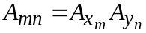 and 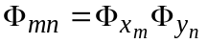

% if idist=0 uniform
% =1 taylor
% =2 cosine-on-a-pedestal
% =3 bayliss
% =4 triangular
disp('distribution types (0,1,2,3)')
disp(' =0 uniform')
disp(' =1 taylor (N must be even)')
disp(' =2 cosine-on-a-pedestal')
disp(' =3 bayliss (N must be even)')
disp(' =4 triangular')
ixdist=input('enter desired distribution in x: ');
iydist=input('enter desired distribution in y: ');

The parameters for the various distributions are “hard-wired” into the code, but can be changed by assigning different values. Examples are shown below.

% cosine-on-a-pedestal distribution
if iydist==2
peddb=14; (the coefficient a in dB)
nexp=2; (the exponent b)
ampy(1:Ny)=cosine(Ny,peddb,nexp);

% bayliss distribution for difference beams -- NEL MUST BE EVEN
if ixdist==3
slldb=25;
nbar=5;
ampx(1:Nx)=bayliss(Nx,slldb,nbar);

% subroutine compute taylor coefficients
if ixdist==1
slldb=25;
nbar=5;
ampx(1:Nx)=taylor(Nx,slldb,nbar);

The aperture efficiency is computed from the formula:

and the directivity of an array of isotropic elements is given by the formula

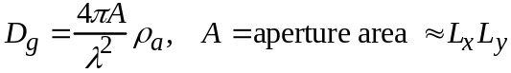

The directivity is the maximum value of the directive gain, which is identical to the gain if the antenna is lossless. In general, losses other than aperture tapering will reduce the directivity of the antenna. When losses are included, the gain is

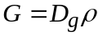

where is the efficiency factor.

% calculate aperture efficiency
s1=0; s2=0;
for i1=1:Nx
for i2=1:Ny
s1=s1+abs(ampxn(i1)*ampyn(i2));
s2=s2+abs(ampxn(i1)*ampyn(i2))^2;
end
end
eta=s1^2/Nx/Ny/s2;
disp(['aperture efficiency: ',num2str(eta)])

Phase Shifter Roundoff

Phase shifters are used to control the location and shape of the antenna beam. Generally a linear phase shift is desired to point a focussed beam in space. The phase shift can be specified in degrees per element or total degrees across the length of the array. The 2 dimensional array factor for scanning can be written as

where

The main beam direction is given by ( ).

Most phase shifters are digital devices, or at least are digitally controlled. Therefore only discrete values of phase shift are allowed, and they may not be the precise values required a particular element as depicted below:

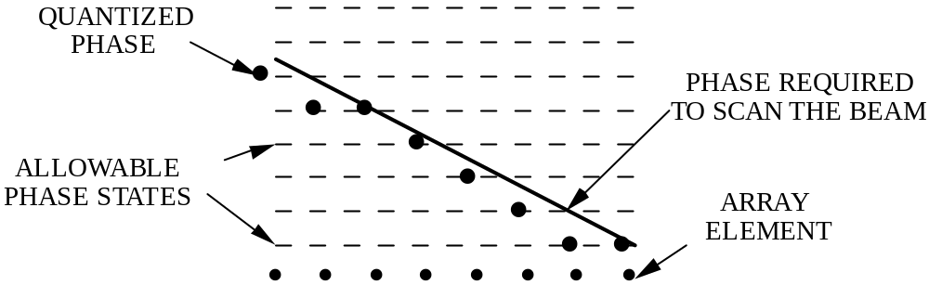

Therefore a roundoff method must be prescribed. Simply truncating or rounding to the closest value will yield a periodic quantization error that causes large sidelobes to occur. Furthermore the beam pointing can deviate significantly from the case of no quantization error. With regard to beam pointing, it is usually best to employ some type of randomization when rounding off. A common method is weighted random roundoff, which is a type of fuzzy logic. Randomization is most effective when the amplitudes of the elements are all roughly the same (i.e., roundoff errors will sum to zero). If not, then large roundoff errors at elements with large amplitudes can dominate. The input sequence is shown below:

disp('enter roundoff technique (0,1,2,3,4)')
disp(' =0 exact phase at each element')
disp(' =1 truncation (standard roundoff)')
disp(' =2 random roundoff ')
disp(' =3 weighted random roundoff')
iph=input('enter roundoff code: ');
% desired scan angle in degrees
ths=input('enter scan angle theta (deg): ');
phs=input('enter scan angle phi (deg): ');

Example 1: Comparison of roundoff methods for a linear array of 60 elements (30 dB Taylor distribution). If the number of phase shifter bits is B, then the phase shift per element can be as small as 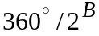. For example, a 4-bit phase shifter has 22.5 degree phase steps.

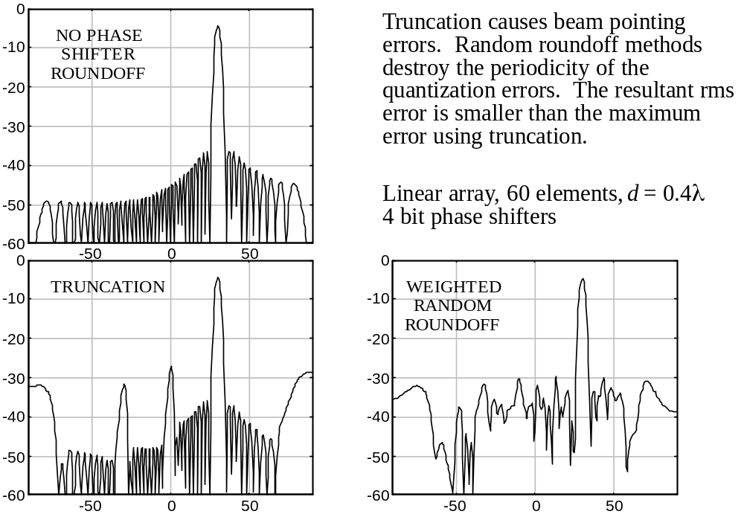

Example 2: Difference beam: 60 elements, 25 dB Bayliss distribution, 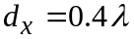

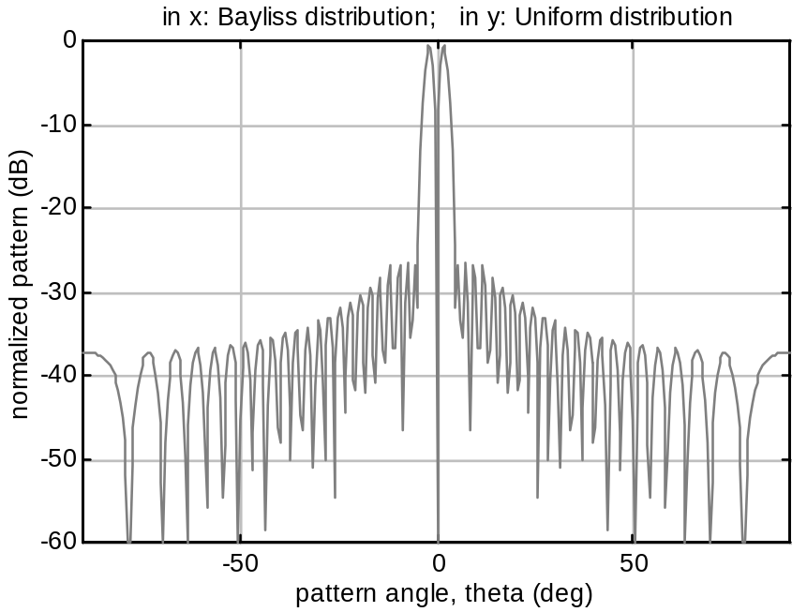

Example 3: Multiple beam antenna, 4 beams squinted at 2.3 degree increments. (In order to plot multiple patterns the user must go into the program an insert “hold on” statements.)

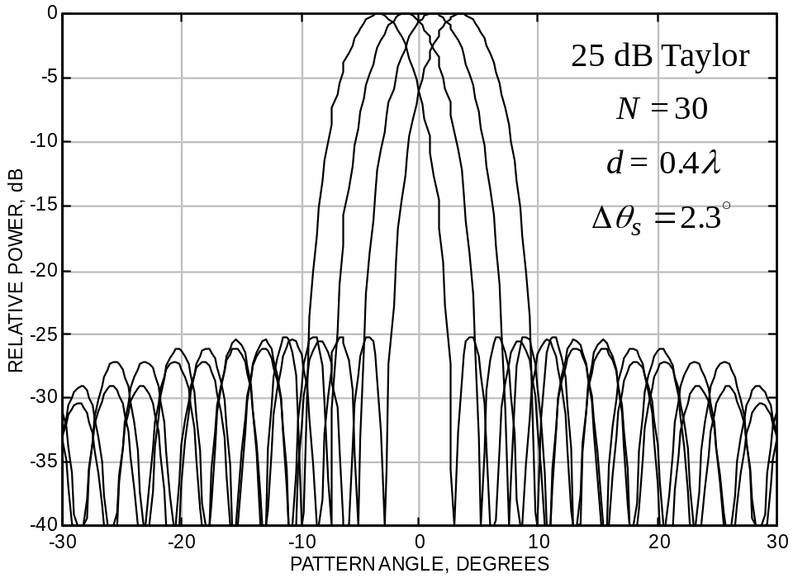
Example 4: Grating lobes; 50 elements, 1.5 wavelength spacing,30 degree scan angle, 25 dB Taylor distribution. Grating lobes are located at about 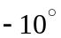 and 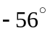.

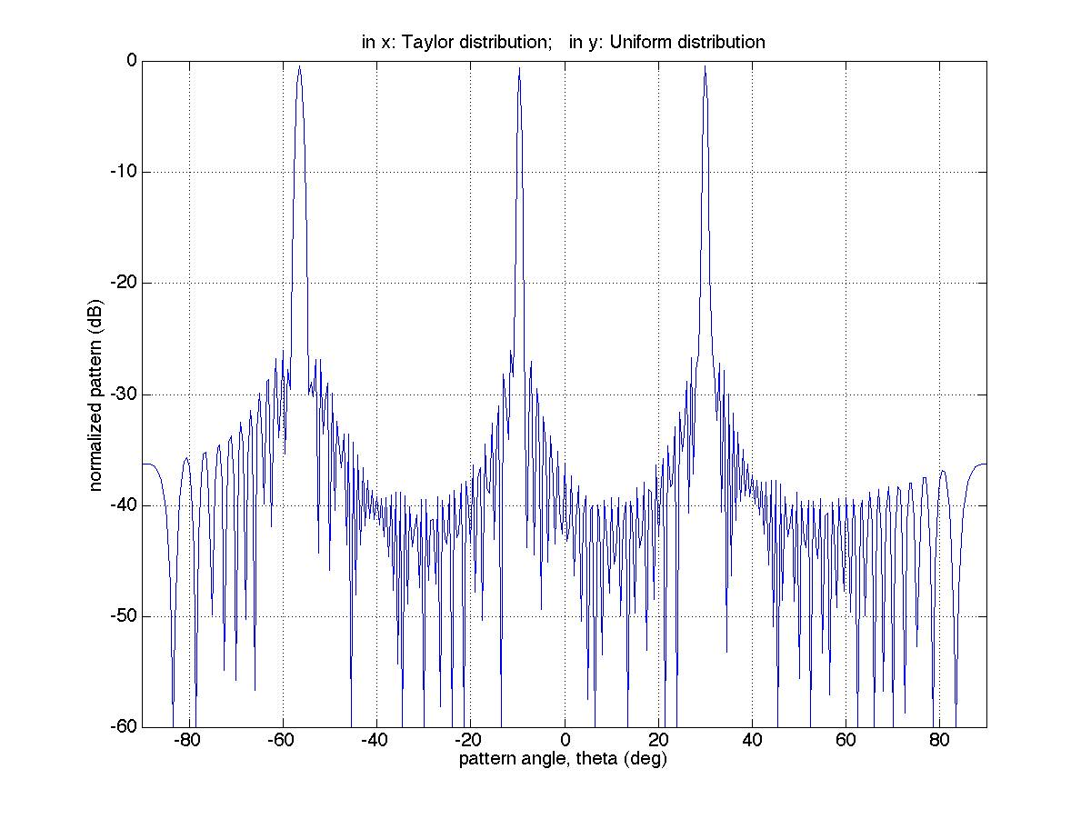
Example 5: Planar array of 10 by 5 elements; uniform distribution in both planes; half wavelength spacing in both planes; no beam scan. The range of values computed are 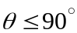 and 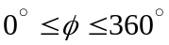 in 1 degree increments. (Run time is about 30 min. on a 260 MHz PC.) Mesh and contour plots are shown.

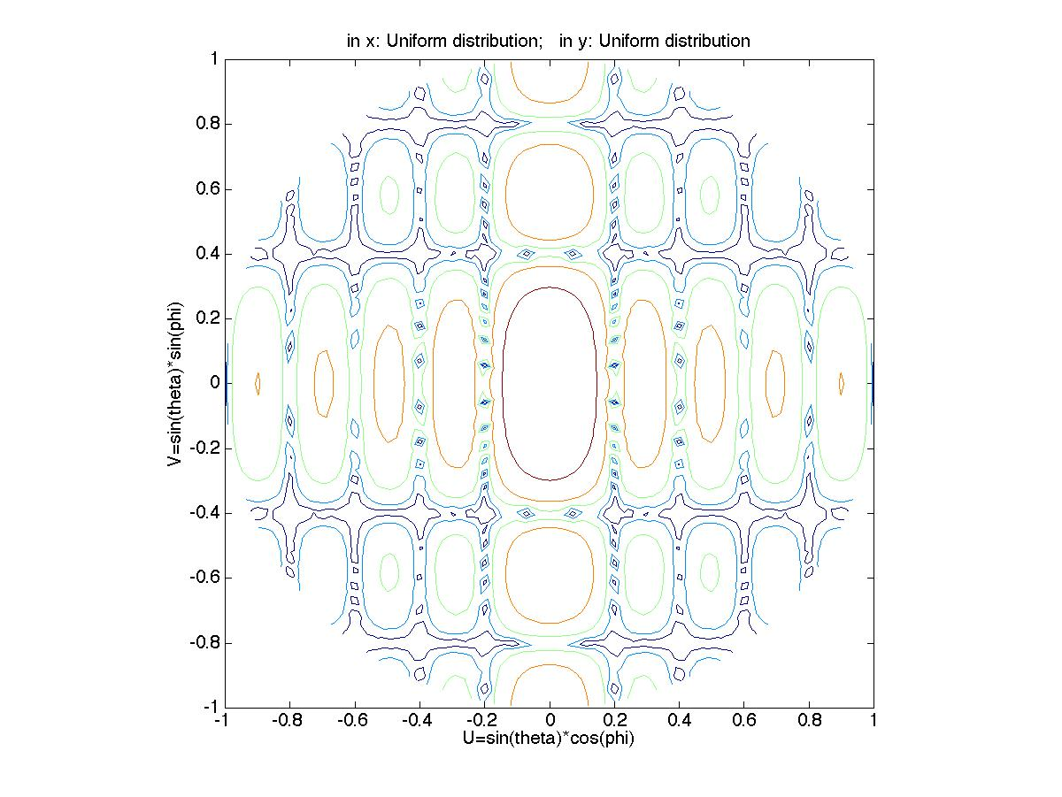
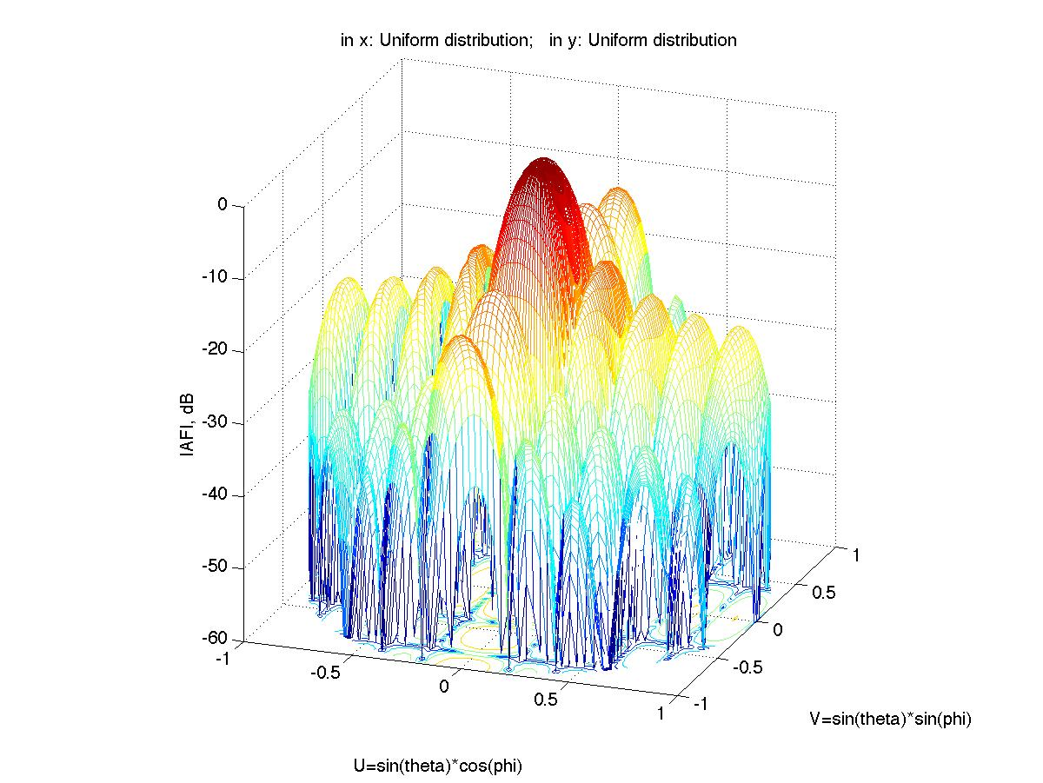

References:

[1] C. A. Balanas, Antenna Theory, Wiley.

[2] J. D. Kraus, Antennas, McGraw-Hill.

(11/10/99)

