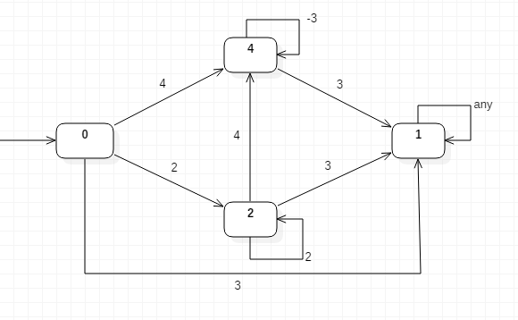

Part 1: pseudo code for f.

int f(x) {

if(x==3){return 3;}

else if(x!=3){return -3;}

else if(x==4){return 4;}

else if(x!=4&&x!=3){return 2;}

}

Part 2: pseudo code for g.

int g(x,y) {

if(x==1){return 1;}

else if((x==0||x==2||x==4)&&y==3){return 1;}

else if((x==0||x==2)&&y==2){return 2;}

else if((x==0||x==2)&&y==4)||(x==4&&y==-3)){return 4;}

}

Part 3: Specification of initial value.

**Initial value = 0**

Part 4: Interpretation of final value.

**1,2: Nice 4: Not Nice**