Specific Aims
Oto Biotech (Oto) is developing a trans-tympanic drug delivery platform for the local treatment of otitis media (OM), achieving superior efficacy while preventing antibiotic resistance and side effects associated with standard treatments. OM, colloquially called a middle ear infection, is one of the most common infections to occur in children, with an estimated ~11 million OM cases annually in children under 5 years old and ~30-40% of first-time OM patients experiencing up to six subsequent episodes.^{1,2} OM is hallmarked by the presence of non-typeable Haemophilus influenzae (NTHi), Streptococcus pneumoniae, and Moraxella catarrhalis, necessitating treatment with antibiotics.^{3,4} The first-line therapy is oral administration of high-dose amoxicillin,^{5,6} with other antibiotics recommended depending on patient allergies and comorbidities, responsible for >25% of all antibiotic prescriptions written to U.S. children.⁵ Oral antibiotics have been associated with severe side effects such as diarrhea, vomiting, and skin rash,⁷ which ultimately can make children feel worse overall before the relief from their ear infection.
Systemic antibiotic exposure for such a prevalent disease is also believed to cause a myriad of long-term health issues. It causes antibiotic resistance in the nasopharynx flora due to the frequent premature termination of treatment. Complete eradication of the OM pathogens requires a rigorous 5-10-day course of treatment but is often terminated before completion due to the challenges associated with administering oral treatments to young patients, creating the perfect condition for resistance development. Indeed, ~15% of bacterial isolates from children with OM have been discovered to exhibit resistance to amoxicillin,^{8,9} worsening treatment outcomes. Untreated or poorly treated OM can cause hearing loss up to 30dB.¹⁰ With the first five years of a child’s life being the most critical for cognitive development, such hearing loss can delay speech and language development and lead to behavioral and mental health issues.¹¹ These developmental delays have been found to increase in children with recurrent OM episodes.¹² Furthermore, systemic antibiotics enter the gastrointestinal (GI) tract and circulate in the bloodstream, disrupting homeostasis and causing widespread resistance in the microbiome,^{13,14} a condition known as microbiome dysbiosis. Childhood microbiome dysbiosis has been connected to asthma, diabetes, Crohn’s disease, and many other conditions later in life.¹⁵
Replacements for oral antibiotics are urgently needed due to challenges of administration, increased antibiotic resistance, diminishing efficacy, and the associated microbiome dysbiosis and health issues later in life. Oto hypothesizes that local delivery of antibiotics to the middle ear, sustained over 7 days, can bypass the systemic and GI exposure and thus avoid microbiome disruptions and other side effects, prevent antibiotic resistance due to poorly-adhered treatment regimens, and achieve faster relief in children with OM. However, prior research has seen limited success with locally-delivered OM therapeutics due to the impermeability of the tympanic membrane (TM) to most molecules.¹⁶ In their proprietary technology (U.S. Provisional Application No.: 63/552,616) and recent publication,¹⁷ founders of Oto discovered that hydroxylated liposomes deliver a record-breaking fraction of antibiotics across an intact TM, an order of magnitude higher than the best-in-class mechanism in the literature (i.e., chemical permeation enhancers).¹⁸ This delivery efficiency is achieved by an active transport mechanism in which the liposomes in Oto’s formulation hitchhike on the neutrophils that are recruited by the infection.¹⁹ Oto has shown that the neutrophils, having phagocytosed the antibiotic-containing liposomes, actively permeate the TM and deliver the liposomes to the site of infection, achieving sterilization of the middle ear within 24 hours of treatment. This efficacy is in stark contrast to the mainstay treatment of oral antibiotics, which takes 5-10 days to achieve middle ear sterilization. Furthermore, Oto developed a hydrogel that serves as a reservoir for the liposomes to achieve sustained 7-day delivery, as well as a mechanism to place the hydrogel conformally onto the TM for ease of administration. The hydrogel is an easy-to-apply liquid at room temperature, enabling its conformal coverage of the TM upon squirting into the ear canal. It also gels quickly and firmly upon contacting the warm TM (due to its reverse thermal gelation properties) and stays in place for > 1 week. Oto’s co-PI’s animal studies revealed that this formulation, when administered via the outer ear canal of chinchillas infected by NTHi (an FDA-accepted preclinical model for OM), eradicated OM in all treated animals (N=4) without side effects. To bring this technology into clinical practice and revolutionize the treatment of OM, the following development is needed:
Aim 1: Optimize the formulation to improve treatment efficacy. In prior work, Oto cured OM caused by NTHi. The treatment of S. pneumoniae and M. catarrhalis may require higher concentrations of antibiotics in the middle ear. In this aim, Oto will investigate how controlling antibiotic dosing and release from the liposomes and liposomes release from the hydrogel impact the trans-TM delivery efficiency using ex vivo models.
Aim 2: Determine in vivo efficacy of the optimized formulation. Oto will use the chinchilla model to determine how well the optimized formulation improves the efficacy and pharmacokinetics/pharmacodynamics in treating OM caused by all common pathogens, compared to topically/systemically applied ear drops.
Aim 3: Demonstrate safety of delivering antibiotics across the tympanic membrane. Oto will assess the hearing sensitivity of the treated animals and the structural integrity of their TM and inner ear hair cells (the critical hearing organ) to confirm that the formulation is safe at a higher dosage of antibiotics.

Significance

B.1 Otitis Media infection and oral antibiotic treatment can be harmful for child development. Otitis media (OM) is an infection of the middle ear that is extremely common in pediatric patients. As many as 85% of children experience at least one OM episode, and 50% experience more than three OM episodes by three years of age.^{20,21} The high occurrence is associated with the enormous healthcare costs, estimated at ~$4.8 billion per year.¹ Timely treatment of OM is critical, as the condition is associated with poor phonological performance,²² behavioral issues,^{23,24} and delayed language development^{23,25-28} and word recognition,²⁷ especially with recurrent or chronic infection. The first-line treatments for OM are a combination of a 2-3 day “watchful wait” period to see if the infection clears on its own and a 5-10-day course of broad-spectrum oral antibiotics. Yet despite watchful wait being the recommended protocol for most acute OM cases, over 90% of physicians prescribe antibiotics immediately, leading to ~10 million antibiotic prescriptions for OM each year.^{21,29-31} The widespread and often unnecessary use of oral antibiotics against a disease of such high prevalence is believed to be partially responsible for the ongoing antibiotic resistance crisis for nasopharynx pathogens, exacerbating recurrent infections and developmental problems, and necessitating more extreme treatments like surgical intervention.

B.2 Difficulties and consequences of antibiotic treatment regimens for OM. Although viral pathogens like respiratory syncytial virus are implicated in the initial development of some OM infections,³² the large majority of acute OM (AOM) cases are driven and sustained by bacterial pathogens. This has led to the widespread use of oral antibiotics to treat AOM. S. pneumoniae, NTHi, and M. catarrhalis are the most common OM bacteria,³³ with NTHi and M. catarrhalis as the predominant drivers of acute infection.^{34,35} Unfortunately, a large proportion of NTHi and M. catarrhalis pathogens are resistant to amoxicillin, the most frequently prescribed antibiotic for AOM.^{36,37} Nevertheless, over 84% of children with AOM in the U.S. continue to receive an amoxicillin prescription immediately upon diagnosis, even though the antibiotic-resistant infections are almost or entirely untreatable.^{38,39} Evidence shows that antibiotic treatment longer than 5 days offers few additional benefits, yet most prescriptions are written for 10-day regimens.³⁶ This further exacerbates unnecessary antibiotic exposure and contributes to the antibiotic resistance crisis. Compliance with longer duration and multi-dose regimens can also be difficult, with complete adherence reported in only 50-62% of patients and fewer than 22% of patients receiving all recommended doses.^{40,41} Unreliable dosing, difficulty with administration, and concern over adverse side effects are all reported by parents as reasons for noncompliance.^{40,41} Thus, a treatment solution that requires fewer doses over a shorter timeframe and minimizes the risk of adverse side effects would not only improve treatment adherence, it would also reduce antibiotic exposure, limit toxicity, and mitigate resistance and recurrent infection.
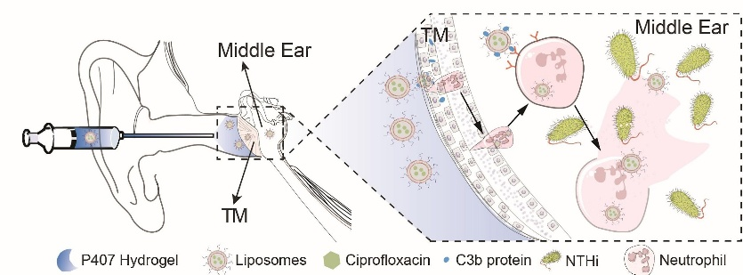
Figure 1: Schematic depicting the application of the hydrogel, mechanism of antibiotic transport across the TM, and release in the middle ear.

B.3 Local drug delivery overcomes drawbacks but is limited by impermeability of the tympanic membrane. Although local delivery of antibiotics would alleviate many of the issues of systemic antibiotic administration, the tympanic membrane (TM), or eardrum, represents a major barrier due to its impermeability to most drug molecules. The most common pediatric surgery performed in the United States is tympanostomy tube insertion for the treatment of recurrent OM, as this allows antibiotic drops to be delivered through the TM directly to the middle ear.⁴² Clinical trials have demonstrated the efficacy of some ototopical agents in treating acute otorrhea, but only in children with perforated eardrums and tympanostomy tubes.^{43,44} For example, ciprofloxacin ear drops, alone or in combination with dexamethasone, have shown excellent efficacy when delivered through existing tympanostomy tubes, but difficulties are reported by parents when attempting to administer the drops at home.⁴⁴ A ciprofloxacin-based suspension gel (Otiprio) was developed to address these challenges as a sustained-release, single-application solution.⁴⁵ However, Otiprio’s use is currently restricted to patients with tympanostomy tubes, and its ability to penetrate the intact TM, even in preclinical models, has not been shown.⁴⁶ Perforated eardrums are found in only ~0.06% of children with AOM,⁴⁷ and tympanostomy tube insertion is reserved for the most severe cases due to the inherent risks of surgical procedures in children; there thus remains a unmet need for local treatment options for the majority of AOM cases. Nevertheless, the efficacy of ciprofloxacin in this context demonstrates that local application can be effective when the eardrum is no longer a barrier. In bypassing systemic circulation, local administration of drugs like ciprofloxacin requires smaller doses while also avoiding the risks of systemic toxicity, such as antibiotic resistance and potential harm to musculoskeletal and gastrointestinal development.⁴⁸ Despite the promising benefits of local therapy for OM, no existing treatments are able to overcome the challenge of TM penetration without surgical intervention.

B.4 Company’s Solution
To bring the benefits of local delivery to all children with AOM, Oto is developing the first drug delivery platform for targeted, non-invasive therapy across the intact (Fig. 1). Oto’s platform consists of three components: an antibiotic, a liposome carrier, and a hydrogel. The liposome helps the antibiotics cross intact TMs, and the hydrogel holds them in place at the TM for the duration of therapy. The hydrogel is also thermoresponsive, so it can be squirted into the ear canal as a liquid but gels rapidly upon contact with the TM. The liposomes exploit natural immune responses during AOM episodes to cross the TM and target the antibiotic delivery to the site of infection. Oto designed the liposomes based on their discovery that neutrophils, the most abundant white blood cells that are known to be recruited by bacterial pathogens, can also readily cross the TM during infection. Oto thereby designed proprietary liposomes that encapsulate ciprofloxacin and hitchhike on neutrophils. Their preliminary results showed that neutrophils phagocytose the antibiotic-containing liposomes and effectively transport them across the TM. Upon reaching the infected middle ear, neutrophils undergo NETosis, releasing the liposomes alongside their Neutrophil Extracellular Traps (NETs) in response to the bacterial pathogens, thus delivering the antibiotics directly to the infected site. This strategy achieves high efficacy and biocompatibility with few off-target effects.
This technology promises to reduce antibiotic usage for AOM 20,000-fold compared to oral antibiotics.⁴⁹ It will enable a pediatrician, at the time of diagnosis, to apply the entire course of treatment to the patient’s eardrum to cure the infection. This overcomes the issue of systemic antibiotic exposure and its side effects while also eliminating issues from missed doses, as no additional administration is needed after hydrogel placement. Furthermore, by giving the treatment during the diagnostic appointment, treatment frequency and dosage is minimized and risk of recurrence limited. This will substantially reduce the economic and healthcare burden compared to current standard of care. Together with the large market for acute, uncomplicated OM treatment, Oto’s technology holds strong potential for both commercial viability and significant clinical impact.

Innovation

C.1 Drug Delivery Platform for Transtympanic Penetration, Enabling the Local Delivery of Antibiotics
C.1.1 Technology Overview. Oto and Cornell (subawardee) have developed the first active delivery mechanism that allows antibiotics to be delivered across the TM without pre-existing TM perforations (i.e., perforated eardrums). The cellular structure of the TM makes it impermeable to most molecules, making local, non-invasive antibiotic delivery through the intact TM to the middle ear nearly impossible. Although existing technologies can deliver local therapy, these require surgically-placed tubes or eardrum perforations for effective delivery. In contrast, Oto’s technology takes advantage of the body’s natural immune response to infection to penetrate the intact TM barrier, thus offering the first solution for active local delivery to treat uncomplicated AOM infection.
C.1.2. Novel Trans-TM Mechanism. During AOM, neutrophils are recruited to the middle ear through chemotaxis.^{50,51} The Oto team discovered that, unlike most cells and molecules, neutrophils can easily pass through the TM. As they migrate, neutrophils engulf foreign pathogens that have been “tagged” for clearance by complement protein fragments, particularly complement component 3 (C3) and its breakdown products, C3b and iC3b.^{52,53} This tagging process, called opsonization, occurs when a highly reactive thioester group in C3b forms a covalent bond with hydroxyl (-OH) groups on the pathogen surface.^{19,54} Based on this, Oto hypothesized that neutrophils can serve as an active transport vehicle to deliver antibiotics through intact TM during an active AOM episode. However, neutrophils require a signal to engage in phagocytosis, so Oto designed a drug delivery system using antibiotic-loaded hydroxyl-bearing liposomes composed of 1,2-distearoyl-sn-glycero-3-phosphoglycerol (DSPG) which can be covalently tagged by the C3b fragments. This mimics the mechanism used by the immune response, flagging the liposomes for uptake by neutrophils and allowing the drug to cross the TM. Upon entering the middle ear where the infection is located, neutrophils release NETS in a process called NETosis to aid in immune defense. The engulfed liposomes also get released (Fig. 1), where they merge with the cell membrane of the pathogens and release their antibiotic cargo for rapid clearance of infection.
C.1.3. Drug Delivery Platform. Oto’s novel drug delivery mechanism involves liposomes loaded with antibiotics, which are carried by neutrophils across the TM. For AOM, Oto opted to load the liposomes with ciprofloxacin, an antibiotic currently approved for use in medicated ear drops for pediatric AOM with perforated eardrums. However, ciprofloxacin is not recommended for systemic administration as it may impact cartilage growth.⁵⁵⁻⁵⁷ While the local delivery of ciprofloxacin has proven highly effective in children with perforated eardrums or implanted tubes, it cannot cross the intact eardrum, limiting the benefit only to a small fraction of OM patients. In contrast, ciprofloxacin readily and effectively crosses the intact TM with Oto’s liposome-based delivery system. Furthermore, in an FDA-approved chinchilla model of AOM infection, Oto’s novel delivery mechanism markedly reduced the dosage of antibiotics required to eradicate AOM. Only 0.5 mg ciprofloxacin, representing 6.25% of the amount used in the best- in-class trans-TM ear drop formulation⁵⁸ and just 0.005% of the equivalent dose required for standard systemic therapy,⁴⁹ is required with Oto’s formulation, minimizing concerns about ciprofloxacin use. Demonstration of efficacy at this low dose in preliminary work (see §C.2) is critical to establishing the technological feasibility of Oto’s novel drug delivery platform.
Liposomes are held at the peripheral surface of the TM by a thermoresponsive hydrogel. This hydrogel is made of Poloxamer 407 (P407), which is fluid at room temperature but quickly and firmly gels at body temperature. These characteristics allow the hydrogel to be applied via syringe and soft catheter, injected as liquid into the ear canal where it flows onto the TM and solidifies into gel form. The hydrogel allows sustained release of the liposomes for 7 days by holding the liposomes at the TM. The hydrogel degrades over time and completely disappears from the ear canal after 21 days,¹⁸ but it can also be removed by a simple water rinse.

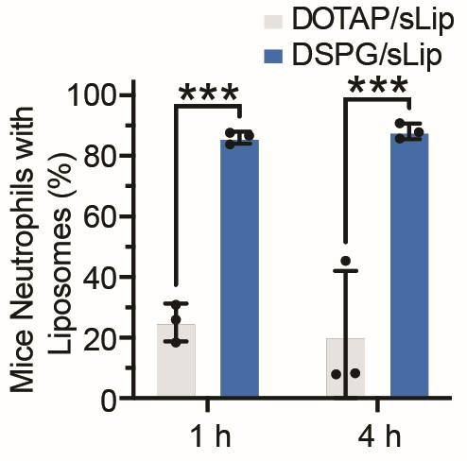
Figure 2: Neutrophils internalized more DSPG/sLip (hydroxylated) than DOTAP/sLip.
C.1.4 Intellectual Property. Cornell owns all associated IP (U.S. Provisional Application No.: 63/552,616), with Oto co-founders (Drs. Tang and Yang) as the inventors. Oto is currently in discussions with the Cornell Technology Licensing (CTL) office about securing exclusive rights to negotiate a license in the future. The Executive Director of CTL and the Office of the Provost are extremely supportive of technology transfer efforts undertaken by Cornell inventors. For future IP protection, Oto works with Klausner Cook, PLLC, a full-service firm with in-house expertise in IP licensing. Oto plans to license IP related to the optimized formulation developed in the proposed Phase I project.
C.2 Preliminary Data
C.2.1 Overview. The preliminary data presented below were recently published in Science Translational Medicine.¹⁷ They demonstrate: (i) Oto’s liposome-mediated delivery mechanism works as hypothesized; (ii) a low dose of ciprofloxacin is sufficient to clear the infection within 24 h in an AOM chinchilla model; and (iii) the hydrogel is biocompatible in the ear. Note that some data presented here show results for various formulations, including a non-hydroxyl-bearing liposome (dioleoyl-3-trimethylammonium propane, or DOTAP). DOTAP is used as a point of reference due to its known trans-TM efficacy. Oto has chosen to pursue the DSPG liposomes given their optimal internalization by neutrophils and biocompatibility. This formulation is superior in efficacy and safety to all previously reported or currently tested formulations.
C.2.2 Opsonization & Internalization Efficiency of Liposomes by Neutrophils In-Vitro. To illustrate neutrophils’ internalization of hydroxyl-bearing v. non-hydroxyl-bearing liposomes, fresh neutrophils were isolated from BALB/c mouse bone marrow and incubated with C3b-opsonized liposomes. 1 h of incubation resulted in 86.0±2.0% of neutrophils internalizing hydroxyl-bearing liposomes (DSPG/sLip), but far fewer non-hydroxyl-bearing liposomes (DOTAP/sLip) (p=0.0003). Incubation for up to 4 h showed a slight increase to 88.1±2.6% for DSPG/sLip that remained minimal for DOTAP/sLip (p=0.0002; Fig. 2), indicating that DSPG/sLip led to distinctly high internalization by neutrophils.

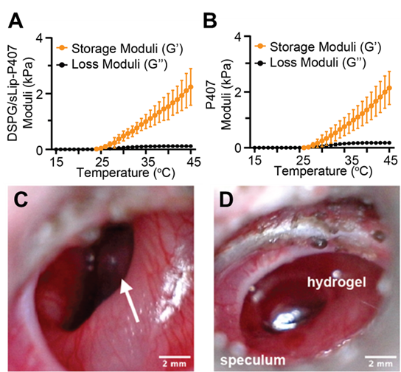
Figure 3: Loading the hydrogel with liposomes did not significantly alter mechanical properties. Elastic moduli of hydrogel formulation with (A) and without (B) liposomes, showing hydrogel gelation is not affected by liposome loading. Image of infected chinchilla TM immediately before (C) and after (D) hydrogel application, with gelation within 1 min of TM contact.
C.2.3 Confirmation of Hydrogel Gelation when Loaded with Liposomes. A P407 concentration of 15% (w/v) was used in all hydrogel formulations as it gels rapidly at body temperature. Storage and loss moduli of the hydrogel are shown in Fig. 3, and no differences in elastic moduli (which describe the slid-like behavior) were observed between DSGP/sLip (Fig. 3A) and DOTAP/sLip (Fig. 3B) hydrogels. At a temperature ramping rate of 1ºC/min, gelation occurs in under one minute, which is consistent with in-vivo administration showing rapid gelation upon application to an infected chinchilla TM (Figs. 3C and 3D).Although amphiphilic compounds are known to disrupt gel formation of P407,^{59,60} incorporating liposomes into 15% (w/v) P407 hydrogel did not change its rheological profile. The unchanged gelation properties ensure the ease of administration for AOM patients and sustained therapeutic effects over a 7-day treatment, which is currently recommended by the American Academy of Pediatrics.⁵
C.2.4 Visualization of TM Permeation by Liposome-Bearing Neutrophils. The liposome-containing hydrogel formulations were applied to chinchilla TMs infected with OM. Their auditory bullae were harvested 24 h post-administration and examined for TM penetration by liposome-bearing neutrophils. Quantification via immunocytohistochemistry was performed in which liposomes were stained with DiI (red) and neutrophils were stained with elastase (green) for microscopy analysis (Fig. 4A). The merged image shows clear overlap of liposomes and neutrophils, confirming liposome internalization and transport across the intact TM. Further, this overlap was observed throughout the TM, indicating that the liposomes remained in the neutrophils during transport. These results confirm that the hitchhiking mechanism enables liposome permeation of the TM.

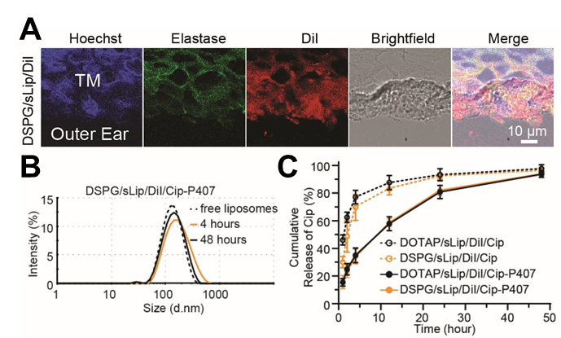
Figure 4: Immunofluorescent staining showing neutrophil-mediated liposome transport across intact TMs (Top). In-vitro release kinetics of the liposome carrying antibiotics (Bottom).
C.2.5 Determination of Release Kinetics of Liposomes & Antibiotics In-Vitro. Liposome-loaded P407 hydrogels were tested using a Transwell® system under infinite sink conditions. DLS analysis showed that liposomes retained their size and integrity during release, with diameters similar to free liposomes (~130–140 nm, Fig. 4B). The antibiotic release kinetics were also tested to estimate the upper-bound of release. Samples were homogenized to break the liposomes and force the release of encapsulated ciprofloxacin (Cip). A maximum of 34.0±5.4% of loaded ciprofloxacin can be released from the hydrogel after 4 h, which increased to 94.0±2.5% after 48 h (Fig. 4C). Release kinetics were similar for the non-hydroxyl-bearing liposomes.

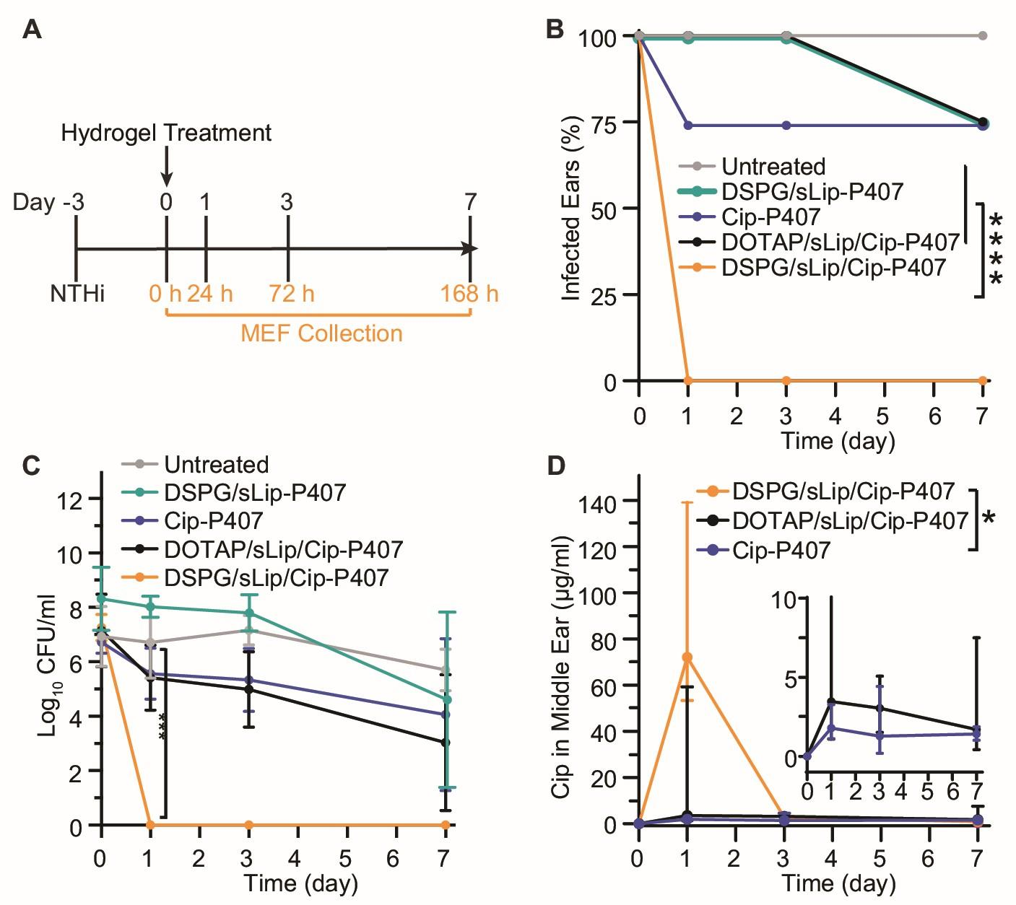
Figure 5: (A) Study timeline. (B) DSPG/sLip/Cip-P407 remarkably cured infection in 24h. (C) CFUs in the MEF. (D) High MEF concentration of ciprofloxacin by DSPG/sLip/Cip-P407 after 24h is linked with quick infection cure times.
C.2.6 In-Vivo Efficacy: Confirmation of Infection Eradication &Pharmacokinetics In-Vivo. In-vivo efficacy was tested in chinchillas with OM (N=4 per group). OM was induced by direct inoculation of NTHi through the auditory bullae (to avoid injection through the TM and maintain its integrity). Infection was confirmed by culturing the middle ear fluid (MEF) aspiration; a NTHi titer of >10⁶ CFU/ml at day 3 confirms successful induction of OM. The untreated group maintained >10⁵ CFU/ml in MEF for 7 days (Fig. 5C).
For treatment, a dose of 200 µL hydrogel loaded with liposomes containing a total of 0.5 mg ciprofloxacin was applied to each TM via a soft catheter. Hydrogels containing the hydroxyl-bearing liposome (DSPG/sLip/Cip-P407) and the non-hydroxyl-bearing liposome (DOTAP/sLip/Cip-P407) were compared, along with an untreated control group, a control group treated with hydrogel containing 0.5 mg free ciprofloxacin (i.e., no liposomes, Cip-P407), and a no-drug control group treated with only a liposome hydrogel (i.e., no cip, DSPG/sLIP-P407). Results show that the drug-free and liposome-free control groups and the group with antibiotic-containing non-hydroxyl-bearing liposomes had only a 25% cure rate after 7 days. In contrast, the hydroxyl-liposome with ciprofloxacin cured 100% of the animals within 24 hours, with MEF cultures showing zero CFU (p=0.0001 vs. untreated) (Fig. 5C). Sterilization was sustained throughout the 7-day treatment. This result was linked to higher drug delivery efficiency, with the average MEF ciprofloxacin concentration around 72.0 µg/ml, which is ~600 times the minimum inhibitory concentration (MIC, Fig 5D).⁶¹ These pharmacokinetics also compare favorably to those achieved by oral administration, which has a much lower concentration reaching the MEF but with a ~1000-folder higher dose.⁶²

C.2.7 Biocompatibility Demonstration. Infected, untreated TMs were 57.4±11.2 μm thick (Fig. 6), 5.8x thicker than pristine TMs (9.9±2.0 μm), and showed acute inflammation with diffuse edema and dense inflammatory cell infiltration. After 7 days of DSPG/sLip/Cip-P407 treatment, TMs appeared nearly normal (12.3±1.4 μm) with no injury, necrosis, or inflammation. In contrast, TMs treated with the non-hydroxyl-bearing liposomes exhibited substantial edema and inflammation. The middle ear mucosa remained unchanged after treatment with Oto’s formulation, confirming treatment biocompatibility.

Approach

D.1 Overview
Preliminary data show that Oto’s novel platform is able to eradicate NTHi within 24 h, a substantial improvement over oral medications for AOM with intact TM (2-3 doses/day for 7-10 days⁶³) and even ear drops for children with perforated TM (2 doses/day for 7 days⁶⁴). This fast-acting, single-application therapy would significantly improve outcomes by accelerating symptom resolution while avoiding adverse side effects of systemic antibiotics. It also eliminates challenges with repeated dosing, enabling faster return daily routines for children and caretakers and leading to better health, economic, and quality of life outcomes.⁶⁵ Nonetheless, Oto recognizes that further increasing the antibiotic loading per dose can lead to two additional benefits: (i) shortening the 24-hour treatment window to a few hours would enhance symptom relief and reduce lost productivity; (ii) the pathogens with higher MICs can become treatable. In this project, Oto aims to increase the antibiotic dose and establish safety and efficacy of eliminating S. pneumoniae and M. catarrhalis, two other common AOM pathogens.

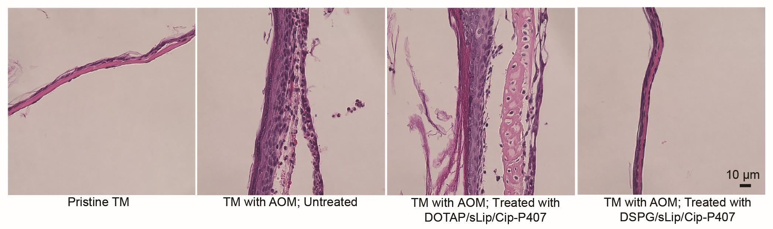
Figure 6: Initial safety indicated by no TM damage after treatment.

D.2 Aim 1: Optimize the formulation to reduce response time (performed by Oto, Months 1-8)
Rationale: To broaden pathogen coverage and shorten curing time, Oto will increase antibiotic loading and optimize the release kinetics while maintaining the demonstrated ease of gelation and handling.
Design of Experiments: Oto will optimize liposomal hydrogel formulations for rapid trans-TM delivery by varying two key formulation factors: liposome composition (DSPG mol%, polyethylene glycol, cholesterol ratios; mean diameter 100–160 nm; PDI <0.2) and ciprofloxacin loading (≥60% encapsulation, 0.5–3.0 mg per-ear equivalent. Resolution IV fractional factorial DoE will be used, which allows estimation of main effects and two-factor interactions while only confounding higher-order interactions that are less likely to be significant. JMP Pro (SAS Institute) and Design-Expert (Stat-Ease) will be used to build the design matrix and select the most information-rich combinations. Candidate formulations will ensure clinically-relevant MIC values of S. pneumoniae and M. catarrhalis are adequately sampled. A regression analysis that accounts for the impact of all key metrics will be used to select the top performing formulations, then confirmatory runs will be conducted to validate reproducibility.
Analysis and Down Selection: Oto will collect transport, release, and rheology data across all groups. A nonparametric Friedman’s test with 80% power and α=0.05 indicated that n=4 per formulation is sufficient for a medium-large effect size (Kendall’s W=0.5). Ex-vivo transport will be assessed in freshly-harvested chinchilla TMs from chinchillas infected with OM pathogens NTHi, S. pneumoniae, and M catarrhalis via transbullar inoculation.^{66,67} Quantification of ciprofloxacin by HPLC/UV and liposomes via fluorescence will be performed for 3 days. Release kinetics will be measured under infinite-sink conditions at 37 °C, monitoring liposome integrity with DLS and cumulative drug release at timepoints aligning with standard practice: 2, 6, 12, 24, 48, and 72 h.^{18,68-70} Gelation will be characterized by oscillatory shear rheology measurements (storage/loss moduli vs. temperature) and syringeability testing through 20–22 G catheters. Multivariable modeling will identify the top 2-3 formulations maximizing early delivery (MEF concentration within 2-4 hours) while sustaining ≥7 day availability.
Metrics of Success: Formulations will be considered successful if projected MEF ciprofloxacin concentrations reach 50 ug/mL within 12 h, which is equivalent to 1000x MIC for NTHi, 50x MIC for S. pneumoniae, and 800x MIC for M. catarrhalis. Rheological criteria include gelation at 25–34°C, cohesive gel formation on the TM, residence ≥7 days ex-vivo, and retained syringeability.
Potential Problems and Alternative Strategies: If the drug loading and trans-TM transport efficiency are below the target for S. pneumoniae and M. catarrhalis, we will attempt using both salt and free base ciprofloxacin simultaneously to boost loading efficiency, explore antibiotics with greater potency than ciprofloxacin, or adjust lipid compositions to improve C3b tagging.

D.3 Aim 2: Determine the efficiency of the optimized formulation in-vivo (Oto & Cornell, Months 6-10)
Rationale: The top 2-3 formulations from Aim 1 will be tested for their efficiency of drug delivery in-vivo using an FDA-approved chinchilla model. Successful completion will demonstrate rapid infection clearance within hours, providing critical data to support the commercial feasibility of a fast-acting, single-application therapy. Animal experiments will be done through a subaward to Cornell, and Oto will perform data analysis.
Establishing OM Infection in Chinchillas: Cornell will culture NTHi, S. pneumoniae, and M. catarrhalis to the mid-log phase and dilute and inject isolates into the auditory bullae via the transbullar inoculation method.^{66,67} Samples of MEF will be collected daily, and CFU counts will be assessed via serial dilution quantitative microbiological assay for bacterial titer in the middle ear (see §C.2.6).Treatment administration will begin once MEF samples reach a concentration of 10⁵ CFU/mL, representing a typical AOM infection and taking 2-3 days.
Groups, Dosing, and MEF Collection: This study will include male and female chinchillas split across 4 treatment groups: 1) experimental (hydrogel + liposomes + ciprofloxacin), 2) a no-drug control (hydrogel + liposomes), 3) a no-liposome control (hydrogel + free ciprofloxacin), and 4) a systemic control (oral amoxicillin and/or ciprofloxacin). Chinchillas will be anesthetized and TM otoscopy performed. Treatment will be applied via catheter threaded through an otoscope speculum. For each pathogen, groups will include 6-8 ears (with two ears per animal used when appropriate), as indicated by the same power analysis in Aim 1. MEF samples will be collected from different animals on a group-balanced, rotating schedule to avoid respiratory and cardiac stress from repeated exposure to anesthesia. Samples will be collected at pre-treatment, 2 h, and 6 h on the first treatment day, then daily for 7 days.
Primary & Secondary Endpoints and Analysis: The primary endpoint for this study is the time to infection clearance, quantified by CFUs in the MEF over time. Oto will calculate the mean±SD CFU/mL MEF at each time point and plot Kaplan-Meier curves for visualizing bacteria survival over time. As a secondary endpoint, the concentration-time profile of ciprofloxacin in the MEF will be assessed via HPLC. The proportion of MEF samples that achieve drug concentrations >10x the MIC of the target pathogens with be quantified for 6 h post-treatment. Daily checks for infection relapse will be performed for 7 days to assess sustained treatment efficacy.
Metrics of Success: Oto’s optimized formulation leads to an average NTHi CFU of 0 within 2-12 hours of treatment application. This infection-clearance timeframe is based on both the clinical need to minimize pain in pediatric patients and on preliminary data demonstrating that this timeframe is achievable. Animals with S. pneumoniae/M. catarrhalis infections should demonstrate statistically significant (p<0.05) reduction vs controls and target initial sterilization ≤12 h. Ciprofloxacin concentrations in the MEF should reach ≥25–50x MIC within 6 h, with a sustained concentration ≥4x MIC in the following 72 h. Oto’s formulation should show superiority to negative controls and non-inferiority to oral antibiotics across all measures.
Potential Problems and Alternative Strategies: While data from Aim 1 will inform trans-TM delivery efficiency in-vitro and ex-vivo, it is possible that metrics like antibiotic concentration in MEF do not translate perfectly in an in-vivo model, reducing eradication efficiency. If antibiotic concentrations in MEF are found to be suboptimal for infection control, the optimization strategies mentioned in §D.2 are applicable here. Drug diffusion may also be limited by the presence of infection-related inflammation and mucus. Although we have not encountered this issue in testing to-date, we may explore adding dexamethasone to the formulation, as combined ciprofloxacin/dexamethasone is already an FDA-approved treatment for OM with perforated eardrums.

D.4 Aim 3: Demonstrate the safety & biocompatibility of top formulations (Oto & Cornell, Months 7-12)
Rationale: Part of the value proposition of targeted drug delivery is the potential to reduce systemic antibiotic side effects. Oto chose ciprofloxacin since it is FDA-approved for pediatric OM infection with perforated eardrums. Large doses of ciprofloxacin have been linked to safety concerns, and although Oto’s delivery platform requires lower doses than ear drops and oral antibiotics, a higher proportion of the drug is expected to reach the target structures. This aim will thus confirm local delivery and assess risk of systemic antibiotic exposure.
Confirmation of Local Delivery: During Aim 2’s in-vivo work, animals will be weighed daily to monitor their general health. Ears will be checked daily for any signs of redness or other irritation. Blood will be drawn from the femoral vein at timepoints aligned with MEF collection in Aim 2 to assess plasma antibiotic levels.
Hearing and Cochlear Safety: FDA-aligned hearing and cochlear health tests will be performed via Auditory Brainstem Response (ABR) thresholds and distortion product otoacoustic emission (DPOAE), respectively, at baseline and 7 days after treatment application. Please see the Vertebrate Animal Plan for protocol methodology.
Histology and Tissue Morphology: At the end of the monitoring period, animals will be euthanized according to American Veterinary Medical Association (AVMA) guidelines. To assess TM integrity, ears will be harvested and hematoxylin and eosin (H&E) staining will be used to evaluate tissue injuries, necrosis, and the presence of inflammatory cells. TM thickness will be measured and compared to the thickness of a TM from a healthy chinchilla to support conclusions about potential inflammation. Fluorescent staining and confocal microscopy will be performed to determine the integrity of hair cells, which are important for auditory function.
Data Analysis & Metrics of Success: All data from the experimental group will be compared to healthy controls using a two-tailed Fisher’s exact test. When appropriate, post-hoc testing with Bonferroni correction will be used to identify between-group differences. Epithelial integrity, necrosis, and inflammatory cell infiltration will be analyzed with cumulative mixed models. Confocal images will be qualitatively assessed. Isolated local delivery and reduced systemic exposure will be deemed successful if a mean plasma ciprofloxacin concentration is ≤20 µg/ml, the pediatric systemic maximum concentration.⁶² For hearing and cochlear safety, no significant ABR threshold shifts (≤10 dB vs baseline), TM thickness must return toward normal (within ~50% of pristine mean), and there should be no hair cell loss or cochlear damage compared to controls.
Potential Problems and Alternative Strategies: Few problems are expected in Aim 3 as Oto’s preliminary data showed excellent safety and biocompatibility and these procedures are routinely performed in the Yang Lab at Cornell. Oto will test whether unexpected hearing shifts are transient by repeated testing after recovery periods.

D.5 Next Steps. Completion of this work will enable a Phase II project in which Oto will modify the formulation based on any safety or efficacy issues from Phase I, develop a GLP hydrogel formulation, and perform powered safety, toxicity, and efficacy studies required for an IND submission. There is currently no existing local treatment for uncomplicated acute OM (i.e., with intact TM), so comparisons with gold standard treatment are not currently planned for Phase II. However, should a competitor emerge during Phase I, the Phase II work plan will be adjusted to include this comparison.

References
1. Ben Debba L, Derreumaux D, Lonnet G, Taddei L, Scherbakov M. Clinical and economic burden of otitis media in children under 5 years of age in the United States: A retrospective study. Hum Vaccin Immunother 2024;20(1):2409510. DOI: 10.1080/21645515.2024.2409510.
2. Williamson I, Dunleavey J, Bain J, Robinson D. The natural history of otitis media with effusion–a three-year study of the incidence and prevalence of abnormal tympanograms in four South West Hampshire infant and first schools. The Journal of Laryngology & Otology 1994;108(11):930-934.
3. Arrieta A, Singh J. Management of recurrent and persistent acute otitis media: new options with familiar antibiotics. The Pediatric infectious disease journal 2004;23(2):S115-S124.
4. Jacobs MR, Dagan R, Appelbaum PC, Burch DJ. Prevalence of antimicrobial-resistant pathogens in middle ear fluid: multinational study of 917 children with acute otitis media. Antimicrobial agents and chemotherapy 1998;42(3):589-595.
5. Lieberthal AS, Carroll AE, Chonmaitree T, et al. The diagnosis and management of acute otitis media. Pediatrics 2013;131(3):e964-e999.
6. Shekelle PG, Takata G, Newberry SJ, et al. Management of Acute Otitis Media: update. Evidence report/technology assessment 2010(198):1-426.
7. Venekamp RP, Burton MJ, van Dongen TM, van der Heijden GJ, van Zon A, Schilder AG. Antibiotics for otitis media with effusion in children. Cochrane Database of Systematic Reviews 2016(6).
8. Mather MW, Drinnan M, Perry JD, Powell S, Wilson JA, Powell J. A systematic review and meta-analysis of antimicrobial resistance in paediatric acute otitis media. International Journal of Pediatric Otorhinolaryngology 2019;123:102-109. DOI: https://doi.org/10.1016/j.ijporl.2019.04.041.
9. Nawaz S, Smith ME, George R, Dodgson K, Lloyd SK. Changes in antimicrobial resistance in acute otitis media and otitis externa. Clinical Otolaryngology 2023;48(5):740-747.
10. Ravicz ME, Rosowski JJ, Merchant SN. Mechanisms of hearing loss resulting from middle-ear fluid. Hearing research 2004;195(1-2):103-130.
11. Gouma P, Mallis A, Daniilidis V, Gouveris H, Armenakis N, Naxakis S. Behavioral trends in young children with conductive hearing loss: a case–control study. European Archives of Oto-Rhino-Laryngology 2011;268:63-66.
12. Niclasen J, Obel C, Homøe P, Kørvel-Hanquist A, Dammeyer J. Associations between otitis media and child behavioural and learning difficulties: Results from a Danish cohort. International Journal of Pediatric Otorhinolaryngology 2016;84:12-20. DOI: https://doi.org/10.1016/j.ijporl.2016.02.017.
13. Lerminiaux NA, Cameron AD. Horizontal transfer of antibiotic resistance genes in clinical environments. Canadian journal of microbiology 2019;65(1):34-44.
14. Li W, Zhang G. Detection and various environmental factors of antibiotic resistance gene horizontal transfer. Environmental Research 2022;212:113267.
15. McDonnell L, Gilkes A, Ashworth M, et al. Association between antibiotics and gut microbiome dysbiosis in children: systematic review and meta-analysis. Gut Microbes 2021;13(1):1870402. DOI: 10.1080/19490976.2020.1870402.
16. Van der Jeught S, Dirckx JJ, Aerts JR, Bradu A, Podoleanu AG, Buytaert JA. Full-field thickness distribution of human tympanic membrane obtained with optical coherence tomography. J Assoc Res Otolaryngol 2013;14(4):483-94. (In eng). DOI: 10.1007/s10162-013-0394-z.
17. Tang W, Ma X, Marlowe C, et al. Neutrophil-mediated delivery of antibiotics across the tympanic membrane for otitis media treatment in a preclinical model. Science Translational Medicine 2026;18(837):eadu9186.
18. Yang R, Sabharwal V, Okonkwo OS, et al. Treatment of otitis media by transtympanic delivery of antibiotics. Sci Transl Med 2016;8(356):356ra120. DOI: 10.1126/scitranslmed.aaf4363.
19. Ricklin D, Hajishengallis G, Yang K, Lambris JD. Complement: a key system for immune surveillance and homeostasis. Nature Immunology 2010;11(9):785-797. DOI: 10.1038/ni.1923.
20. Assiri K, Hudise J, Obeid A. Risk factors for chronic and recurrent Otitis Media in children: A review article. Indian Journal of Otolaryngology and Head & Neck Surgery 2024;76(1):1464-1469.
21. Venekamp RP, Sanders SL, Glasziou PP, Rovers MM. Antibiotics for acute otitis media in children. Cochrane Database Syst Rev 2023;11(11):CD000219. DOI: 10.1002/14651858.CD000219.pub5.
22. Abdel-Aziz M, Sabry OA, Ahmed AS, Farag HM. The effect of otitis media with effusion on phonological performance of preschool children. The Egyptian Journal of Otolaryngology 2024;40(1):21.
23. Aarhus L, Tambs K, Kvestad E, Engdahl B. Childhood otitis media: a cohort study with 30-year follow-up of hearing (the HUNT study). Ear and hearing 2015;36(3):302.
24. Altamimi AA, Robinson M, McKinnon EJ, et al. The association between otitis media in early childhood with later behaviour and attention problems: A longitudinal pregnancy cohort. International Journal of Pediatric Otorhinolaryngology 2023;168:111545.
25. American Academy of Family Physicians, American Academy of Otolaryngology-Head Neck Surgery, American Academy of Pediatrics Subcommittee on Otitis Media With Effusion. Otitis media with effusion. Pediatrics 2004;113(5):1412-1429.
26. Rosenfeld RM, Culpepper L, Doyle KJ, et al. Clinical practice guideline: otitis media with effusion. Otolaryngology–Head and Neck Surgery 2004;130:S95-S118.
27. Sahling M. Effects of otitis media with effusion on speech perception and production in preschoolers. Macquarie University; 2024.
28. Savaş M. The effect of otitis media with effusion on language and cognitive skills in school age children. Experimed 2023;13(2):156-162.
29. El Feghaly RE, Nedved A, Katz SE, Frost HM. New insights into the treatment of acute otitis media. Expert Rev Anti Infect Ther 2023;21(5):523-534. DOI: 10.1080/14787210.2023.2206565.
30. Frost HM, Becker LF, Knepper BC, Shihadeh KC, Jenkins TC. Antibiotic Prescribing Patterns for Acute Otitis Media for Children 2 Years and Older. J Pediatr 2020;220:109-115 e1. DOI: 10.1016/j.jpeds.2020.01.045.
31. Sun D, Rivas-Lopez V, Liberman DB. A Multifaceted Quality Improvement Intervention to Improve Watchful Waiting in Acute Otitis Media Management. Pediatr Qual Saf 2019;4(3):e177. DOI: 10.1097/pq9.0000000000000177.
32. Kenmoe S, Dozier M, Liang J, Jenkins R, Nair H. The Burden of Respiratory Syncytial Virus in Children With Acute Otitis Media: A Systematic Review and Meta-Analysis. Influenza Other Respir Viruses 2026;20(2):e70223. DOI: 10.1111/irv.70223.
33. Mittal R, Parrish JM, Soni M, Mittal J, Mathee K. Microbial otitis media: recent advancements in treatment, current challenges and opportunities. J Med Microbiol 2018;67(10):1417-1425. DOI: 10.1099/jmm.0.000810.
34. Kaur R, Fuji N, Pichichero ME. Dynamic changes in otopathogens colonizing the nasopharynx and causing acute otitis media in children after 13-valent (PCV13) pneumococcal conjugate vaccination during 2015-2019. Eur J Clin Microbiol Infect Dis 2022;41(1):37-44. DOI: 10.1007/s10096-021-04324-0.
35. Kaur R, Morris M, Pichichero ME. Epidemiology of Acute Otitis Media in the Postpneumococcal Conjugate Vaccine Era. Pediatrics 2017;140(3). DOI: 10.1542/peds.2017-0181.
36. Katz SE, Jenkins TC, Stein AB, et al. Durations of Antibiotic Treatment for Acute Otitis Media and Variability in Prescribed Durations Across Two Large Academic Health Systems. Journal of the Pediatric Infectious Diseases Society 2024;13(9):455-465. DOI: 10.1093/jpids/piae073.
37. Kim SH, Kim J-R, Song J-J, Chae S-W. Trend and patterns in the antibiotics prescription for the acute otitis media in Korean children. International Journal of Pediatric Otorhinolaryngology 2020;130:109789. DOI: https://doi.org/10.1016/j.ijporl.2019.109789.
38. Frost HM, Bizune D, Gerber JS, Hersh AL, Hicks LA, Tsay SV. Amoxicillin Versus Other Antibiotic Agents for the Treatment of Acute Otitis Media in Children. J Pediatr 2022;251:98-104 e5. DOI: 10.1016/j.jpeds.2022.07.053.
39. Smolinski NE, Antonelli PJ, Winterstein AG. Watchful Waiting for Acute Otitis Media. Pediatrics 2022;150(1). DOI: 10.1542/peds.2021-055613.
40. Youngster I, Gelernter R, Klainer H, Paz H, Kozer E, Goldman M. Electronically monitored adherence to short-term antibiotic therapy in children. Pediatrics 2022;150(6):e2022058281.
41. Frost HM, Keith A, Fletcher DR, et al. Clinical outcomes associated with amoxicillin treatment for acute otitis media in children. Journal of the Pediatric Infectious Diseases Society 2024;13(3):203-210.
42. Nagar RR, Deshmukh PT. An Overview of the Tympanostomy Tube. Cureus 2022;14(10):e30166. DOI: 10.7759/cureus.30166.
43. Bluestone CD, Klein JO. Otitis media in infants and children: PMPH-USA, 2007.
44. Wall GM, Stroman DW, Roland PS, Dohar J. Ciprofloxacin 0.3%/dexamethasone 0.1% sterile otic suspension for the topical treatment of ear infections: a review of the literature. Pediatr Infect Dis J 2009;28(2):141-4. DOI: 10.1097/INF.0b013e31818b0c9c.
45. Edmunds AL. Otiprio: An FDA-Approved Ciprofloxacin Suspension Gel for Pediatric Otitis Media With Effusion. P T 2017;42(5):307-311. (https://www.ncbi.nlm.nih.gov/pubmed/28479839).
46. Wang X, Fernandez R, Tsivkovskaia N, et al. OTO-201: nonclinical assessment of a sustained-release ciprofloxacin hydrogel for the treatment of otitis media. Otol Neurotol 2014;35(3):459-69. DOI: 10.1097/MAO.0000000000000261.
47. Kim AS, Betz JF, Reed NS, Ward BK, Nieman CL. Prevalence of Tympanic Membrane Perforations Among Adolescents, Adults, and Older Adults in the United States. Otolaryngol Head Neck Surg 2022;167(2):356-358. (In eng). DOI: 10.1177/01945998211062153.
48. Li S, Chen Z, Huang L, et al. Safety of Quinolones in Children: A Systematic Review and Meta-Analysis: S. Li et al. Pediatric Drugs 2022;24(5):447-464.
49. Samarei R. Comparison of local and systemic ciprofloxacin ototoxicity in the treatment of chronic media otitis. Global Journal of Health Science 2014;6(7):144.
50. Keshavan S, Calligari P, Stella L, Fusco L, Delogu LG, Fadeel B. Nano-bio interactions: a neutrophil-centric view. Cell Death & Disease 2019;10(8):569.
51. Massa HM, Spann KM, Cripps AW. Innate immunity in the middle ear mucosa. Frontiers in Cellular and Infection Microbiology 2021;11:764772.
52. Lee WL, Harrison RE, Grinstein S. Phagocytosis by neutrophils. Microbes and infection 2003;5(14):1299-1306.
53. Närkiö-Mäkelä M, Hellwage J, Tahkokallio O, Meri S. Complement-regulator factor H and related proteins in otitis media with effusion. Clinical Immunology 2001;100(1):118-126.
54. Reddy ST, Van Der Vlies AJ, Simeoni E, et al. Exploiting lymphatic transport and complement activation in nanoparticle vaccines. Nature biotechnology 2007;25(10):1159-1164.
55. Adikwu E, Brambaifa N, Adikwu E. Ciprofloxacin induced chondrotoxicity and tendinopathy. Am J Pharmacol Toxicol 2012;7(3):94-100.
56. Channa HMA, Ashfaq M, Mastoi SM, Qureshi MA. Effect of ciprofoxacin on growing cartilage in albino rat pups. Journal of Ayub Medical College Abbottabad 2006;18(3).
57. Huddleston P, Steckelberg J, Hanssen A, Rouse M, Bolander M, Patel R. Ciprofloxacin inhibition of experimental fracture-healing. JBJS 2000;82(2):161-73.
58. Yang R, Sabharwal V, Shlykova N, Okonkwo OS, Pelton SI, Kohane DS. Treatment of Streptococcus pneumoniae otitis media in a chinchilla model by transtympanic delivery of antibiotics. JCI insight 2018;3(19):e123415.
59. Hecht E, Hoffmann H. Interaction of ABA block copolymers with ionic surfactants in aqueous solution. Langmuir 1994;10(1):86-91.
60. Kancharla S, Bedrov D, Tsianou M, Alexandridis P. Structure and composition of mixed micelles formed by nonionic block copolymers and ionic surfactants in water determined by small-angle neutron scattering with contrast variation. Journal of Colloid and Interface Science 2022;609:456-468.
61. Pérez-Vázquez M, Román F, Aracil B, Cantón R, Campos J. Laboratory Detection of <i>Haemophilus influenzae</i> with Decreased Susceptibility to Nalidixic Acid, Ciprofloxacin, Levofloxacin, and Moxifloxacin Due to <i>gyrA</i> and <i>parC</i> Mutations. Journal of Clinical Microbiology 2004;42(3):1185-1191. DOI: doi:10.1128/jcm.42.3.1185-1191.2004.
62. Harrison CJ. Using antibiotic concentrations in middle ear fluid to predict potential clinical efficacy. The Pediatric infectious disease journal 1997;16(2):S12-S16.
63. Thanaviratananich S, Laopaiboon M, Vatanasapt P. Once or twice daily versus three times daily amoxicillin with or without clavulanate for the treatment of acute otitis media. Cochrane Database Syst Rev 2013;2013(12):Cd004975. (In eng). DOI: 10.1002/14651858.CD004975.pub3.
64. Mayo Clinic. Ciprofloxacin and dexamethasone (otic route). (https://www.mayoclinic.org/drugs-supplements/ciprofloxacin-and-dexamethasone-otic-route/description/drg-20061674).
65. Crawford B, Hashim SSM, Prepageran N, et al. Impact of pediatric acute otitis media on child and parental quality of life and associated productivity loss in Malaysia: a prospective observational study. Drugs-real world outcomes 2017;4(1):21-31.
66. Bakaletz LO. Chinchilla as a robust, reproducible and polymicrobial model of otitis media and its prevention. Expert review of vaccines 2009;8(8):1063-1082.
67. Brown C. Middle ear sample collection in the chinchilla. Lab animal 2007;36(9):22-23.
68. Khoo X, Simons EJ, Chiang HH, et al. Formulations for trans-tympanic antibiotic delivery. Biomaterials 2013;34(4):1281-1288.
69. Liu SS, White JM, Chao Z, et al. A Pseudo‐Surfactant Chemical Permeation Enhancer to Treat Otitis Media via Sustained Transtympanic Delivery of Antibiotics. Advanced healthcare materials 2024;13(22):2400457.
70. Yang R, Saarinen R, Okonkwo OS, Hao Y, Mehta M, Kohane DS. Transtympanic delivery of local anesthetics for pain in acute otitis media. Molecular pharmaceutics 2019;16(4):1555-1562.

