**System Update Log**

1. Add new function for CO & BM
   1. Co can submit comment to BM after researched one client.
      1. 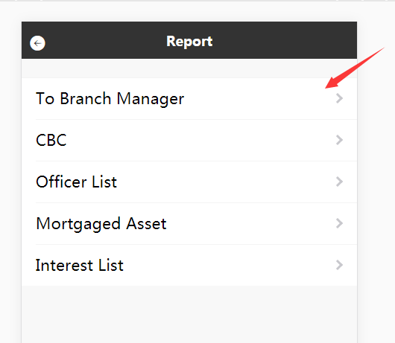
      2. 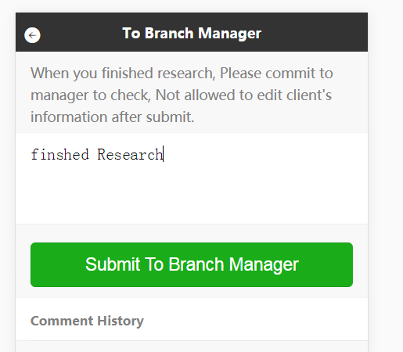
      3. 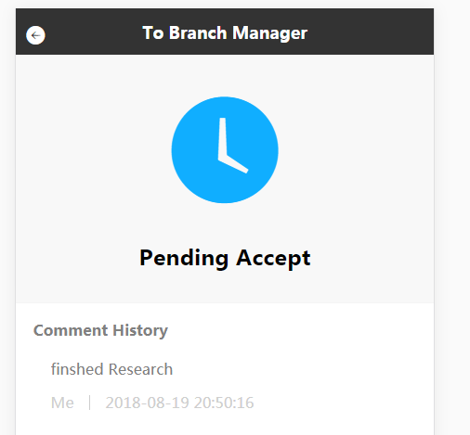
   2. BM Can Accept New application of Co( co can’t modify client-information after accept)
      1. 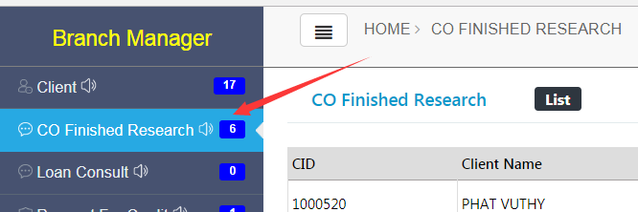
      2. 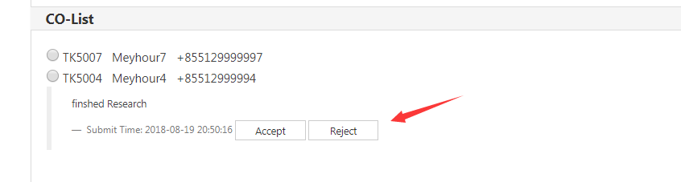
2. Updated Suggest-Credit For CO
   1. 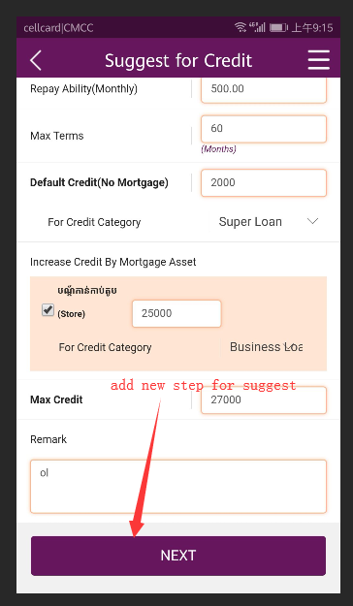
   2. 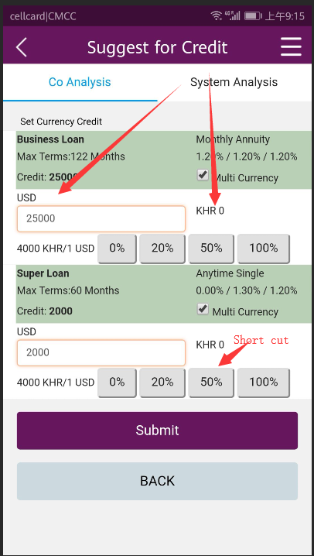
   3. We can set multi currency for one loan-product of one client.
   4. Just need to input USD amount, automatically calculate KHR amount.
   5. 0%, 20%,50%,100%, they are short-cut-button. Click it can auto-input USD-Amount
3. Updated Suggest-Credit For BM
   1. 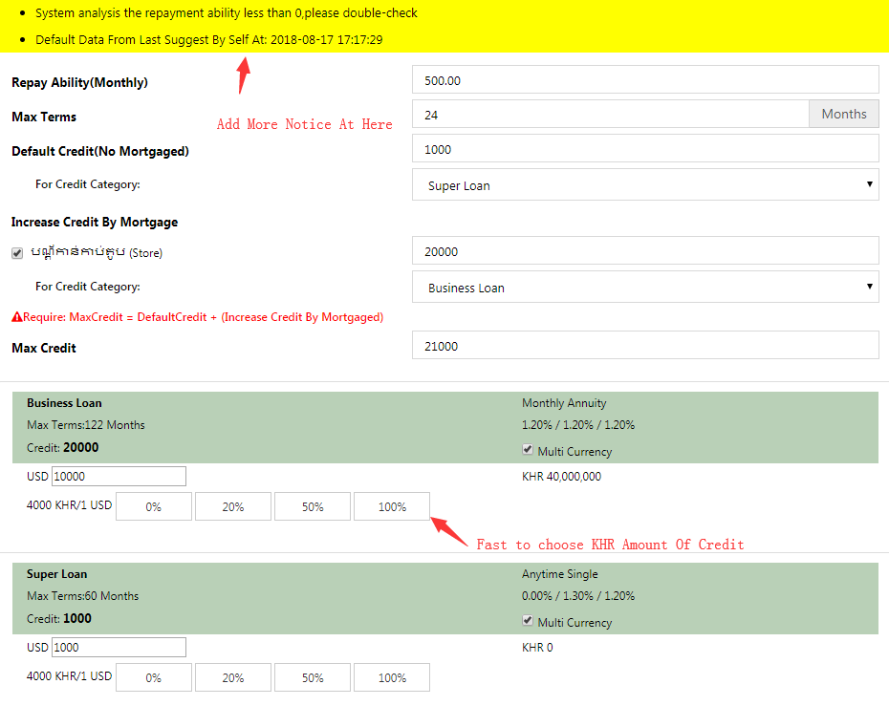
   2. 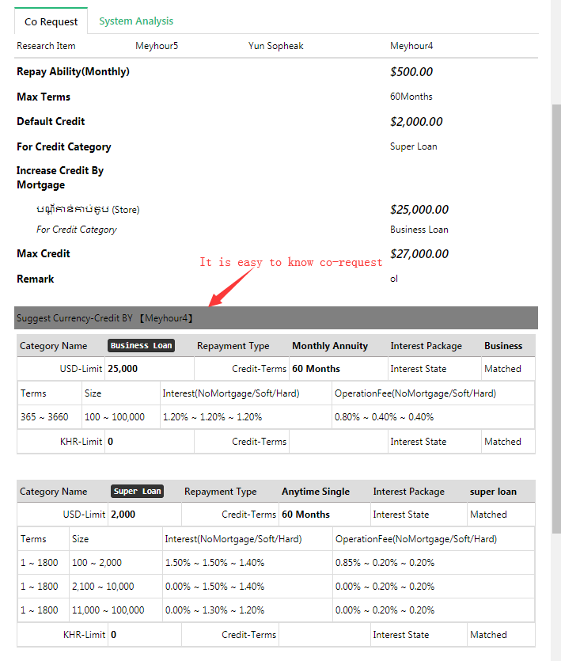
4. Updated Approval-Credit Page
   1. Show Interest-package at Here.
5. Updated Loan At Counter-Teller
   1. 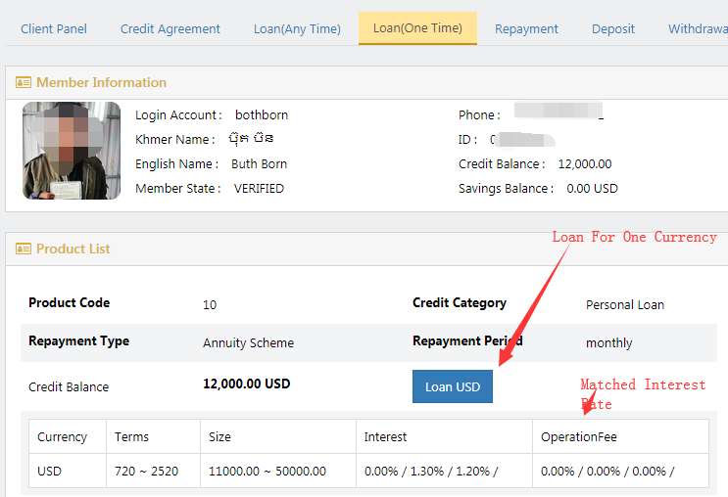
6. More
   1. 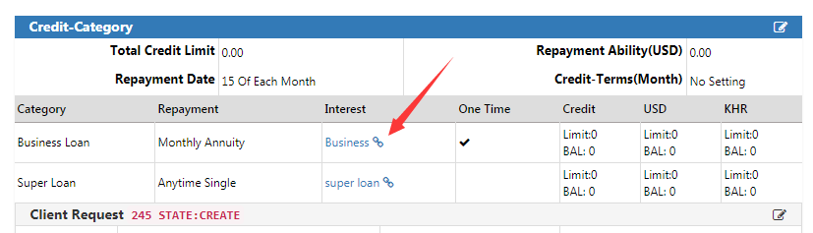Check Interest-Rate-List At here for operator/bm