CS294-112 Homework 1

**Figure 1:** This is the table for question 2.2. The tasks used were Humanoid-V2 and Hopper-V2. Behavioral cloning on Humanoid-V2 results in worse results than on Hopper-V2. These results were generated with a 2-layer NN created using Tensorflow with a dense hidden layer of size 16 units using the RELU activation function. The results were gathered using 5, 10, 20, 40, 80, 160, and 320 rollouts with 30 epochs to train the NN. I used a batch size of 64. The x values were normalized with the mean and standard deviation before training and evaluating.



**Figure 2:** This is the graph for question 2.3. I used the Hopper-V2 task/environment. The hyperparameter I experimented with was the number of rollouts used to train the NN. I chose this hyperparameter since, during my implementation of the neural network, I tried using 5 rollouts and 10 rollouts and noticed drastically different results. I wanted to explore this further and improve my results. Also, since the amount of data is positively correlated with the accuracy of a deep learning network, I expected my results to improve as I increased the amount of data. I wanted to verify this hypothesis and confirm what Professor Levine stated in lecture.

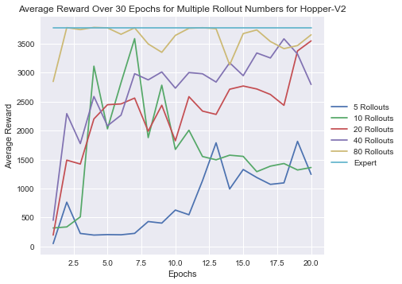

**Figure 3:** This is the graph for question 3.2. I used the Hopper-V2 task with 10 epochs per iteration for 20 iterations of DAgger. The original data I used was the Hopper-V2 data with 5 rollouts. I used a 2-layer NN with a 64-unit dense hidden layer with a batch size of 64. The x values were normalized with the mean and standard deviation before training and evaluating. The behavioral cloning data is for 20 rollouts. I used this because at the end of the 20 iterations of DAgger, the amount of data is closest to the 20 rollout behavioral cloning data (Around 20,000 observation-action pairs).

