CS294-112 Homework 2: Policy Gradients

**Problem 4:**

**Figure 1:** Average returns vs. Number of iterations for SB

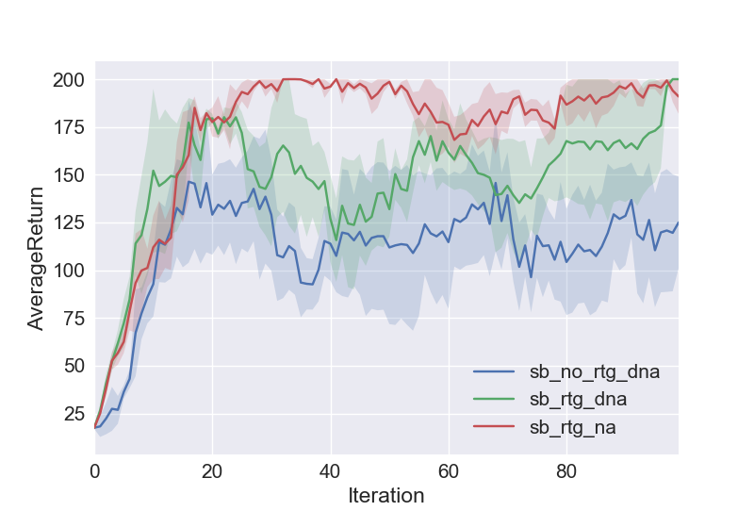

**Figure 2:** Average returns vs. Number of iterations for LB

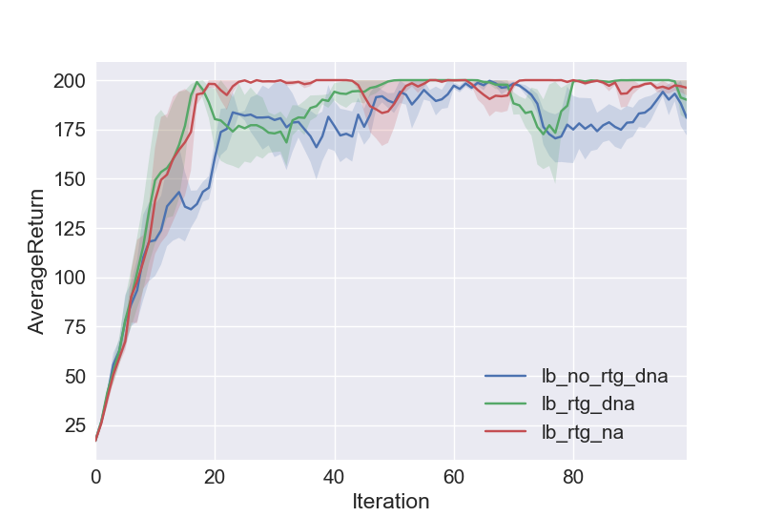

**Short Answers:**

Which gradient estimator has better performance without advantage centering – the trajectory centric one, or the one using reward to go?

The one using reward to go has better performance without advantage centering.

Did advantage centering help?

Yes

Did the batch size make an impact?

Yes. A larger batch size allowed for a faster convergence rate.

**Command Line Expressions:**

python train_pg_f18.py CartPole-v0 -n 100 -b 1000 -e 3 -dna --exp_name sb_no_rtg_dna

python train_pg_f18.py CartPole-v0 -n 100 -b 1000 -e 3 -rtg -dna --exp_name sb_rtg_dna

python train_pg_f18.py CartPole-v0 -n 100 -b 1000 -e 3 -rtg --exp_name sb_rtg_na

python train_pg_f18.py CartPole-v0 -n 100 -b 5000 -e 3 -dna --exp_name lb_no_rtg_dna

python train_pg_f18.py CartPole-v0 -n 100 -b 5000 -e 3 -rtg -dna --exp_name lb_rtg_dna

python train_pg_f18.py CartPole-v0 -n 100 -b 5000 -e 3 -rtg --exp_name lb_rtg_na

**Problem 5:**

**Figure 3:** Average returns vs. Number of iterations for InvertedPendulum. I used a batch size of 4000 and a learning rate of 0.01.

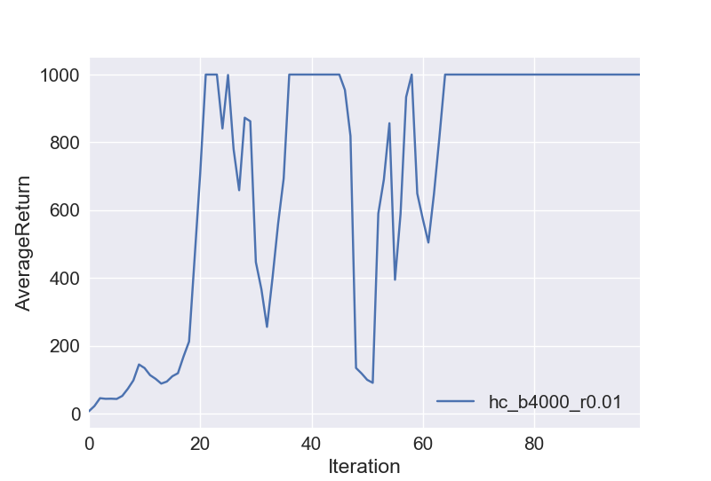

**Command Line Expressions:**

python train_pg_f18.py InvertedPendulum-v2 -ep 1000 --discount 0.9 -n 100 -e 3 -l 2 -s 64 -b 4000 -lr 0.01 -rtg --exp _name hc_b4000_r0.01

**Problem 7:**

**Figure 4:** Average returns vs. Number of iterations for LunarLander

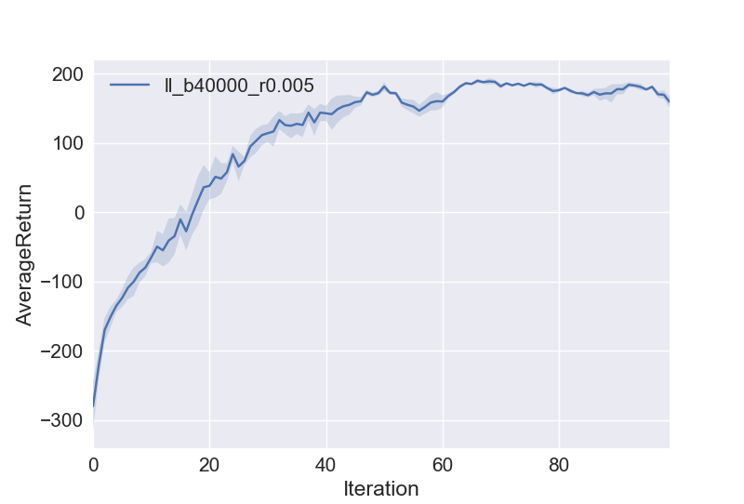

**Command Line Expressions:**

python train_pg_f18.py LunarLanderContinuous-v2 -ep 1000 --discount 0.99 -n 100 -e 3 -l 2 -s 64 -b 40000 -lr 0.005 -rtg --nn_baseline --exp_name ll_b40000_r0.005

**Problem 8:**

**Figure 5:** Average returns vs. Number of Iterations for HalfCheetah

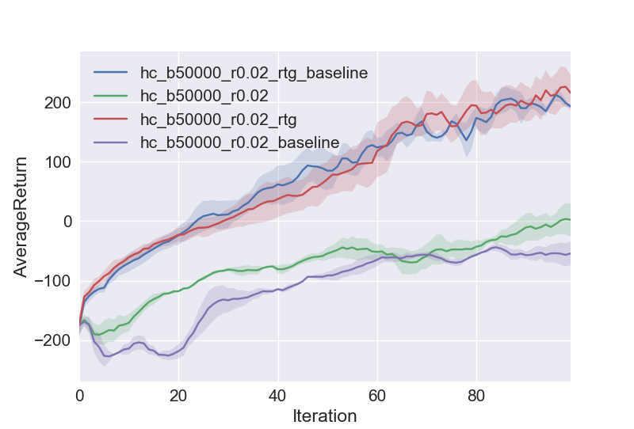

**Short Answers:**

How did the batch size and learning rate affect the performance?

In general, an increased batch size and lower learning rate correlated with a better performance. A batch size of 50000 and learning rate of 0.02 seemed to give optimal performance.

**Command Line Expressions:**

python train_pg_f18.py HalfCheetah-v2 -ep 150 --discount 0.9 -n 100 -e 3 -l 2 -s 32 -b 50000 -lr 0.02 --exp_name hc_b50000_r0.02

python train_pg_f18.py HalfCheetah-v2 -ep 150 --discount 0.9 -n 100 -e 3 -l 2 -s 32 -b 50000 -lr 0.02 -rtg --exp_name hc_b50000_r0.02_rtg

python train_pg_f18.py HalfCheetah-v2 -ep 150 --discount 0.9 -n 100 -e 3 -l 2 -s 32 -b 50000 -lr 0.02 --nn_baseline --exp_name hc_b50000_r0.02_baseline

python train_pg_f18.py HalfCheetah-v2 -ep 150 --discount 0.9 -n 100 -e 3 -l 2 -s 32 -b 50000 -lr 0.02 -rtg --nn_baseline --exp_name hc_b50000_r0.02_rtg_baseline