Download CentOS 1

Workstation Player 1

在虚拟机中安装CentOS7 2

设置阿里开源镜像 10

1、备份 11

2、下载新的CentOS-Base.repo 到/etc/yum.repos.d/ 11

1、备份(如有配置其他epel源) 11

2、下载新repo 到/etc/yum.repos.d/ 11

安装常用工具 11

To install glib on CentOS/RedHat/Fedora:(tagbar依赖) 12

Missing separate debuginfos, use: debuginfo-install glibc-2.12-1.47.el6_2.9.i686 libgcc-4.4.6-3.el6.i686 libstdc++-4.4.6-3.el6.i686 12

Install And Configure FTP Server On CentOS 7 12

安装nodejs 13

怎么备份VMware虚拟磁盘文件或移植到其他虚拟机 13

# Download CentOS

<https://www.centos.org/download/>

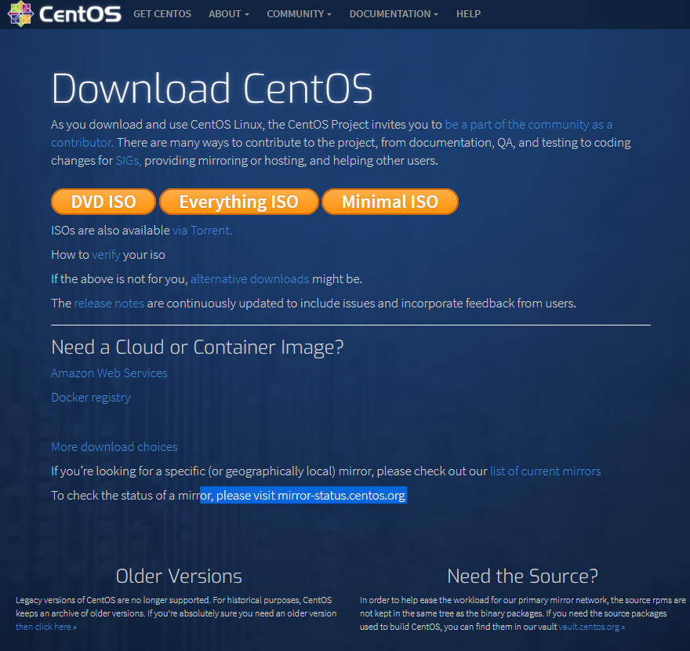

# Workstation Player

<https://www.vmware.com/products/workstation-player.html>

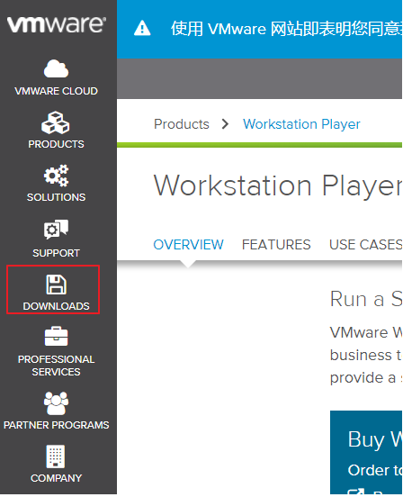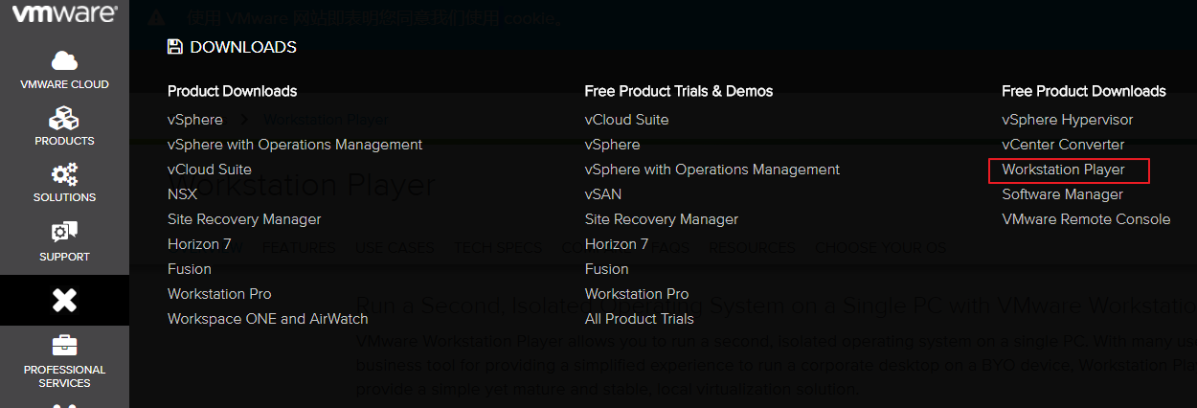

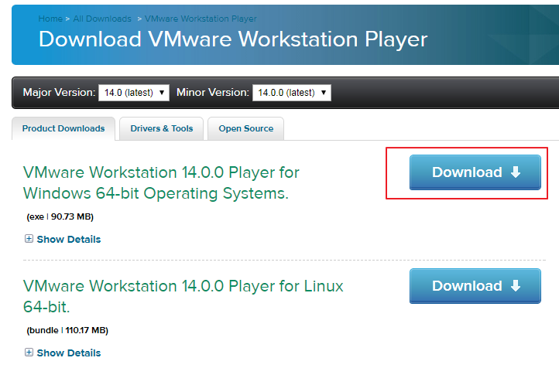

# 在虚拟机中安装CentOS7

<http://jingyan.baidu.com/article/eae0782787b4c01fec548535.html>

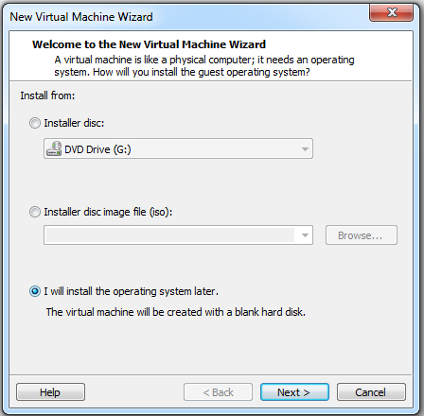

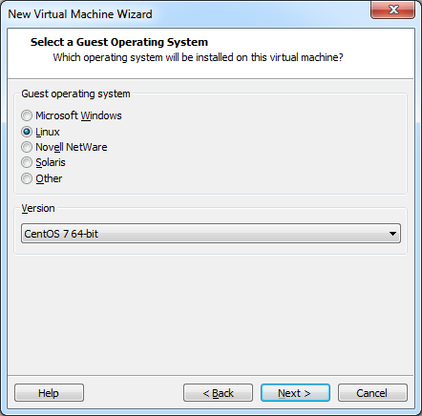

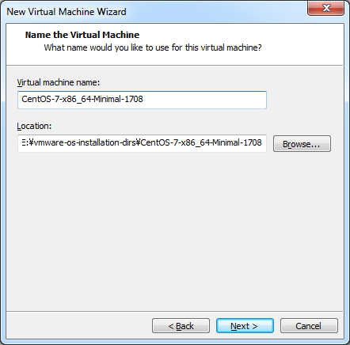

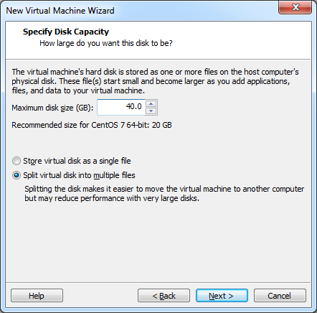

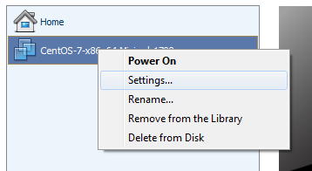

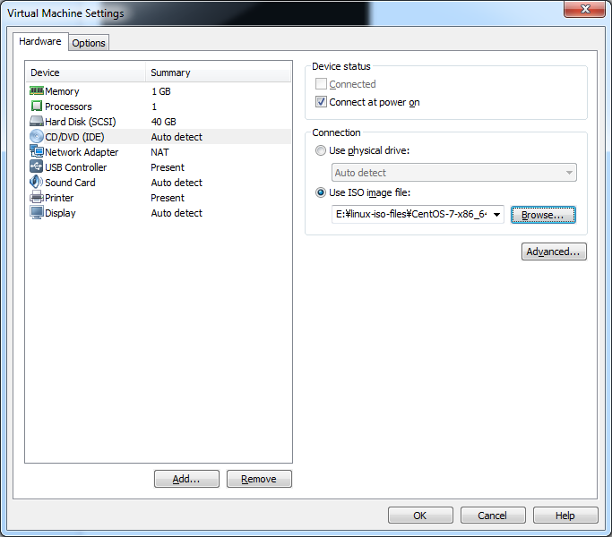

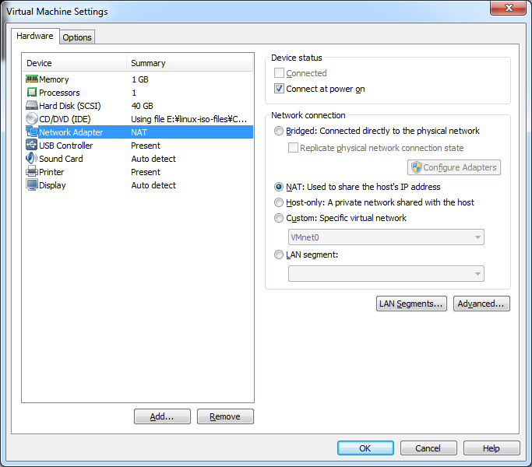

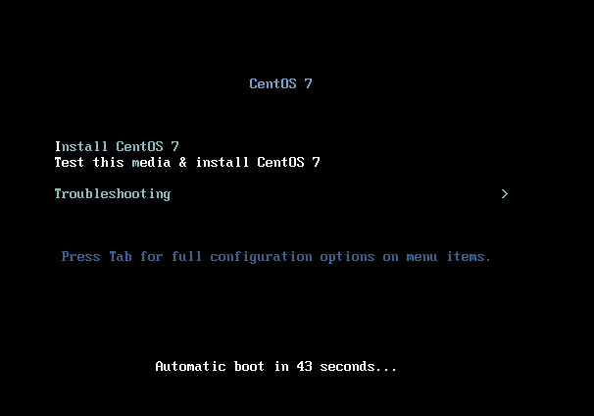

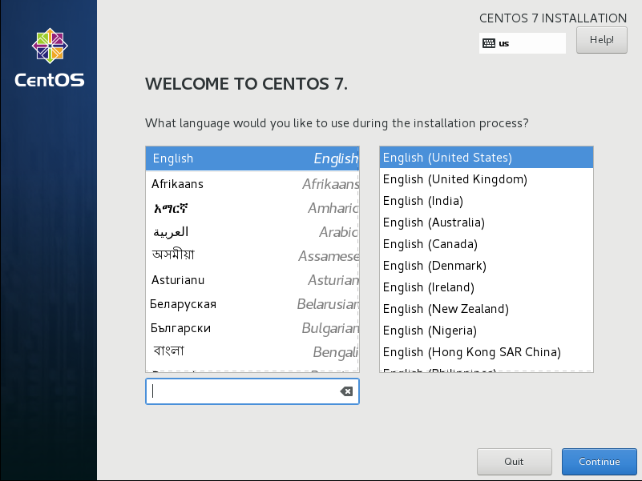

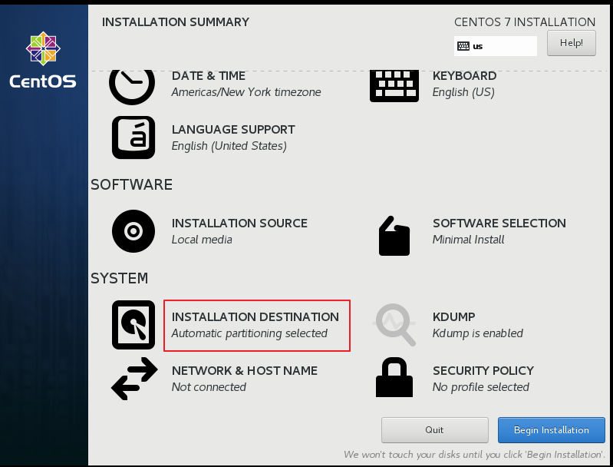

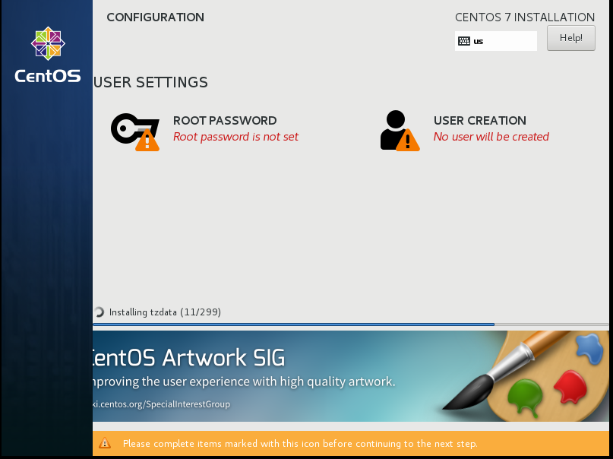

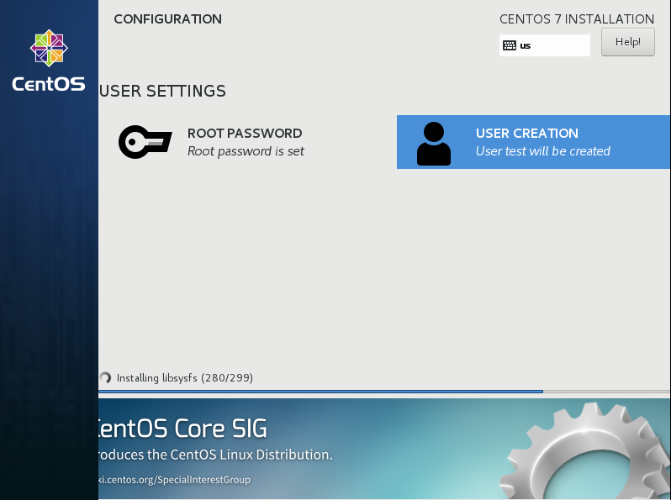

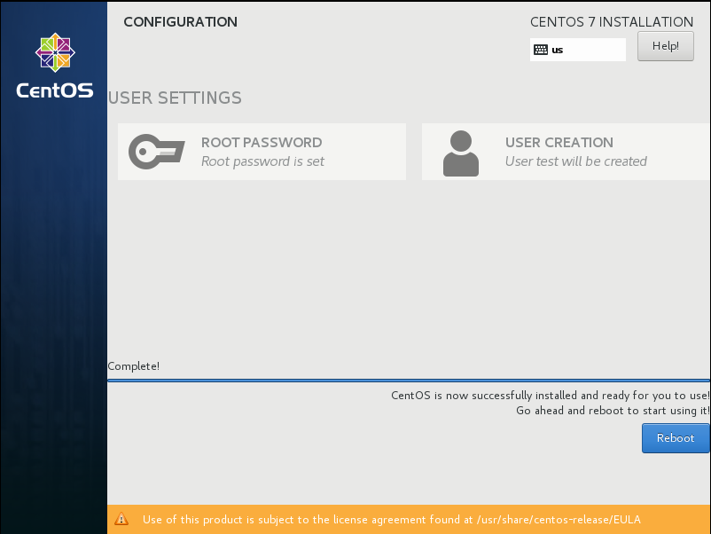

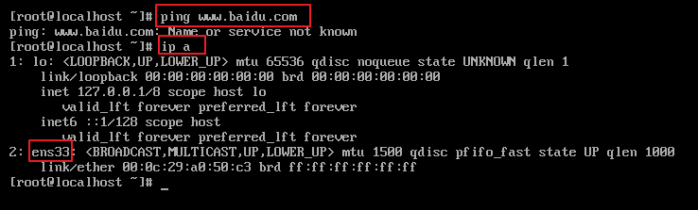





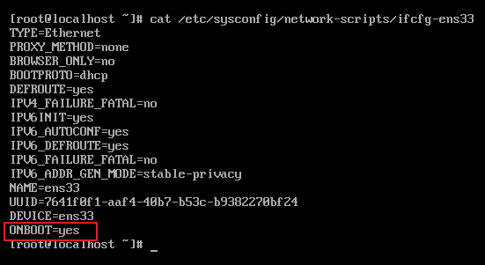

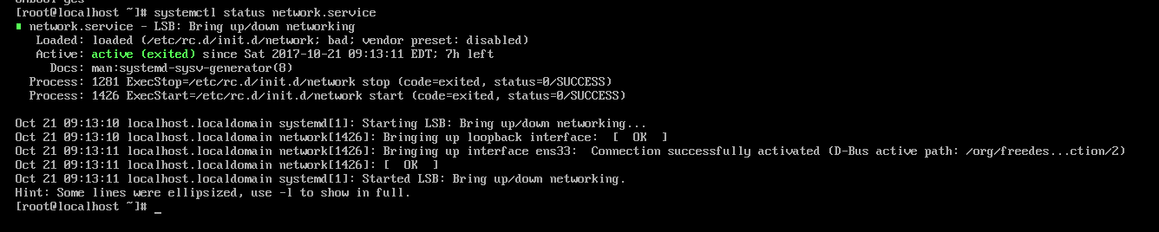



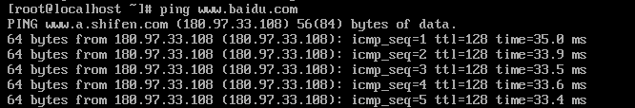

**设置为静态ip (static ip)**

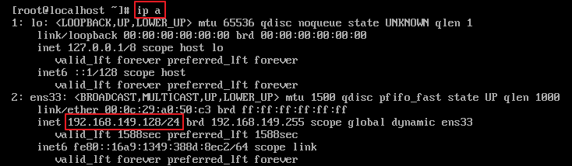



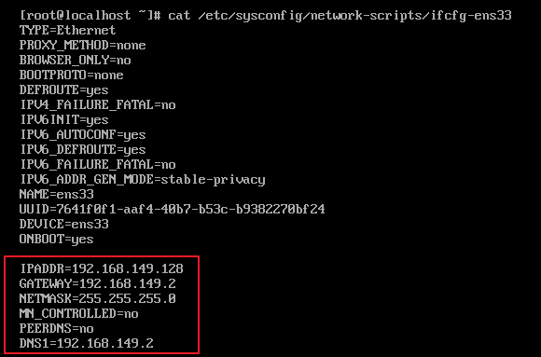

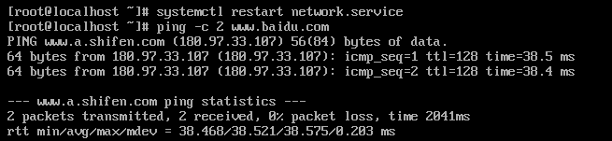

**因为是开发机，且在内网中，为了不分散开发过程中的注意力，所以打算关闭firewall防火墙和selinux,不过生产环境中不建议这么做。**

**关闭firewall:**

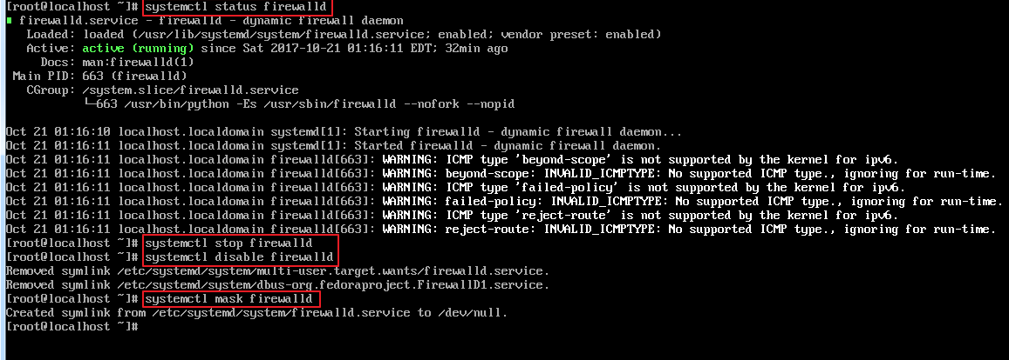

**关闭selinux:**

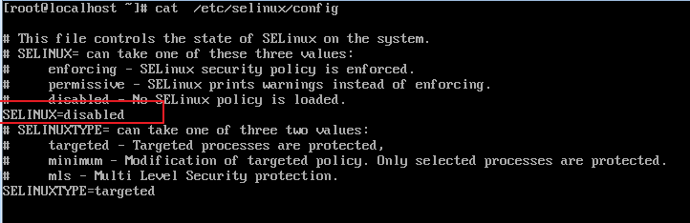

重新启动虚拟机，是selinux修改生效：



检查sshd服务，发现sshd服务已经启动，所以可以直接使用putty进行远程登录：

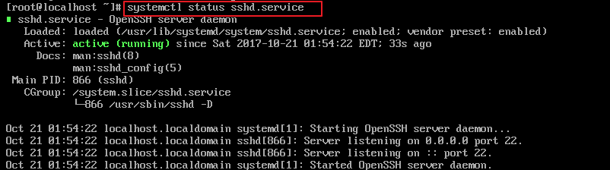

# 设置阿里开源镜像

<http://mirrors.aliyun.com/>

<http://mirrors.aliyun.com/help/centos>

[root@localhost ~]# yum install wget #安装wget下载工具，mini默认没有安装该工具

### 1、备份

mv /etc/yum.repos.d/CentOS-Base.repo /etc/yum.repos.d/CentOS-Base.repo.backup

### 2、下载新的CentOS-Base.repo 到/etc/yum.repos.d/

#### CentOS 7

curl -o /etc/yum.repos.d/CentOS-Base.repo http://mirrors.aliyun.com/repo/Centos-7.repo

<http://mirrors.aliyun.com/help/epel>

### 1、备份(如有配置其他epel源)

mv /etc/yum.repos.d/epel.repo /etc/yum.repos.d/epel.repo.backup

mv /etc/yum.repos.d/epel-testing.repo /etc/yum.repos.d/epel-testing.repo.backup

### 2、下载新repo 到/etc/yum.repos.d/

#### epel(RHEL 7)

wget -O /etc/yum.repos.d/epel.repo http://mirrors.aliyun.com/repo/epel-7.repo

# 安装常用工具

yum install vim-enhanced

yum install automake gcc gcc-c++ kernel-devel cmake

sudo yum install -y ruby ruby-devel lua lua-devel luajit \

luajit-devel ctags git python python-devel \

python3 python3-devel tcl-devel \

perl perl-devel perl-ExtUtils-ParseXS \

perl-ExtUtils-XSpp perl-ExtUtils-CBuilder \

perl-ExtUtils-Embed

ln -s /usr/bin/xsubpp /usr/share/perl5/ExtUtils/xsubpp

<https://www.linuxmoz.com/centos-install-build-essentials/>

yum install gcc gcc-c++ kernel-devel

yum install screen

[test@localhost ~]$ cat ~/.screenrc

hardstatus alwayslastline "%{.bW}%-w%{.rW}%n %t%{-}%+w %=%{..G} %H %{..Y} %Y-%m-%d %c"

shell "bash"

startup_message off

vbell off

altscreen on

attrcolor b ".I"

defbce "on"

termcapinfo xterm* 'is=\E[r\E[m\E[2J\E[H\E[?7h\E[?1;4;6l'

termcapinfo xterm 'Co#256:AB=\E[48;5;%dm:AF=\E[38;5;%dm'

term screen-256color

yum install git-all

vundle:

git clone https://github.com/VundleVim/Vundle.vim.git ~/.vim/bundle/Vundle.vim

yum install tree unix2dos

**yum install clang**

<http://geeksterminal.com/how-to-install-glib-glibc/1392/>

### To install glib on CentOS/RedHat/Fedora:(tagbar依赖)

**yum install** glib**\***

**如果要调试，可以安装gdb**

**[root@localhost ~]# yum install gdb**

[**http://stackoverflow.com/questions/10389988/missing-separate-debuginfos-use-debuginfo-install-glibc-2-12-1-47-el6-2-9-i686**](http://stackoverflow.com/questions/10389988/missing-separate-debuginfos-use-debuginfo-install-glibc-2-12-1-47-el6-2-9-i686)

# [Missing separate debuginfos, use: debuginfo-install glibc-2.12-1.47.el6_2.9.i686 libgcc-4.4.6-3.el6.i686 libstdc++-4.4.6-3.el6.i686](http://stackoverflow.com/questions/10389988/missing-separate-debuginfos-use-debuginfo-install-glibc-2-12-1-47-el6-2-9-i686)

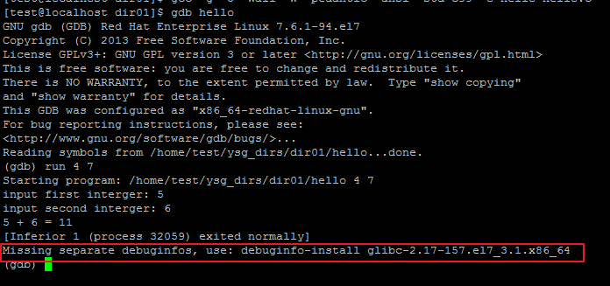

debuginfo-install is a command of yum-utils, so

1. yum install yum-utils
2. debuginfo-install glibc
3. if the warning's still there, edit /etc/yum.repos.d/CentOS-Debuginfo.repo, set enabled=1

**增加命令补全功能：**

yum install bash-completion bash-completion-extras #https://www.cyberciti.biz/faq/fedora-redhat-scientific-linuxenable-bash-completion/

# Install And Configure FTP Server On CentOS 7

<https://www.unixmen.com/install-configure-ftp-server-centos-7/>

<https://www.server-world.info/en/note?os=CentOS_7&p=ftp>

<http://stanleyss.com/install-configure-vsftpd-sftp-centos-7/>

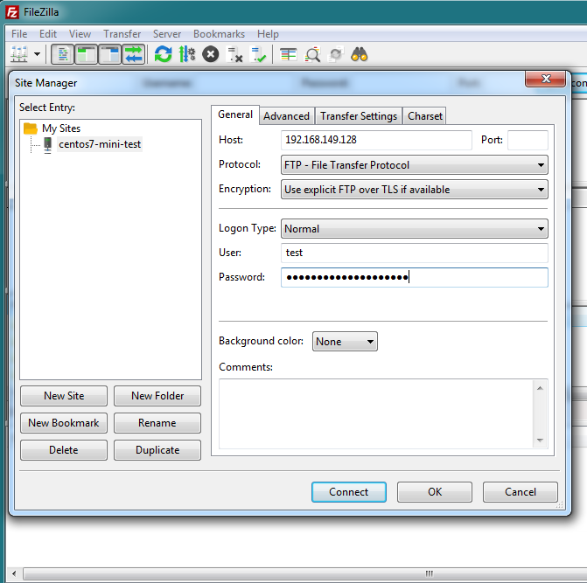

# 安装nodejs

yum install nodejs

[root@localhost ~]# node -v

v6.11.3

添加淘宝镜像：

<http://cnodejs.org/topic/4f9904f9407edba21468f31e>

3.编辑 ~/.npmrc 加入下面内容

registry = https://registry.npm.taobao.org

# 怎么备份VMware虚拟磁盘文件或移植到其他虚拟机

<http://jingyan.baidu.com/article/a681b0de17b3173b1843468f.html>