**note:**因为yumi multiboot usb creator不支持Fedora24（目前最高支持Fedora20），所以我这次选择了etcher这个跨平台的开源软件。

<https://www.etcher.io/>

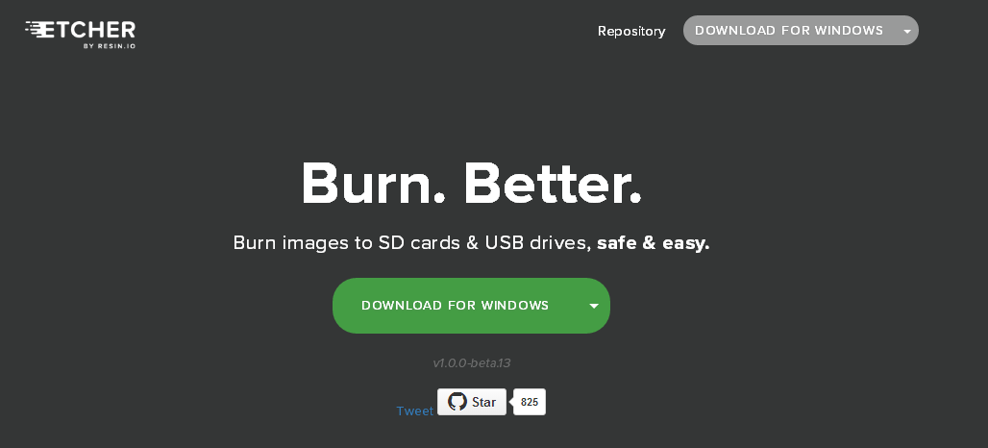

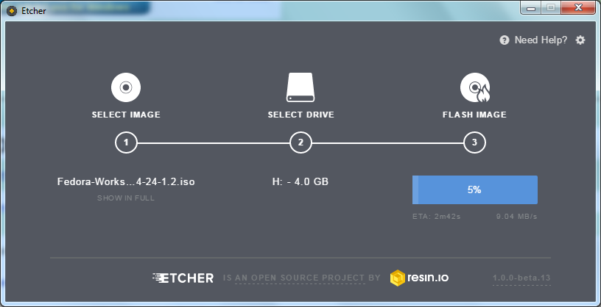

<http://www.pendrivelinux.com/yumi-multiboot-usb-creator/>

# YUMI – Multiboot USB Creator

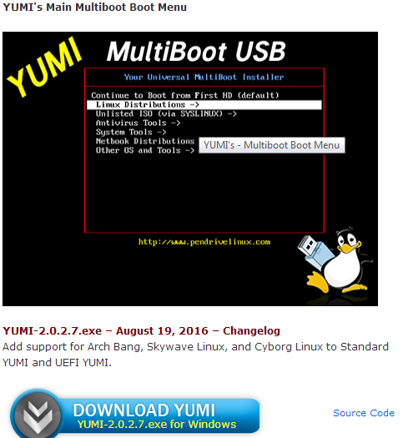

**How to Install Fedora 24 workstation**

<http://www.ostechnix.com/install-fedora-24-workstation/>

* [**Etcher – A beauitiful App to create bootable SD cards or USB drives**](http://www.ostechnix.com/etcher-beauitiful-app-create-bootable-sd-cards-usb-drives/)

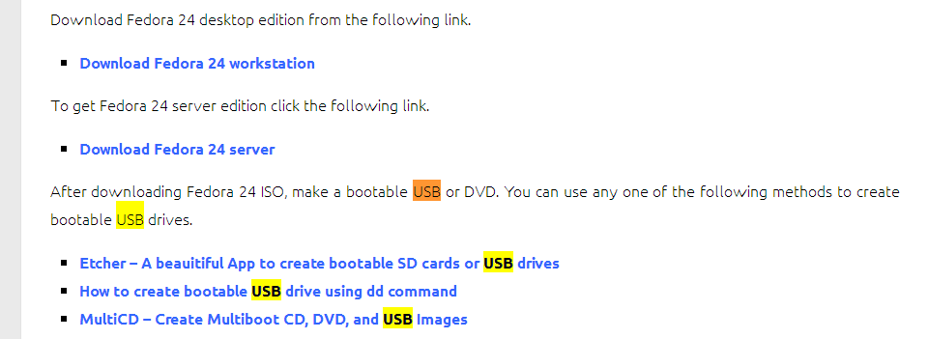

<http://www.ostechnix.com/etcher-beauitiful-app-create-bootable-sd-cards-usb-drives/>

# Etcher – A beauitiful App to create bootable SD cards or USB drives

Tired of creating bootable USB drives using complex tools? Looking for any alternative way to make bootable USB drives? Meet **Etcher**, a beautiful, simple and free GUI tool that allows you to burn OS images to USB drives and SD cards. It is created using JS, HTML, node.js and Electron. No more complicated install instructions, It just works out of the box. You don’t need to be Geek to install and use it. Etcher is cross platform tool, so It works on Windows, Mac OS X, and on almost all GNU/Linux distributions. Etcher is also available command app, so you could you use it on your Linux servers that doesn’t have any graphical user interface.