<http://stackoverflow.com/questions/3316244/set-gvim-font-in-vimrc-file>

# [set gvim font in .vimrc file](http://stackoverflow.com/questions/3316244/set-gvim-font-in-vimrc-file)

I use the following (Uses Consolas size 11 on Windows, Menlo Regular size 14 on Mac OS X and Inconsolata size 12 everywhere else):

if has("gui_running")

if has("gui_gtk2")

set guifont=Inconsolata\ 12

elseif has("gui_macvim")

set guifont=Menlo\ Regular:h14

elseif has("gui_win32")

set guifont=Consolas:h11:cANSI

endif

endif

Edit: And while you're at it, you could take a look at Coding Horror's [Programming Fonts blog post](http://www.codinghorror.com/blog/2004/12/progamming-fonts.html).

Edit²: Added MacVim.

<http://blog.sina.com.cn/s/blog_60d3a48a01018jer.html>

修改gvim的字体

**在_vimrc中写：**

**set guifont=courier_new:h10    //设置字体为Courier New,大小10号**

<http://blog.csdn.net/rrrrssss00/article/details/7255700>

[Windows下gVim中英文字体分别设置的问题(guifont/guifontwide)](http://blog.csdn.net/rrrrssss00/article/details/7255700)

1. "以下为解决中文显示问题,以及相应带来的提示及菜单乱码问题
2. set encoding=utf-8 " 设置vim内部使用的字符编码,原来是cp936
3. lang messages zh_CN.UTF-8 " 解决consle输出乱码
4. "解决菜单乱码
5. source $VIMRUNTIME/delmenu.vim
6. source $VIMRUNTIME/menu.vim
8. set guifont=Menlo:h13:cANSI
9. set guifontwide=幼圆:b:h13:cGB2312
10. gVim中可以对英文和中文分别设置显示的字体(其实是设置单字节字符和双字节字符分别显示)
12. 分别使用
13. :set guifont=
14. :set guifontwide=
15. 语句来设置
17. 但是,guifontwide的设置只有在 encoding=utf-8 时才能生效
18. 所以,在这两条语句之前,需要先设置encoding
20. 设置了encoding之后,菜单栏以及命令行中的显示又会出现乱码,所以,还需要对这些进行重新设置:
22. 总体的字体相关设置如下面的代码,将其添加到vimrc中即可,例子中,英文字体使用Menlo,中文字体使用幼圆(粗体):

<http://www.cnblogs.com/antisamael/articles/2313503.html>

# [Windows下用gVim搭建AS3开发环境](http://www.cnblogs.com/antisamael/articles/2313503.html)

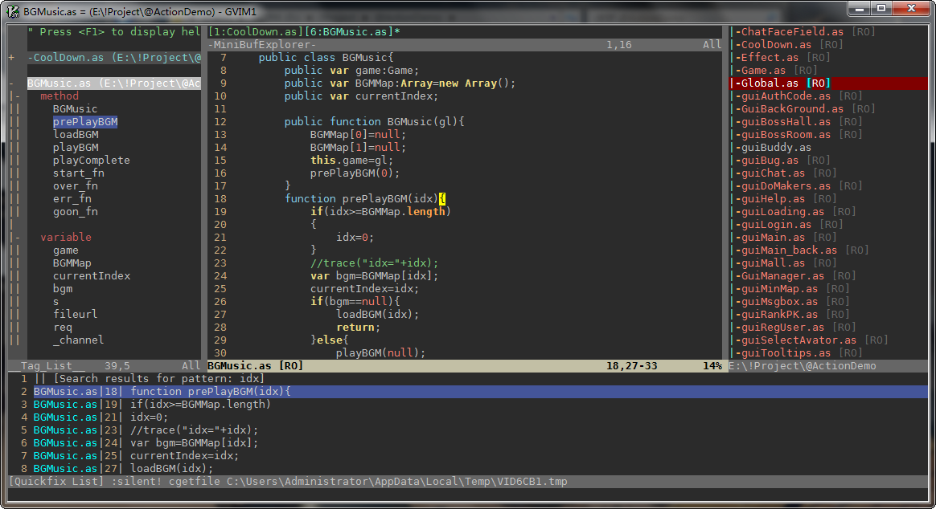

<https://github.com/VundleVim/Vundle.vim>

# [VundleVim](https://github.com/VundleVim)/[Vundle.vim](https://github.com/VundleVim/Vundle.vim)

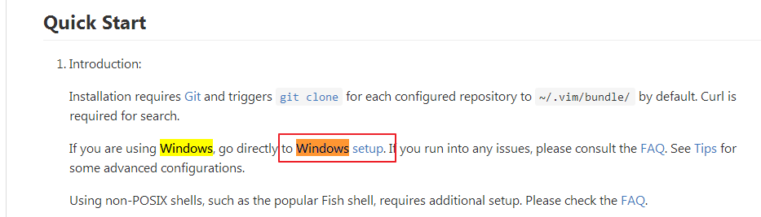

<https://github.com/VundleVim/Vundle.vim/wiki/Vundle-for-Windows>

1. 安装git软件
2. Program Files (x86)\Git\cmd 目录下新建一个名为curl.cmd的文件C:\

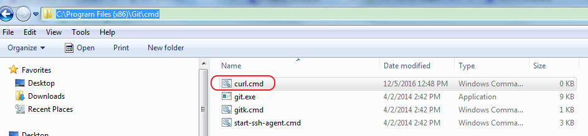

curl的内容如下：

<https://github.com/VundleVim/Vundle.vim/wiki/Vundle-for-Windows>

@rem Do not use "echo off" to not affect any child calls.

@setlocal

@rem Get the abolute path to the parent directory, which is assumed to be the

@rem Git installation root.

@for /F "delims=" %%I in ("%~dp0..") do @set git_install_root=%%~fI

@set PATH=%git_install_root%\bin;%git_install_root%\mingw\bin;%git_install_root%\mingw64\bin;%PATH%

@rem !!!!!!! For 64bit msysgit, replace 'mingw' above with 'mingw64' !!!!!!!

@if not exist "%HOME%" @set HOME=%HOMEDRIVE%%HOMEPATH%

@if not exist "%HOME%" @set HOME=%USERPROFILE%

@curl.exe %*

## Vundle on Windows

### Different File Names

By default, Vim on Windows will still look for .vimrc and install to ~/.vim. Since this isn't standard on Windows (you would have to enable hidden files) an alternative is to use _ files. That means instead of having a .vimrc file it will be a _vimrc in your home. Instead of .vim, we usually use a folder called vimfiles.

Additionally, if you've set %HOME% environmental variable to some directory, that's the directory vim will search as ~/, thus you have to put _vimrc file and vimfiles folder under the directory or remove %HOME% from environmental variable settings to use %USERPROFILE% as default.

To make these changes, open the cmd prompt or msysgit bash and execute the following lines. If you do not have gvim on your path, use vim instead.

cd %USERPROFILE%

git clone https://github.com/VundleVim/Vundle.vim.git %USERPROFILE%/vimfiles/bundle/Vundle.vim

注意：将如上的%USERPROFILE%改成$USERPROFILE



" set the runtime path to include Vundle and initialize

set rtp+=$USERPROFILE/vimfiles/bundle/Vundle.vim/

call vundle#begin('$USERPROFILE/vimfiles/bundle/')

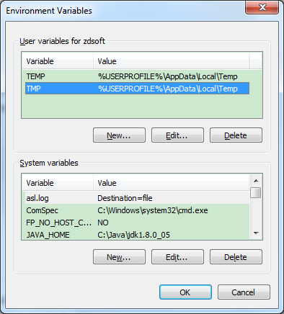

## E484: Can't open file C:\Users\<userid>\AppData\Local\Temp\... Error

Under certain situations a Virus Checker or a Windows itself may prevent file creation in the Windows Temp folder located under the %USERPROFILE% folder. One possible solution might be to change the location of your %TEMP% and %TMP% variables to point elsewhere (perhaps C:\temp). To do this launch Control Panel -> System -> Advanced system settings -> Environment Variables and I change your TMP and TEMP variables from %USERPROFILE%\AppData\Local\Tempto C:\temp relaunched vim and then try your Vundle command that was previously failing with theE484 error.

<http://www.360doc.com/content/16/1029/16/16002580_602336936.shtml>

