5.1

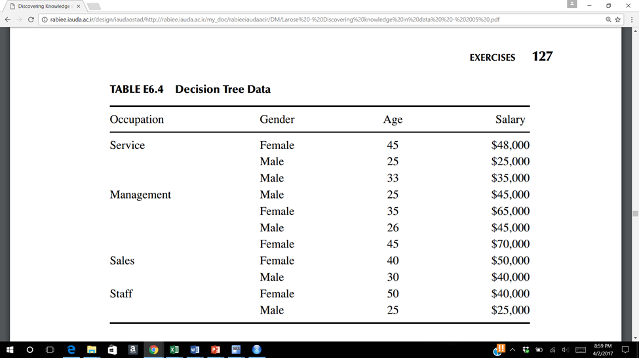

Consider the data in Table above (end of chapter 6 or 8). The target variable is salary. Start by discretizing salary and age as follows:

Less than $35,000 Level 1

$35,000 to less than $45,000 Level 2

$45,000 to less than $55,000 Level 3

Above $55,000 Level 4

0 – 30 <= 30

31 - 40 <= 40

Above 40 <= 50

5.1 Use Excel to construct a C4.5 decision tree to classify salary based on the other variables.

5.2

The “breast cancer dataset” in CANVAS was obtained from the University of Wisconsin Hospitals, Madison from Dr. William H. Wolberg. The features in the dataset, described below, have been categorized from 1 to 10.

Use these categorized features to answer the following questions.

Important: make sure your categories are represented by the “factor” data type in R and DO NOT replace the missing values.

Features Domain

-- -----------------------------------------

Sample code number id number

F1. Clump Thickness 1 - 10

F2. Uniformity of Cell Size 1 - 10

F3. Uniformity of Cell Shape 1 - 10

F4. Marginal Adhesion 1 - 10

F5. Single Epithelial Cell Size 1 - 10

F6. Bare Nuclei 1 - 10

F7. Bland Chromatin 1 - 10

F8. Normal Nucleoli 1 - 10

F9. Mitoses 1 - 10

Diagnosis Class: (2 for benign, 4 for malignant)

5.2

Use the C5.0 methodology to develop a classification model for the Diagnosis.