Investigate …

subtitle

Stat4ward

February 28, 2019

# GOAL

Listing

# The goal of this analysis is to …

# DATA

# Data from ….

Body

Body2

|  |  |  |  |  |  |  |  |  |
| --- | --- | --- | --- | --- | --- | --- | --- | --- |
|  | records | | n.max | | n.start | | events | median |
| ARM=Placebo | 44 | | 44 | | 44 | | 30 | 27.43 |
| ARM=DCC-2618 150 mg QD | 85 | | 85 | | 85 | | 38 | NA |
|  | | 0.95LCL | | 0.95UCL | |
| ARM=Placebo | | 19.57 | | 45.71 | |
| ARM=DCC-2618 150 mg QD | | 61.57 | | NA | |

# ANALYSIS

##   
## Call:  
## glm(formula = ClassX ~ FF_median, family = binomial(link = "probit"),   
## data = dat)  
##   
## Deviance Residuals:   
## Min 1Q Median 3Q Max   
## -1.4855 -0.2998 -0.0008 0.0416 2.5000

# Heading 1

## Heading 2

### Heading 3

#### Heading 4

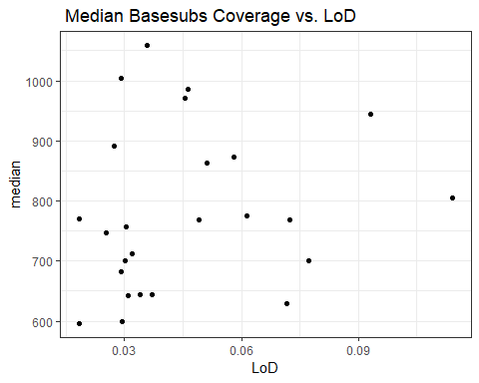

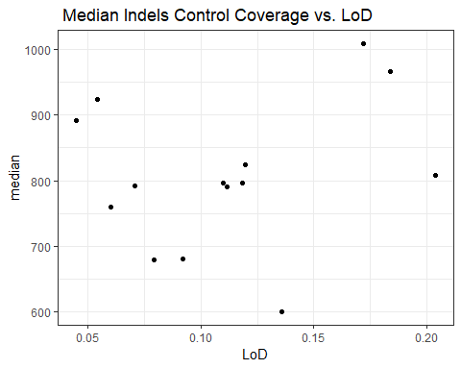

Median of Normalized Coverage vs.LoD

|  |  |  |  |
| --- | --- | --- | --- |
| **LoD** | **Gene** | **Protein Effect** | **Effect** |
| 0.0111 | KRAS | Q61K | 181C>A |
| 0.0111 | APC | Q412* | 1234C>T |

## Call:  
## coxph(formula = modform.inter, data = dat, method = "breslow")  
##   
## coef exp(coef) se(coef) z p  
## ARMDCC-2618 150 mg QD -0.211200 0.809612 0.531295 -0.398 0.690985  
## BSDIAM01 0.008142 1.008175 0.002159 3.771 0.000163  
## ARMDCC-2618 150 mg QD: BSDIAM01 -0.003744 0.996263 0.002546 -1.470 0.141488  
##   
## Likelihood ratio test=31.98 on 3 df, p=5.297e-07  
## n= 129, number of events= 68