Lab 7(a): Using R on ARC's Resources

Hardware
Cascades is a 196-node (computer) cluster built in 2016. Almost all of the nodes on Cascades have 32 cores and 128 GB memory. Instructions and examples for using Cascades are available at http://www.arc.vt.edu/cascades
Descriptions and instructions for other ARC clusters are available at: http://www.arc.vt.edu/computing

Login
- Log into the Cascades login node with your PID and password:
(a) Mac/Linux: Open a terminal and type
ssh YOURPID@cascades2.arc.vt.edu

(b) Windows: Download SSHSecureShellClient-3.2.9.zip from Canvas/labs/lab7, unzip the installation file.

Run the Secure Shell Client installation program (SSHSecureShellClient-3.2.9.exe) and respond to the on-screen prompts. When the installation is complete, you should have one icon for the Secure Shell Client on your desktop.

Configuring the Windows Secure Shell Client (establish the VPN connection first then connect to the cascades cluster).

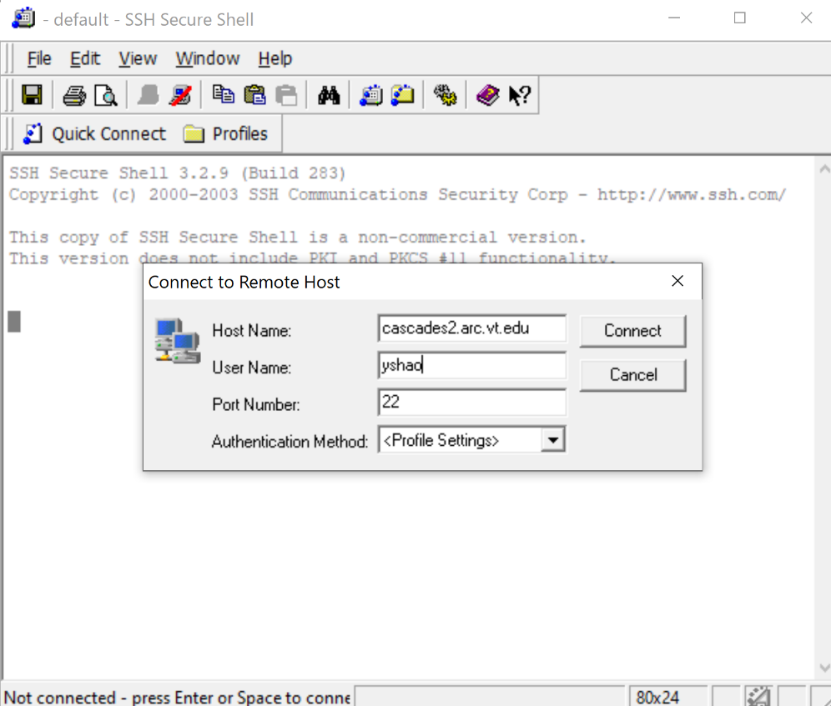

Click on the quick connect and enter the full "Host name" (e.g., cascades2.arc.vt.edu for ARC system "Cascades") and your "User name" (account name or user id) in the two fields on this screen.

Click on the "Connect" button. You will then be prompted to enter your password; do so and click on the "OK" button. ARC's clusters are subject to two-factor authentication. So you will need to approve the two-factor request (e.g., Duo Push) after entering your password.

(c) VT ARC also provide a web-based, integrated, single access point for all of your HPC resources:
https://ondemand.arc.vt.edu/pun/sys/dashboard

Software Stack
Software on ARC clusters are managed with a module environment.

To load R on Cascades, you might use the following linux commands to setup you R environment:

#create a folder for your R libraries (e.g., raster, rgdal). The R libraries will be installed to this folder.
mkdir $HOME/R/lib
#load required libraries and R/3.4.1
module purge
module load gcc openblas R/3.4.1
module load gdal proj geos
#Add the directory that you created to the R LIBS environment variable so R knows to look there when you try to load the library:
export R_LIBS="$HOME/R/lib:$R_LIBS"

The installation of raster, rgdal, rgeos libraries takes a couple more steps:
Step1: change directory to /home/yourpid/R/lib and then download lib.zip from https://code.vt.edu/yshao/rprog/-/raw/main/lib.zip
cd R/lib
wget https://code.vt.edu/yshao/rprog/-/raw/main/lib.zip
(wget is used here for downloading files from a web link).

Step2: unzip lib.zip.
unzip lib.zip

Start R program and try if you can load ‘raster’ and ‘rgdal’ libraries:

Lab7b: Implement WUI mapping in Linux environment

- Make a working directory (e.g., lab7) in you home directory
mkdir /home/yourpid/lab7

- Change directory to /home/yourpid/lab7 (Note you are currently in /home/yourpid/R/lib, so it’s important to navigate to you actual working directory for lab7).
cd /home/yourpid/lab7
- Download lab7b (wui mapping for VA) files using wget command and then unzip using unzip command:
wget https://code.vt.edu/yshao/rprog/-/raw/main/lab7b.zip
unzip lab7b.zip

You should see the following files/folders in your lab7 folder:

- The following step will setup your R environment within the ARC system, enter the following command:
#request resource
interact --partition=dev_q --nodes=1 -A geog5984
#load R and several other packages (Important to load these libraries and tell ARC system where your R libraries are located)
module purge
module load gcc openblas R/3.4.1 gdal proj geos
export R_LIBS="$HOME/R/lib:$R_LIBS"

- list files (use ls command) and make user your R code is within the lab7 folder
ls

- Run your script:
Rscript lab7_example.R

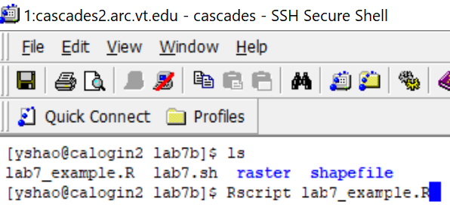

You’ll see results (wui1.shp, wui2.shp….) in populate the working folder in a few minutes.

- The previous steps use an ‘interactive’ approach to run the lab4 script. This is useful for some small tasks and the interactive window will only available for a couple of hours. For more computationally-intensive work, you’ll typically need to submit a job to the cluster.
Cascades is a shared resource, so this is done by submitting a job to a schedule, a piece of software that tries to balance many users' needs. Note: This sometimes means that you will have to wait until the resources that you need are available (i.e. until other users are done)!

For this lab, I have prepared the lab7.sh to support the job submission. All you need to do is enter the following command. Lab7.sh includes all linux commands for requesting computing resource, loading R and other libraries, and running Rscript. I’ll do a quick dome and explain specifics using an instructional video.

sbatch lab7.sh
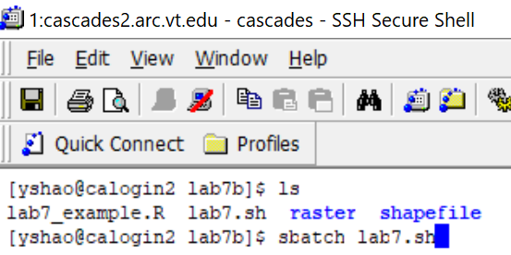

Deliverables
- Download output (wui1, wui2, …) from the lab7b folder and display them in Mapview. Attach screenshot/figure here.

- Make a nice wui map and upload the pdf/word document to canvas (ggplot?)

