文创信息

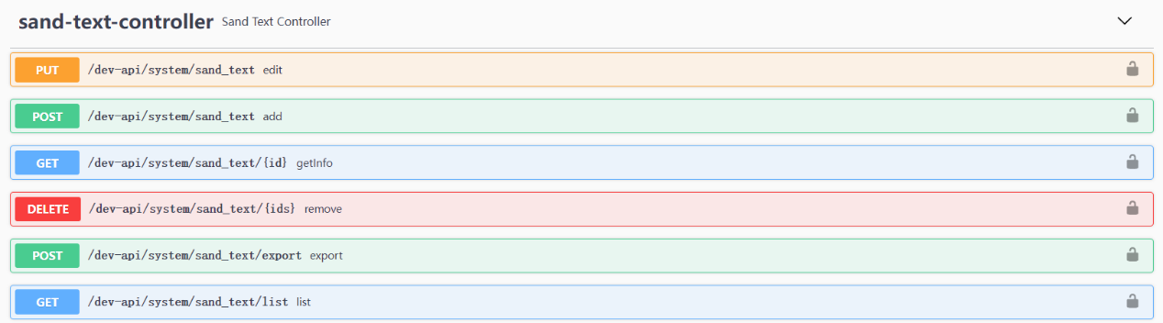

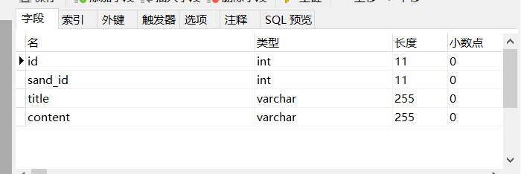

1. **编辑私信（edit）**

**PUT /dev-api/system/sand_text**

|  |  |  |  |
| --- | --- | --- | --- |
| 参数 | 类型 | 值 | 描述 |
| id | int | * |  |
| sand_id | int | * |  |
| title | int | * |  |
| content | int | * |  |

1. **添加信息（add）**

**POST /dev-api/system/ sand_text**

|  |  |  |  |
| --- | --- | --- | --- |
| 参数 | 类型 | 值 | 描述 |
| id | int | * |  |
| sand_id | int | * |  |
| title | int | * |  |
| content | int | * |  |

1. **删除私信（remove）**

**DELETE /dev-api/system/sand_text/{ids} 这个ids是沙盘的id的数组，不是sand_id**

|  |  |  |  |
| --- | --- | --- | --- |
| 参数 | 类型 | 值 | 描述 |
| id | int | * |  |

1. **查询私信表 选择下面的参数**

**GET /dev-api/system/sand_text/list**

|  |  |  |  |
| --- | --- | --- | --- |
| 参数 | 类型 | 值 | 描述 |
| id | int | * |  |
| sand_id | int | * |  |
| title | int | * |  |
| content | int | * |  |