这是私信的接口  
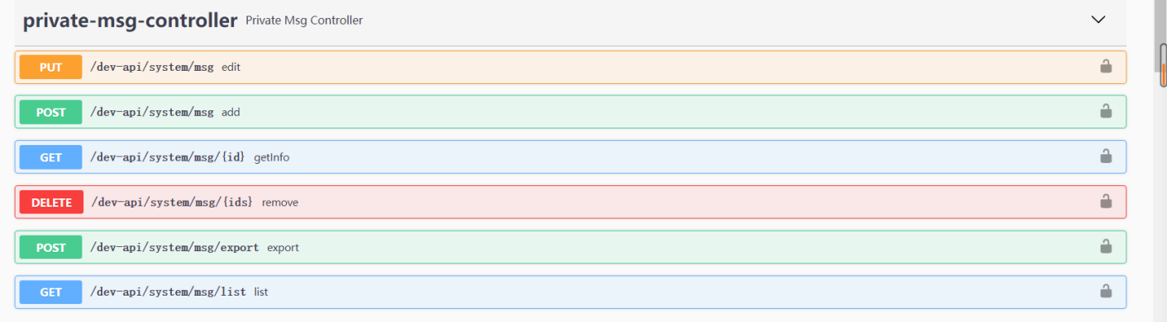

这是私信的数据库

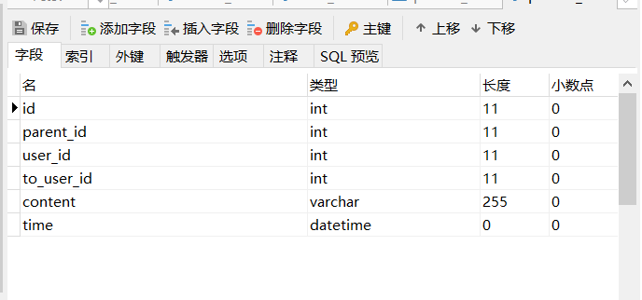

1. **编辑私信（edit）**

**PUT /dev-api/system/msg**

|  |  |  |  |
| --- | --- | --- | --- |
| 参数 | 类型 | 值 | 描述 |
| id | int | * |  |
| parent_id | int | * |  |
| user_id | int | * |  |
| to_user_id | int | * |  |
| content | varchar | * |  |
| time | datetime | * |  |

1. **添加信息（add）**

**POST /dev-api/system/msg**

|  |  |  |  |
| --- | --- | --- | --- |
| 参数 | 类型 | 值 | 描述 |
| id | int | * |  |
| parent_id | int | * |  |
| user_id | int | * |  |
| to_user_id | int | * |  |
| content | varchar | * |  |
| time | datetime | * |  |

1. **删除私信（remove）**

**DELETE /dev-api/system/msg/{id} 这个id是信息的id**

|  |  |  |  |
| --- | --- | --- | --- |
| 参数 | 类型 | 值 | 描述 |
| id | int | * |  |
| parent_id | int | * |  |
| user_id | int | * |  |
| to_user_id | int | * |  |
| content | varchar | * |  |
| time | datetime | * |  |

1. **查询私信表 选择下面的参数**

**GET /dev-api/system/msg/list**

|  |  |  |  |
| --- | --- | --- | --- |
| 参数 | 类型 | 值 | 描述 |
| id | int | * |  |
| parent_id | int | * |  |
| user_id | int | * |  |
| to_user_id | int | * |  |
| content | varchar | * |  |
| time | datetime | * |  |