Cloud Computing Lab Report 10
Name: Shunyi Yang
ID Number: 202283910016 November 21st, 2025

1. Experiment Overview
This lab demonstrates how to deploy a predictive machine learning model using KServe on a local Kubernetes cluster powered by Minikube.
The experiment covers the complete workflow, including KServe installation, model deployment using an InferenceService, service monitoring, external access configuration, and sending inference requests.

A simple pre-trained sklearn model provided by KServe is used to validate the end-to-end inference pipeline.

2. Experimental Environment
Operating System: Windows 11
Shell: PowerShell
Kubernetes: Minikube (Docker driver)
Kubernetes Version: v1.34.0
KServe Version: v0.14.x

3. Install and Configure KServe on Minikube
3.1 Start Minikube
minikube delete
minikube start --driver=docker --memory=6144 --cpus=4
[Screenshot]: Minikube successfully started
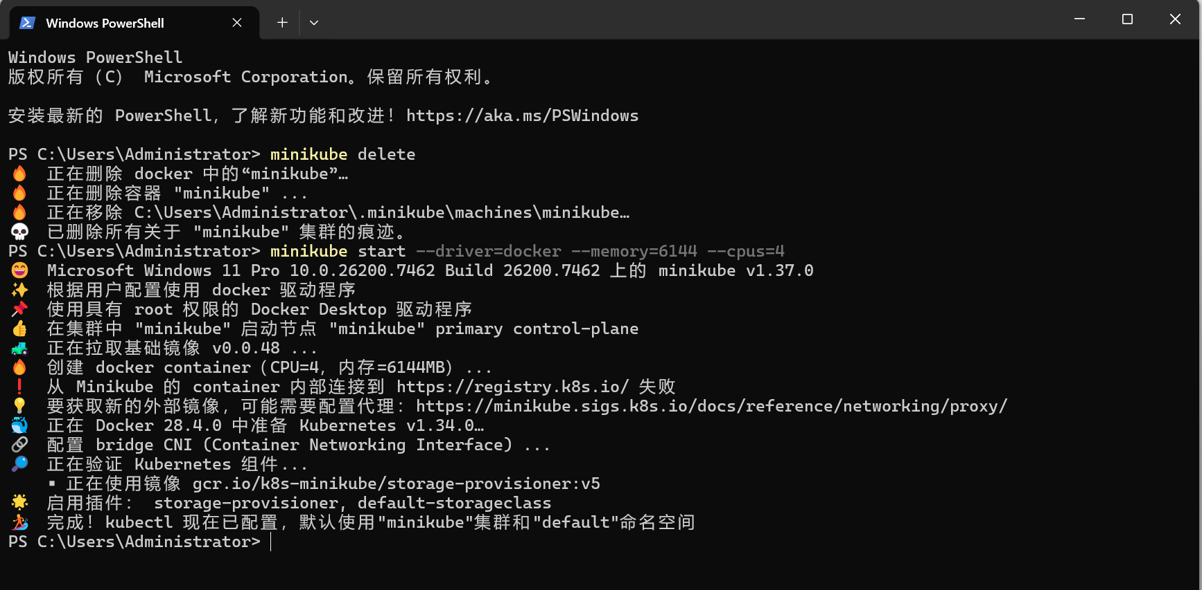

3.2 Install KServe CRDs and Controller
kubectl apply -f kserve.yaml
Verify installation:
kubectl get pods -n kserve
[Screenshot]: KServe controller pods running
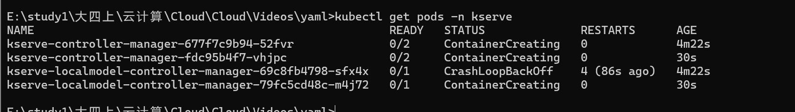
3.3 Install Cert-Manager (Required by KServe)
kubectl apply -f cert-manager.yaml
kubectl get pods -n cert-manager
[Screenshot]: cert-manager pods in Running state
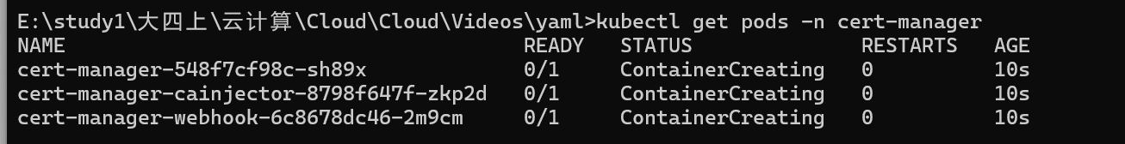

4. Deploy a Predictive Model Using InferenceService
4.1 Create InferenceService YAML
Create a file named sklearn-isvc.yaml:

apiVersion: serving.kserve.io/v1beta1
kind: InferenceService
metadata:
name: sklearn-iris
spec:
predictor:
sklearn:
storageUri: gs://kfserving-examples/models/sklearn/iris

Apply the configuration:

kubectl apply -f sklearn-isvc.yaml

4.2 Verify InferenceService Status
kubectl get inferenceservice

kubectl describe inferenceservice sklearn-iris

5. Monitor the Service and Debug Common Issues
5.1 Check Pod Status
kubectl get pods

If the service is not ready, logs can be checked using:

kubectl logs <pod-name>

Common issues observed during deployment include image pull delays and insufficient cluster resources. Reducing model size or increasing Minikube memory can help resolve these problems.

6. Access the InferenceService from Outside the Cluster
6.1 Port Forwarding
kubectl port-forward svc/sklearn-iris-predictor-default 8080:80

7. Send Inference Requests and Interpret Results
7.1 Send Prediction Request

In a new PowerShell window:

curl -X POST http://localhost:8080/v1/models/sklearn-iris:predict `
-H "Content-Type: application/json" `
-d '{
"instances": [
[6.8, 2.8, 4.8, 1.4]
]
}'

7.2 Output Interpretation

The response contains a numeric prediction representing the predicted class of the Iris dataset.

Example output:

{
"predictions": [1]
}

This confirms that the deployed model is reachable and capable of serving inference requests correctly.

8. Summary

In this experiment, KServe was successfully installed and configured on a local Minikube cluster.
A predictive model was deployed using an InferenceService, and the service lifecycle was monitored using Kubernetes commands.
External access was achieved through port forwarding, and inference requests were sent to validate the model serving pipeline.

This lab demonstrates the practicality of KServe for deploying and managing machine learning models in a Kubernetes-native manner.

