Cloud Computing Lab Report 2
Name: Shunyi Yang
ID Number: 202283910016 November 21st, 2025

1. Experiment Overview

This experiment aims to establish secure connectivity between computers located behind NATs by using a cloud-based virtual machine with a public IP address as a Nebula lighthouse. A free-tier Google Cloud virtual machine is deployed in a cloud data center to act as the lighthouse node, providing node discovery and coordination services. Nebula, a lightweight and secure overlay networking tool, is used to build a virtual private network that allows all participating nodes to communicate with each other regardless of their physical network locations.

2. Experimental Process

1.download nebula-windows-amd64.zip from github

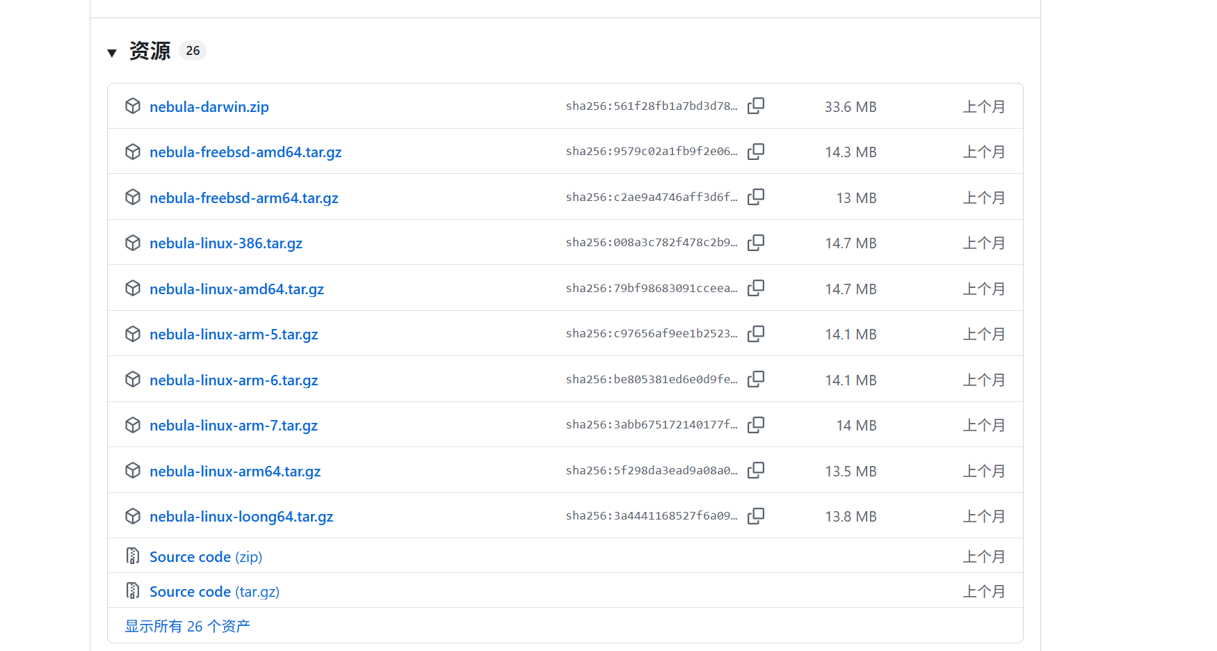
2.Obtain three files from the instructor: your name.crt, your name.key, and ca.crt.
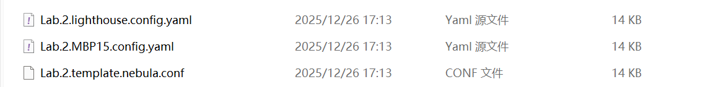

3. Installation of Nebula
3.1. Installation of the macOS client brew install nebula
Verify installation:
nebula-cert -version

3.2. Installation of Cloud-based Virtual Machine
wget https://github.com/slackhq/nebula/releases/download/v1.9.5/nebula-linux-amd64.tar.gz tar -xzf nebula-linux-amd64.tar.gz
sudo mv nebula nebula-cert /usr/local/bin/

4. Establishing a Certificate Authority (CA)
On any host (it is recommended to use a local macOS):
nebula-cert ca -name "LeiNetwork"
Generate file:
ca.crt
ca.key

Distribute ca.crt to all nodes, and ca.key should be properly saved.
5. Generate certificates for each node
5.1. Lighthouse certificate
nebula-cert sign -name "lighthouse" -ip "192.168.100.1/24"
5.2. Client certificates
nebula-cert sign -name "MBP15" -ip "192.168.100.15/24"
nebula-cert sign -name "mini" -ip "192.168.100.10/24"

Each node will receive the corresponding .crt and .key files.
6. Configuring Nebula's config.yaml
Use Meld or Beyond Compare to compare the official sample configuration files, and modify the following key contents.
Common configuration for all nodes pki:
ca: ca.crt
cert: <Node Name>.crt
key: <Node Name>.key
static_host_map:
"192.168.100.1": ["<Public IP of the cloud server>: 4242"]
listen:
host: 0.0.0.0 port: 4242

6.2. Lighthouse Node Configuration lighthouse:
am_lighthouse: true

6.3. Client Node Configuration lighthouse:
am_lighthouse: false
hosts:
"192.168.100.1"
7. Starting the Nebula Service
1. macOS Client sudo nebula -config ~/.nebula/config.yaml

2. Cloud Lighthouse sudo nebula -config /etc/nebula/config.yaml

IX. Connectivity Test
At any node, execute:
ping 192.168.100.1
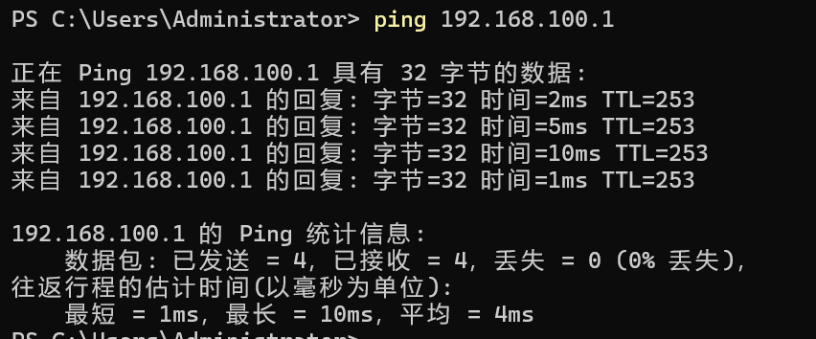

3. Summary

In this experiment, a cloud virtual machine with a public IP address was successfully used as a Nebula lighthouse to enable secure communication between multiple computers behind NATs. The results demonstrate that Nebula can effectively provide encrypted, peer-to-peer connectivity across different networks without requiring traditional VPN infrastructure. This approach offers a low-cost, scalable, and secure solution for distributed systems and cloud-based networking scenarios.

