Cloud Computing Lab Report 3
Name: Shunyi Yang
ID Number: 202283910016 November 21st, 2025

1. Experiment Overview

This experiment focuses on building and publishing a personal website using GitHub Pages, which is a Platform as a Service (PaaS) for hosting static websites. The experiment aims to demonstrate how static web content can be deployed online without managing servers or infrastructure.

2. Experimental Process

First, a GitHub account is created to enable access to repository hosting and version control services. After logging into GitHub, a new public repository named cloud-computing.github.io is created, following GitHub Pages naming conventions.
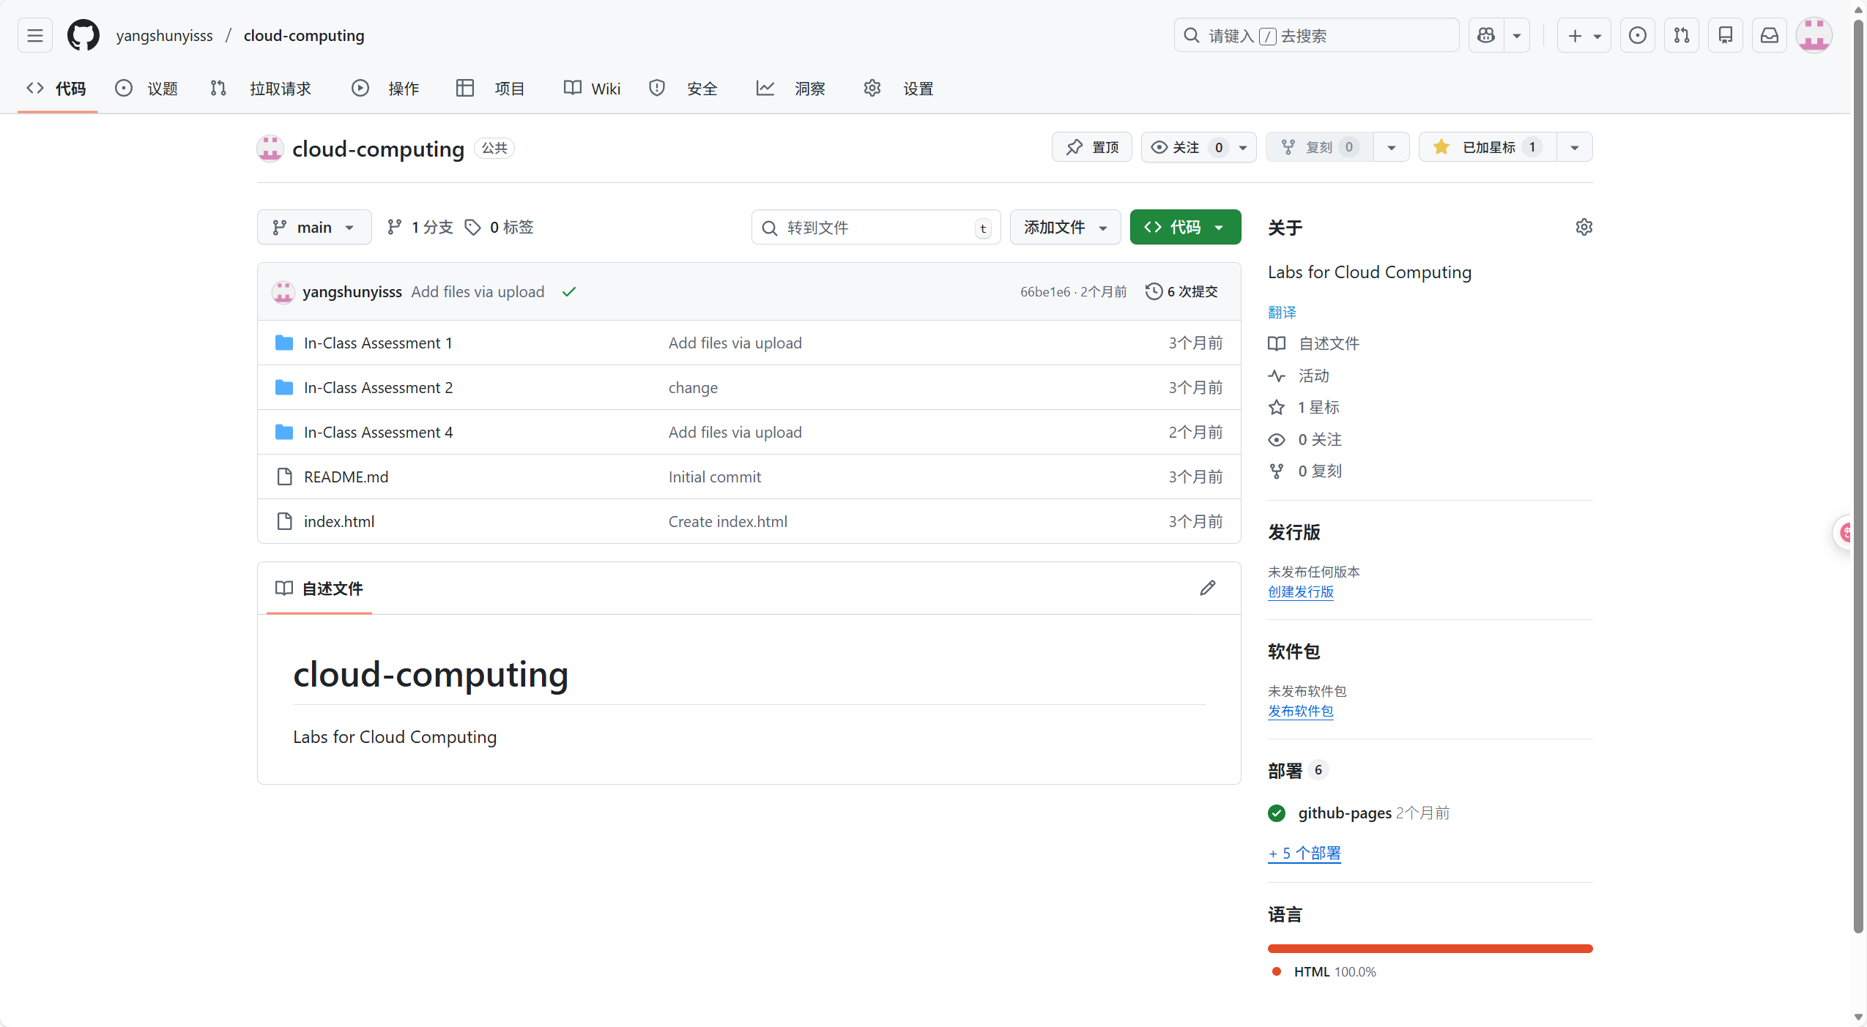

Next, an index.html file is added to the repository root directory to serve as the homepage of the website. This file contains basic HTML content introducing the website owner. Optional customization is performed by adding CSS styles or selecting a Jekyll theme to improve the website’s appearance and layout.
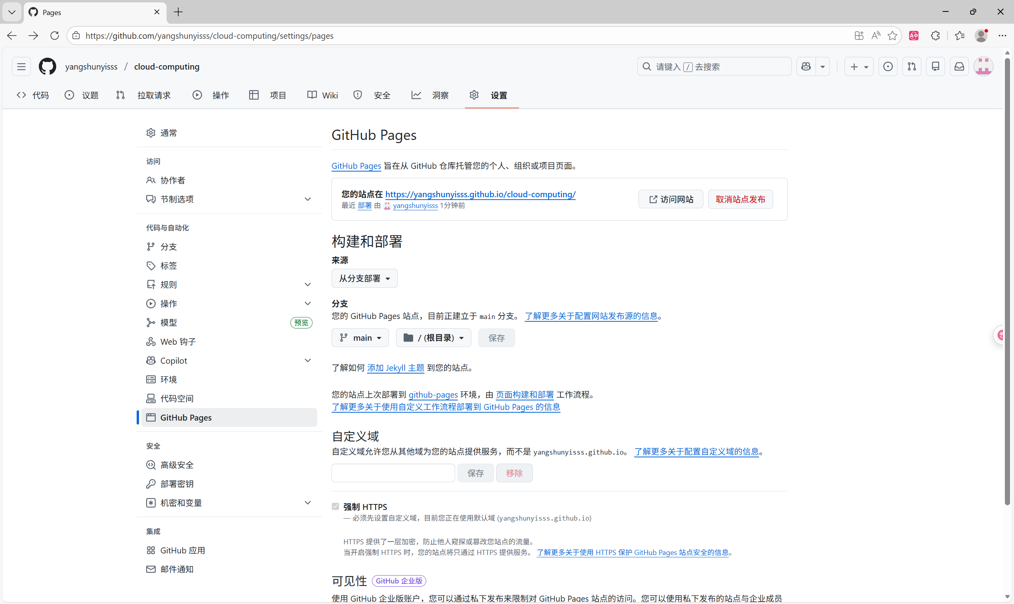
After preparing the website content, GitHub Pages is enabled in the repository settings by selecting the main branch as the source. GitHub automatically builds and deploys the website. Once deployment is complete, the website is accessed via

https://yangshunyisss.github.io/cloud-computing/ to verify successful publication. Any future updates to the website are managed through GitHub’s version control system and are automatically reflected online after each commit.
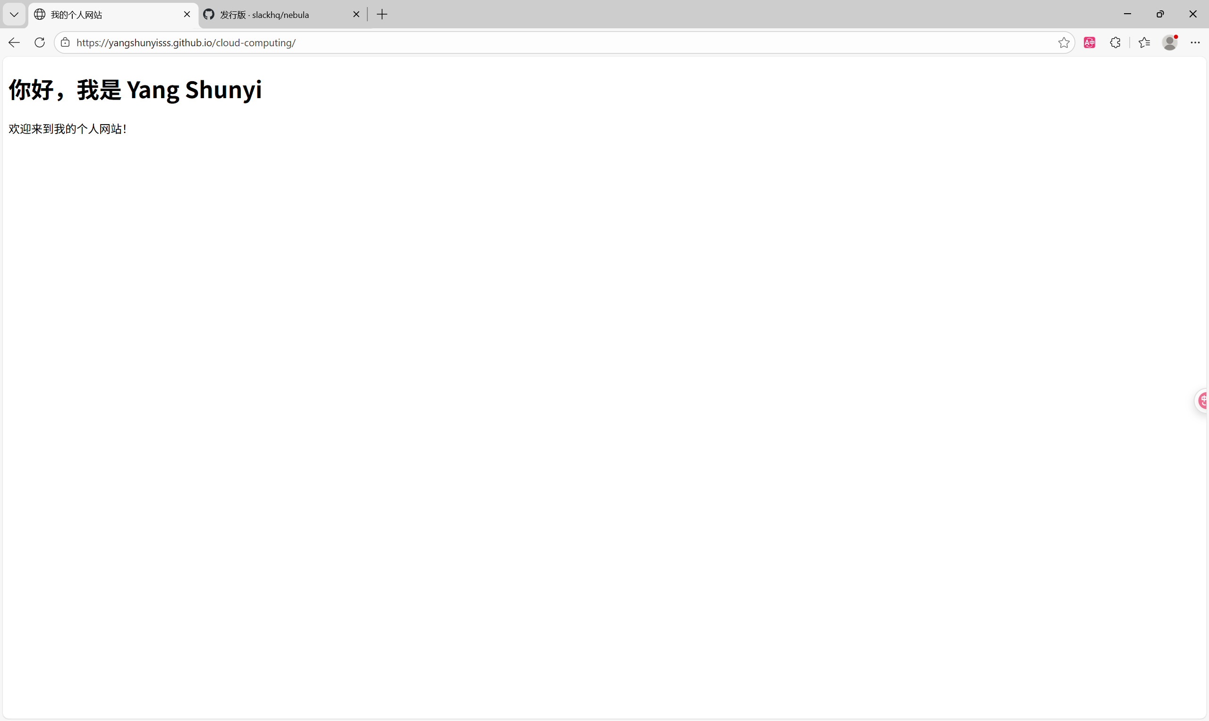

3. Summary

In this experiment, a personal static website is successfully created and published using GitHub Pages. The experiment demonstrates the effectiveness of GitHub Pages as a PaaS solution for hosting static websites and highlights the convenience of using GitHub for both version control and web deployment.

