Cloud Computing Lab Report 4
Name: Shunyi Yang
ID Number: 202283910016 November 21st, 2025

1. Experiment Overview

This experiment focuses on installing and using Gitea, a lightweight self-hosted Git service. The experiment is conducted in two parts: installing Gitea using Docker and installing Gitea directly without Docker. Through this lab, Docker Desktop is installed, Gitea services are deployed, repositories are created, and large file support (LFS) is tested. The experiment helps develop practical skills in containerized services, Git-based collaboration tools, and data management.

2. Experimental Process

2.1 Install Docker Desktop
Windows
Windows Subsystem for Linux (WSL) is installed first:
wsl --install
Then Docker Desktop is downloaded and installed. A Docker account is registered and logged in before use.

2.2 Install Gitea Using Docker
Gitea is deployed using Docker according to the official documentation.
A directory for Gitea data is created, and the container is started using Docker Compose or docker run. After the container starts successfully, Gitea is accessed via a web browser at:
http://localhost:3000
Initial configuration is completed through the web interface, including database selection and admin account creation.
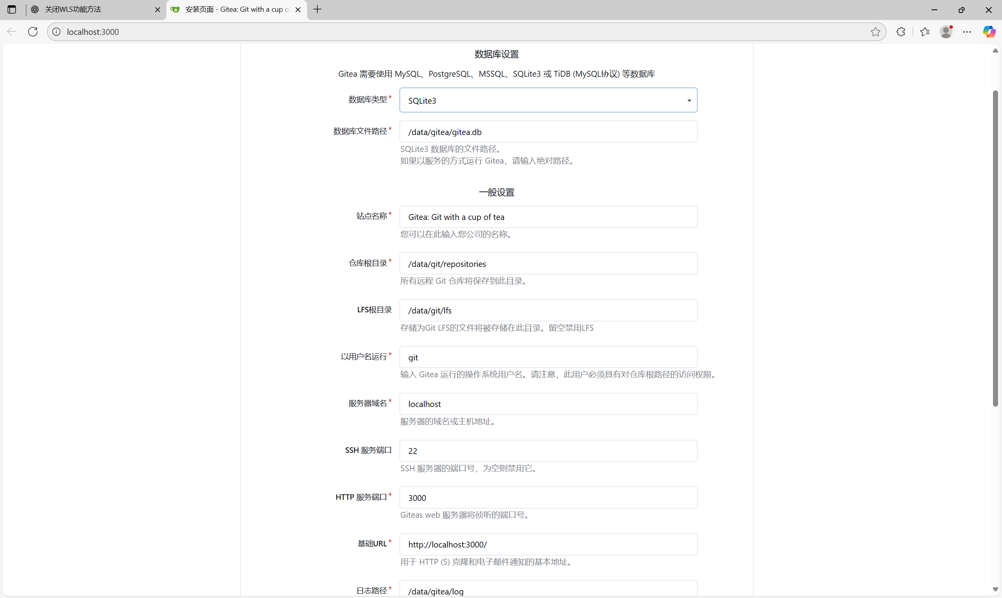

2.3 Git LFS Support Verification (Question a)
Gitea supports Git Large File Storage (LFS).
Proof:
Gitea provides native Git LFS support as part of its repository settings.
Git LFS can be enabled in the Gitea admin or repository configuration.
During repository creation and settings inspection, Git LFS options are visible.
Large files can be pushed successfully using Git LFS commands.
This confirms that Gitea supports LFS functionality.

2.4 Create a Repository with a Large File (Question b)
A new repository is created in Gitea. Git LFS is initialized locally:
git lfs install
git lfs track "*.bin"

A large file (larger than 1 GB) is generated and added to the repository:
dd if=/dev/zero of=largefile.bin bs=1M count=1024
git add .
git commit -m "Add large file using Git LFS"
git push

The file is successfully pushed to the Gitea repository, demonstrating large file support.
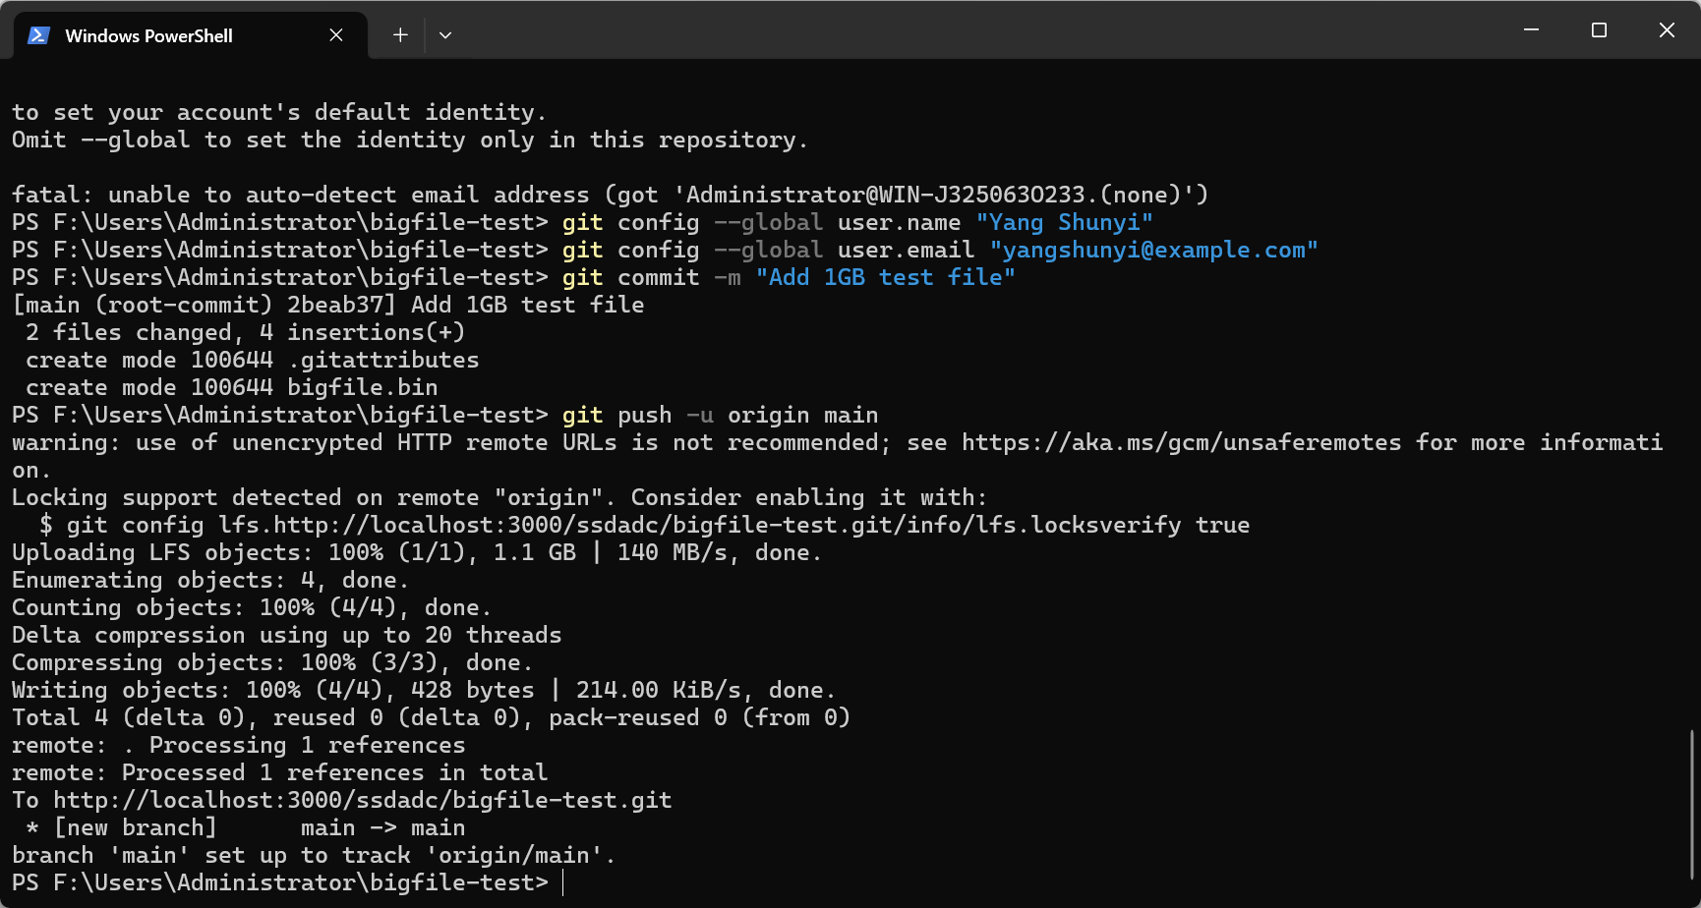
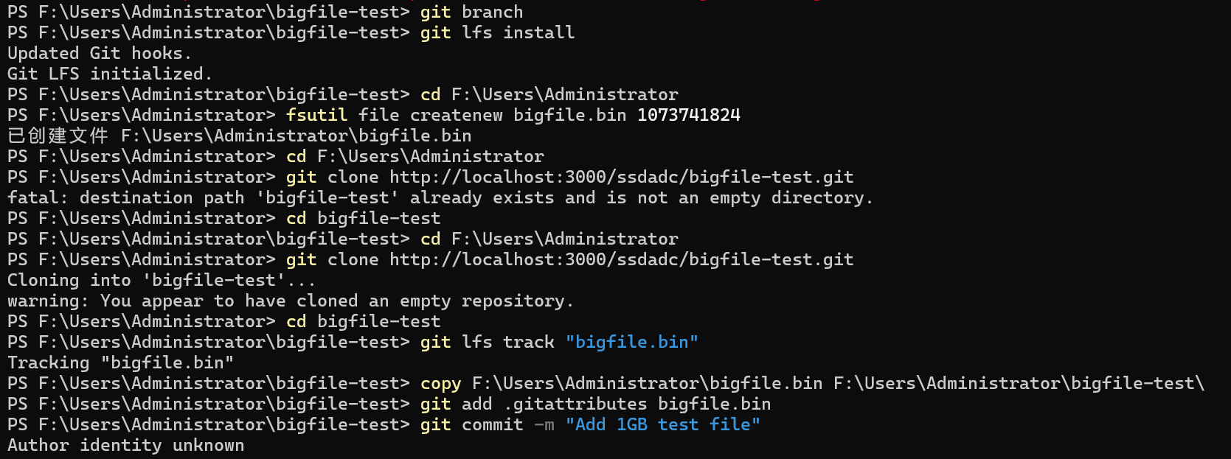
2.5 Create a Repository for This Module (Question c)

Another repository is created specifically for this module. All lab-related files, such as configuration files and documentation, are committed and pushed to this repository using standard Git commands.

This repository serves as the submission repository for the course module.
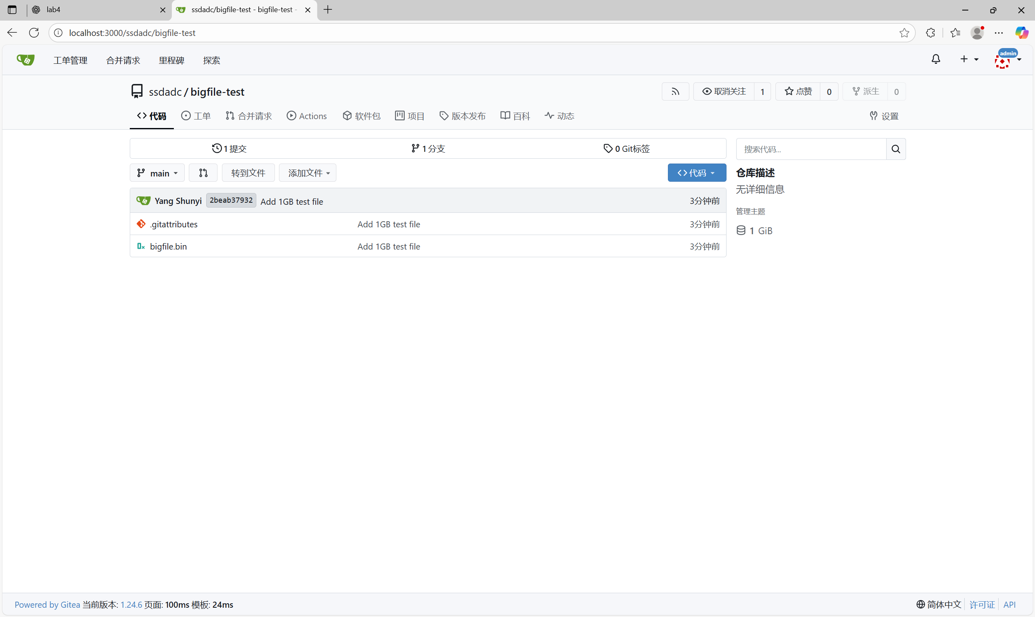
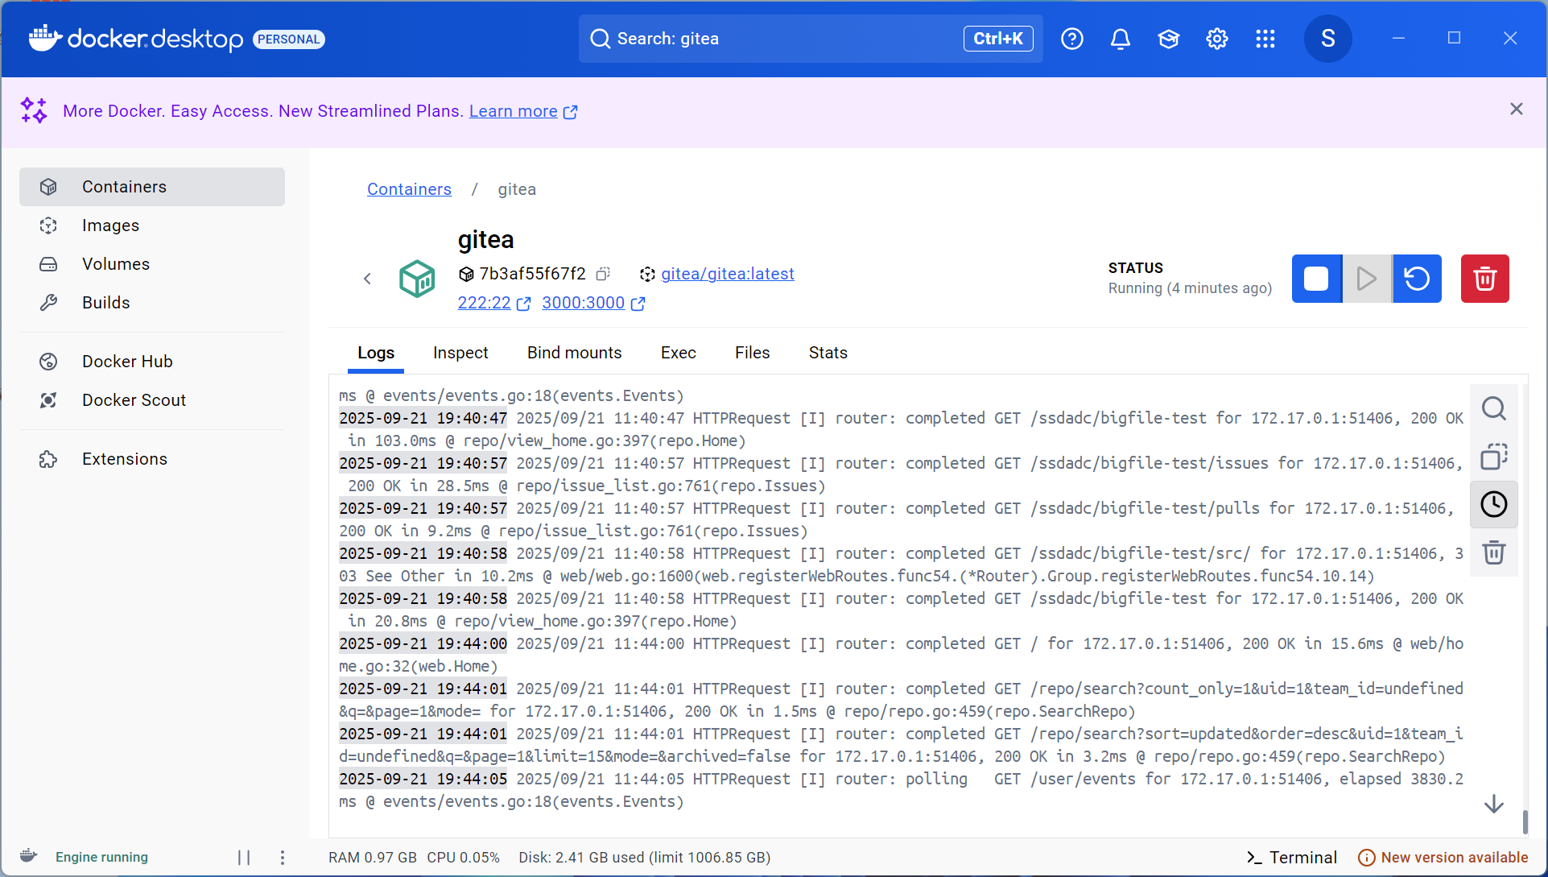
2.6 (Optional) Backup and Restore

All Gitea data directories are copied to an external USB storage device. On another computer, Gitea is installed, and the backed-up data is restored to the appropriate directories. After restarting Gitea, repositories and user data are successfully recovered.

2.7 Install Gitea Without Docker

Gitea is also installed directly on the system without using Docker. A standalone Gitea binary is downloaded and executed. During setup, a database (such as SQLite or MySQL) is selected. The installation is completed through the web interface, and basic functionality is verified.

3. Summary

In this lab, Docker Desktop was successfully installed, and Gitea was deployed using Docker and without Docker. Git LFS support was verified by pushing a large file exceeding 1 GB. Multiple repositories were created and managed within Gitea, demonstrating its capabilities as a self-hosted Git service. This experiment provided hands-on experience with containerized applications, version control systems, and data management techniques.

