Cloud Computing Lab Report 5
Name: Shunyi Yang
ID Number: 202283910016 November 21st, 2025

1. Experiment Overview
This experiment follows the official Docker “Get Started” tutorials to understand fundamental Docker concepts and container operations. The objective of this lab is to learn how containers, images, Docker Compose, and multi-container applications work in practice. All steps are performed locally using Docker Desktop, and screenshots are taken to demonstrate successful execution.

2. Experimental Process

2.1 Environment Setup
Docker Desktop is installed according to the official documentation.
Windows: Docker Desktop with WSL 2 support
Reference:
https://docs.docker.com/desktop/install/windows-install/
https://docs.docker.com/desktop/wsl/
After installation, Docker Desktop is started and verified.
Screenshot:
Docker Desktop running
Output of:
docker --version
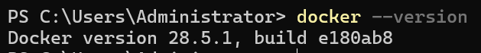
Notes:
Docker Desktop provides Docker Engine, CLI, and Docker Compose in a single environment.

2.2 What Is a Container
Reference:
https://docs.docker.com/get-started/docker-concepts/the-basics/what-is-a-container/
A container is a lightweight and isolated runtime environment that packages an application with its dependencies.
Command:
docker run hello-world
Screenshot:
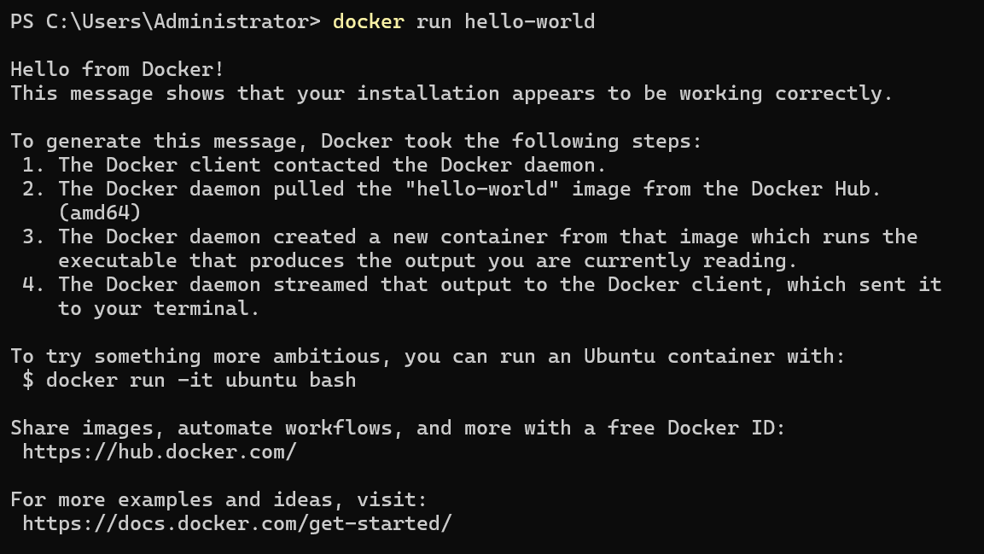
Notes:
This confirms that Docker is correctly installed and containers can run successfully.

2.3 What Is an Image
Reference:
https://docs.docker.com/get-started/docker-concepts/the-basics/what-is-an-image/
A Docker image is a read-only template used to create containers.
Command:
docker images
Screenshot:
List of local Docker images
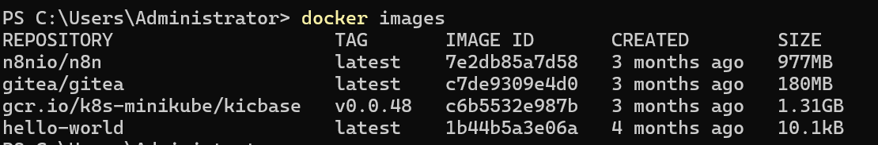
Notes:
Containers are created from images, and multiple containers can be created from the same image.

2.4 What Is Docker Compose
Reference:
https://docs.docker.com/get-started/docker-concepts/the-basics/what-is-docker-compose/
Docker Compose is a tool for defining and running multi-container applications using a YAML configuration file.
Screenshot:
Example docker-compose.yml
Docker Compose overview page or CLI output

Notes:
Docker Compose simplifies managing applications with multiple services.

2.5 Publishing Ports
Reference:
https://docs.docker.com/get-started/docker-concepts/running-containers/publishing-ports/
Ports can be published to allow access to a container from the host machine.
Command:
docker run -p 8080:80 nginx
Screenshot:
Nginx welcome page
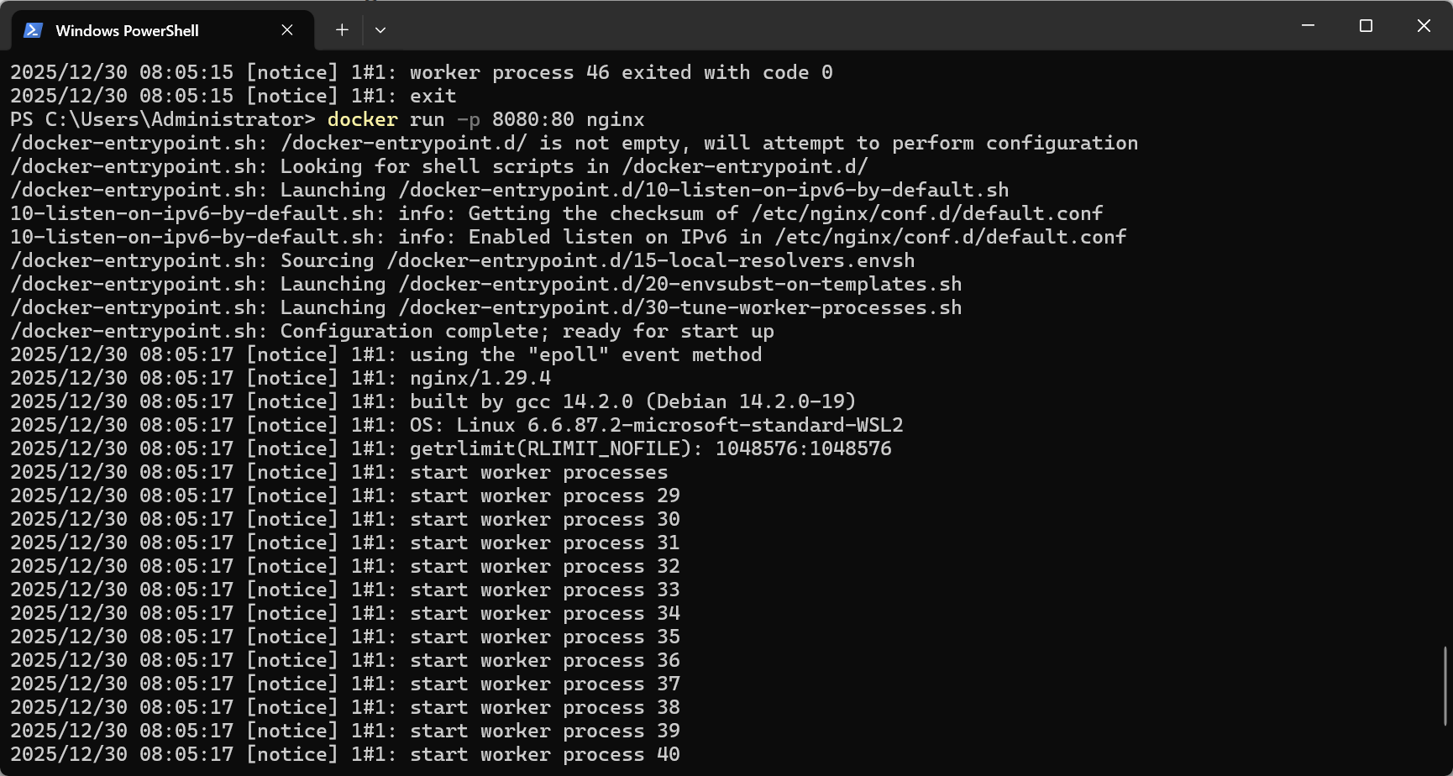
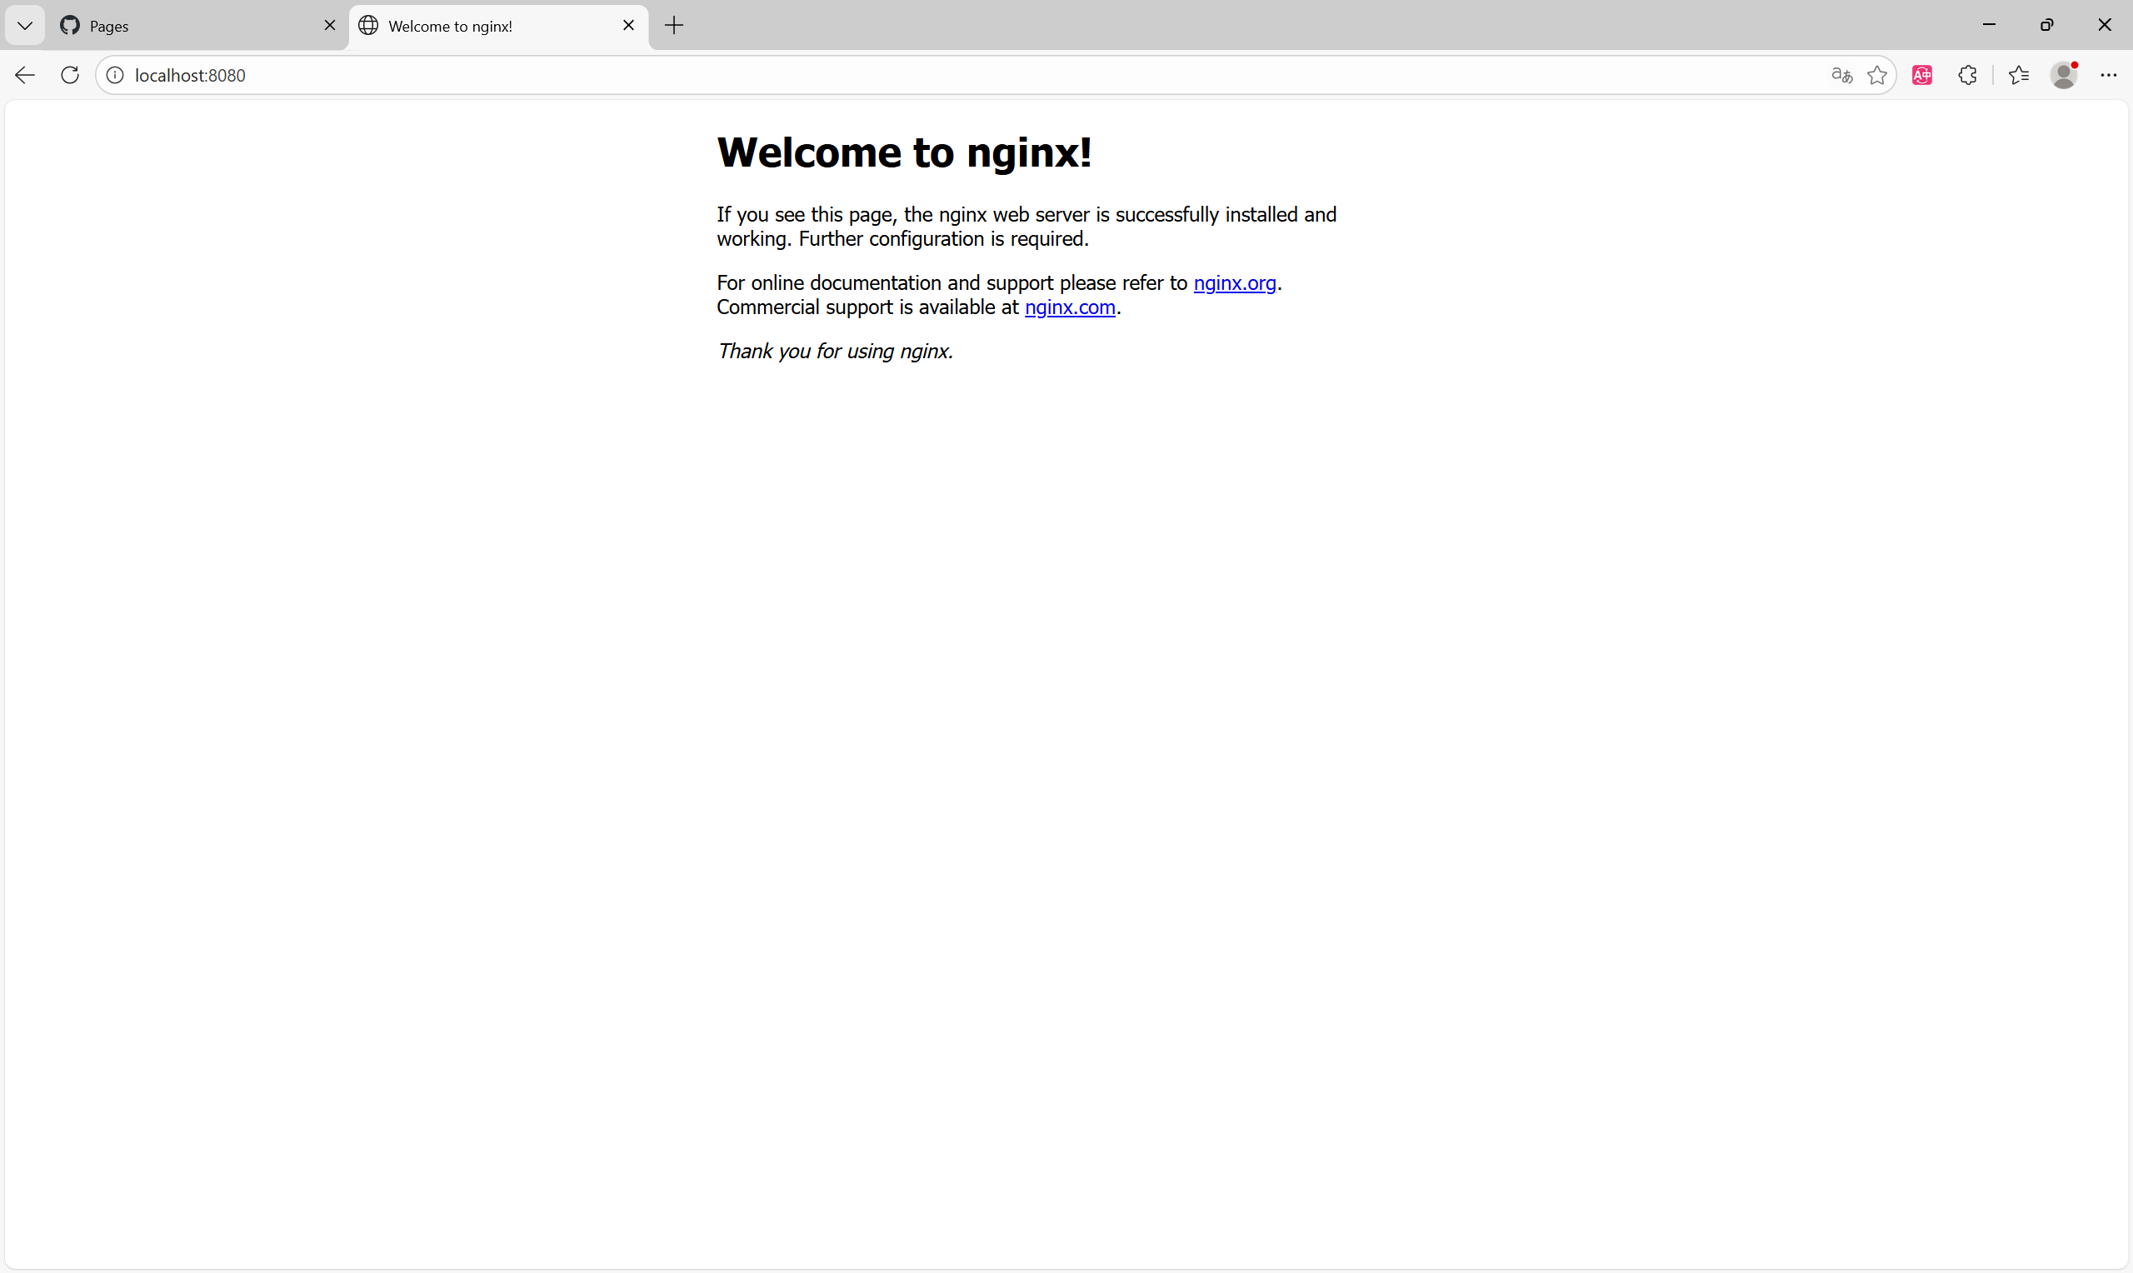
Notes:
The -p option maps a container port to a host port.

2.6 Multi-Container Applications
Reference:
https://docs.docker.com/get-started/docker-concepts/running-containers/multi-container-applications/
Docker Compose is used to run applications consisting of multiple containers.
Command:
docker compose up
Notes:
Multi-container applications are common in real-world systems such as web + database setups.

3. Summary

In this experiment, core Docker concepts were learned by following the official Docker tutorials. Containers, images, port publishing, data persistence, file sharing, and multi-container applications were practiced using Docker Desktop. This lab provided practical experience with container-based application deployment and management, forming a foundation for future cloud-native development.

