Cloud Computing Lab Report 6
Name: Shunyi Yang
ID Number: 202283910016 November 21st, 2025

1. Experiment Overview
The purpose of this experiment is to learn and practice the basic workflow of Kubernetes using Minikube in a local environment.

By following the official Kubernetes tutorials, this experiment covers the complete lifecycle of a containerized application, including cluster setup, application deployment, service exposure, scaling, and application updates.

Through this lab, the following learning objectives are achieved:
Understanding the basic architecture and core components of Kubernetes
Running a local Kubernetes cluster using Minikube
Using kubectl to manage Kubernetes resources
Learning the roles of Pod, Deployment, and Service
Practicing application deployment, scaling, and rolling updates in Kubernetes

This experiment was completed individually, and all operations were performed on a local machine.

2. Experimental Process
2.1 Environment Setup
Before starting the experiment, the following software was installed and verified:
Docker Desktop
Minikube
kubectl
The environment was verified using the following commands:
kubectl version --client
minikube versio
Screenshot: kubectl and Minikube version output
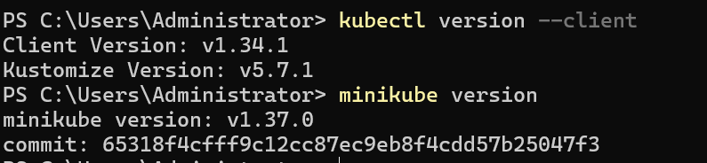

2.2 Starting the Minikube Cluster (Hello Minikube)
The local Kubernetes cluster was started using Minikube:
minikube start

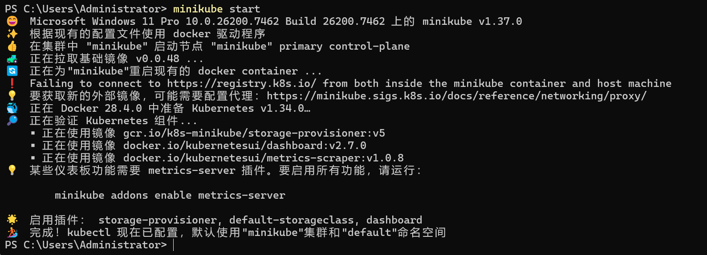After the cluster started successfully, the cluster status was checked:
kubectl cluster-info
kubectl get nodes
The output confirmed that a single-node Kubernetes cluster was running locally.
Screenshot: Minikube start and node status
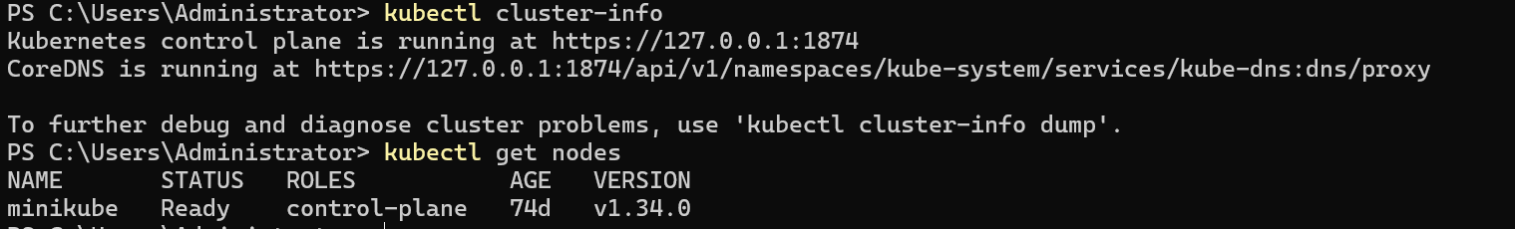

2.3 Deploying an Application
A sample application was deployed using a Kubernetes Deployment:
kubectl create deployment kubernetes-bootcamp \
--image=gcr.io/google-samples/kubernetes-bootcamp:v1
The Deployment and Pod status were checked:
kubectl get deployments
kubectl get pods
Kubernetes automatically created a Pod and ran the containerized application.
Screenshot: Deployment and Pod running
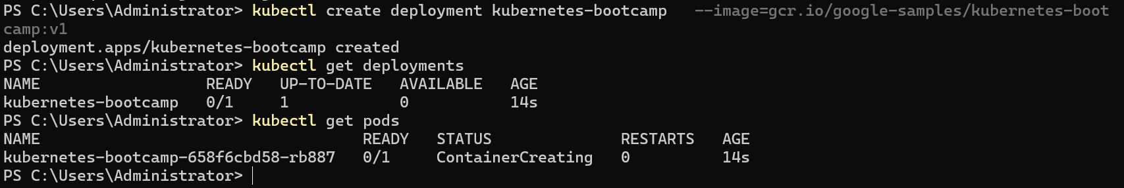

2.4 Exploring the Application
Detailed information about the running Pod was inspected:
kubectl describe pod <pod-name>
The current resources in the cluster were also listed:
kubectl get pods
kubectl get services
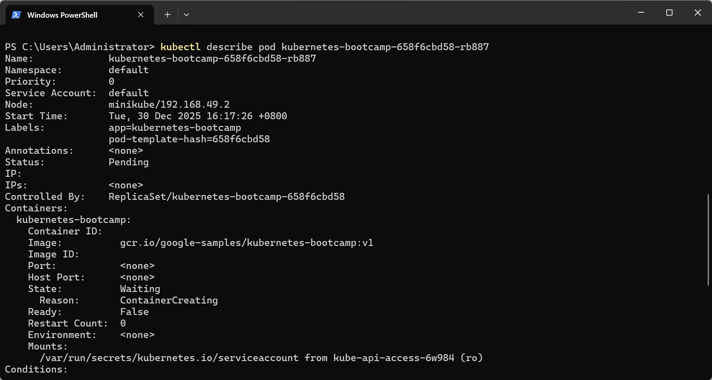
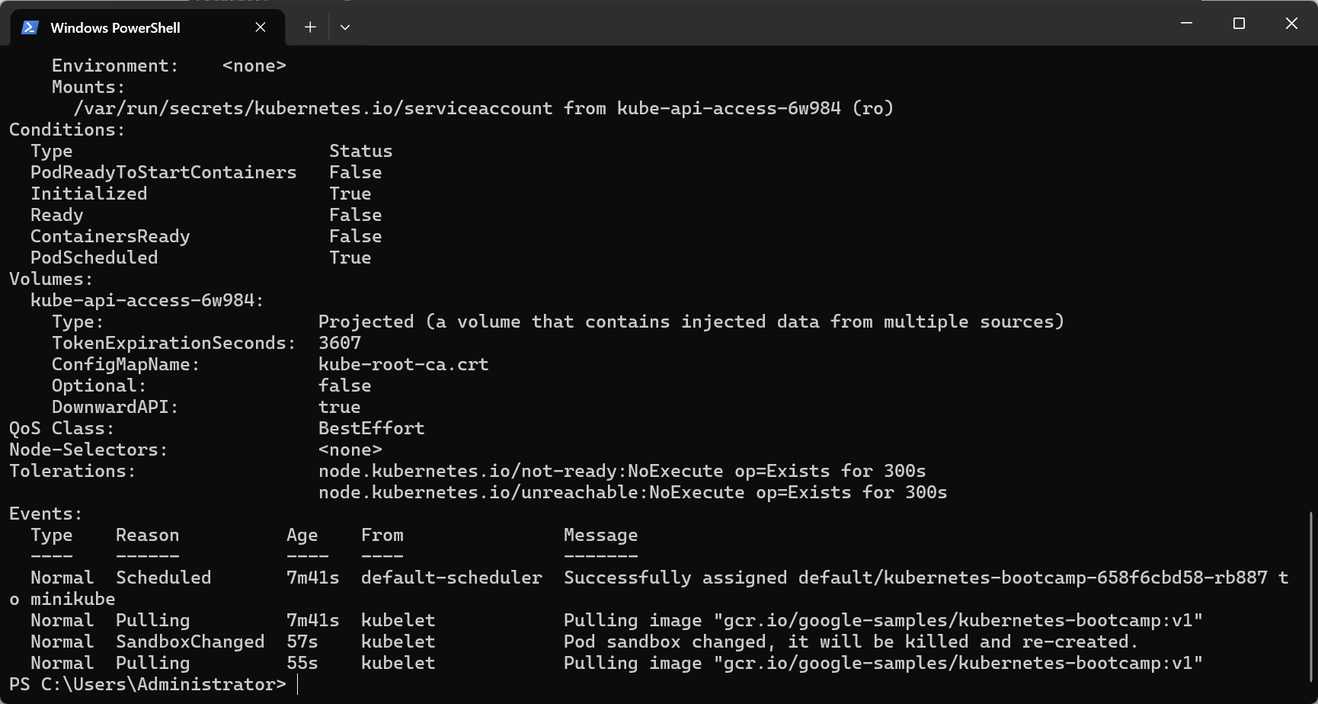
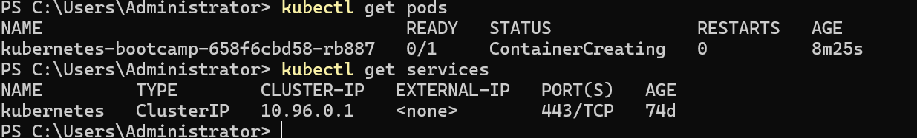
This step helped to understand Pod details such as IP address, node information, and container status.

2.5 Exposing the Application
To make the application accessible from outside the cluster, a Service was created:
kubectl expose deployment kubernetes-bootcamp \
--type=NodePort --port=8080
The Service was verified using:
kubectl get services
The application was accessed using:
minikube service kubernetes-bootcamp
The application page was successfully opened in a web browser.
Screenshot: Service details and browser access
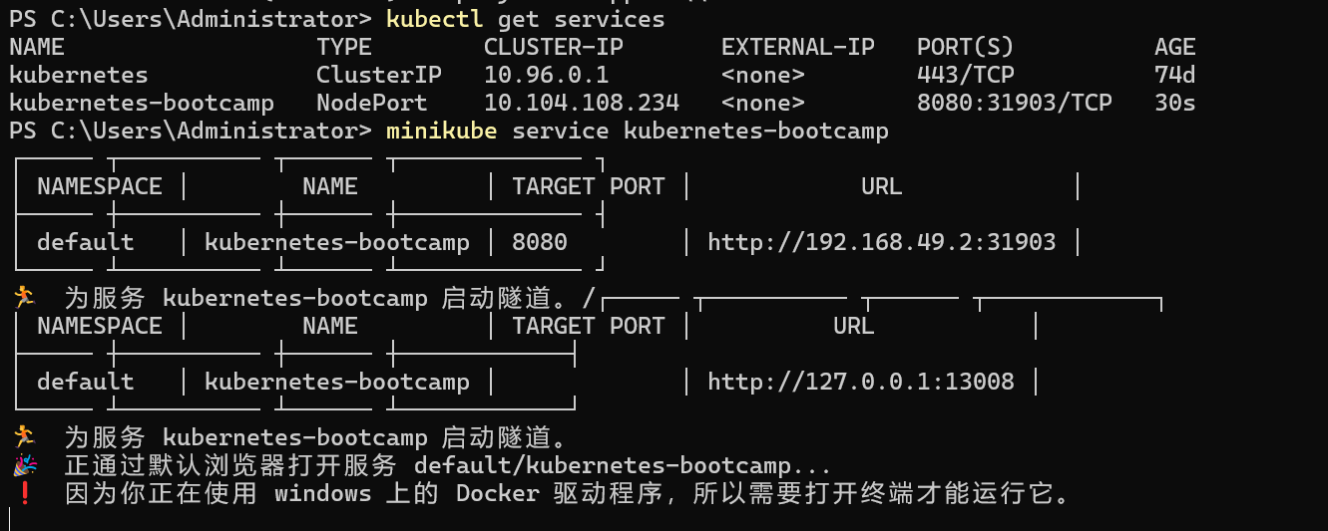
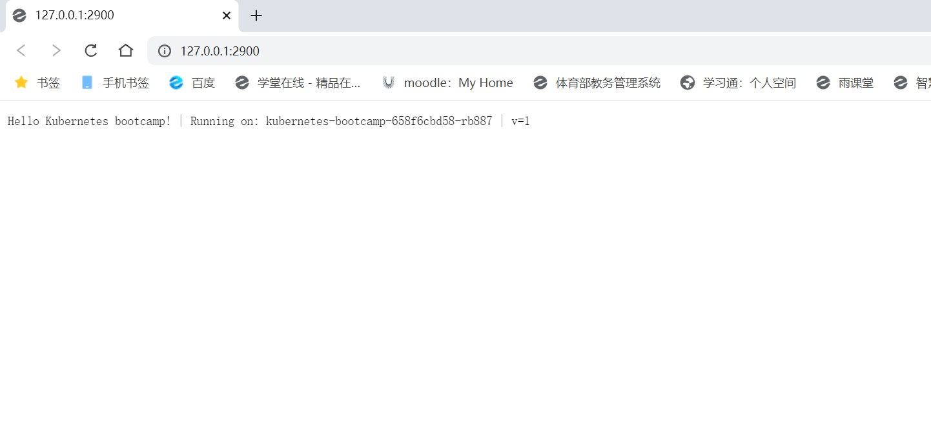

2.6 Scaling the Application
The application was scaled to multiple replicas:
kubectl scale deployment kubernetes-bootcamp --replicas=4
The number of running Pods was verified:
kubectl get pods
Kubernetes automatically created additional Pods to handle the increased load.
Screenshot: Multiple Pods running
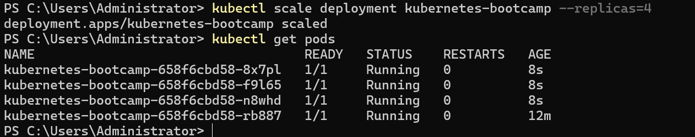

2.7 Updating the Application
The application image was updated to a new version:
kubectl set image deployment/kubernetes-bootcamp \
kubernetes-bootcamp=gcr.io/google-samples/kubernetes-bootcamp:v2
The rollout status was monitored:
kubectl rollout status deployment/kubernetes-bootcamp
The application was accessed again to confirm that the update was applied successfully.
Screenshot: Updated application version

3. Summary

In this experiment, the basic functionality of Kubernetes was explored using Minikube.
A local Kubernetes cluster was successfully created, and a containerized application was deployed, exposed, scaled, and updated.

This lab provided hands-on experience with core Kubernetes concepts such as Deployments, Pods, and Services.
The experiment helped build a solid foundation for understanding container orchestration and cloud-native application deployment.

