Cloud Computing Lab Report 7
Name: Shunyi Yang
ID Number: 202283910016 November 21st, 2025

1. Experiment Overview
The goal of this experiment is to install and explore Istio, a popular service mesh for Kubernetes, by following the official Istio Getting Started documentation.

This lab focuses on understanding how Istio enhances Kubernetes networking by providing traffic management, observability, and security features without modifying application code.

By completing this experiment, the following objectives are achieved:
Understanding the concept and purpose of a service mesh
Installing Istio on a Kubernetes cluster
Deploying a sample microservices application
Observing traffic flow through the Istio data plane
Exploring basic Istio features such as automatic sidecar injection and traffic routing
This experiment was completed individually on a local Kubernetes environment.

2. Experimental Process
2.1 Environment Preparation
Before installing Istio, the following tools were installed and verified:
Docker Desktop
Kubernetes (via Minikube)
kubectl
The cluster status was verified using:
kubectl get nodes
Screenshot: Kubernetes node status

2.2 Downloading and Installing Istio
Istio was downloaded using the official installation script:
curl -L https://istio.io/downloadIstio | sh -
After extraction, the Istio binary was added to the system path:
cd istio-*
export PATH=$PWD/bin:$PATH
The installation was verified:
istioctl version
Screenshot: istioctl version output
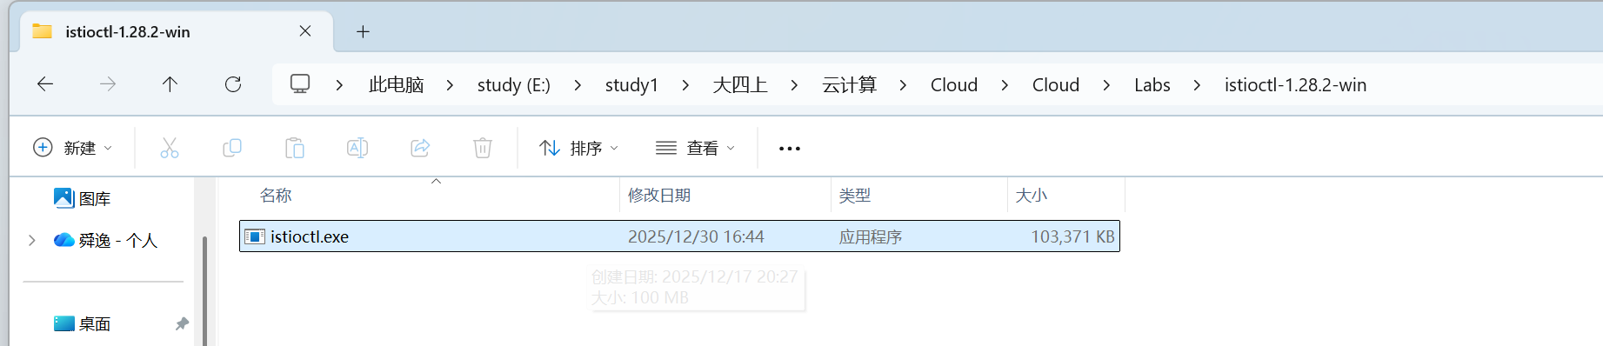

2.3 Installing Istio on the Cluster
Istio was installed using the demo profile, which enables core features suitable for learning and experimentation:
istioctl install --set profile=demo -y
After installation, Istio system components were checked:
kubectl get pods -n istio-system
All Istio components were confirmed to be running.
Screenshot: Istio system pods running
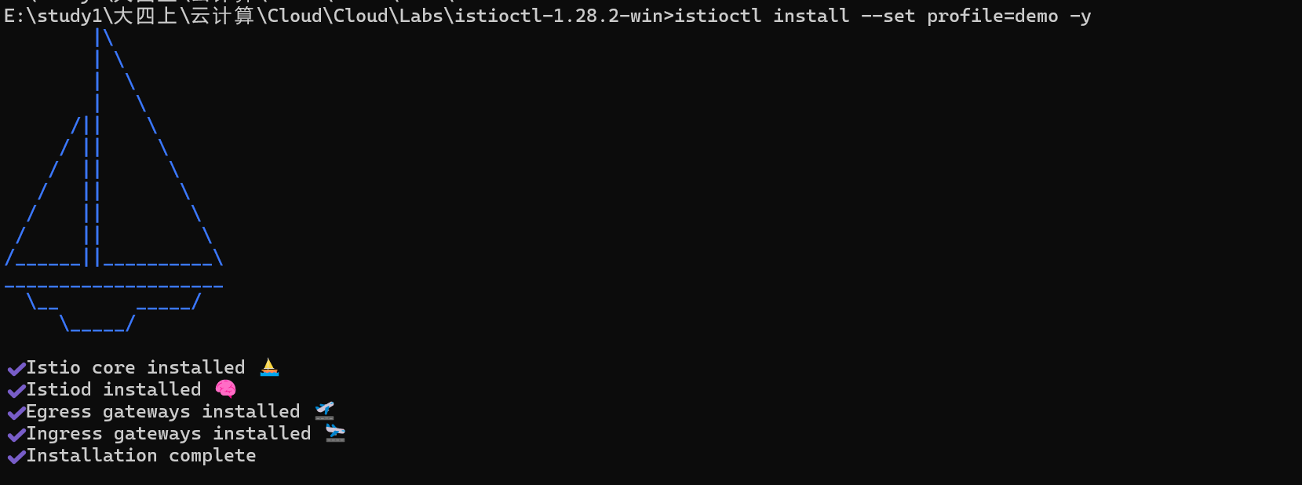
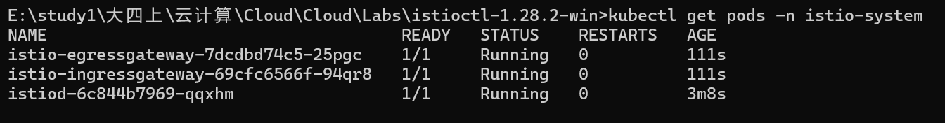

2.4 Enabling Automatic Sidecar Injection
To allow Istio to automatically inject Envoy sidecars into application Pods, a namespace label was added:
kubectl label namespace default istio-injection=enabled
This ensures that all applications deployed in the default namespace will be managed by Istio.
Screenshot: Namespace labeling confirmation
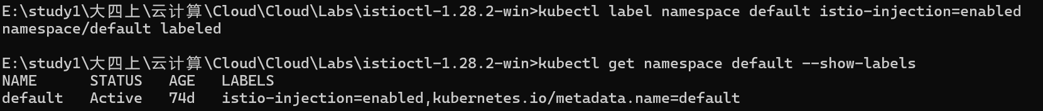

2.5 Deploying the Sample Application
The Bookinfo sample application was deployed:
kubectl apply -f samples/bookinfo/platform/kube/bookinfo.yaml
The status of Pods and Services was verified:
kubectl get pods
kubectl get services
All application Pods were running successfully.
Screenshot: Bookinfo Pods and Services
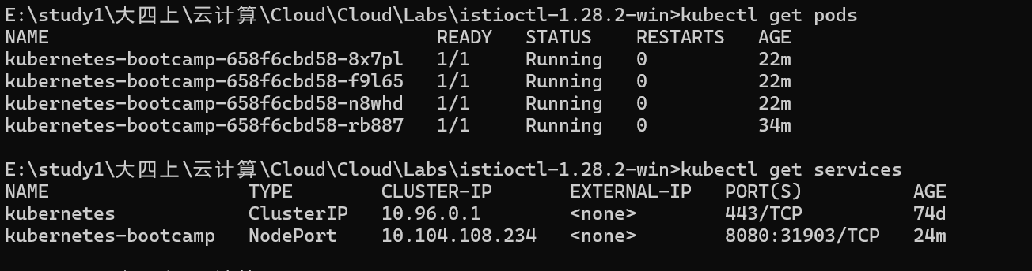

2.6 Verifying the Application
The Bookinfo application was accessed internally to confirm it was running correctly:
kubectl exec "$(kubectl get pod -l app=ratings -o jsonpath='{.items[0].metadata.name}')" \
-c ratings -- curl -s productpage:9080/productpage | grep -o "<title>.*</title>"
The correct HTML title confirmed the application was reachable.

2.7 Exposing the Application via Istio Gateway
The Istio Gateway and VirtualService were applied:
kubectl apply -f samples/bookinfo/networking/bookinfo-gateway.yaml
The external access information was obtained:
istioctl analyze
kubectl get gateway
The application was accessed through the Istio Ingress Gateway using the provided URL.

2.8 Observing Traffic Management
Multiple refreshes of the Bookinfo product page demonstrated different service versions responding to requests, showing that Istio was successfully managing traffic between microservices.
This step highlighted Istio’s ability to control and observe service-to-service communication.

3. Summary
In this experiment, Istio was successfully installed and configured on a Kubernetes cluster using the demo profile.
A microservices-based sample application was deployed with automatic sidecar injection enabled.

The experiment demonstrated how Istio enhances Kubernetes by providing transparent traffic management and observability without changing application code.
This lab provided practical experience with service mesh concepts and laid the foundation for advanced Istio features such as traffic routing, security policies, and monitoring.

