Cloud Computing Lab Report 8
Name: Shunyi Yang
ID Number: 202283910016 November 21st, 2025

1. Experiment Overview
This lab focuses on exploring Istio’s traffic management capabilities in a Kubernetes-based microservices environment.
By following the official Istio documentation, this experiment demonstrates how Istio can control and manage service traffic without modifying application code.

The experiment covers the following four traffic management topics:
Traffic Shifting
Request Routing
Fault Injection
Circuit Breaking

Through these tasks, the experiment illustrates how Istio can be used to support application upgrades, testing, resilience, and reliability in microservices architectures.

2. Experimental Process
Prerequisite
Kubernetes cluster running (Minikube)
Istio installed with demo profile
Bookinfo sample application deployed
Automatic sidecar injection enabled

2.1 Traffic Shifting
Traffic shifting allows traffic to be gradually moved from one service version to another.
Step 1: Deploy Destination Rules

Kubectl apply
-f https://raw.githubusercontent.com/istio/istio/1.28.2/samples/bookinfo/networking/destination-rule-all.yaml
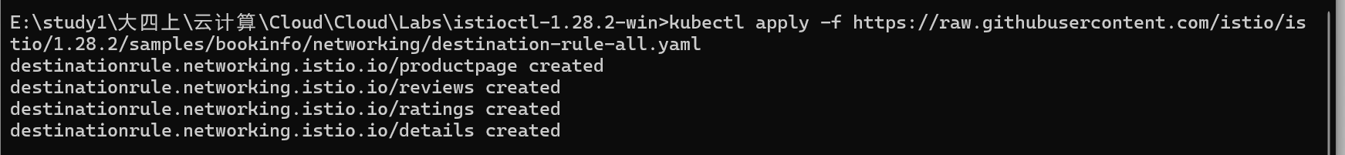
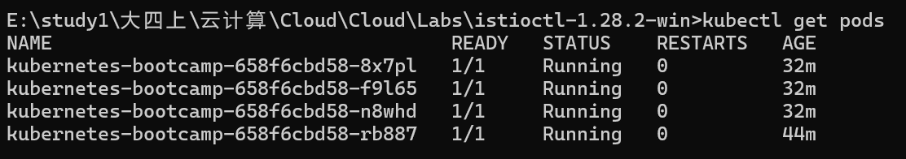
Note: On Windows, the Bookinfo configuration files were applied directly from the official Istio GitHub repository, as the Windows Istio client package does not include the samples directory.

Step 2: Route 100% Traffic to v1
kubectl apply -f samples\bookinfo\networking\virtual-service-all-v1.yaml
After refreshing the Bookinfo page multiple times, only version v1 of the reviews service is displayed.
Screenshot: Reviews v1 only
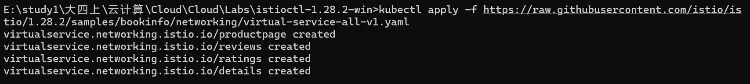
Step 3: Shift Traffic (50% v1, 50% v3)
kubectl apply -f samples\bookinfo\networking\virtual-service-reviews-50-v3.yaml
Refreshing the page now shows mixed versions of the reviews service, demonstrating traffic shifting.
Screenshot: Mixed v1 and v3 reviews

2.2 Request Routing
Request routing allows traffic to be routed based on request attributes such as headers.

Step 1: Apply Header-Based Routing Rule
kubectl apply -f samples\bookinfo\networking\virtual-service-reviews-test-v2.yaml
This rule routes requests from a specific user (e.g., jason) to reviews v2.
Step 2: Verify Behavior
Log in as user jason → reviews v2 is displayed
Log in as any other user → reviews v1 is displayed
This demonstrates fine-grained request routing based on HTTP headers.
Screenshot: User-specific routing behavior
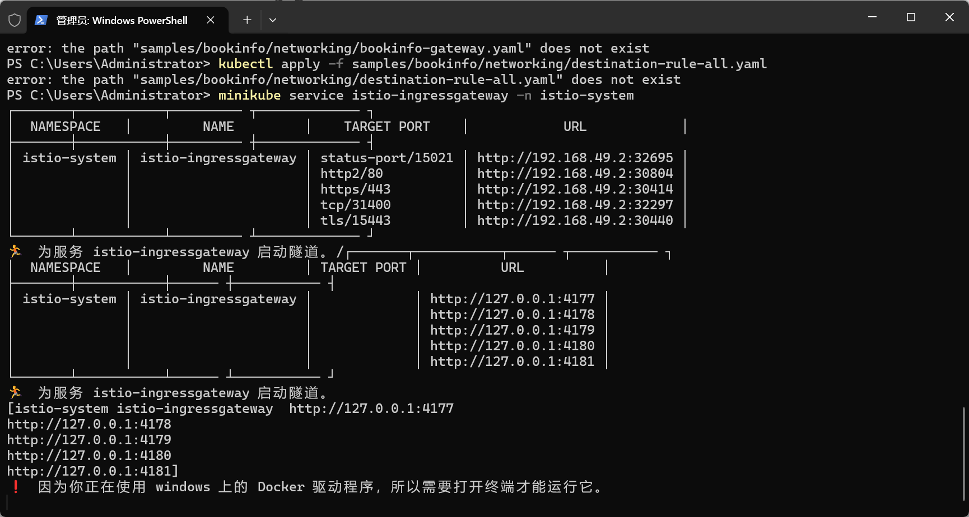
2.3 Fault Injection
Fault injection is used to test the resilience of services by introducing artificial delays or errors.
Step 1: Apply Delay Injection Rule
kubectl apply -f samples\bookinfo\networking\virtual-service-ratings-test-delay.yaml
This configuration injects a delay for requests from a specific user.

Step 2: Observe Delay
When logged in as the configured user, the Bookinfo page responds slowly, while other users experience normal behavior.
This demonstrates how Istio can simulate network latency for testing.
Screenshot: Delayed response observed
2.4 Circuit Breaking
Circuit breaking prevents cascading failures by limiting the number of concurrent connections and requests.
Step 1: Apply Circuit Breaker Configuration
kubectl apply -f samples\bookinfo\networking\destination-rule-reviews.yaml
This sets limits on connections and requests for the reviews service.
Screenshot: DestinationRule with circuit breaker

Step 2: Generate Load
kubectl exec -it deploy/productpage -- /bin/bash
Inside the pod:
for ($i=0; $i -lt 1000; $i++) { curl http://reviews:9080/reviews/0 }

Under heavy load, some requests fail, showing that circuit breaking is working.
Screenshot: Failed requests under load

3. Summary
In this lab, Istio’s traffic management features were successfully explored using the Bookinfo sample application.
Traffic shifting demonstrated gradual service version migration, request routing showed header-based traffic control, fault injection simulated service failures, and circuit breaking protected services under high load.

This experiment highlights how Istio enhances microservices reliability and flexibility by providing advanced traffic control mechanisms at the service mesh level.

