Cloud Computing Lab Report 9
Name: Shunyi Yang
ID Number: 202283910016 November 21st, 2025

1. Experiment Overview
This lab provides hands-on experience with Knative, a Kubernetes-based platform for building, deploying, and managing serverless, cloud-native applications.
The experiment focuses on installing Knative Serving and Eventing using YAML manifests and exploring their core functionality.
The objectives of this lab are:
To understand the role of Knative in serverless architectures
To install Knative Serving and Eventing on a local Kubernetes cluster
To configure networking using Istio
To explore Knative Functions with a local container registry
To gain familiarity with Knative Serving and Eventing concepts
This experiment was completed individually using Minikube on a local machine.

2. Experimental Process
2.1 Kubernetes Cluster Setup
Minikube was started with sufficient CPU and memory resources to support Knative:
minikube start ``
--driver=docker `
--memory=6144 `
--cpus=4 `
--kubernetes-version=v1.34.0The cluster status was verified:
kubectl get nodes
Screenshot: Minikube running and node status
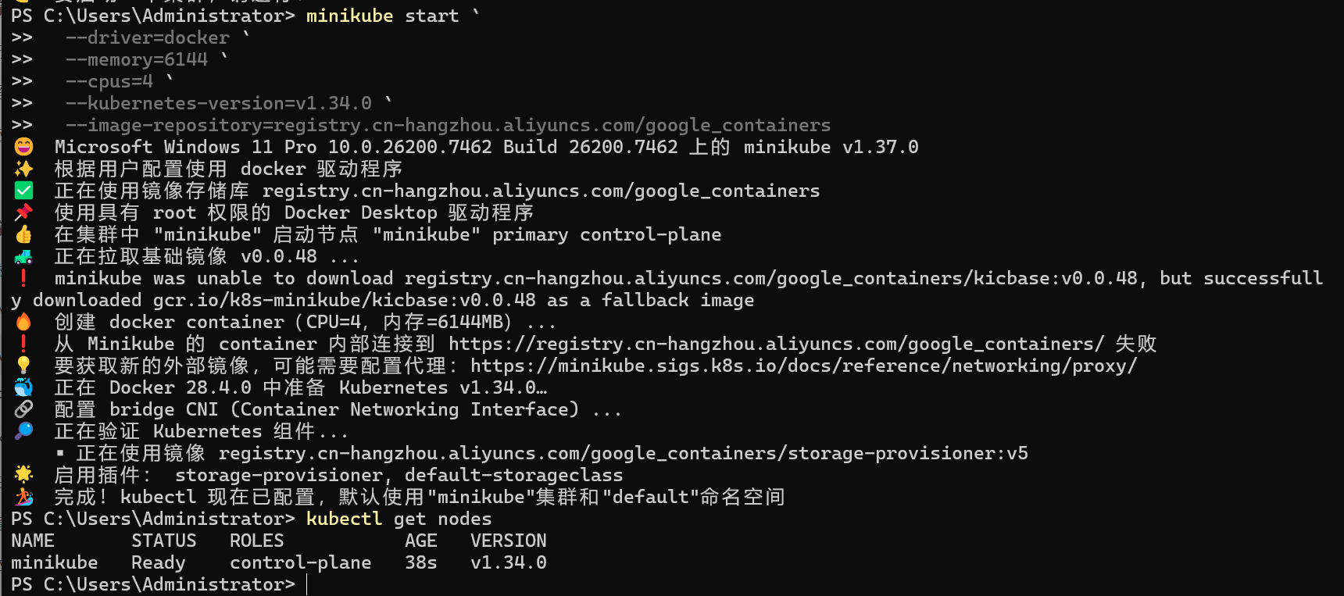

2.2 Installing Knative Serving (YAML)
Step 1: Install Knative Serving CRDs
kubectl apply -f serving-crds.yaml
Screenshot: Serving CRDs applied
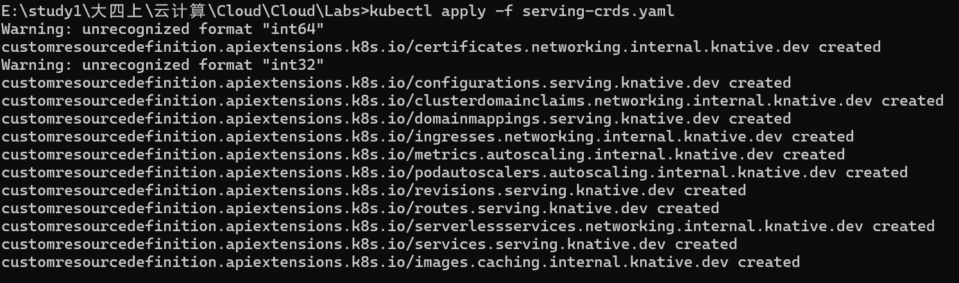、

Step 2: Install Knative Serving Core Components
kubectl apply -f serving-core.yaml
Verify pods:
kubectl get pods -n knative-serving
Screenshot: Knative Serving pods running
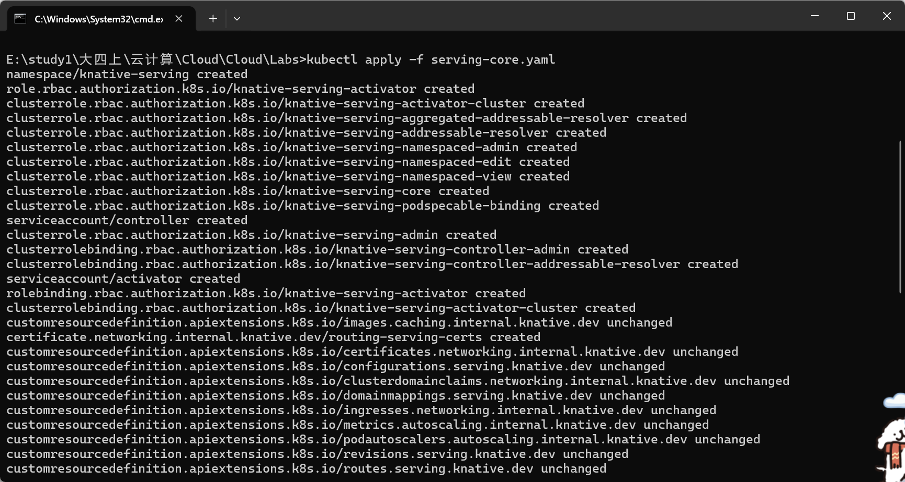
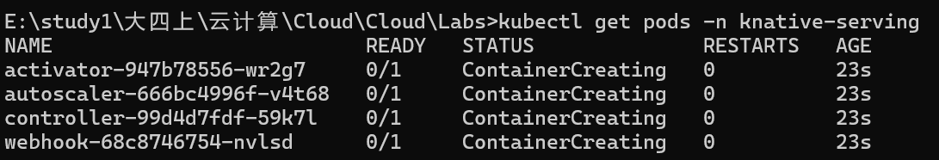
2.3 Installing Istio for Knative Networking
Step 1: Install Istio
kubectl apply -f istio.yaml
Check system pods:
kubectl get pods -A
Screenshot: Istio components
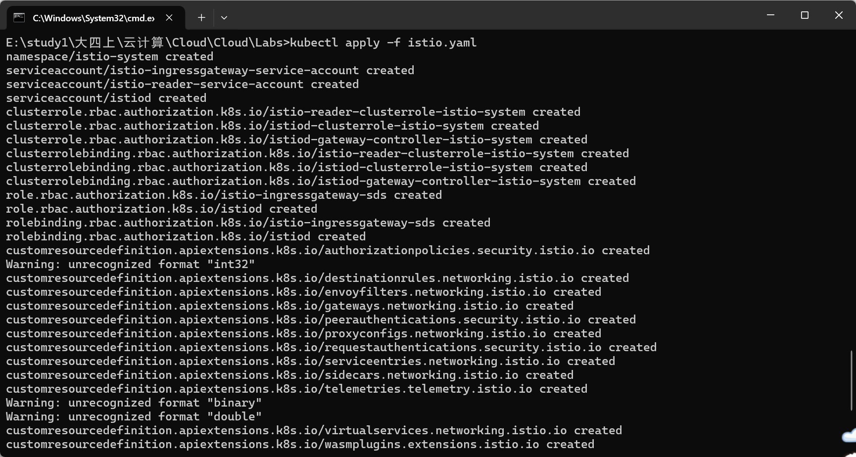
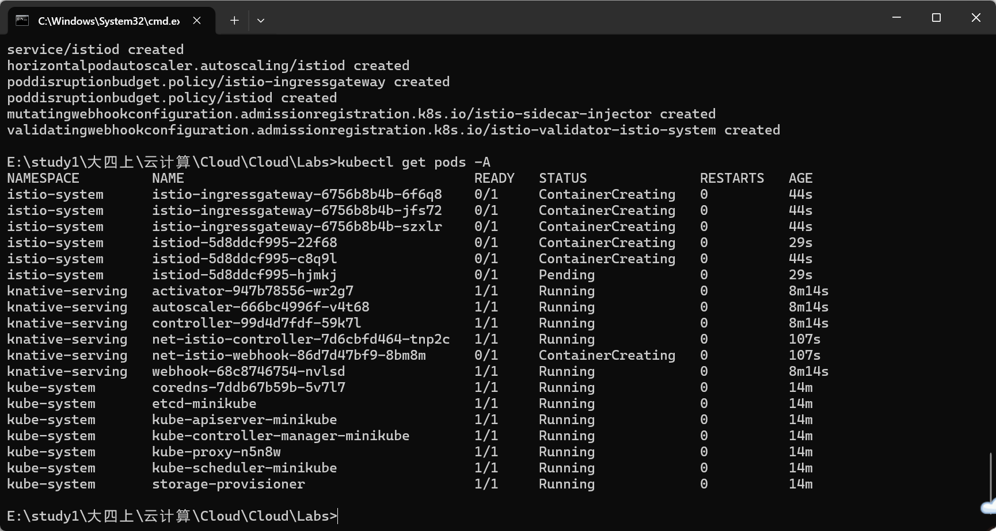

Step 2: Install Knative Net-Istio
kubectl apply -f net-istio.yaml
Verify Istio system:
kubectl get pods -n istio-system
kubectl --namespace istio-system get service istio-ingressgateway
Screenshot: Istio ingress gateway
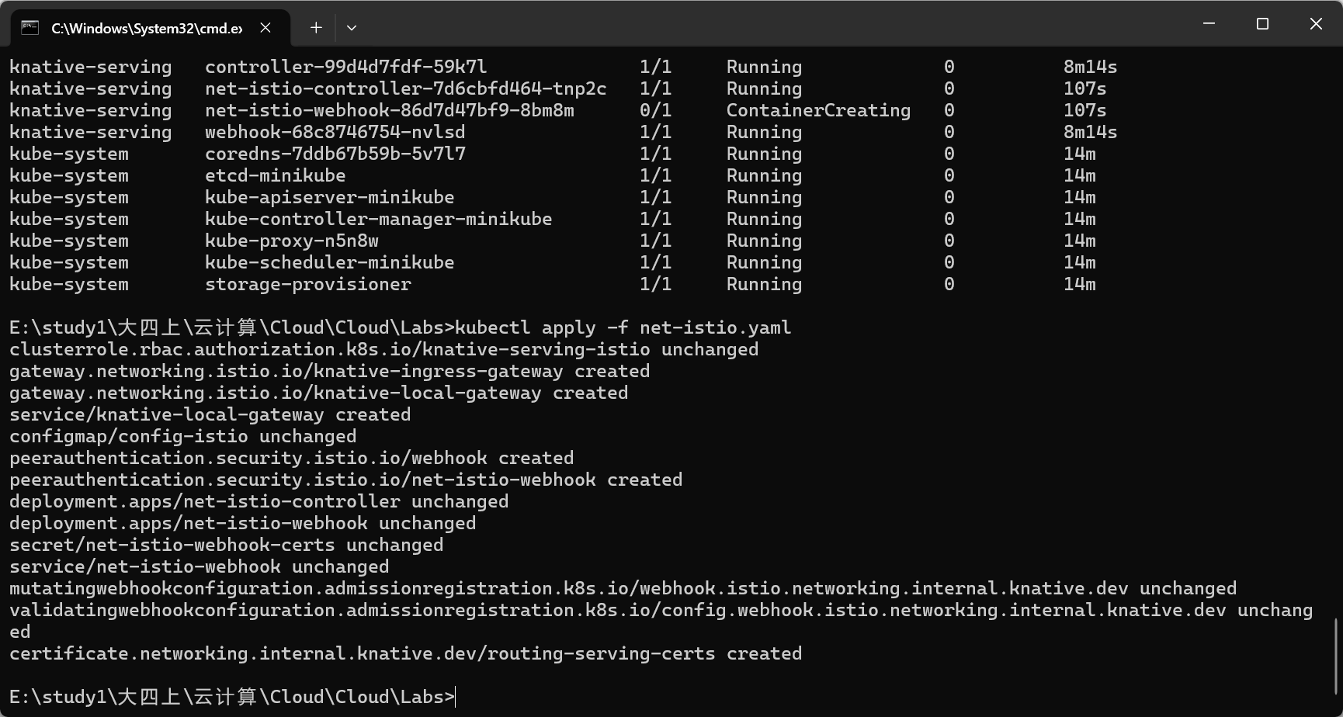
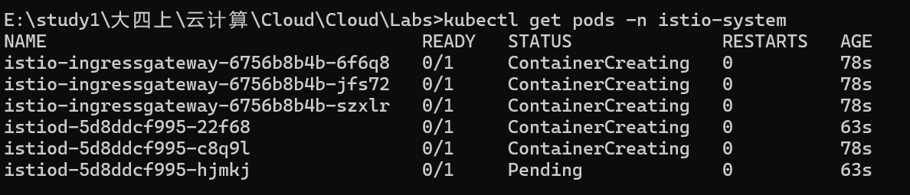

2.4 Installing Cert-Manager
Cert-Manager is required for Knative to manage TLS certificates.
kubectl apply -f cert-manager.yaml
Verify installation:
kubectl get pods --namespace cert-manager
Screenshot: Cert-manager pods
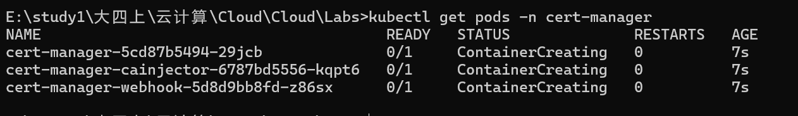

2.5 Installing Knative Eventing
Knative Eventing components were installed using YAML:
kubectl apply -f eventing.yaml
Verify Eventing pods:
kubectl get pods -n knative-eventing
Screenshot: Knative Eventing pods
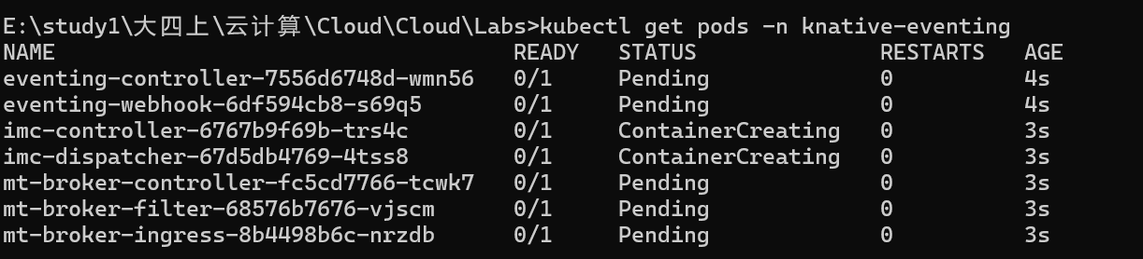

2.6 Knative Functions (Local Registry)
Notes
Local container registry is used
The “Deploying a function” step is skipped as instructed
Step 1: Verify Knative Functions CLI
kn func version
Screenshot: Knative Functions version

Step 2: Create a Go Function
func create -l go hello
cd hello
Screenshot: Function project structure

Step 3: Run Function Locally
kn func run
Screenshot: Local function running

Step 4: Start Local Container Registry
docker run -d -p 5001:5000 --name registry registry:2
Verify registry:
docker ps
Screenshot: Local registry container

Step 5: Run Function Using Local Registry
func run --registry localhost:5001
Invoke function:
func invoke
Screenshot: Function invocation result
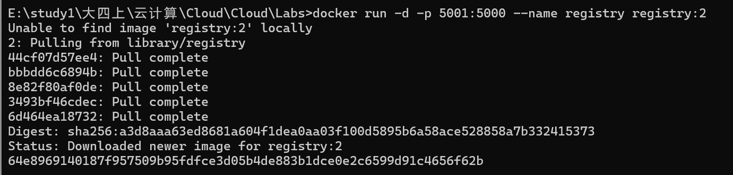
2.7 Knative Serving (First Service)
Following the Knative Serving getting-started guide, a basic Knative service was created and deployed to verify Serving functionality.
kubectl get ksvc
The service automatically scaled based on traffic, demonstrating Knative’s serverless behavior.
Screenshot: Knative Service status

2.8 Knative Eventing (Getting Started)
Basic Eventing components were verified to ensure that Knative Eventing was installed correctly and ready for event-driven workloads.
kubectl get brokers
kubectl get triggers
Screenshot: Eventing resources
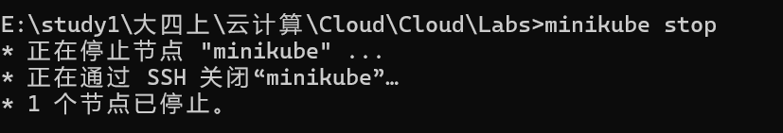

3. Summary
In this lab, Knative Serving and Eventing were successfully installed on a Kubernetes cluster using YAML-based installation.
Istio was configured as the networking layer, and Cert-Manager was installed to support secure communication.

Knative Functions were explored using a local container registry, demonstrating local development and execution of serverless functions.
This experiment provided practical experience with serverless application platforms and highlighted how Knative extends Kubernetes for cloud-native, event-driven workloads.

