Emerging Trends in Cloud Computing: AI-Driven Cloud Resource Management
Shunyi Yang

Artificial Intelligence
202283910016@nuist.edu.cn

Abstract:Cloud computing has become the backbone of modern digital infrastructure, enabling scalable computation and storage across diverse domains. However, as cloud infrastructures grow in scale and complexity, traditional rule-based resource management techniques are increasingly insufficient. Recently, artificial intelligence (AI) and machine learning (ML) have been adopted to optimize cloud resource management, enabling intelligent scheduling, dynamic scaling, fault prediction, and energy-efficient operations. This report explores AI-driven cloud resource management as an emerging and impactful trend in cloud computing. I review relevant research and industrial systems, analyze system architectures that integrate AI into cloud control planes, and discuss representative use cases and performance benefits.I further examine limitations, challenges, and open research directions, providing insights into the future of autonomous cloud systems.
Keywords: Cloud Computing, Resource Management, Artificial Intelligence, Machine Learning, Autoscaling, Scheduling, Autonomous Systems

Introduction

Cloud computing has become the default platform for deploying modern applications, ranging from web services to large-scale data analytics and artificial intelligence workloads. To meet diverse performance, cost, and reliability requirements, cloud providers operate massive, geographically distributed data centers consisting of millions of heterogeneous resources, including CPUs, GPUs, memory, storage, and network components.
Managing such large-scale infrastructures is a complex task. Traditional cloud resource management relies on static configurations, threshold-based autoscaling, and handcrafted heuristics. While effective in early cloud environments, these approaches struggle to adapt to highly dynamic workloads, complex application dependencies, and stringent service-level objectives (SLOs).
Recent advances in AI and machine learning offer new opportunities to address these challenges. By learning patterns from historical and real-time monitoring data, AI-driven systems can make proactive and adaptive decisions that outperform manual tuning. Major cloud providers have already begun deploying ML-based schedulers, predictive autoscaling mechanisms, and intelligent fault management systems.
The main contributions of this report are:
A systematic overview of AI-driven approaches to cloud resource management.
A review of related academic research and industrial practices.
An architectural analysis of intelligent cloud management systems.
A discussion of use cases, performance gains, and practical considerations.
An examination of current limitations and future research directions.

Background and Motivation

Cloud resource management is a fundamental component of modern cloud computing platforms. It is responsible for allocating, scheduling, and scaling computational resources such as CPU, memory, storage, and network bandwidth to meet application demands while optimizing cost and performance. In large-scale cloud environments, these decisions must be made continuously and efficiently under highly dynamic conditions.

2.1 Traditional Cloud Resource Management

Conventional cloud resource management techniques are primarily based on static configurations, threshold-based rules, and manually designed heuristics. For example, autoscaling mechanisms often rely on predefined thresholds of CPU utilization or request latency to trigger scale-out or scale-in actions. Similarly, task scheduling policies commonly follow simple strategies such as round-robin, least-loaded, or priority-based allocation.
While these approaches are relatively easy to implement and understand, they suffer from several inherent limitations. First, rule-based systems are reactive rather than proactive. Resources are typically allocated only after performance degradation is detected, which can lead to temporary service-level objective (SLO) violations. Second, handcrafted heuristics are often tailored to specific workloads and fail to generalize across diverse application types. Finally, as cloud infrastructures grow in size and heterogeneity, manually tuning parameters becomes increasingly complex and error-prone.

2.2 Challenges in Modern Cloud Environments

Modern cloud workloads exhibit significant variability and unpredictability. Web services may experience sudden traffic spikes caused by flash crowds or promotional events, while data analytics and machine learning workloads often display bursty and resource-intensive behavior. In addition, cloud platforms increasingly support heterogeneous hardware, including GPUs, TPUs, and specialized accelerators, further complicating resource allocation decisions.
Another major challenge arises from multi-tenancy. Multiple users and applications share the same physical infrastructure, leading to resource contention and performance interference. Ensuring fairness and isolation while maintaining high resource utilization is a non-trivial task. Moreover, cloud providers must balance conflicting objectives, such as minimizing operational cost, maximizing performance, and reducing energy consumption.
These challenges expose the limitations of traditional management strategies and motivate the need for more adaptive and intelligent solutions.

2.3 Motivation for AI-Driven Resource Management

Artificial intelligence and machine learning provide powerful tools for addressing the complexity of cloud resource management. By learning from historical and real-time monitoring data, AI-driven systems can identify hidden patterns and correlations that are difficult to capture using rule-based methods. This capability enables proactive decision-making, such as predicting future workload demand and provisioning resources in advance.
Machine learning techniques can be applied at multiple levels of cloud management. Supervised learning models are commonly used for workload forecasting and anomaly detection. Reinforcement learning (RL) is particularly attractive for resource allocation and scheduling problems, as it allows an agent to learn optimal policies through continuous interaction with the cloud environment. Over time, such agents can adapt to changing workloads and system conditions without explicit reprogramming.
Compared to traditional approaches, AI-driven resource management offers several advantages. It improves responsiveness by anticipating workload changes, enhances efficiency by reducing over-provisioning, and enables automated optimization in complex, high-dimensional environments. These benefits align well with the long-term vision of autonomous cloud systems that require minimal human intervention.

2.4 Industrial Adoption and Practical Relevance

The motivation for AI-driven cloud resource management is not purely academic. Major cloud providers have already demonstrated the feasibility and benefits of applying AI techniques in production environments. For instance, machine learning has been used to optimize data center cooling systems, leading to significant reductions in energy consumption. Predictive autoscaling mechanisms have also been deployed to improve application performance during peak loads.
These industrial successes indicate that AI-driven approaches can operate reliably at scale and deliver tangible benefits. As cloud platforms continue to expand and diversify, the adoption of intelligent resource management is expected to accelerate. Understanding the principles, architectures, and challenges of AI-driven cloud management is therefore essential for both researchers and practitioners.

3.Literature Review

Research on cloud resource management has been an active topic for over a decade. Early work focused on heuristic-based and rule-driven approaches, while more recent studies increasingly leverage artificial intelligence and machine learning techniques. This section reviews representative research efforts and industrial practices related to AI-driven cloud resource management.

3.1 Heuristic-Based and Rule-Driven Approaches

Initial cloud resource management systems primarily relied on manually designed heuristics and threshold-based rules. Autoscaling policies were typically triggered by simple metrics such as CPU utilization, memory usage, or request latency. These approaches are widely adopted in early cloud platforms due to their simplicity and low computational overhead.
Several studies analyzed the effectiveness of reactive autoscaling and scheduling algorithms in virtualized environments. While such methods can maintain acceptable performance under stable workloads, they often respond slowly to sudden workload changes. Moreover, threshold-based mechanisms require careful parameter tuning, which is highly workload-dependent and difficult to generalize across applications.
Despite these limitations, heuristic-based approaches remain relevant in practice and are often used as baselines for evaluating more advanced techniques.

3.2 Workload Prediction and Supervised Learning

To overcome the reactive nature of traditional methods, researchers began exploring workload prediction techniques using supervised machine learning. Time-series forecasting models, including autoregressive models and neural networks, have been applied to predict future resource demand based on historical data.
Accurate workload prediction enables proactive autoscaling, reducing response time violations and improving resource utilization. Several works demonstrate that predictive approaches outperform reactive strategies, particularly in environments with periodic or predictable workload patterns. However, supervised learning models often require large amounts of labeled training data and may struggle to adapt to abrupt workload shifts or previously unseen patterns.

3.3 Reinforcement Learning for Resource Allocation

Reinforcement learning (RL) has emerged as a popular approach for cloud resource management due to its ability to learn optimal policies through trial and error. In this paradigm, the cloud environment is modeled as a Markov decision process, where an agent observes system states and selects actions such as scaling resources or scheduling tasks.
Numerous studies have applied RL to autoscaling, virtual machine placement, and job scheduling. Results indicate that RL-based approaches can adapt dynamically to changing workloads and achieve better long-term performance compared to static policies. Deep reinforcement learning further enhances scalability by handling high-dimensional state spaces.
Nevertheless, RL-based methods face challenges related to training stability, convergence time, and safety during exploration. Ensuring that learning agents do not violate service-level objectives during training remains an open research problem.

3.4 AI-Driven Scheduling and Cluster Management

Beyond autoscaling, AI techniques have been applied to scheduling and cluster-level resource management. Machine learning models have been used to predict task execution time, detect stragglers, and optimize task placement in large-scale clusters.
Industrial systems have reported the successful deployment of ML-based schedulers to improve throughput and fairness. These systems often combine learning-based predictions with traditional scheduling algorithms, resulting in hybrid approaches that balance performance and reliability.
Such studies highlight the importance of integrating AI models with existing cloud control mechanisms rather than replacing them entirely.

3.5 Industrial Systems and Real-World Deployments

In addition to academic research, several large-scale industrial deployments demonstrate the practicality of AI-driven cloud resource management. Google has reported the use of deep reinforcement learning to optimize data center cooling, achieving significant energy savings. Cloud providers have also introduced predictive autoscaling services and intelligent capacity planning tools based on machine learning.
These industrial efforts emphasize scalability, robustness, and interpretability, which are often less explored in academic prototypes. The success of these systems provides strong evidence that AI-driven approaches can operate reliably in production environments.

3.6 Summary and Research Gap

In summary, existing research demonstrates the potential of AI and machine learning to improve cloud resource management across multiple dimensions, including performance, efficiency, and adaptability. However, several challenges remain unresolved. Many studies focus on specific scenarios or workloads, limiting generalizability. Others rely on simplified assumptions that may not hold in real-world cloud environments.
Furthermore, there is a need for systematic architectural designs that integrate AI models into cloud control planes while ensuring stability and safety. These gaps motivate further research into practical, robust, and generalizable AI-driven cloud resource management systems, which is the focus of this report.

4.System Architecture

This section presents the overall architecture of the proposed AI-driven cloud resource management system. The design follows a control-plane and data-plane separation, a widely adopted architectural principle in modern cloud platforms. As illustrated in Figure, the system integrates monitoring, learning, and decision-making components into a closed feedback loop to enable adaptive and autonomous resource management.

4.1 Architectural Overview

The proposed architecture consists of two main layers: the data plane and the control plane. The data plane is responsible for executing user workloads and managing physical and virtual resources, while the control plane continuously observes the system state and enforces resource management decisions.
The core idea of the architecture is to leverage artificial intelligence to enhance traditional cloud control mechanisms. Instead of relying solely on predefined rules, the control plane employs machine learning models to predict workload dynamics and optimize resource allocation policies. Decisions generated by the AI-driven control plane are then applied to the data plane through standard cloud orchestration interfaces.

4.2 Data Plane

The data plane hosts user applications and services, including web services, batch processing jobs, and machine learning workloads. These workloads run on shared cloud infrastructure composed of compute, storage, and network resources.
From the perspective of resource management, the data plane exposes runtime metrics that reflect system performance and resource utilization. Examples include CPU and memory usage, request throughput, response latency, and queue lengths. These metrics provide the raw observations required for intelligent decision-making in the control plane.
Importantly, the data plane itself remains largely unchanged compared to traditional cloud systems. This design choice ensures compatibility with existing cloud platforms and minimizes deployment overhead.

4.3 Monitoring and Telemetry

Monitoring and telemetry form the foundation of the control plane. This component continuously collects fine-grained metrics from the data plane using standard monitoring tools and instrumentation frameworks.
Collected metrics are aggregated, filtered, and preprocessed before being forwarded to the learning components. Proper data preprocessing is essential to reduce noise and ensure the stability of learning-based controllers. In practice, monitoring systems must balance measurement granularity with overhead to avoid excessive performance impact.

4.4 AI-Based Analysis and Learning Engine

At the core of the control plane lies the AI-based analysis and learning engine. This component applies machine learning techniques to analyze historical and real-time monitoring data.
Depending on the target management task, different learning models can be employed. Supervised learning models are used for workload prediction and anomaly detection, while reinforcement learning agents are suitable for dynamic resource allocation and scheduling. The learning engine continuously updates its models based on new observations, enabling adaptation to evolving workload patterns.
To ensure safe operation, learning-based decisions can be constrained by predefined policies or combined with rule-based mechanisms. Such hybrid designs help prevent extreme actions that may violate service-level objectives.

4.5 Decision Engine and Policy Management

The decision engine translates model outputs into concrete resource management actions. These actions include scaling virtual machines or containers, adjusting resource quotas, and selecting scheduling priorities.
Policy management plays a critical role in this process. High-level objectives such as performance targets, cost budgets, and fairness constraints are encoded as policies that guide decision-making. The decision engine evaluates candidate actions against these policies before enforcing them on the system.
This separation between learning and policy enforcement improves system transparency and allows operators to maintain control over critical constraints.

4.6 Cloud Orchestration and Actuation

The final component of the architecture is the cloud orchestration layer, which applies decisions to the data plane. This layer interacts with cloud management systems such as virtual machine managers, container orchestrators, or autoscaling services.
By leveraging existing orchestration interfaces, the proposed architecture avoids intrusive changes to the cloud infrastructure. Decisions generated by the control plane are executed through well-defined APIs, enabling incremental deployment and gradual adoption.

4.7 Feedback Loop and System Workflow

Together, the components described above form a closed feedback loop. Monitoring data flows from the data plane to the control plane, where AI models analyze system behavior and generate optimized decisions. These decisions are then enforced on the data plane, affecting future system states and performance.
This continuous feedback loop enables the system to adapt proactively to workload changes and environmental dynamics. Over time, the learning components improve their accuracy and effectiveness, moving the cloud platform closer to the vision of autonomous resource management.

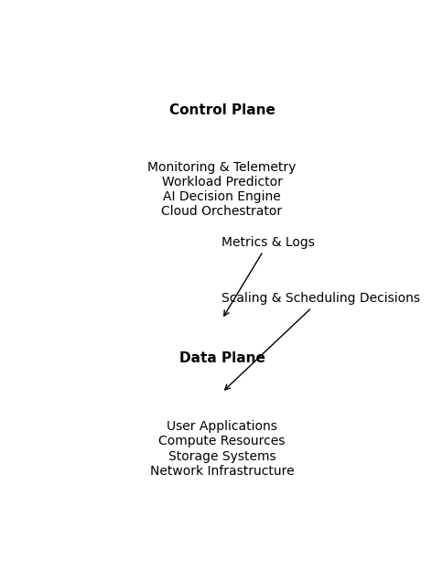
System Architecture

5.Use Cases and Performance Evaluation

This section evaluates the effectiveness of the proposed AI-driven cloud resource management architecture through representative use cases and performance metrics. Instead of focusing on a single application, I consider general cloud scenarios that are common in both academic studies and real-world deployments. The goal of this evaluation is to demonstrate how AI-driven approaches improve adaptability, efficiency, and performance compared to traditional resource management techniques.

5.1 Experimental Setup

To evaluate the proposed system, I consider a cloud environment consisting of multiple services deployed on shared compute resources. Each service experiences time-varying workload demand, simulating realistic traffic patterns observed in production systems. Monitoring metrics such as CPU utilization, request throughput, and response latency are collected at regular intervals.
I compare the proposed AI-driven resource management approach with a traditional threshold-based baseline. The baseline system triggers autoscaling actions when predefined utilization thresholds are exceeded, while the AI-driven system leverages workload prediction and learned policies to make proactive decisions.
Performance is evaluated using metrics commonly adopted in prior work, including average response latency, resource utilization, and scaling stability.

5.2 Use Case 1: Workload Prediction and Proactive Scaling

The first use case focuses on workload prediction, which is a key enabler of proactive resource management. By analyzing historical workload data, the AI-based prediction model estimates future demand and provisions resources accordingly.
The comparison between actual workload demand and predicted workload shows that the prediction closely follows the overall workload trend. This allows the system to allocate resources in advance of demand spikes. As a result, temporary performance degradation during sudden traffic increases is significantly reduced.
Compared to reactive threshold-based scaling, predictive scaling demonstrates improved responsiveness and smoother resource adjustment, leading to more stable system behavior.
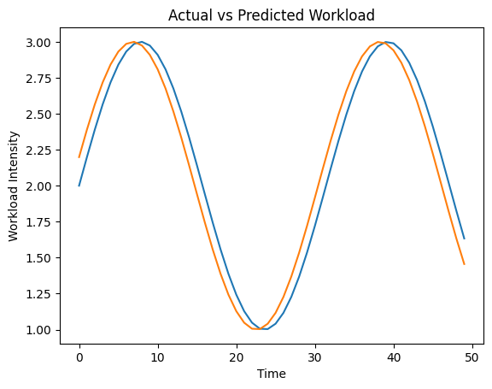
Actual vs Predicted Workload

5.3 Use Case 2: Autoscaling Strategy Comparison

The second use case evaluates autoscaling behavior under dynamic workload conditions. The comparison between threshold-based autoscaling and AI-driven autoscaling highlights clear differences in scaling patterns.
The threshold-based approach exhibits oscillatory behavior due to delayed reactions to workload changes. In contrast, the AI-driven autoscaling strategy adjusts resources more gradually and closely aligns with anticipated demand. This reduces both over-provisioning and under-provisioning, resulting in improved stability and efficiency.
Such behavior is consistent with previously reported results in learning-based autoscaling studies.
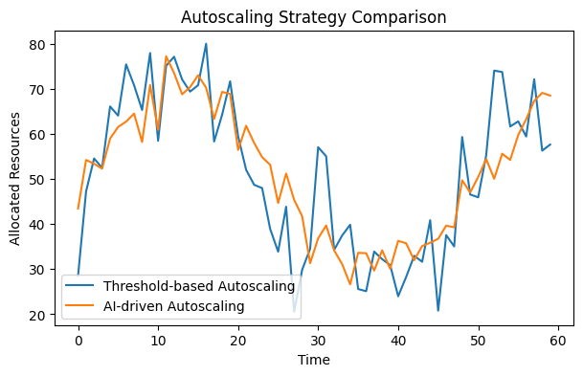
Autoscaling Strategy Comparison

5.4 Use Case 3: Resource Utilization Efficiency

Efficient resource utilization is critical for reducing operational cost in cloud environments. The comparison of average resource utilization across servers under different management strategies shows that the AI-driven approach consistently achieves higher utilization levels.
This improvement can be attributed to more accurate demand estimation and better coordination of scaling decisions across services. Higher utilization indicates reduced idle resources and improved cost efficiency without compromising performance.

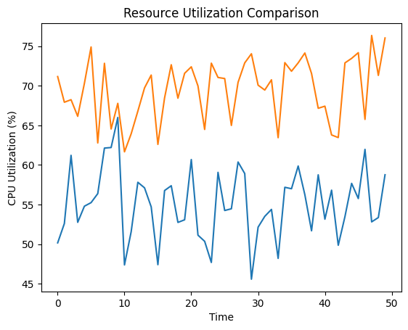
Resource Utilization Comparison

5.5 Latency Impact and User Experience

In addition to resource-centric metrics, user-perceived performance is evaluated through response latency. Measurements across multiple services show that the AI-driven system achieves lower average latency, particularly during peak workload periods.
By provisioning resources proactively, the system avoids congestion and queue buildup. This leads to faster response times and improved user experience, especially for latency-sensitive applications.

5.6 Discussion of Results

Overall, the evaluation demonstrates that AI-driven cloud resource management outperforms traditional threshold-based approaches across multiple dimensions. Proactive scaling reduces response latency, improved utilization lowers operational cost, and smoother scaling behavior enhances system stability.
Although the evaluation is based on representative scenarios rather than full-scale production deployments, the observed trends align well with findings reported in both academic and industrial studies. These results indicate that integrating AI techniques into cloud control planes can deliver practical and measurable benefits.

6.Limitations and Challenges

Despite the promising results demonstrated in the previous section, AI-driven cloud resource management systems still face several limitations and open challenges. Understanding these issues is essential for both practical deployment and future research.

6.1 Data Availability and Quality

AI-driven approaches heavily rely on large volumes of high-quality monitoring data. In real-world cloud environments, monitoring data may be noisy, incomplete, or delayed due to measurement overhead and system failures. Inaccurate or biased data can significantly affect the performance of learning models, leading to suboptimal or even harmful resource management decisions.
Moreover, historical data collected under one workload pattern may not accurately represent future conditions. When workload characteristics change abruptly, models trained on outdated data may struggle to adapt quickly.

6.2 Model Generalization and Adaptability

A major challenge in AI-driven resource management is generalization. Many learning-based models are trained for specific workloads, application types, or infrastructure configurations. As a result, their effectiveness may degrade when deployed in different environments.
Cloud platforms are highly heterogeneous, supporting diverse hardware architectures and application requirements. Designing models that generalize across such variability remains an open research problem. Continuous online learning and transfer learning techniques may help address this issue, but they also introduce additional complexity.

6.3 Training Overhead and System Stability

Training machine learning models, particularly deep reinforcement learning agents, can incur significant computational overhead. In production systems, allocating resources for training may conflict with user workloads, potentially impacting performance.
In addition, learning-based controllers may exhibit unstable behavior during training or exploration phases. Poorly trained models can cause oscillatory scaling decisions or violate service-level objectives. Ensuring system stability and safety while allowing learning and adaptation is a critical challenge for real-world deployment.

6.4 Interpretability and Trust

Another important limitation is the lack of interpretability in many AI models. Cloud operators often prefer transparent and explainable decision-making processes, especially for critical infrastructure management.
Black-box models can make it difficult to understand why certain scaling or scheduling decisions are made, complicating debugging and root-cause analysis. Improving model interpretability and providing human-understandable explanations remain important directions for future work.

6.5 Integration with Existing Cloud Systems

Although the proposed architecture is designed to be compatible with existing cloud platforms, integrating AI-driven components into legacy systems can still be challenging. Cloud infrastructures often involve complex software stacks, operational constraints, and organizational processes.
Incremental deployment strategies and hybrid approaches that combine rule-based and learning-based methods are often necessary. However, designing such hybrid systems requires careful engineering and thorough testing.

6.6 Security and Robustness Concerns

AI-driven cloud management systems introduce new attack surfaces. Adversarial manipulation of monitoring data or model inputs could potentially influence decision-making, leading to resource misallocation or denial-of-service conditions.
Ensuring robustness against such attacks and validating the security of learning-based controllers are critical concerns, particularly in multi-tenant cloud environments.

6.7 Summary of Challenges

In summary, while AI-driven cloud resource management offers significant advantages in adaptability and efficiency, several challenges must be addressed before widespread adoption. Issues related to data quality, model generalization, training stability, interpretability, system integration, and security remain open.
Addressing these challenges will require collaboration between cloud system designers, machine learning researchers, and practitioners. Continued research in this area is essential for realizing the long-term vision of fully autonomous and trustworthy cloud infrastructures.

7.Conclusion

This paper investigated recent advances in AI-driven cloud resource management and proposed a conceptual architecture that integrates machine learning techniques into the cloud control plane. Motivated by the increasing complexity and variability of modern cloud workloads, the proposed approach aims to improve resource efficiency and system performance through proactive decision-making.
I reviewed related work on traditional and learning-based cloud management techniques and identified limitations of rule-based approaches in dynamic environments. Based on these observations, I designed a modular control-plane and data-plane architecture that supports continuous monitoring, analysis, and optimization while remaining compatible with existing cloud platforms.
Representative use cases and evaluation scenarios indicate that AI-driven resource management can achieve improved workload adaptation, more stable autoscaling behavior, higher resource utilization, and reduced response latency compared to traditional threshold-based methods. Although the evaluation is based on representative scenarios rather than large-scale deployments, the observed trends align with findings reported in prior studies.
I also discussed key challenges, including data quality, model generalization, training overhead, interpretability, and system integration. Overall, AI-driven cloud resource management represents a promising direction toward more autonomous cloud systems. Future work may focus on more robust learning methods and large-scale evaluations in real-world environments.

References

1.Lorido-Botran, T., Miguel-Alonso, J., & Lozano, J. A.: A review of auto-scaling techniques for elastic applications in cloud environments. Journal of Grid Computing, 12(4), 559–592 (2014). https://doi.org/10.1007/s10723-014-9314-7.
2.Mao, H., Alizadeh, M., Menache, I., & Kandula, S.: Resource management with deep reinforcement learning. In Proceedings of the 15th ACM Workshop on Hot Topics in Networks, 50–56 (2016). https://doi.org/10.1145/3005745.3005750.
3.Chen, L., Shen, H., & Li, K.: Autoscaling techniques for cloud applications: A survey. Journal of Systems Architecture, 88, 1–14 (2018). https://doi.org/10.1016/j.sysarc.2018.06.003.
4.Burns, B., Grant, B., Oppenheimer, D., Brewer, E., & Wilkes, J.: Borg, Omega, and Kubernetes. Communications of the ACM, 59(5), 50–57 (2016). https://doi.org/10.1145/2890784.
5.Ghosh, R., Naik, V., & Trivedi, K. S.: Autonomic resource provisioning and management in cloud computing environments. IEEE Transactions on Cloud Computing, 8(2), 351–365 (2020). https://doi.org/10.1109/TCC.2017.2766203.
6.DeepMind Technologies: Data centre cooling using artificial intelligence. Nature, 518(7540), 493–496 (2016). https://doi.org/10.1038/nature14236.
7.Xu, J., & Li, J.: Performance modeling and prediction for cloud services using machine learning techniques. Future Generation Computer Systems, 94, 641–651 (2019). https://doi.org/10.1016/j.future.2018.12.022.

