Individual Report — Synthetic Replication (EDSL)
Due: Friday (05/29) at 11:59 PM — Submit via Canvas
Name: | Shuting Yang
Date Submitted: | 5/23/2026

Assignment Overview
In this assignment, you will compare how humans and AI language models respond to the same survey questions. You will:
• Identify a published survey dataset with demographic breakdowns (e.g., from Pew Research Center, Gallup, or the General Social Survey)
• Select one or two survey questions and a corresponding visualization from the original report
• Replicate the survey using the Polly interface or EDSL framework, assigning AI agents with personas that match the demographics of the human sample
• Analyze and compare the human and AI response distributions
This is an individual assignment. Each student submits their own report.
Suggested Section Lengths
Section | Suggested Length
1. Human Survey Data Source | 200–300 words
2. AI Survey Design & Persona Construction | 250–400 words
3. Comparative Analysis | 300–500 words
4. Discussion | 200–300 words
5. Appendix | Code, figures, and tables (no word limit)
Total (excluding appendix) | 1,000–1,500 words

1. Human Survey Data Source
Describe the published survey you selected. What organization conducted it, when, and with what population? What specific survey question(s) did you choose and why? Include the exact question wording from the original survey. Describe the sample demographics and identify the specific plot or visualization from the original report that you will use as your benchmark for comparison.
Suggested: 200–300 words

Data Source Summary
Data Source: | Pew Research Center
Survey Title / Report: | Support for a US TikTok ban continues to decline, and half of adults doubt it will happen
URL: | https://www.pewresearch.org/short-reads/2024/09/05/support-for-a-us-tiktok-ban-continues-to-decline-and-half-of-adults-doubt-it-will-happen/
Survey Question(s) Selected: | "Would you support or oppose the U.S. government banning TikTok?"
Sample Size (Human): | N = 10,658 (Rep/Lean Rep: 4,918; Dem/Lean Dem: 5,431)
Key Demographics Reported: | Party (Rep/lean Rep, Dem/lean Dem); TikTok usage (Use TikTok, Do not use TikTok)

[Provide your narrative description of the data source, why you selected these questions, and what the original findings show. Reference the specific plot or visualization you are using as a benchmark.]

This report uses data from Wave 150 of Pew Research Center's American Trends Panel (ATP), a nationally representative panel of U.S. adults. The survey was conducted between July 15 and August 4, 2024, using both online (n = 10,262) and live telephone (n = 396) interviews administered in English and Spanish. The total sample size was 10,658, with a margin of error of plus or minus 1.2 percentage points at the 95% confidence level. The sample was weighted to reflect the demographic composition of U.S. adults using benchmarks from the 2022 American Community Survey and other national reference surveys.

The survey question selected for replication is: "Would you support or oppose the U.S. government banning TikTok?" (survey code: SOCIAL_BAN), with three response options: Support, Oppose, and Not sure. This question was chosen for two reasons. First, it uses simple and direct wording with only three response options, which reduces the risk of the AI misinterpreting the question and makes the comparison between human and AI responses more straightforward. Second, the Pew report provides clearly disaggregated results across two subgroup dimensions, party identification and TikTok usage, which together create four analytically distinct cells that are well-suited for AI persona replication and allow for a more nuanced evaluation of where AI responses match or diverge from human data.

The original topline results show that 32% of U.S. adults supported a TikTok ban, 28% opposed it, and 39% were not sure. By party, Republican/lean Republican respondents showed 42% support compared to 24% among Democratic/lean Democratic respondents. By TikTok usage, the divide was even larger: only 10% of TikTok users supported a ban, versus 42% of non-users. The two benchmark visualizations are shown in Figures 1 and 2 below. Note that only the Jul-Aug 2024 data points are used as benchmark values in this replication.

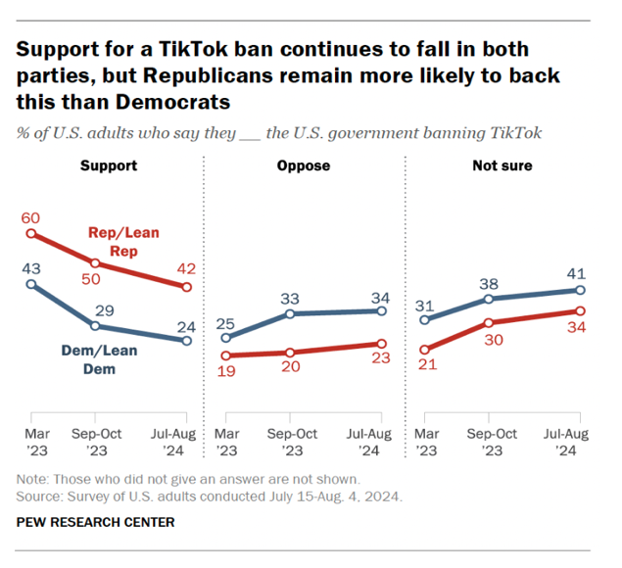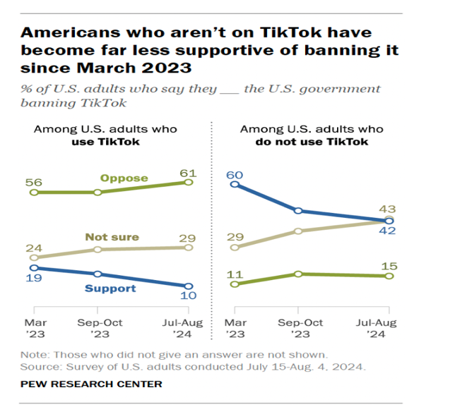
Figure 1. Support for a TikTok ban by party Figure 2. Support for a TikTok ban by TikTok usage
Note: Benchmark values used in this replication are from the Jul-Aug 2024 time point only.

2. AI Survey Design & Persona Construction
Describe how you built your AI survey workflow. What model(s) did you use? How did you construct agent personas to approximate the demographic composition of the original human sample? Be specific about which attributes you assigned (age, gender, race, education, political affiliation, etc.), how many agents you created, and the rationale behind your mapping choices. If you made any modifications to the original survey question wording for the AI context, explain what you changed and why.
Suggested: 250–400 words

AI Configuration Summary
AI Model(s) Used: | GPT-4o (temperature = 1.0)
Platform: | EDSL (version 1.0.8)
Number of AI Agents: | 4
Persona Attributes Assigned: | Party, TikTok usage
Persona-to-Sample Mapping: | 2 party groups × 2 TikTok usage groups = 4 cells, each mapped directly to the subgroups reported in the Pew benchmark
Survey Questions Administered: | "Would you support or oppose the U.S. government banning TikTok?" (Support / Oppose / Not sure)  — no modifications from original wording
Number of Responses per Agent: | 5 (n=5 runs per agent, 20 total responses)

[Provide your narrative description of the AI survey design, persona construction decisions, and any modifications to question wording.]

This replication used GPT-4o via the EDSL framework (version 1.0.8), with temperature set to 1.0 to allow realistic response variance across runs. Four AI agents were created using a 2×2 grid design: two party groups (Republican/lean Republican and Democrat/lean Democrat) crossed with two TikTok usage groups (Use TikTok and Do not use TikTok). Each agent was assigned a short persona description following this structure: "You are a [party] who leans [party]. You [regularly use / do not use] TikTok. You are a U.S. adult answering a survey question about TikTok policy." Other demographic attributes such as age, education, gender, and race were not included in the persona, because the Pew report does not provide benchmark data broken down by those characteristics for this specific question, making them impossible to validate.

These two attributes were chosen because they correspond directly to the two subgroup dimensions reported in the Pew benchmark. Party was selected because the Pew report identifies it as the primary driver of TikTok ban attitudes, with Republicans 18 percentage points more supportive than Democrats. TikTok usage was selected because it produces the starkest divide in the data: 61% of users oppose a ban compared to only 15% of non-users, making it the most informative second dimension to test.

Each agent answered the survey question five times (n=5 per agent, 20 total responses) rather than once. This design choice was made to avoid a binary outcome problem: with only one run per agent, each cell would produce either 0% or 100% support, which cannot meaningfully be compared to the proportional human benchmark data. Averaging over five runs per agent produces a more stable and comparable estimate for each cell. The survey question wording was kept identical to the original Pew questionnaire, with the same three response options: Support, Oppose, and Not sure, and no modifications were made to the question text.

3. Comparative Analysis
Present your comparison of human and AI responses. Include visualizations that place the original human data alongside the AI-generated data (e.g., side-by-side bar charts, overlaid distributions). Describe the patterns you observe: where do the AI responses match the human data? Where do they diverge? Are there specific demographic subgroups where the AI responses are more or less accurate? Report any summary statistics or statistical tests you used to quantify the similarity or divergence.
Suggested: 300–500 words

[Present your comparative analysis here. Include or reference your figures and any statistical comparisons. Place figures and tables in the Appendix and reference them here.]

Figure 3 presents side-by-side comparisons of human and AI response distributions across both subgroup dimensions, showing the percentage of respondents supporting a U.S. TikTok ban. The metric used to quantify divergence is mean absolute error (MAE), which measures the average difference in percentage points between AI and human values across groups within each dimension. Because each agent answered the question five times, the AI support rate for each cell is calculated as the proportion of "Support" responses out of five runs, rather than a single binary outcome.

By Party Identification: The AI correctly reproduced the direction of the partisan gap: Republican/lean Republican agents were more supportive of a ban than Democrat/lean Democrat agents, consistent with the Pew benchmark. However, the magnitude of the gap was substantially exaggerated. Among Rep/Lean Rep agents, AI support was 50% compared to 42% in the human data, an overestimation of 8 percentage points. The larger discrepancy occurred in the Dem/Lean Dem group, where the AI produced 0% support against a human benchmark of 24%, a gap of 24 percentage points. This means that across all five runs, not a single Democratic agent expressed support for the ban, which is clearly inconsistent with the real-world data showing that nearly one in four Democratic-leaning adults supported it. The MAE across the two party groups was 16.0 percentage points, indicating moderate to poor alignment overall.

By TikTok Usage: Alignment was somewhat better across TikTok usage groups, with a MAE of 9.0 percentage points. The AI again captured the correct direction of the divide: agents who do not use TikTok were more supportive of a ban than those who use it. Among non-users, the AI produced 50% support compared to 42% in the human data, an overestimation of 8 percentage points. Among TikTok users, the AI produced 0% support against a human benchmark of 10%, a gap of 10 percentage points. Similar to the Democratic group, the TikTok user agent never once selected "Support" across five runs, despite 10% of real TikTok users supporting a ban in the Pew survey.

Overall, AI (GPT-4o) exhibits a consistent pattern of polarization across both dimensions: the group with higher human support was overestimated (Rep/Lean Rep: 42% → 50%; Do not use TikTok: 42% → 50%), while the group with lower human support was pushed all the way down to 0% (Dem/Lean Dem: 24% → 0%; Use TikTok: 10% → 0%). This is not random error in different directions, but a systematic pattern where the AI amplifies the existing gap between groups. The model correctly identifies which group is more supportive, but exaggerates the contrast by making the minority position disappear entirely. This suggests that GPT-4o treats demographic personas as strong predictors of a single "correct" response, rather than as probabilistic tendencies that still allow for within-group variation. The better overall performance on the TikTok usage dimension (MAE = 9.0 pp) compared to the party dimension (MAE = 16.0 pp) may be because the gap between the two usage groups in the human data is already very large (10% vs. 42%), so even after polarization the AI estimates are not as far off in absolute terms.

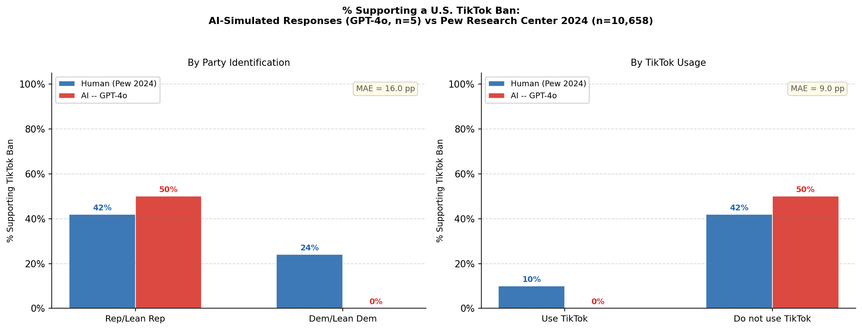
Figure 3. Percentage of respondents supporting a U.S. TikTok ban: AI-simulated responses (GPT-4o, n=5 per agent) vs. human responses (Pew Research Center, 2024, n=10,658), by party identification (left panel) and by TikTok usage (right panel). MAE = mean absolute error in percentage points.

4. Discussion
Reflect on what your comparison reveals about the utility and limitations of AI-generated survey data. Consider the following questions: What might explain the areas where AI responses diverged from human responses? Are there types of survey questions, topics, or demographic dimensions where AI agents perform better or worse? What are the implications for using synthetic respondents as pilot data, for augmenting human samples, or as a substitute for human data collection? What would you do differently if you were to repeat this exercise?
Suggested: 200–300 words

The results reveal a clear limitation of using AI agents to simulate survey responses on politically charged policy questions. GPT-4o correctly reproduced the direction of the partisan gap and the TikTok usage gap, but systematically exaggerated them by pushing minority positions within each group to zero.

Several factors may explain this gap.

First, Pew's real-world data show that 24% of Democrats supported the ban and 10% of TikTok users supported the ban, indicating that, in reality, there were indeed minority groups who held this position. However, GPT-4o reduced these probabilities to 0%, making its responses overly absolute. This polarization pattern likely reflects LLM stereotyping: the model recognizes the “majority” tendency but ignores the heterogeneity within real human populations.

Second, the persona description used in this replication was minimal, giving the model little information beyond party affiliation and TikTok usage. As Sarstedt et al. (2024) note, simple demographic prompts often lead LLMs to produce prototypical responses, collapsing the genuine variation that exists within a group. If additional traits such as age, education, political views, or level of national security concern had been included, the model might have produced more nuanced responses.

Third, the model itself is a limiting factor. GPT-4o is a relatively simple and outdated model that has largely been superseded by newer models, so its ability to accurately simulate human responses is limited. Switching to a more advanced model, such as Claude 4.6, might lead to substantial improvements in the results.

These findings suggest that for politically contested questions like the TikTok ban, where real opinion distributions are gradual rather than binary, the AI's stereotyping behavior constitutes a serious limitation. By contrast, questions with stronger within-group consensus, or topics that are less politically polarized, may be more suitable for AI replication.

In terms of implications, these results suggest that synthetic respondents are most useful as pilot data for exploring the general direction of group differences, rather than as a substitute for real human responses. The AI correctly identified that Republicans and non-TikTok users are more supportive of a ban, which could be useful for early-stage hypothesis generation. However, the specific percentages were unreliable enough that using this data alone would lead to substantially incorrect conclusions about the magnitude of group differences. As a complement to human samples, synthetic data could help researchers prioritize which subgroups to focus on before fielding a full survey, but should not be used as a direct replacement for human data collection.

Limitations and future work: This replication has several limitations. First, each demographic cell contains only one agent, so the AI "response rate" is binary rather than a true proportion. Running 5–10 agents per cell and averaging would produce more stable estimates. Second, the persona may be underspecified; adding traits such as age, education, or region might improve alignment. Sarstedt et al. (2024) also point out that LLMs tend to amplify group stereotypes and underrepresent within-group variation, which is consistent with the 0% results observed here for Democratic and TikTok-user agents. Third, AI responses were elicited without the survey context real respondents experienced. Future work could test whether adding preceding questions as context changes the distribution. Fourth, testing a more recent or capable LLM could also improve alignment, as model performance on human simulation tasks varies substantially across versions.

References

Sarstedt, M., Adler, S. J., Rau, L., & Schmitt, B. (2024). Using large language models to generate silicon samples in consumer and marketing research. Psychology & Marketing, 41, 1254-1270.

5. Appendix
Include all supporting materials: your EDSL/Polly code or workflow screenshots, figures comparing human and AI response distributions, summary statistics tables, and any additional analyses. Each figure and table should have a descriptive caption. Your code should be documented well enough that a classmate could reproduce your workflow.

A. Code / Workflow
[Include links to your EDSL/Polly code and annotated workflow screenshots here.]
- EDSL code (GitHub link): https://github.com/yangshuting0525/30755-EDSL
- Coop results link: https://www.expectedparrot.com/content/85ff02c7-5136-43dc-8061-bdc5e1d8ec0a
- Workflow screenshots:
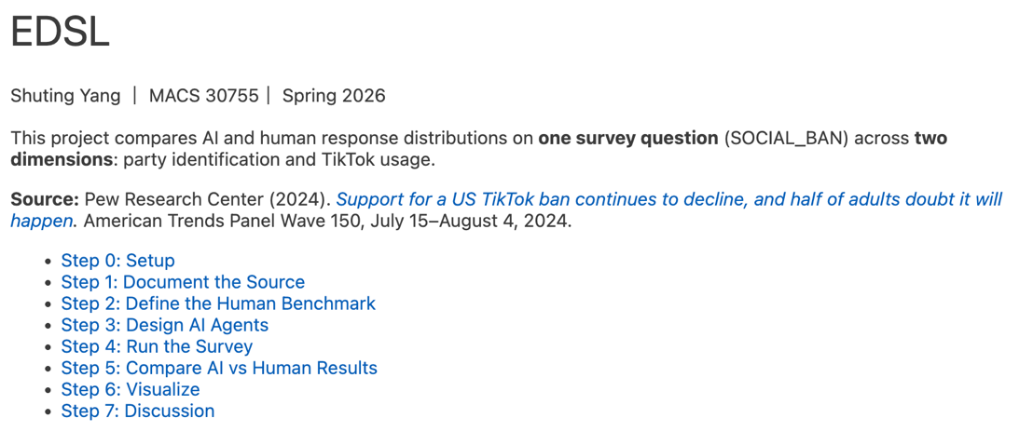
B. Figures
[Include your comparative visualizations here. Each figure should have a caption describing what it shows.]
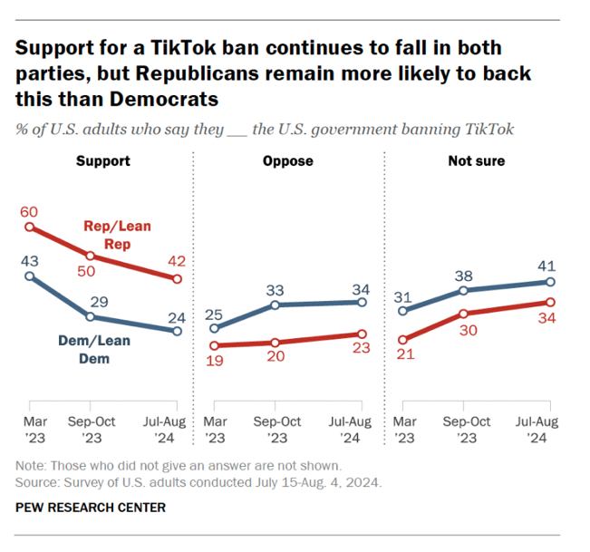
Figure 1. Support for a TikTok ban by party Figure 2. Support for a TikTok ban by TikTok usage
Note: Benchmark values used in this replication are from the Jul-Aug 2024 time point only.

Figure 3. Percentage of respondents supporting a U.S. TikTok ban: AI-simulated responses (GPT-4o, n=5 per agent) vs. human responses (Pew Research Center, 2024, n=10,658), by party identification (left panel) and by TikTok usage (right panel). MAE = mean absolute error in percentage points.

C. Summary Statistics
[Include any summary statistics tables or additional quantitative comparisons here.]

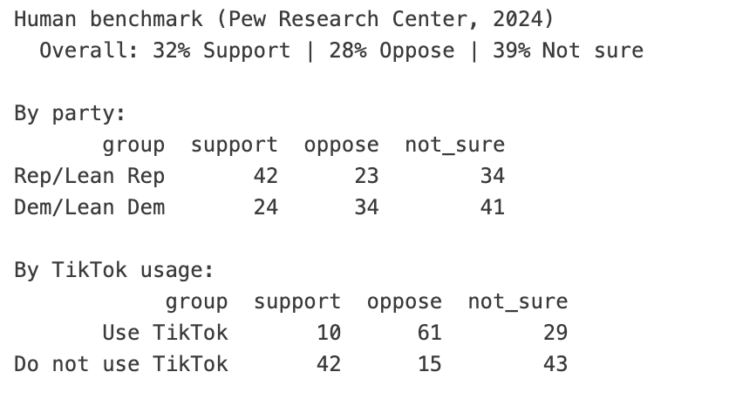
Table 1. Human benchmark from Pew Research Center (2024), % support/oppose/not sure by party and TikTok usage.

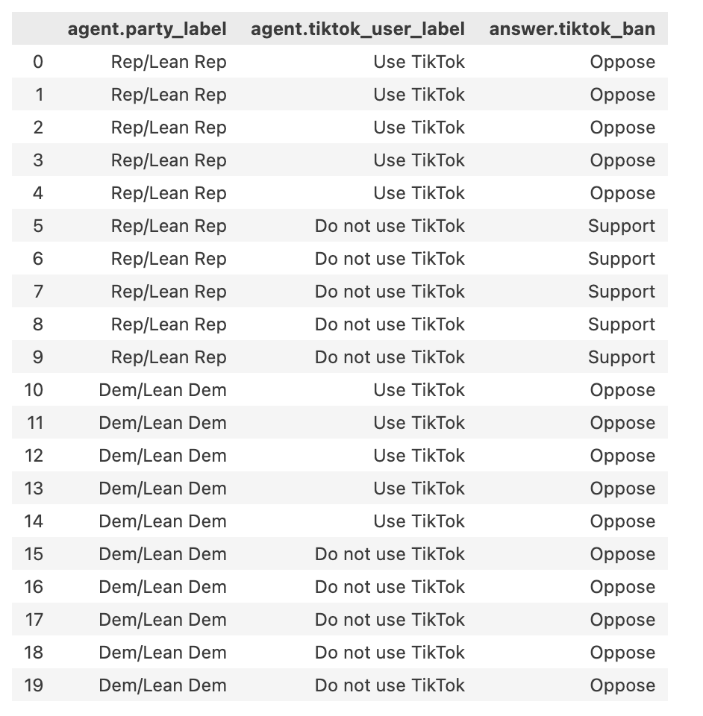
Table 2. Raw GPT-4o responses across 4 agents × 5 runs (20 total).

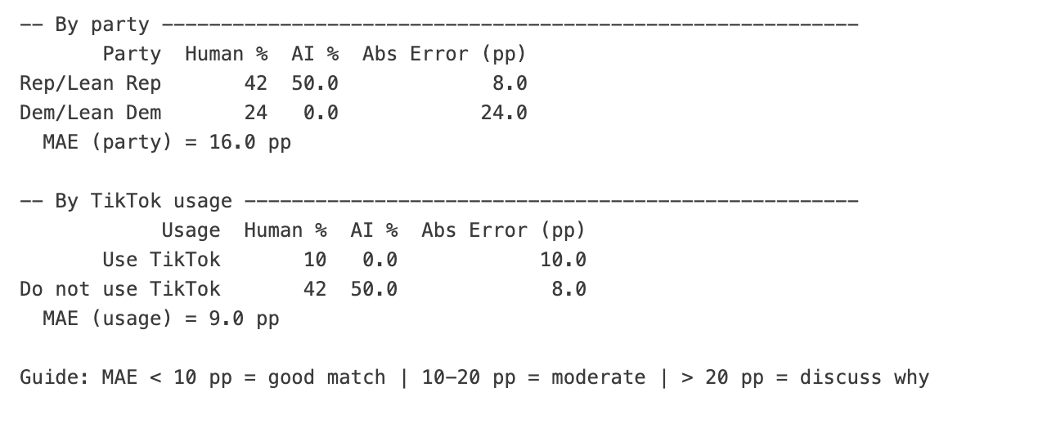
Table 3. AI vs. human support rates for a U.S. TikTok ban, by party and TikTok usage. MAE = 16.0 pp by party (moderate); MAE = 9.0 pp by usage (good match).

Evaluation Criteria
Your report will be evaluated on:
• Data source selection: Did you choose a reputable survey with clear demographic breakdowns and identify specific questions suitable for replication? [4pts]
• Persona construction: Are the AI agent personas well-justified and mapped thoughtfully to the human sample demographics? [4pts]
• Analysis quality: Are the comparisons clear, well-visualized, and supported by appropriate summary statistics? [4pts]
• Critical reflection: Does the discussion demonstrate thoughtful engagement with the strengths and limitations of AI-generated survey data? [4pts]
• Reproducibility: Is the code or workflow documented clearly enough that a classmate could replicate the analysis? [2pts]
• Writing quality: Is the memo concise, well-organized, and within the suggested word limits? [2pts]

Suggested Data Sources
You may use any reputable published survey, but here are some good starting points:
• Pew Research Center (pewresearch.org): Extensive demographic breakdowns on politics, technology, social trends
• Gallup (gallup.com): Polling on social issues, economics, well-being
• General Social Survey / GSS (gss.norc.org): Long-running survey on American attitudes and behaviors
• American National Election Studies / ANES (electionstudies.org): Political attitudes and voting behavior
• World Values Survey (worldvaluessurvey.org): Cross-national data on beliefs and values
Choose a survey with clearly reported demographic breakdowns and publicly available question wording so you can accurately construct AI agent personas.

