**Plot histogram for Tencent:**

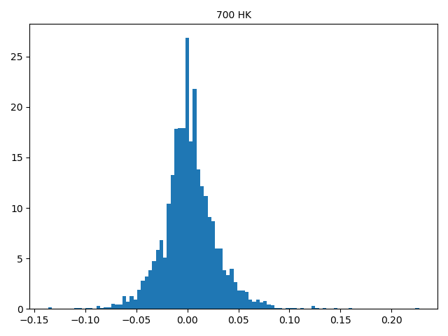

**Perform a normal test and plot histogram for p value:**

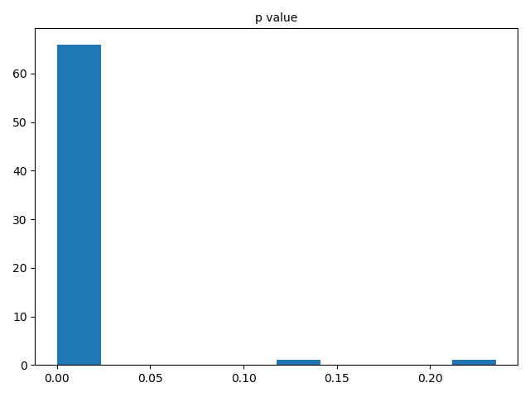

From the figure above, it is obvious to see the constituents’ return **are not** normal distributed, which is reasonable because in the reality, if the distribution of stock return is normal, than there will be no arbitrage and no one will trade anymore.

**Perform an autocorrelation test and plot histogram together for each group of p-values under different lag value:**

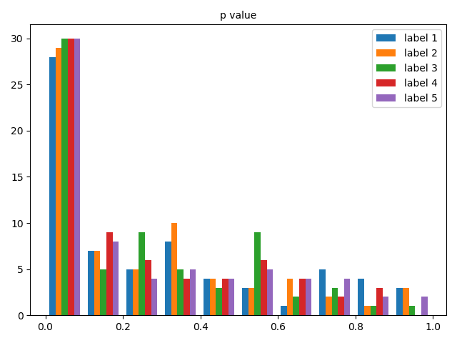

**Especially, when lag equals to five, the histogram of p-value should be:**

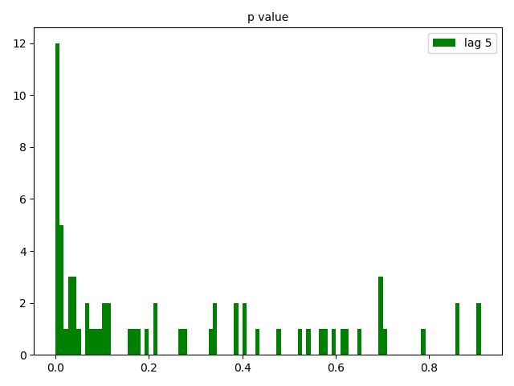

According to the figure above, we can conclude that the constituents’ returns **are not** exhibiting zero serial correlation across lags.