Supplementary Materials for
GraphSC: Deep Graph Learning with Spectral Clustering for Flexible Gene Co-Expression Module Detection across Pan-Cancer
This file contains:
Supplementary figures
Figure. S1 MES scores of GraphSC using different edge construction parameters.
Supplementary tables
Table S1. Statistical significance of MES differences between GraphSC and benchmark methods across eight TCGA datasets.
Table S2. Statistical significance of MES differences between GraphSC with and without the graph attention mechanism.
Table S3. Statistical significance of MES differences between spectral clustering and alternative clustering algorithms across eight TCGA datasets.
Table S4. Comparison of MES scores using different cluster centers in GraphSC.
Table S5. Comparison of MES scores using different information in the MES loss of GraphSC.
Supplementary figures
Figure. S1 MES scores of GraphSC using different edge construction parameters.
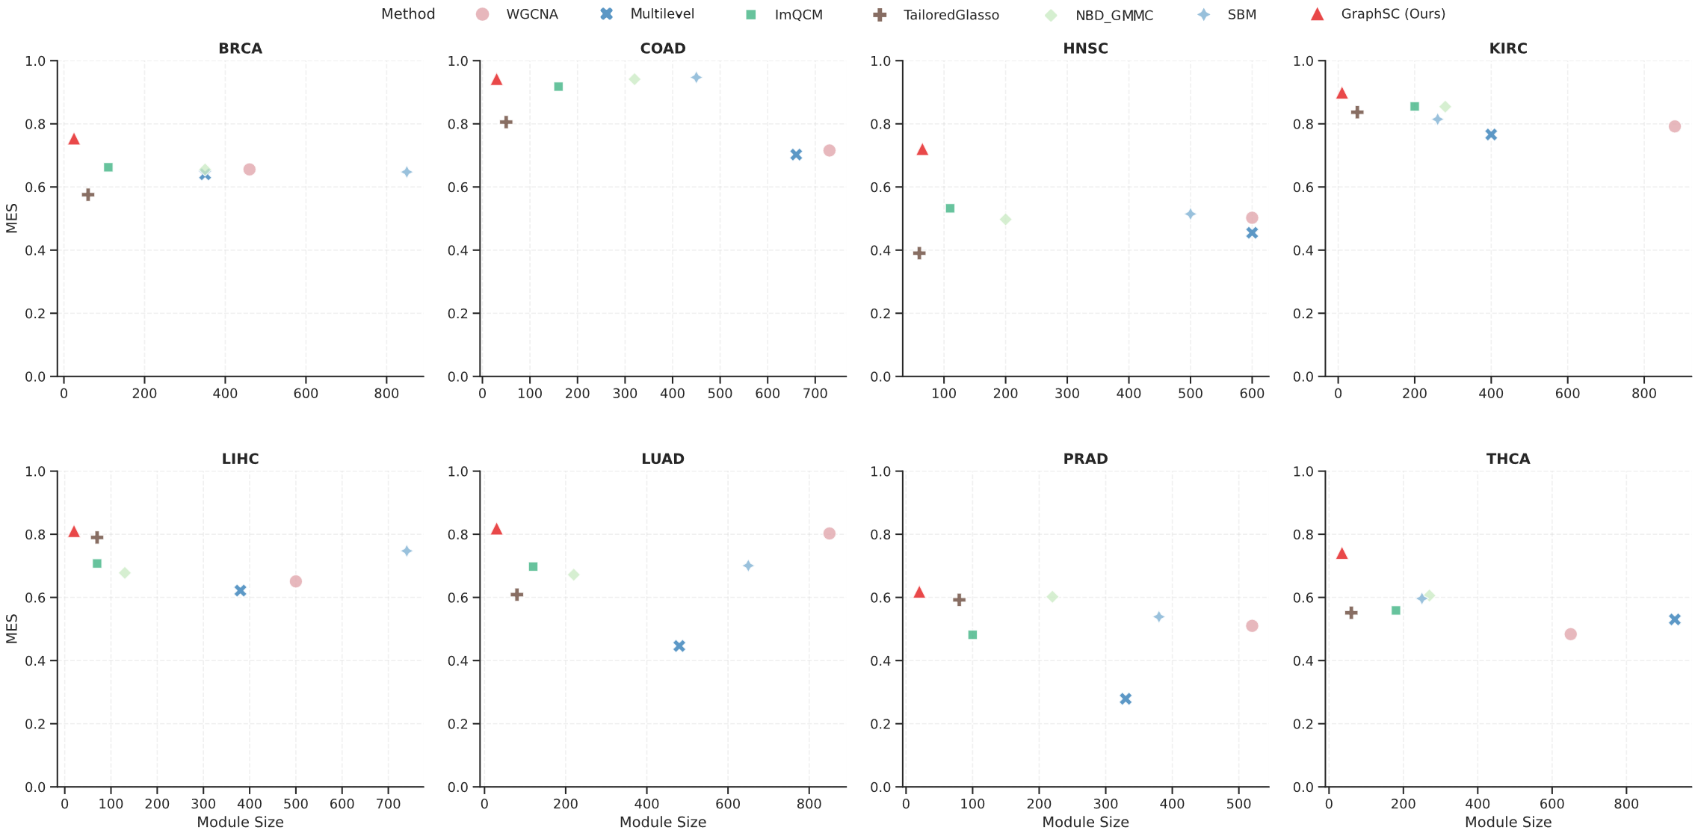
Supplementary tables
Table S1. Statistical significance of MES differences between GraphSC and benchmark methods across eight TCGA datasets.
Dataset | WGCNA | Multilevel | ImQCM | TailoredGlasso | NBD-GMMC | SBM
BRCA | 0.074 | 0.001 | 0.001 | 0.001 | 0.001 | 0.005
COAD | 0.001 | 0.001 | 0.001 | 0.001 | 0.006 | 0.007
HNSC | 0.062 | 0.022 | 0.001 | 0.001 | 0.001 | 0.007
KIRC | 0.001 | 0.160 | 0.001 | 0.086 | 0.080 | 0.080
LIHC | 0.001 | 0.018 | 0.001 | 0.001 | 0.082 | 0.024
LUAD | 0.001 | 0.001 | 0.001 | 0.001 | 0.001 | 0.012
PRAD | 0.016 | 0.016 | 0.326 | 0.001 | 0.156 | 0.023
THCA | 0.010 | 0.001 | 0.001 | 0.054 | 0.034 | 0.026
Note: Values represent two-sided P values obtained from paired bootstrap tests comparing the MES of GraphSC with each benchmark method. P < 0.05 indicates a statistically significant difference, with significant P values highlighted in bold.

Table S2. Statistical significance of MES differences between GraphSC with and without the graph attention mechanism.
Dataset | BRCA | COAD | HNSC | KIRC | LIHC | LUAD | PRAD | THCA
P value | 0.0669 | 0.0142 | 0.0845 | 0.0212 | 0.0327 | 0.0365 | 0.0774 | 0.0489
Note: P values are obtained from paired bootstrap tests comparing GraphSC with and without the graph attention mechanism. Statistically significant P values (P < 0.05) are highlighted in bold.
Table S3. Statistical significance of MES differences between spectral clustering and alternative clustering algorithms across eight TCGA datasets.
Dataset | GMMC | Agglo | KMeans | BIRCH | DBSCAN
BRCA | 0.0355 | 0.0292 | 0.0290 | 0.0002 | 0.0680
COAD | 0.0400 | 0.0992 | 0.0774 | 0.0002 | 0.0002
HNSC | 0.0008 | 0.0008 | 0.0045 | 0.0002 | < 0.0001
KIRC | 0.0505 | 0.0452 | 0.0621 | 0.0002 | < 0.0001
LIHC | 0.0026 | 0.0001 | 0.0002 | 0.0002 | 0.0002
LUAD | 0.0062 | 0.0082 | 0.0109 | 0.0002 | < 0.0001
PRAD | 0.0270 | 0.0054 | 0.0050 | 0.0004 | 0.0022
THCA | 0.0072 | 0.0063 | 0.0029 | 0.0002 | < 0.0001
Note: P values are obtained from paired bootstrap tests comparing spectral clustering with each alternative clustering algorithm. Statistically significant P values (P < 0.05) are highlighted in bold.
Table S4. Comparison of MES scores using different cluster centers in GraphSC.
Dataset | 0.5K | 0.75K | K | 1.25K | 1.5K
BRCA | 0.7329 | 0.7491 | 0.7540 | 0.7506 | 0.7146
COAD | 0.9112 | 0.9209 | 0.9425 | 0.9154 | 0.9105
HNSC | 0.7145 | 0.7156 | 0.7208 | 0.7163 | 0.7103
KIRC | 0.8629 | 0.8721 | 0.8994 | 0.8749 | 0.8720
LIHC | 0.7940 | 0.7989 | 0.8107 | 0.8029 | 0.7916
LUAD | 0.8042 | 0.7990 | 0.8188 | 0.8190 | 0.8037
PRAD | 0.5996 | 0.6060 | 0.6187 | 0.6046 | 0.5916
THCA | 0.7439 | 0.7350 | 0.7415 | 0.7518 | 0.7400

Table S5. Comparison of MES scores using different information in the MES loss of GraphSC.
Dataset | labels | labels + OS | labels + OS.time | labels + OS + OS.time
BRCA | 0.7540 | 0.7535 | 0.7470 | 0.7503
COAD | 0.9425 | 0.9572 | 0.9429 | 0.9558
HNSC | 0.7208 | 0.7135 | 0.7074 | 0.7028
KIRC | 0.8994 | 0.8952 | 0.8817 | 0.8853
LIHC | 0.8107 | 0.7743 | 0.8208 | 0.8004
LUAD | 0.8188 | 0.7799 | 0.7861 | 0.7939
PRAD | 0.6187 | 0.6101 | 0.6240 | 0.6191
THCA | 0.7415 | 0.7535 | 0.7676 | 0.7665

