**Problem**

Seattle has a reputation for having a lot of rain. Therefore, we want to determine whether or not it rains more in Seattle compared to a city such as St. Louis.

**Data + Analysis**

We gathered data from the NOAA National Centers for Environmental Information website and searched for precipitation data from the years of 2018 -2022 for both Seattle and St. Louis. With that data, there were some missing pieces of precipitation data, so they were inferred based on the precipitation of the same day on other years.

**Results**

Looking at the overall statistics of the two cities, we can see that the mean precipitation of Seattle is about 0.11 inches of rain per day, while the mean precipitation of St. Louis is about 0.13 inches of rain per day. However, most of this is because both of the cities have many days without rain, as shown below:

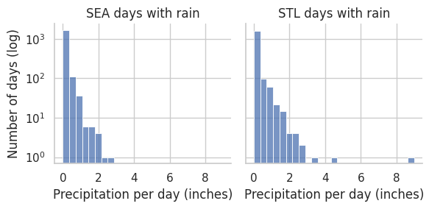

There were also some days that had significantly more rain than the average. For example, it rained over 8 inches for a day in July 2022 in St. Louis.

Because of this, we also looked at the distribution of days per month that had rain, as shown below:

Based on this, we can come to a few conclusions:

* Seattle has many more rainy days that St. Louis. Additionally, those rainy days seem to be concentrated primarily in the fall and winter months – in the summer months, the number of rainy days per month in Seattle tends to be about the same as in St. Louis.
* Additionally, St. Louis has a consistent number of rainy days each month, and each month has rain on less than half of the total days.

Finally, we also looked at another measure of raininess: how much rain there is when it does rain. We took the median rainfall for each month for days where it rained:

This shows that when it rains in St. Louis, it rains significantly harder than when it rains in Seattle. This is especially true in the summer months. This also explains the mean precipitation being about equivalent despite St. Louis having fewer rainy days than Seattle.

**Conclusion**

Most people would consider Seattle to be rainier than St. Louis, because most people consider the number of days in which it rains to be more representative of the general raininess of a place. The average amount of rain in each place is about the same, and St. Louis has much more rain than Seattle does when it does rain.