Clinical Pharmacology Assessment
CYB003 Blood-Pressure Exposure–Response: Time-Matched Concentration vs Cₘₐₓ
Study CYB003-101 (exploratory PK/PD) — Draft v0.1

1. Bottom Line
Two exposure–response views of the same Day-8 data point in opposite directions. Against time-matched CYB003 concentration (within-subject), ΔΔSBP and ΔΔDBP rise steeply and significantly with drug level. Against individual Cₘₐₓ (between-subject), the relationship is flat and non-significant (slightly negative for SBP, slightly positive for DBP). This is not a contradiction: the two analyses estimate different parameters. The within-subject relationship is the valid basis for an exposure–response characterization; the between-subject Cₘₐₓ regression is uninformative over a single-dose exposure range and must not be read as “no effect.” CYB003 has a real, transient, concentration-linked pressor effect (≈ +20/+11 mmHg SBP/DBP at geometric-mean Cₘₐₓ), which should be carried forward as a within-subject, reference-corrected concentration–response and confirmed across doses.

2. The Two Analyses
Endpoint is the reference-corrected change ΔΔ = (Day 8 change-from-baseline) − (Day 1 change-from-baseline), time-matched by participant and nominal timepoint. Day 1 (CYP probes alone, no CYB003) is the within-subject time-matched control, removing circadian drift and the probe cocktail's own hemodynamic effects (notably metoprolol). Models are linear mixed-effects with a random intercept; slopes carry 90% CI. n = 33 participants.
Contrast | Exposure variable | SBP slope (90% CI) | DBP slope (90% CI)
Within-subject | Time-matched conc. (ng/mL) | +1.14 (+0.93, +1.36) | +0.67 (+0.52, +0.81)
Between-subject | Individual Cₘₐₓ (ng/mL) | −0.31 (n.s.) | +0.28 (n.s.)
Table 1. Slopes (mmHg per ng/mL). Within-subject = ΔΔ vs time-matched concentration; between-subject = subject-level ΔΔ vs individual Cₘₐₓ. Predicted ΔΔ at geometric-mean Cₘₐₓ (26.9 ng/mL): SBP +20.4 (16.5, 24.3), DBP +11.1 (8.8, 13.5) mmHg.
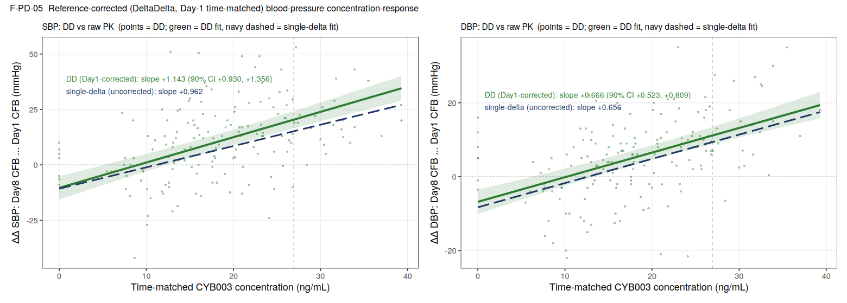
Figure 1. ΔΔ SBP and DBP vs time-matched CYB003 concentration (within-subject). Green = reference-corrected fit; navy dashed = uncorrected single-Δ fit. The positive slope persists — and steepens for SBP — after Day-1 correction, so it is not circadian.
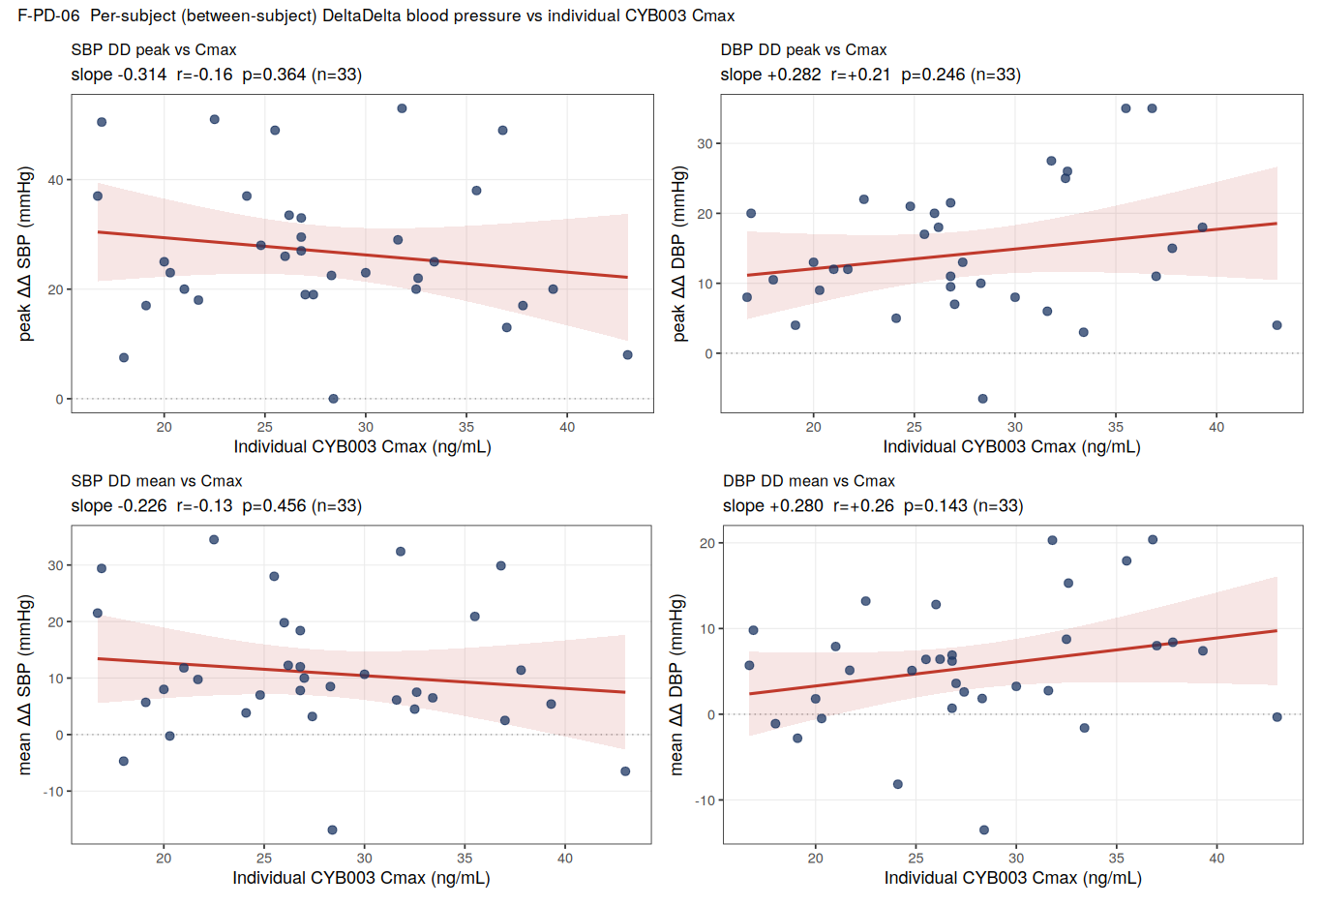
Figure 2. Subject-level ΔΔ (peak and mean) vs individual Cₘₐₓ (between-subject). No significant gradient for either endpoint; SBP slightly negative, DBP slightly positive.

3. Why the Trends Are Opposite
A within/between decomposition (a single model with concentration split into each subject's own fluctuation and their mean level) shows the effect lives almost entirely in the within-subject dimension:
Endpoint | Within-subject slope (90% CI) | Between-subject slope (90% CI)
SBP | +1.25 (+1.02, +1.47) | +0.16 (−0.47, +0.79)
DBP | +0.71 (+0.56, +0.86) | +0.38 (−0.01, +0.77)
Table 2. Within- vs between-subject slopes from one decomposition model (mmHg per ng/mL). The within slope is precise and clearly positive; the between slope is imprecise and indistinguishable from zero.
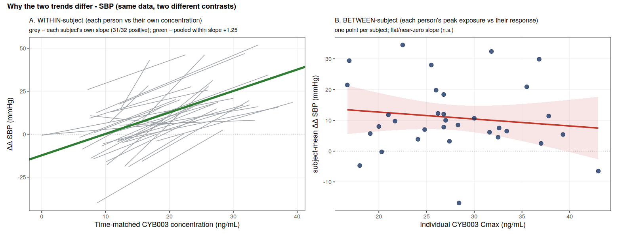
Figure 3. Same SBP data, two contrasts. A: each participant vs their own concentration — 31/32 individual slopes positive. B: each participant's peak exposure vs their response — flat.
Three reasons the within-subject relationship is strong and the between-subject one is not:
- Exposure leverage. Within a participant, concentration sweeps the full 0 → Cₘₐₓ → 0 profile. Across participants, Cₘₐₓ spans only ~17–43 ng/mL (2.6-fold) at a single 16 mg dose — little between-subject range to detect a slope.
- Noise structure. The within-subject contrast cancels every stable personal trait (baseline BP, autonomic tone, body size, the probe-cocktail effect, anticipatory rise) because each participant is their own control. The between-subject contrast is dominated by exactly those inter-individual differences — they are the scatter in Figure 2 — which swamp the modest exposure effect and widen the CI roughly four-fold.
- Cₘₐₓ is a weak proxy. A single peak value does not represent the time-integrated exposure each participant's BP actually tracks; individual AUC performs no better here.
The opposite signs (SBP negative, DBP positive) are simply noise around zero, not a physiological signal — both between-subject slopes are non-significant with CIs spanning zero.

4. Recommendation: Which to Carry into a Dose–Response
Use the within-subject, time-matched, reference-corrected (ΔΔ) concentration–response as the primary exposure–response model. It isolates the drug effect, uses the full exposure range, controls stable inter-individual confounders, is estimated with high precision, and is mechanistically interpretable (BP follows the concentration–time course).
Do not use the between-subject Cₘₐₓ regression to define or to dismiss the relationship. Over a single-dose, narrow-Cₘₐₓ range it is underpowered and confounded; its near-zero, sign-unstable slope is the expected result and carries no evidence against a drug effect. Reserve between-subject exposure metrics for when multiple dose levels widen the exposure range.
Distinguish exposure–response from dose–response. This single-dose study yields an exposure–response slope, not a dose–response curve. Build the dose–response by linking dose → exposure (population PK) → effect (the within-subject C-R), then project the expected BP change across the intended therapeutic dose range. Confirm the exposure-dependence directly using the program's other dose levels (e.g., MAD / therapeutic-dose cohorts) before finalizing.

5. Clinical Pharmacology Approach
- Model. Linear ΔΔ concentration–response with random intercept (and random slope if supported); the Day-1 period serves as the placebo/time-matched control (ΔΔ), analogous to the concentration–QTc paradigm. Test an Eₘₐₓ form if higher-dose data show curvature.
- Report within/between explicitly (decomposition), rather than a single pooled concentration term, so the effect is not diluted or misread.
- Hysteresis. SBP/DBP track concentration directly (minimal delay), so a direct-effect model is appropriate; pulse lags Cₘₐₓ and, if modeled, needs an effect-compartment (kₑ₀).
- Covariates. Screen baseline BP, body size, and age on the C-R, interpreting cautiously given healthy young males, n ≈ 33.
- Confirm and translate. Verify exposure-dependence across doses; project peak and time-course BP at therapeutic exposures; evaluate orthostatic change and duration (peak ~2 h, resolution by 8–12 h). Recommend protocolized BP monitoring over the Tₘₐₓ window and consider serial/ambulatory BP in future studies.

6. Message to Convey
- CYB003 produces a real, transient, concentration-linked increase in blood pressure — BP rises and falls with drug level, reproducibly across nearly all participants (31/32).
- The effect is pharmacologic, not an artifact: it survives placebo/time (Day-1) correction, so it is not circadian or attributable to the probe cocktail.
- Magnitude at 16 mg: ≈ +20/+11 mmHg (SBP/DBP) at peak concentration, transient (peak ~2 h, resolving by 8–12 h).
- Peak exposure (Cₘₐₓ) does not identify who responds most over this narrow single-dose range; flat Cₘₐₓ plots are an expected statistical feature and must not be presented as evidence of no effect.
- The exposure–response is characterized within-subject and will be confirmed and dose-projected via population PK and additional dose levels; BP is a monitorable, time-limited effect consistent with the supervised dosing setting, pending confirmation at therapeutic doses.

7. Limitations
Single 16 mg dose (narrow exposure range; exposure–response, not dose–response); healthy adult males, n ≈ 33; CYP probe cocktail co-administered (mitigated by ΔΔ correction); within-subject concentration and time are partly collinear (mitigated by, and robust to, the Day-1 reference correction); parent CYB003 only, no active metabolite in the dataset; exploratory analysis without multiplicity adjustment.

