PK/PD ANALYSIS REPORT
Exploratory Exposure-Response Analysis of CYB003 on Blood Pressure, Heart Rate, and Hallucination
Study CYB003-101
A Phase 1, Open-Label, Two-Period, Fixed-Sequence Drug-Drug Interaction Study of CYB003 with a CYP Probe Cocktail in Healthy Adult Male Participants
Item | Detail
Compound | CYB003 (deuterated psilocybin analog)
Analysis type | Exploratory pharmacokinetic/pharmacodynamic (PK/PD) exposure-response
Data source | ADaM datasets (ADSL, ADPC, ADPP, ADVS, ADAE)
Report version / date | Draft v0.3 / 09 September 2026
Prepared by | Tairan Yang
Status | Draft for internal review

List of Tables
Table | Title
Table 1 | Participant Disposition and Analysis Populations
Table 2 | Analysis Dataset Composition
Table 3 | Number of Participants with Data by Nominal Timepoint
Table 4 | Linear Mixed-Effects Model Estimates: ΔΔ Blood Pressure versus CYB003 Concentration
Table 5 | Between-Subject Regression of Participant-Level ΔΔ Blood Pressure on Individual Cₘₐₓ
Table 6 | Within-Subject and Between-Subject Slope Estimates for ΔΔ Blood Pressure
Table 7 | Linear Mixed-Effects Model Estimates: ΔΔ Pulse Rate versus CYB003 Concentration
Table 8 | Hallucination/Perceptual Adverse Events: Incidence and Timing
Table 9 | Hallucination Exposure-Response Analyses

List of Figures
Figure | Title
Figure 1 | ΔΔ SBP and ΔΔ DBP versus Time-Matched CYB003 Concentration
Figure 2 | Participant-Level Peak and Mean ΔΔ SBP and DBP versus Individual CYB003 Cₘₐₓ
Figure 3 | Within-Subject versus Between-Subject Concentration-ΔΔ SBP Relationships
Figure 4 | ΔΔ Pulse Rate versus CYB003 Concentration and Time-Ordered Mean Effect versus Mean Concentration
Figure 5 | Hallucination Episodes Recalibrated to Time of CYB003 Dose
Figure 6 | Hallucination Onset, Duration, and Resolution by Preferred Term and Severity
Figure 7 | Hallucination Exposure-Response
Figure 8 | Participant 01-033: Day 8 Blood Pressure and CYB003 Concentration-Time Profile

List of Abbreviations
Abbreviation | Definition
ADaM | Analysis Data Model
AE / TEAE | Adverse event / treatment-emergent adverse event
AUC₀₋∞ | Area under the plasma concentration-time curve from time zero extrapolated to infinity
BP | Blood pressure
CI | Confidence interval
Cₘₐₓ | Maximum observed plasma concentration
CSR | Clinical Study Report
CYP | Cytochrome P450
DBP / SBP | Diastolic / systolic blood pressure
DDI | Drug-drug interaction
Δ / ΔΔ | Change from baseline / reference-corrected change (Day 8 Δ minus Day 1 Δ)
E-R | Exposure-response
IQR | Interquartile range
LME | Linear mixed-effects
MedDRA | Medical Dictionary for Regulatory Activities
NCA | Non-compartmental analysis
OLS | Ordinary least squares
OR | Odds ratio
PD / PK | Pharmacodynamic / pharmacokinetic
REML | Restricted maximum likelihood
t_{½} | Terminal elimination half-life
T_{ₘₐₓ} | Time of maximum observed plasma concentration

1. Introduction
CYB003 is a deuterated psilocybin analog under development for the treatment of major depressive disorder. Study CYB003-101 was a Phase 1, open-label, two-period, fixed-sequence drug-drug interaction (DDI) study in healthy adult male participants designed to evaluate the effect of a single 16 mg oral dose of CYB003 on the pharmacokinetics of a six-probe cytochrome P450 (CYP) cocktail. Participants received the probe cocktail alone on Day 1 (Period 1) and the cocktail co-administered with CYB003 on Day 8 (Period 2) following a 7-day washout.
In addition to the primary DDI objective, serial CYB003 plasma concentrations were collected concurrently with serial vital signs and adverse event (AE) data. These data permit characterization of the exposure-response (E-R) relationships for the on-target pharmacodynamic (PD) effects of CYB003. The primary pharmacokinetic (PK) and DDI analyses are reported in the Clinical Study Report (CSR, Section 11); the present report describes the exploratory PK/PD analyses that support the PK/PD section of the CSR. Period 1 (probe cocktail alone) serves as a within-subject, time-matched reference for the hemodynamic endpoints.

2. Objectives
The objectives of this analysis were:
- To characterize the E-R relationship between CYB003 plasma concentration and reference-corrected change in supine systolic (SBP) and diastolic (DBP) blood pressure.
- To characterize the E-R relationship between CYB003 plasma concentration and reference-corrected change in supine pulse rate, including a graphical assessment of hysteresis.
- To characterize the relationship between CYB003 exposure and the incidence, probability, and duration of hallucination/perceptual AEs.
- To evaluate and contrast within-subject (time-matched concentration) and between-subject (individual Cₘₐₓ) exposure dependence.

3. Data

3.1 Source Data and Analysis Populations
Analyses were based on the ADaM datasets ADSL (disposition and demographics), ADPC (CYB003 plasma concentrations), ADPP (CYB003 non-compartmental PK parameters), ADVS (vital signs), and ADAE (adverse events). The Safety Population, defined as all participants who received at least one dose of any study intervention (n = 36), was used for all E-R analyses. Thirty-four participants received CYB003 on Day 8, of whom 33 had evaluable CYB003 PK parameters (Cₘₐₓ, AUC₀₋∞, and terminal t½). Participant disposition is summarized in Table 1.
Table 1. Participant Disposition and Analysis Populations
Population | N
Safety Population (≥ 1 dose of any study intervention) | 36
Dosed in Period 1 (probe cocktail alone, Day 1) | 36
Dosed in Period 2 (CYB003 16 mg + probe cocktail, Day 8) | 34
PK Population | 35
DDI PK Population | 33
Completed study | 34
Evaluable CYB003 PK parameters (Cₘₐₓ, AUC₀₋∞, t½) | 33

3.2 Data Handling
- Timepoint matching. Exposure and response records were matched on the nominal post-dose hour derived from the analysis timepoint label (ATPT). The numeric timepoint code (ATPTN) was not used for matching because it is not harmonized across ADaM domains (actual hours in ADPC; ordinal index in ADVS).
- Duplicate records. Where more than one record existed for the same participant, parameter, period, and nominal time (e.g., repeat or unscheduled measurements), values were averaged prior to analysis.
- Reference correction. Hemodynamic responses were analyzed as the reference-corrected change, ΔΔ = (Day 8 change from baseline) − (Day 1 change from baseline) at the same nominal time, where baseline is the pre-dose value of the respective period. This correction removes circadian variation and the intrinsic hemodynamic effects of the probe cocktail.
- Concentrations. Pre-dose (0 h) CYB003 concentrations were set to 0 ng/mL and retained as the zero-concentration reference. Post-dose concentrations below the lower limit of quantification were handled according to the CSR PK conventions.
- Missing data. Records lacking either the concentration or the response at a matched timepoint were excluded from the corresponding analysis. No imputation was performed.
- Adverse events. Hallucination/perceptual events were identified by MedDRA preferred term (hallucination; hallucination, visual; hallucination, auditory; hallucination, tactile; somatic hallucination; illusion; visual processing disorder). Event onset and resolution date-times were expressed relative to the Day 8 CYB003 dosing date-time.

3.3 Analysis Datasets
The composition of the analysis datasets and the number of participants contributing data at each nominal timepoint are summarized in Table 2 and Table 3, respectively.
Table 2. Analysis Dataset Composition
Analysis | Observations | Participants | Nominal timepoints (h)
ΔΔ SBP/DBP versus concentration | 222 | 34 | 0, 1, 2, 4, 6, 8, 12, 24
ΔΔ pulse rate versus concentration | 222 | 34 | 0, 1, 2, 4, 6, 8, 12, 24
Probability of active hallucination versus concentration | 390 | 34 | All PK sampling times, 0-48
Between-subject (participant-level versus Cₘₐₓ) | 33 | 33 | —
Hallucination episodes (timing and duration) | 47 episodes | 30 | —
Table 3. Number of Participants with Data by Nominal Timepoint (Day 8 unless noted)
Hour | CYB003 concentration | SBP/DBP (Day 1 / Day 8)
0 (pre-dose) | 34 | 36 / 34
1 | 34 | 36 / 33
2 | 34 | 36 / 31
3 | 33 | —
4 | 31 | 36 / 30
6 | 33 | 36 / 34
8 | 34 | 36 / 34
12 | 34 | 36 / 34
16 | 33 | —
24 | 34 | 36 / 34
48 | 34 | —
The smaller numbers of Day 8 vital-sign observations at 2-4 h (30-31) coincide with the highest concentrations.

4. Methods

4.1 Software
Analyses were performed in R version 4.3.3 (nlme 3.1 for mixed-effects models; ggplot2 for graphics). Fixed-effect estimates agreed to three decimal places between implementations.

4.2 Exposure Metrics
Two exposure metrics were used. First, the time-matched CYB003 plasma concentration at each response timepoint was used for within-subject E-R analyses; this metric spans each participant’s full concentration range from 0 ng/mL through Cₘₐₓ to elimination. Second, individual summary exposure metrics from non-compartmental analysis (Cₘₐₓ, AUC₀₋∞, and terminal t½) were used for between-subject E-R analyses. The geometric mean Cₘₐₓ (26.9 ng/mL) and the maximum observed Cₘₐₓ (43.0 ng/mL) were used as reference exposures for model predictions.

4.3 Pharmacodynamic Endpoints
- Hemodynamic endpoints: supine SBP, DBP, and pulse rate (ADVS), analyzed as ΔΔ (Section 3.2).
- Hallucination endpoints: (a) incidence of any hallucination/perceptual AE; (b) active-episode status at each PK sampling time, defined as the nominal time falling within an episode’s onset-resolution interval; and (c) episode duration, per-participant total window (first onset to last resolution), onset time, and resolution time.

4.4 Statistical Analysis

4.4.1 Within-Subject Concentration-Response (Continuous Endpoints)
For each continuous endpoint, a linear mixed-effects (LME) model was fitted by restricted maximum likelihood (REML):
Yᵢⱼ = (β₀ + ηᵢ) + β₁·(Cᵢⱼ − C̄) + εᵢⱼ
where Yᵢⱼ is the response for participant i at timepoint j, Cᵢⱼ is the time-matched CYB003 concentration, C̄ is the overall mean concentration (used for centering to improve numerical stability), ηᵢ ~ N(0, ω²) is a participant-specific random intercept, and εᵢⱼ ~ N(0, σ²) is the residual error. The slope β₁ and the model-predicted response at the geometric mean and maximum Cₘₐₓ are presented with two-sided 90% confidence intervals (CIs) derived from the fixed-effect variance-covariance matrix (delta method). A participant-specific random slope was evaluated and not retained because it did not improve model fit. Linearity of the concentration-response relationship was assessed by comparison of the fitted line with observed means by concentration quantile.

4.4.2 Between-Subject Exposure-Response
Participant-level summary responses (peak and mean ΔΔ) were regressed on individual Cₘₐₓ by ordinary least squares (OLS); Pearson correlation coefficients (r) and p-values are presented. Individual AUC₀₋∞ was evaluated as an alternative exposure metric.

4.4.3 Separate Estimation of Within-Subject and Between-Subject Slopes
To estimate the within-subject and between-subject slopes separately within a single model, two concentration terms were included as fixed effects: each participant’s mean concentration, which reflects differences in exposure between participants, and the difference between each observation and that participant’s mean, which reflects changes in exposure within a participant over time. In addition, an individual concentration-response slope was estimated by OLS for each participant with at least four matched observations and non-constant concentration, and the number of participants with a positive slope was tabulated.

4.4.4 Assessment of Hysteresis
A possible delay between concentration and effect (hysteresis) was assessed graphically by plotting the mean effect against the mean concentration at each nominal timepoint and connecting the points in time order. A wide counter-clockwise loop indicates that the effect lags the concentration, whereas a narrow loop with the peak effect occurring near the peak concentration indicates no appreciable delay. This assessment was exploratory and descriptive; no delayed-effect (effect-compartment) model was fitted, and such modeling would be considered only if the graphical assessment indicated a meaningful delay.

4.4.5 Hallucination
Incidence was analyzed by logistic regression on individual Cₘₐₓ and AUC₀₋∞. The probability of an active episode at each PK sampling time was analyzed by logistic regression on the time-matched concentration (pooled across participants; odds ratio per 10 ng/mL presented), and the model-predicted probability was evaluated at 0 ng/mL and at the geometric mean Cₘₐₓ. The relationship between exposure and duration was evaluated by Spearman rank correlation and OLS regression of the longest episode duration and the per-participant total window on Cₘₐₓ, AUC₀₋∞, and terminal t½. Episode onset, duration, and resolution were summarized descriptively (median and IQR) overall and by preferred term and severity.

4.5 Model Evaluation and Sensitivity Analyses
Model adequacy was assessed by visual inspection of fitted lines and 90% confidence bands against the observed data and against observed means by concentration quantile; by comparison of reference-corrected (ΔΔ) and baseline-corrected (single Δ) fits; by evaluation of optimizer sensitivity (estimates for ΔΔ endpoints were robust across optimizers); and by independent reproduction of the estimates in a second software implementation (Section 4.1). All analyses were exploratory and no adjustment for multiplicity was applied.

5. Results

5.1 Blood Pressure

5.1.1 Within-Subject Concentration-Response
Reference-corrected SBP and DBP increased with time-matched CYB003 concentration (Table 4, Figure 1). The positive slope persisted after Day 1 reference correction and, for SBP, was steeper than the baseline-corrected (single Δ) slope, indicating a concentration-dependent effect that is not attributable to circadian variation or to the probe cocktail.
Table 4. Linear Mixed-Effects Model Estimates: ΔΔ Blood Pressure versus CYB003 Concentration
Endpoint | Parameter | Estimate | 90% CI | p-value
ΔΔ SBP | Slope (mmHg per ng/mL) | 1.03 | 0.88, 1.17 | < 0.001
 | Predicted ΔΔ at Cₘₐₓ 26.9 ng/mL (mmHg) | 24.8 | 21.0, 28.5 | —
 | Predicted ΔΔ at Cₘₐₓ 43.0 ng/mL (mmHg) | 41.3 | — | —
 | Baseline-corrected (single Δ) slope, for reference | 0.91 | 0.78, 1.05 | < 0.001
ΔΔ DBP | Slope (mmHg per ng/mL) | 0.57 | 0.47, 0.66 | < 0.001
 | Predicted ΔΔ at Cₘₐₓ 26.9 ng/mL (mmHg) | 13.6 | 11.2, 15.9 | —
 | Baseline-corrected (single Δ) slope, for reference | 0.65 | 0.56, 0.75 | < 0.001
N = 222 observations from 34 participants. REML estimation; participant-specific random intercept; concentration centered at the overall mean. CIs by the delta method.
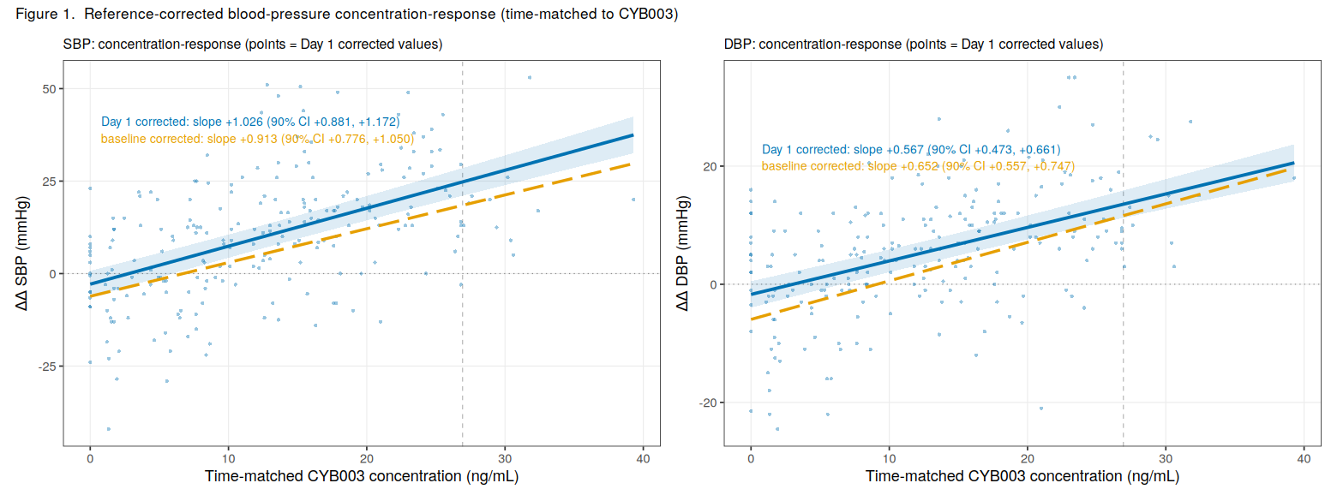
Figure 1. ΔΔ SBP (left) and ΔΔ DBP (right) versus Time-Matched CYB003 Concentration
Points: individual ΔΔ observations. Solid line and shaded band: Day 1 reference-corrected LME fit with 90% CI. Dashed line: baseline-corrected (single Δ) fit. Vertical dashed line: geometric mean Cₘₐₓ.

5.1.2 Between-Subject Exposure-Response
No statistically significant relationship was identified between individual Cₘₐₓ and participant-level peak or mean ΔΔ for either SBP or DBP (Table 5, Figure 2). Point estimates were of opposite sign for the two endpoints and all confidence intervals included zero. Results using individual AUC₀₋∞ were similar.
Table 5. Between-Subject Regression of Participant-Level ΔΔ Blood Pressure on Individual Cₘₐₓ
Endpoint | Response summary | Slope (mmHg per ng/mL) | r | p-value | N
ΔΔ SBP | Peak | −0.30 | −0.16 | 0.37 | 33
 | Mean | −0.21 | −0.12 | 0.50 | 33
ΔΔ DBP | Peak | 0.29 | 0.23 | 0.20 | 33
 | Mean | 0.25 | 0.23 | 0.19 | 33
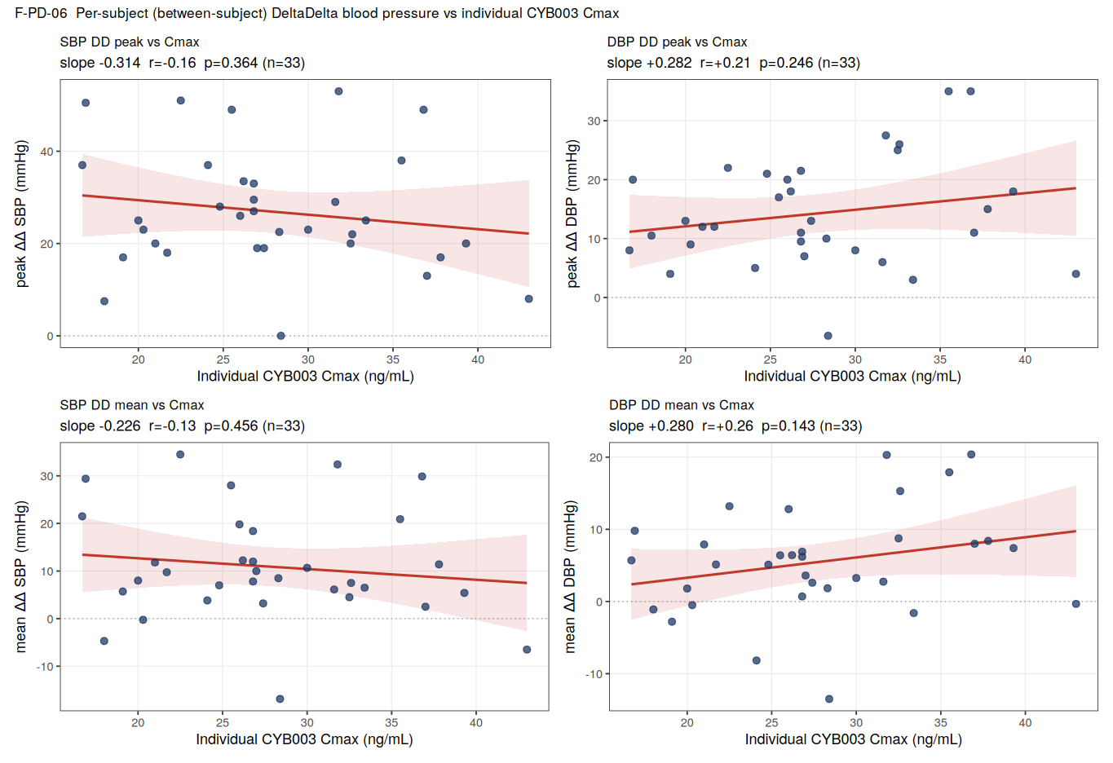
Figure 2. Participant-Level Peak and Mean ΔΔ SBP and DBP versus Individual CYB003 Cₘₐₓ

5.1.3 Within-Subject and Between-Subject Slopes
When the within-subject and between-subject slopes were estimated separately in a single model (Table 6), the E-R relationship was confined to the within-subject slope, which was precisely estimated and clearly positive; the between-subject slope was imprecise, with a confidence interval including zero. Of the 33 participants with an estimable individual slope, 31 (SBP) and 30 (DBP) had a positive slope (Figure 3).
Table 6. Within-Subject and Between-Subject Slope Estimates for ΔΔ Blood Pressure versus CYB003 Concentration
Endpoint | Slope component | Slope (mmHg per ng/mL) | 90% CI | Participants with slope > 0
ΔΔ SBP | Within-subject | 1.03 | 0.88, 1.18 | 31 / 33
 | Between-subject | 0.16 | −0.47, 0.79 | —
ΔΔ DBP | Within-subject | 0.56 | 0.46, 0.66 | 30 / 33
 | Between-subject | 0.38 | −0.01, 0.77 | —
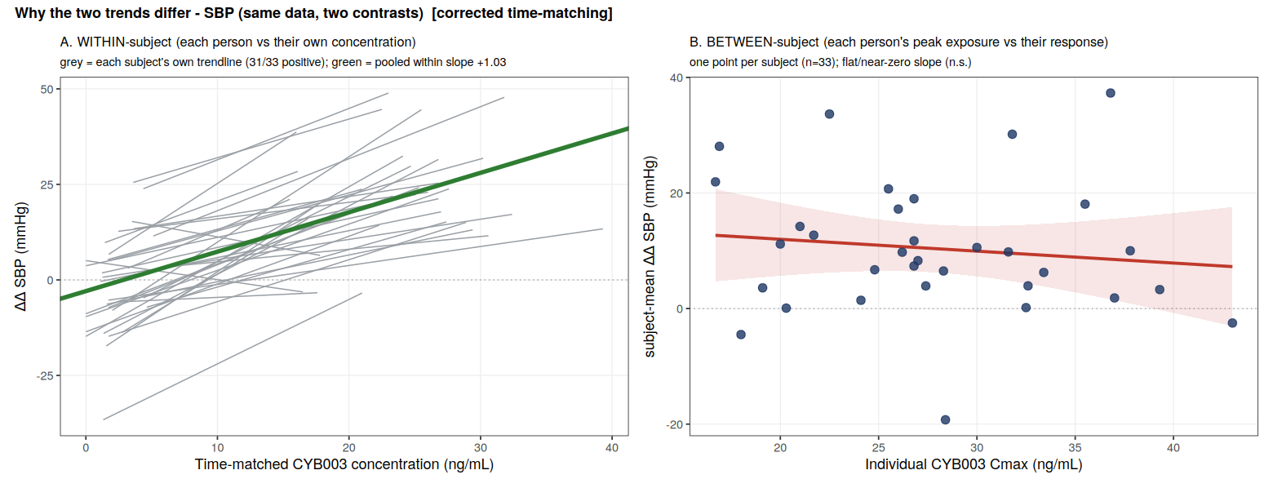
Figure 3. Within-Subject (A) versus Between-Subject (B) Concentration-ΔΔ SBP Relationships
A: grey lines are individual participant OLS fits (5-8 observations each); green line is the pooled within-subject slope. B: one point per participant (mean ΔΔ versus Cₘₐₓ) with OLS fit and 90% CI.

5.2 Heart Rate
Reference-corrected pulse rate increased with CYB003 concentration (Table 7, Figure 4A). Because the Day 1 reference correction accounts for the negative chronotropic effect of the probe cocktail (metoprolol), the ΔΔ slope exceeded the baseline-corrected slope. The between-subject relationship with Cₘₐₓ was not statistically significant. The time-ordered plot of mean effect versus mean concentration showed a narrow loop with the peak effect occurring near the peak concentration (Figure 4B), indicating no appreciable delay between concentration and effect; delayed-effect modeling was therefore not pursued.
Table 7. Linear Mixed-Effects Model Estimates: ΔΔ Pulse Rate versus CYB003 Concentration
Parameter | Estimate | 90% CI | p-value
Within-subject slope (bpm per ng/mL) | 0.53 | 0.40, 0.65 | < 0.001
Predicted ΔΔ at Cₘₐₓ 26.9 ng/mL (bpm) | 13.8 | 10.5, 17.1 | —
Predicted ΔΔ at Cₘₐₓ 43.0 ng/mL (bpm) | 22.3 | — | —
Observed peak mean ΔΔ (bpm), 4 h | 14.8 | — | —
Between-subject slope, mean ΔΔ versus Cₘₐₓ (bpm per ng/mL; r = −0.13) | −0.19 | — | 0.46
N = 222 observations from 34 participants (within-subject); 33 participants (between-subject).
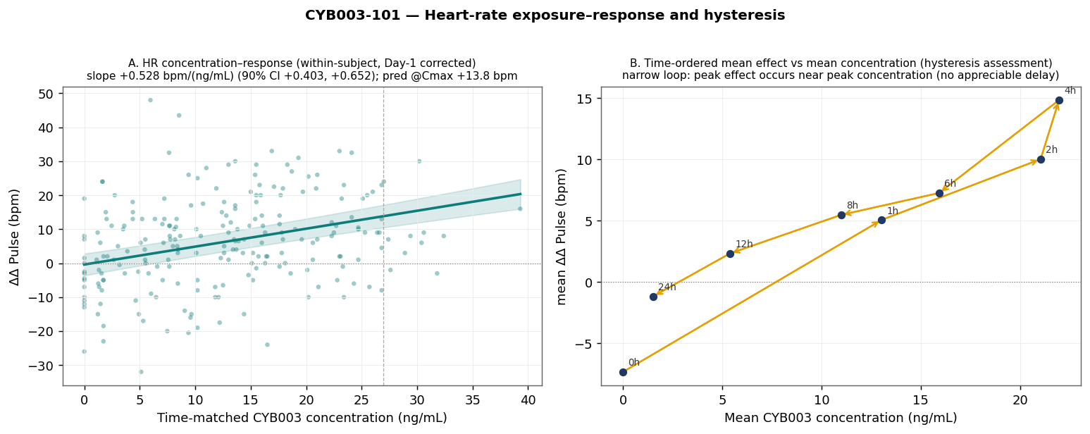
Figure 4. ΔΔ Pulse Rate versus Time-Matched CYB003 Concentration (A) and Time-Ordered Mean Effect versus Mean Concentration (B)

5.3 Hallucination

5.3.1 Incidence, Timing, and Severity
Hallucination/perceptual AEs were reported by 30 of 34 participants dosed with CYB003 (88%), comprising 47 episodes; the most frequent preferred term was ‘Hallucination, visual’ (24 episodes in 24 participants). Onset was early and episodes were transient and self-limiting (Table 8, Figure 5, Figure 6). All events were mild or moderate in severity and resolved without intervention.
Table 8. Hallucination/Perceptual Adverse Events: Incidence and Timing Relative to CYB003 Dose
Parameter | Value
Participants with ≥ 1 event, n (%) | 30 / 34 (88%)
Episodes, n | 47
Hallucination, visual: episodes, n (participants) | 24 (24)
Onset, h post-dose, median (IQR) | 1.02 (0.65, 1.36)
Episode duration, h, median (IQR) | 4.78 (3.46, 5.80)
Resolution, h post-dose, median (IQR) | 5.83 (4.83, 6.84); maximum 11.3
Per-participant total window, h, median | 5.4
Severity, n: mild / moderate / severe | 43 / 4 / 0
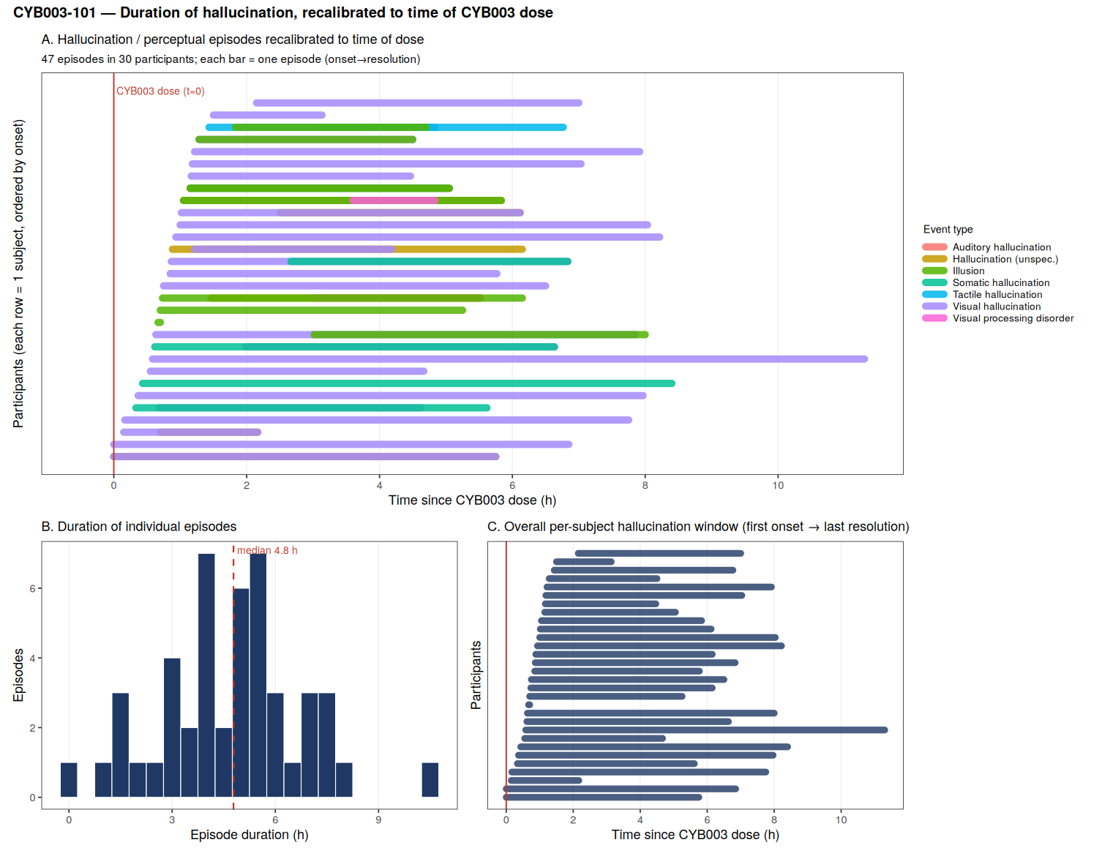
Figure 5. Hallucination Episodes Recalibrated to Time of CYB003 Dose: Episode Timelines (A), Episode Duration Distribution (B), and Per-Participant Windows (C)
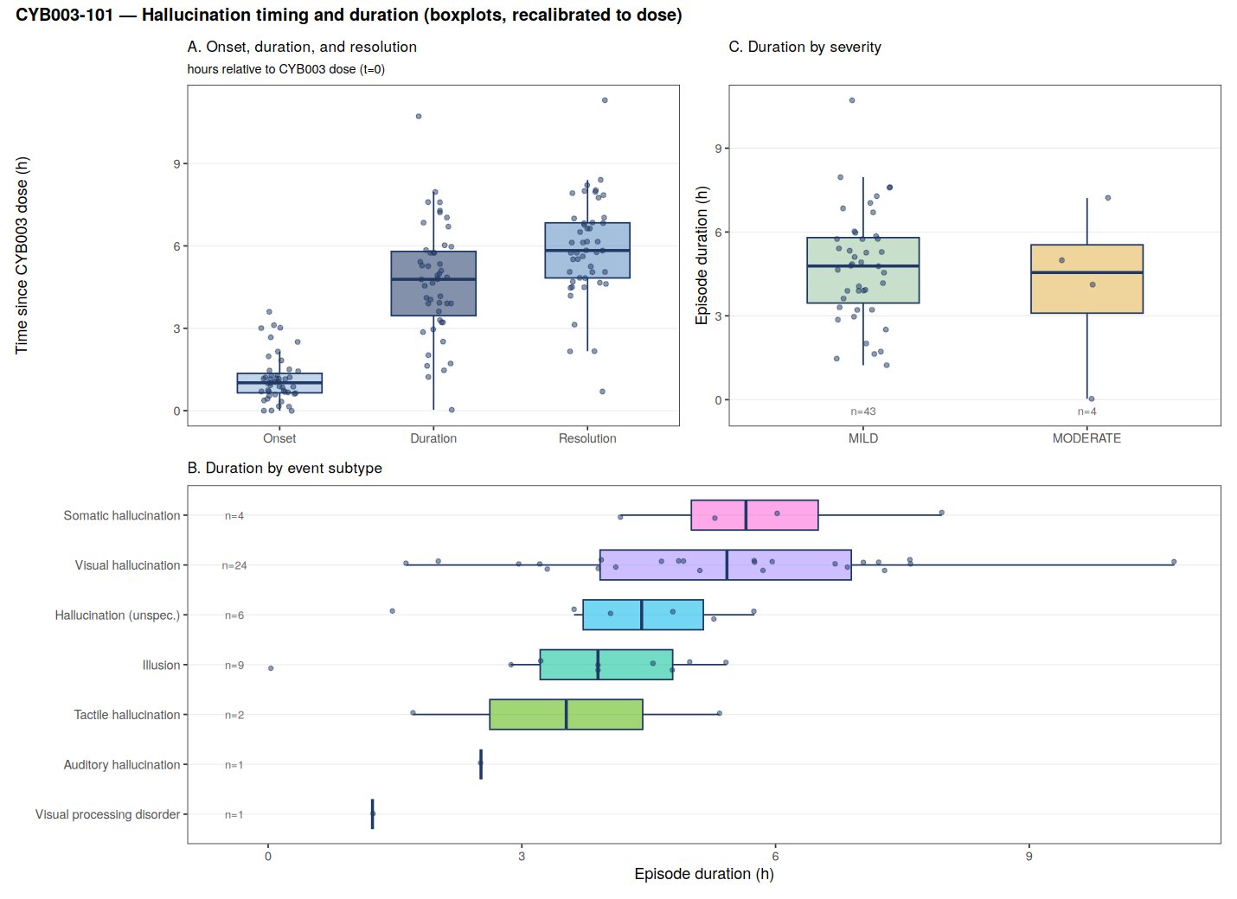
Figure 6. Hallucination Onset, Duration, and Resolution (A), Duration by Preferred Term (B), and Duration by Severity (C)

5.3.2 Exposure-Response
Incidence was not significantly related to individual Cₘₐₓ or AUC₀₋∞, consistent with the near-universal occurrence of events at the studied dose. In contrast, the probability of an active episode at a given time increased steeply with time-matched concentration, and the prevalence of active hallucination over time followed the mean concentration-time profile. The duration of the perceptual experience was associated with terminal t½ but not with Cₘₐₓ or AUC₀₋∞ (Table 9, Figure 7).
Table 9. Hallucination Exposure-Response Analyses
Analysis | Estimate | p-value | N
Probability of active episode versus time-matched concentration, OR per 10 ng/mL | 5.65 | < 0.001 | 390
Predicted probability of active episode: 0 ng/mL → Cₘₐₓ 26.9 ng/mL | 0.07 → 0.89 | — | —
Total window versus terminal t_{½}, Spearman ρ | 0.40 | 0.031 | 29
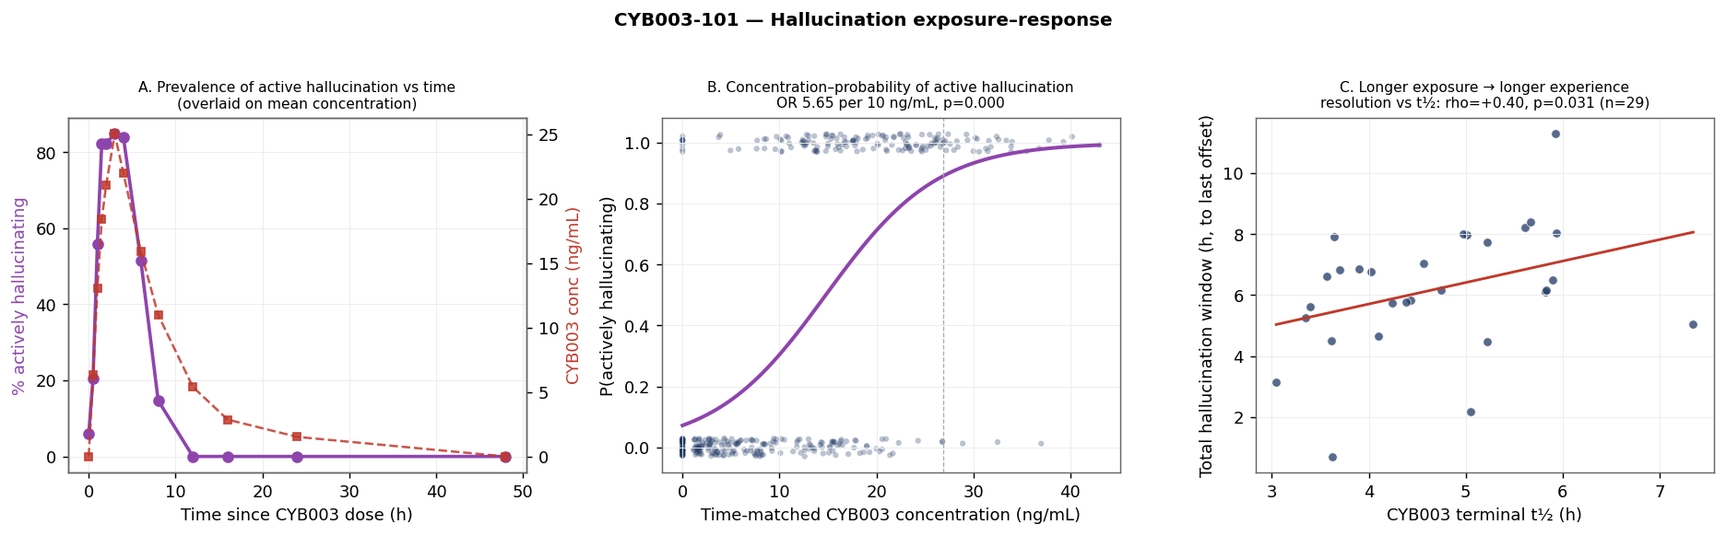
Figure 7. Prevalence of Active Hallucination versus Time with Mean Concentration Overlay (A), Concentration-Probability of Active Hallucination (B), and Total Hallucination Window versus Terminal t½ (C)

5.4 Illustrative Individual Profile
Participant 01-033 (55-year-old male, 63.1 kg) experienced the longest visual hallucination in the study (10.7 h; mild; resolved without intervention). The participant’s Cₘₐₓ (26.8 ng/mL) was close to the population geometric mean, whereas Tₘₐₓ (4.0 h) was later than the population median (approximately 2.9 h) and terminal t½ (5.9 h) was longer than the population mean (approximately 4.5 h), consistent with more sustained exposure. Concurrent hemodynamic changes (SBP +28 mmHg and DBP +11 mmHg near Tₘₐₓ, returning to baseline by 24 h) followed the exposure profile; on Day 1 (probe cocktail alone), blood pressure was essentially unchanged. This profile illustrates, at the individual level, the within-subject E-R relationship and the association between prolonged elimination and prolonged perceptual effect (Figure 8).
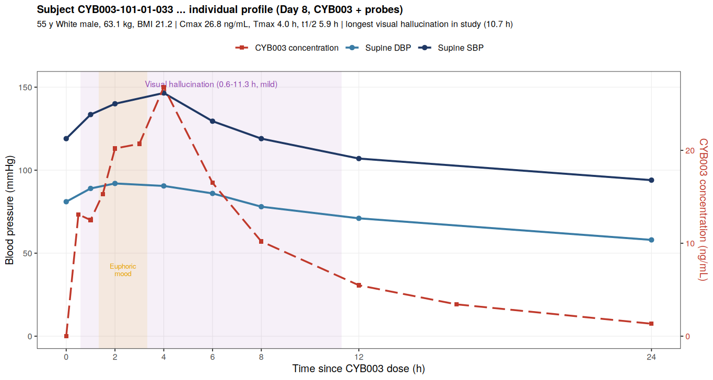
Figure 8. Participant 01-033: Day 8 Blood Pressure and CYB003 Concentration-Time Profile with Adverse Event Windows

6. Discussion
Following a single 16 mg dose, CYB003 produced concentration-dependent PD effects comprising a pressor response (SBP and DBP), a positive chronotropic response, and a perceptual (hallucinogenic) effect, each following the plasma concentration-time course.
A consistent feature across the hemodynamic endpoints was the apparent inconsistency between the within-subject and between-subject E-R relationships: the within-subject concentration-response was precisely estimated and clearly positive (31 of 33 individual SBP slopes positive), whereas the between-subject relationship with individual Cₘₐₓ was flat and imprecise. Three factors account for this difference.
First, the two analyses differ in the contrast in exposure available to detect a slope. Within a participant, concentration traverses the complete profile from 0 ng/mL through Cₘₐₓ and back toward zero during elimination, providing a wide span over which the response can be related to concentration. Between participants, exposure varies only to the extent that individual Cₘₐₓ values differ, which at a single 16 mg dose spanned approximately 2.6-fold; this limited spread provides little ability to detect a between-subject slope.
Second, the two analyses are subject to different sources of variability. In the within-subject analysis each participant serves as their own control, so that stable inter-individual differences (in baseline blood pressure, body size, autonomic tone, and response to the study procedures) do not enter the residual variance. The between-subject analysis compares participants with one another, and these same inter-individual differences become the dominant source of variability, obscuring any modest exposure-related component. This is reflected in the approximately four-fold wider confidence interval for the between-subject slope relative to the within-subject slope.
Third, the two analyses use different amounts of information. The within-subject analysis draws on 222 serial time-matched observations (5 to 8 per participant) that capture both the rise and the decline of the response in relation to concentration. The between-subject analysis reduces each participant to a single summary value, and a single peak concentration is an incomplete descriptor of the exposure profile to which the hemodynamic response relates; use of individual AUC₀₋∞ in place of Cₘₐₓ gave similar results.
Consequently, the absence of a between-subject relationship does not constitute evidence against a drug effect. The within-subject concentration-response, which uses the full exposure profile and is unaffected by stable inter-individual differences, is the appropriate basis for E-R characterization and for projection across doses.
The hallucination analyses indicated that the determinants of effect intensity and effect duration differ. The probability of active hallucination at a given time was strongly concentration-dependent (odds ratio 5.6 per 10 ng/mL), whereas the duration of the experience correlated with terminal t½ rather than with peak or total exposure. Participants with slower elimination of CYB003 experienced longer perceptual effects at comparable peak concentrations, as illustrated by participant 01-033. These findings suggest that the concentration attained primarily determines the magnitude and likelihood of the effect, whereas the rate of elimination determines its duration.
The Day 1 (probe cocktail alone) period served as a within-subject, time-matched reference for the hemodynamic endpoints, removing circadian variation and the intrinsic effects of the cocktail, notably metoprolol. The positive concentration-response slopes persisted after this correction and were steeper for SBP and pulse rate, supporting a drug-related rather than procedural origin. No appreciable hysteresis was observed for heart rate on exploratory time-ordered plots.
Limitations. The analysis is based on a single dose level (16 mg) and therefore characterizes exposure-response rather than dose-response; extrapolation to other doses requires linkage through population PK and confirmation with additional dose levels. The population comprised healthy adult males (n = 34). Within a single-dose profile, concentration and time are partially collinear; the reference correction mitigates but does not eliminate this. The hallucination endpoint is categorical (AE preferred term) with no continuous measure of intensity; logistic models were pooled across participants without a random effect given the exploratory scope. Some Day 8 vital-sign observations at 2-4 h (the highest concentrations) were missing. Only parent CYB003 was quantified. All analyses were exploratory and unadjusted for multiplicity.

7. Conclusions
- A single 16 mg oral dose of CYB003 produced transient, concentration-dependent increases in supine blood pressure (model-predicted ΔΔ SBP +24.8 mmHg and ΔΔ DBP +13.6 mmHg at the geometric mean Cₘₐₓ) and pulse rate (+13.8 bpm), which resolved with drug elimination.
- Hallucination/perceptual AEs occurred in 88% of participants. The probability of an active episode increased steeply with concentration (odds ratio 5.6 per 10 ng/mL), and the duration of the experience was associated with terminal t_{½} rather than with peak or total exposure.
- E-R relationships were evident within-subject but not between-subject over the narrow single-dose Cₘₐₓ range; the within-subject concentration-response is the appropriate basis for characterization and dose projection.
- The findings are exploratory. The hemodynamic and perceptual effects were transient and resolved within the observation period. Confirmation of the exposure-response relationships across dose levels is recommended.

