Exploratory PK/PD (Exposure–Response) Analysis
Study CYB003-101
Results memo to populate the CSR “PK/PD Analysis” section — Draft v0.1

1. Summary
Day 8 CYB003 plasma concentrations were time-matched to vital-sign and 12-lead ECG changes from pre-dose and analyzed by linear mixed-effects concentration–response (C-R) models (random intercept per participant), with a supportive per-subject analysis of individual peak response versus individual Cₘₐₓ. CYB003 geometric-mean Cₘₐₓ was 26.9 ng/mL (max 43.0).
- Blood pressure: a clear positive concentration–response. Predicted ΔSBP at geometric-mean Cₘₐₓ was +16.15 mmHg (+13.39, +18.90) and ΔDBP +10.09 mmHg (+8.55, +11.63); observed peak mean rises were +18 and +11 mmHg at ~2 h.
- Pulse: a smaller, delayed rise (predicted +5.65 bpm at GM Cₘₐₓ); the effect peaks at 4–6 h, after CYB003 Tₘₐₓ (~2.9 h) — i.e., counter-clockwise hysteresis (Figure F-PD-03).
- QTcF: no prolongation signal. The C-QTc slope was slightly negative (-0.469 ms per ng/mL) and predicted ΔQTcF at geometric-mean Cₘₐₓ was -6.47 ms (-9.87, -3.07); the entire prediction lies below the 10 ms threshold. PR and QRS showed no meaningful relationship.
- Caveat: the positive BP/HR slopes reflect a within-subject temporal association; because concentration and time are collinear in a single-dose profile, they cannot be cleanly separated from time-related (circadian/procedural) effects. Consistent with this, individual Cₘₐₓ did not predict individual peak response (all between-subject r ≈ 0, p > 0.3).

2. Methods
- Population / period: Safety Population, Day 8 (CYB003 + probe cocktail) only.
- Exposure: CYB003 plasma concentration (ADPC, PARAMCD = CYB003), matched to each response by participant and nominal timepoint.
- Response: change from Day 8 pre-dose (ADaM CHG) for supine SBP/DBP/pulse (ADVS) and QTcF/PR/QRS (ADEG).
- Model: linear mixed-effects, CHG ~ concentration with a per-participant random intercept (REML); predictor centered for numerical stability. Slopes and predictions reported with two-sided 90% CI. Predicted Δ evaluated at geometric-mean and maximum CYB003 Cₘₐₓ.
- Supportive: OLS of individual peak |Δ| against individual CYB003 Cₘₐₓ/AUC (ADPP). Diagnostic: observed mean Δ vs time overlaid on concentration (hysteresis).
Software: R 4.3.3 (nlme for mixed-effects models, ggplot2 for figures). This is an exploratory analysis; estimates are descriptive and not adjusted for multiplicity.

3. Vital-Sign Concentration–Response (Primary)
Endpoint | n | Slope /ng·mL⁻¹ (90% CI) | Pred. Δ at GM Cₘₐₓ (90% CI) | Obs. peak mean | ρ
Δ Supine SBP (mmHg) | 203 | +0.977 (+0.79, +1.17) | +16.15 (+13.39, +18.90) | +18.20 | +0.50
Δ Supine DBP (mmHg) | 203 | +0.685 (+0.56, +0.81) | +10.09 (+8.55, +11.63) | +11.00 | +0.60
Δ Supine Pulse (bpm) | 203 | +0.320 (+0.17, +0.47) | +5.65 (+3.42, +7.87) | +8.40 | +0.24
Table T-PD-01. Vital-sign concentration–response (Day 8). Slope = change per ng/mL CYB003; predictions at geometric-mean Cₘₐₓ = 26.9 ng/mL. Observed peak mean = largest mean change across nominal timepoints. ρ = Spearman (concentration vs Δ).
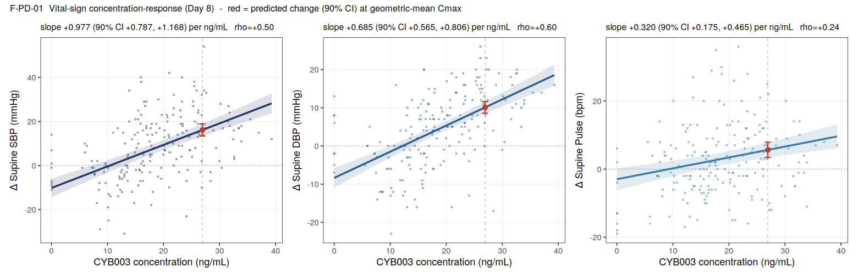
Figure F-PD-01. ΔSBP, ΔDBP, and Δpulse versus time-matched CYB003 concentration with mixed-model fit and 90% CI band. Red point = predicted Δ (90% CI) at geometric-mean Cₘₐₓ.
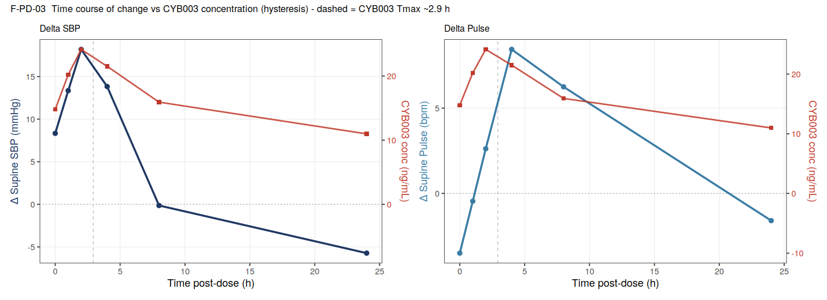
Figure F-PD-03. Time course of mean Δ-response (left axis) and mean CYB003 concentration (right axis). ΔSBP tracks concentration (direct effect); Δpulse peaks after CYB003 Tₘₐₓ (dashed line), indicating hysteresis.

4. Concentration–QTc and Conduction Intervals
Endpoint | n | Slope /ng·mL⁻¹ (90% CI) | Pred. Δ at GM Cₘₐₓ (90% CI) | Pred. Δ at max Cₘₐₓ (90% CI)
Δ QTcF (ms) | 94 | -0.469 (-0.76, -0.17) | -6.47 (-9.87, -3.07) | -14.00 (-20.97, -7.04)
Δ PR (ms) | 94 | -0.009 (-0.64, +0.63) | +1.45 (-4.35, +7.25) | +1.30 (-13.04, +15.64)
Δ QRS (ms) | 94 | +0.139 (+0.01, +0.26) | -0.49 (-1.77, +0.80) | +1.75 (-1.13, +4.63)
Table T-PD-02. Concentration–QTc and conduction-interval models (Day 8). The upper 90% CI of predicted ΔQTcF at both geometric-mean and maximum Cₘₐₓ remains below the 10 ms threshold of regulatory interest.
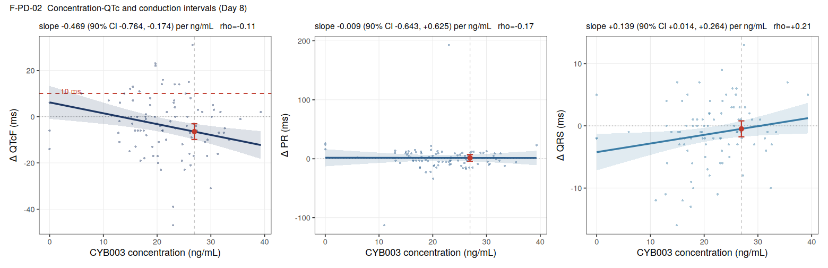
Figure F-PD-02. ΔQTcF, ΔPR, and ΔQRS versus CYB003 concentration with mixed-model fit and 90% CI. Dashed red line (left panel) = 10 ms threshold; red point = predicted Δ (90% CI) at geometric-mean Cₘₐₓ.

5. Supportive Per-Subject Exposure–Response
Individual peak response was regressed on individual CYB003 Cₘₐₓ across participants with evaluable CYB003 PK. In contrast to the within-subject C-R slopes, none of the between-subject relationships was significant, indicating that participants with higher peak CYB003 exposure did not show larger peak cardiovascular effects over the range studied.
Endpoint | n | Slope vs Cₘₐₓ | Pearson r | p-value
Δ Supine SBP (mmHg) | 33 | -0.421 | -0.13 | 0.458
Δ Supine DBP (mmHg) | 33 | +0.149 | +0.08 | 0.673
Δ Supine Pulse (bpm) | 33 | +0.440 | +0.18 | 0.304
Δ QTcF (ms) | 33 | -0.096 | -0.04 | 0.827
Table T-PD-03. Supportive per-subject exposure–response (individual peak response vs individual CYB003 Cₘₐₓ).
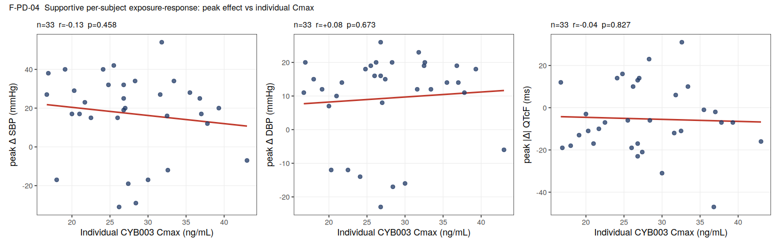
Figure F-PD-04. Individual peak response versus individual CYB003 Cₘₐₓ. Flat between-subject slopes support a time-related contribution to the within-subject C-R associations.

6. Interpretation and Limitations
- Cardiovascular effect is real but modest and transient. CYB003 16 mg was associated with a peak mean SBP/DBP rise of ~18/11 mmHg near 2 h and a delayed pulse rise of ~8 bpm at 4–6 h, resolving by 8–12 h — consistent with the CSR safety narrative, now quantified against exposure.
- Time–concentration confounding. In a single-dose serial design, concentration and elapsed time are collinear; late low-concentration timepoints fall below pre-dose (circadian recovery), which steepens the linear C-R slope. The slopes should be read as associations, not calibrated pharmacodynamic gains.
- Hysteresis for pulse. The pulse effect lags concentration (Figure F-PD-03); a direct-effect slope understates the peak. An effect-compartment or time-course model would be needed to characterize it properly.
- Between- vs within-subject discordance. Individual Cₘₐₓ did not predict individual peak response, reinforcing caution about a purely concentration-driven mechanism over this narrow exposure range.
- QTcF conclusion is robust. Both the slope and the predicted ΔQTcF (upper 90% CI < 10 ms at max Cₘₐₓ) indicate no QT prolongation, supporting — and quantifying — the CSR's categorical finding.
- Not analyzable: no continuous pharmacodynamic/efficacy endpoint is present in the ADaM (ADQS = C-SSRS only), so exposure vs psychedelic effect was not evaluated.

7. Conclusions
CYB003 16 mg produces a transient, exposure-associated rise in blood pressure (peak ~18/11 mmHg near 2 h) and a smaller, delayed rise in pulse, with no evidence of QTcF prolongation (predicted ΔQTcF below 10 ms across the observed concentration range). These exploratory exposure–response results populate the CSR “PK/PD Analysis” section and should be interpreted as descriptive associations given the single-dose, time-confounded design.

