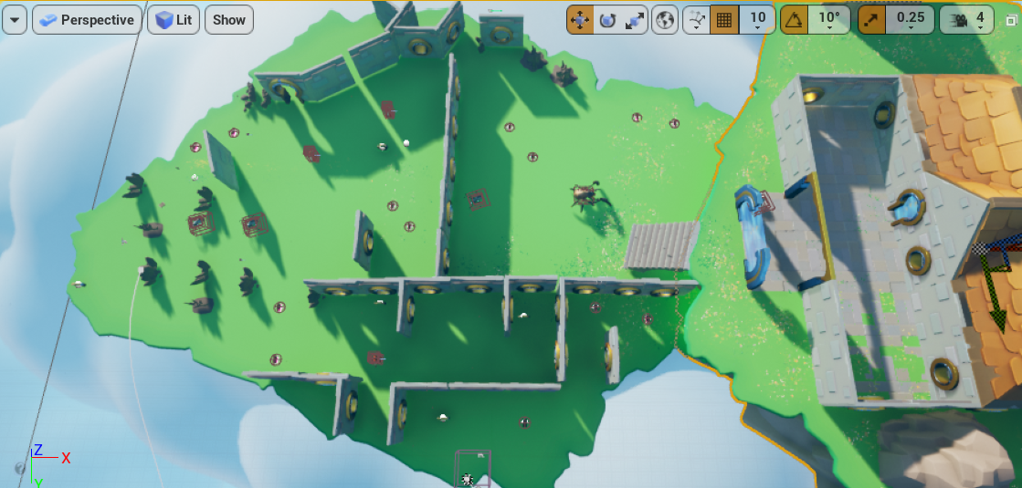

This is the entire view of my game. For the enemy design by myself (on the mid), since it can’t be destroyed and will create lava path which will not disappear, I only assign one this kind of enemy in case we can not pass the game. Also, to avoid it to be too simple, since it will randomly walk, I assign it a relatively big space to walk and that area is the only path to the final check point. In this way, that enemy is more like a final boss to pass. For the level design, you can see the above half is relatively sparser in terms of walls while the below half is denser. In the sparse area, I assign more enemy so the player can get experience playing with those enemy. However, most of the collectible items are not in that area, many of them are in the below half area. Hence, the player can not only try to play in an open area but also a closed area. But since I give a relatively long hit recover time, if the player doesn’t handle the enemies in the beginning well, the player will get a hard time in the below half area. It looks like many paths are leading to the cliff, but if the player explores carefully, they will find there are several collectible items which require them to carefully go through these paths facing the cliffs.