Observations:

1. Temperature is going up as the location moving away from latitude 0. Which is expected, the closer to the Equator, the hotter it gets. Both scatter plot and the linger regression plot for Max Temp vs Latitude prove this observation.

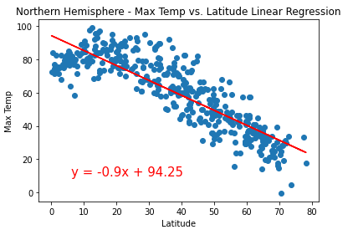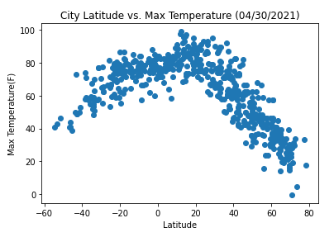 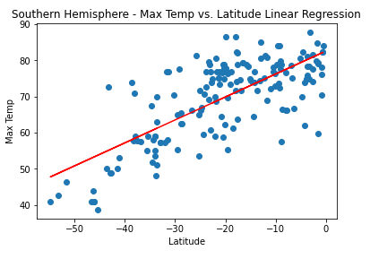

1. There no real correlation between wind speed, cloudiness, humidity with latitude regardness it is in northern hemisphere or southern hemisphere. The linear regression R values for these plots are all below 0.2 or greater than -0.2.
2. The heat map for humidity shows that coastal areas or islands have high humidity in general. Couple examples below:

