WenXin Yang

MMP460

Wireframe

https://yangw9197.github.io/MMP460/Portfoliowebsite/Portfolio.html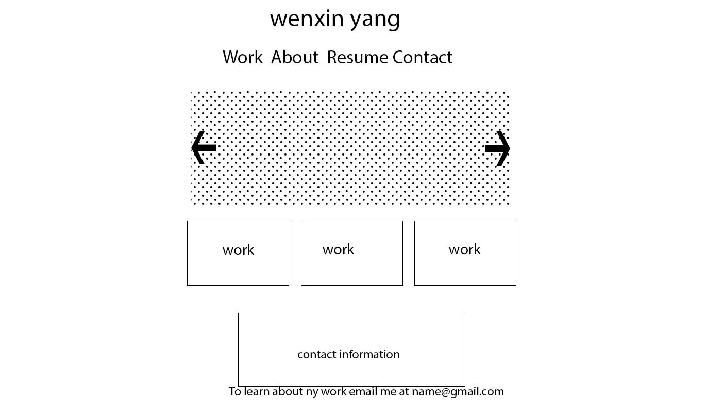

Contact Information

yangw9197@gmail.com

My skills

HTML/CSS/PHP

Logo Design

Web Design

Wordpress

Poster

Digital Graphic Design

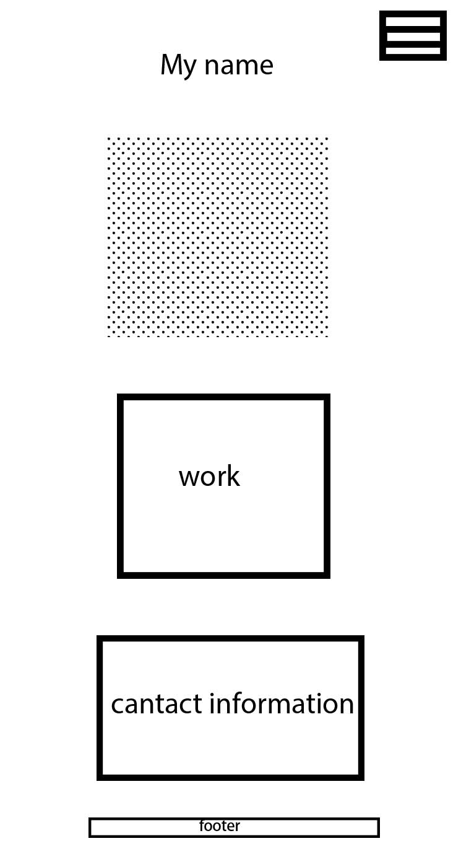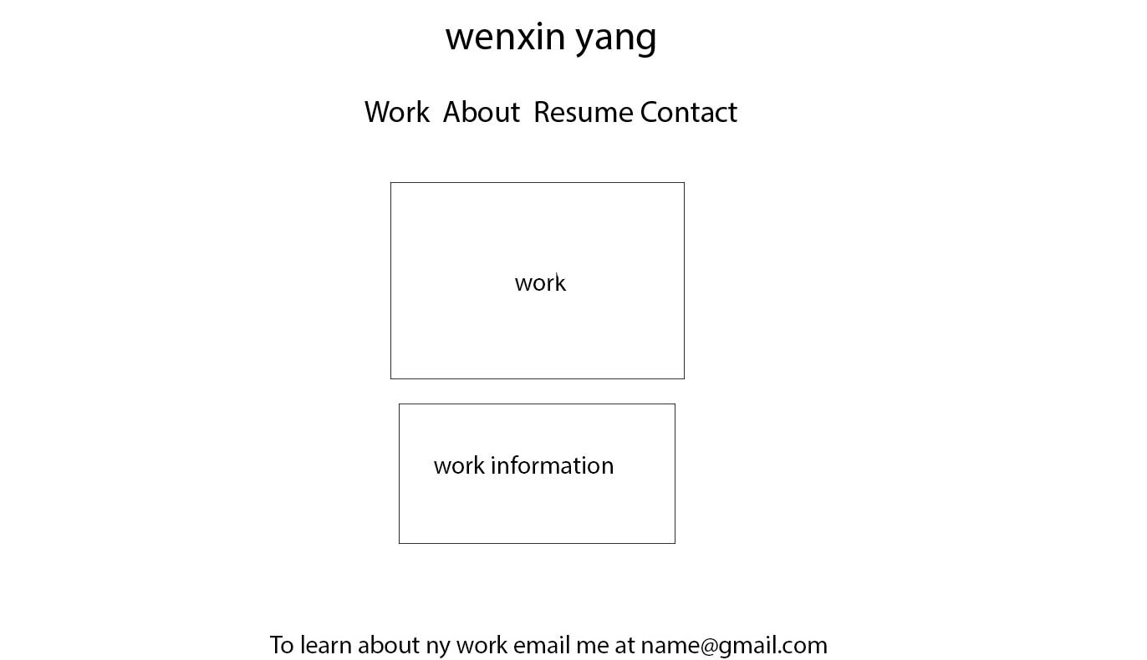

WeeklyRecipes

It is a website about recipes that easy way to cook, and serve many busy working people

The Nature Music Festival

It is a website about Music Festival and various types of music will be included such as classical music, electronic music, popular music, and children’s music

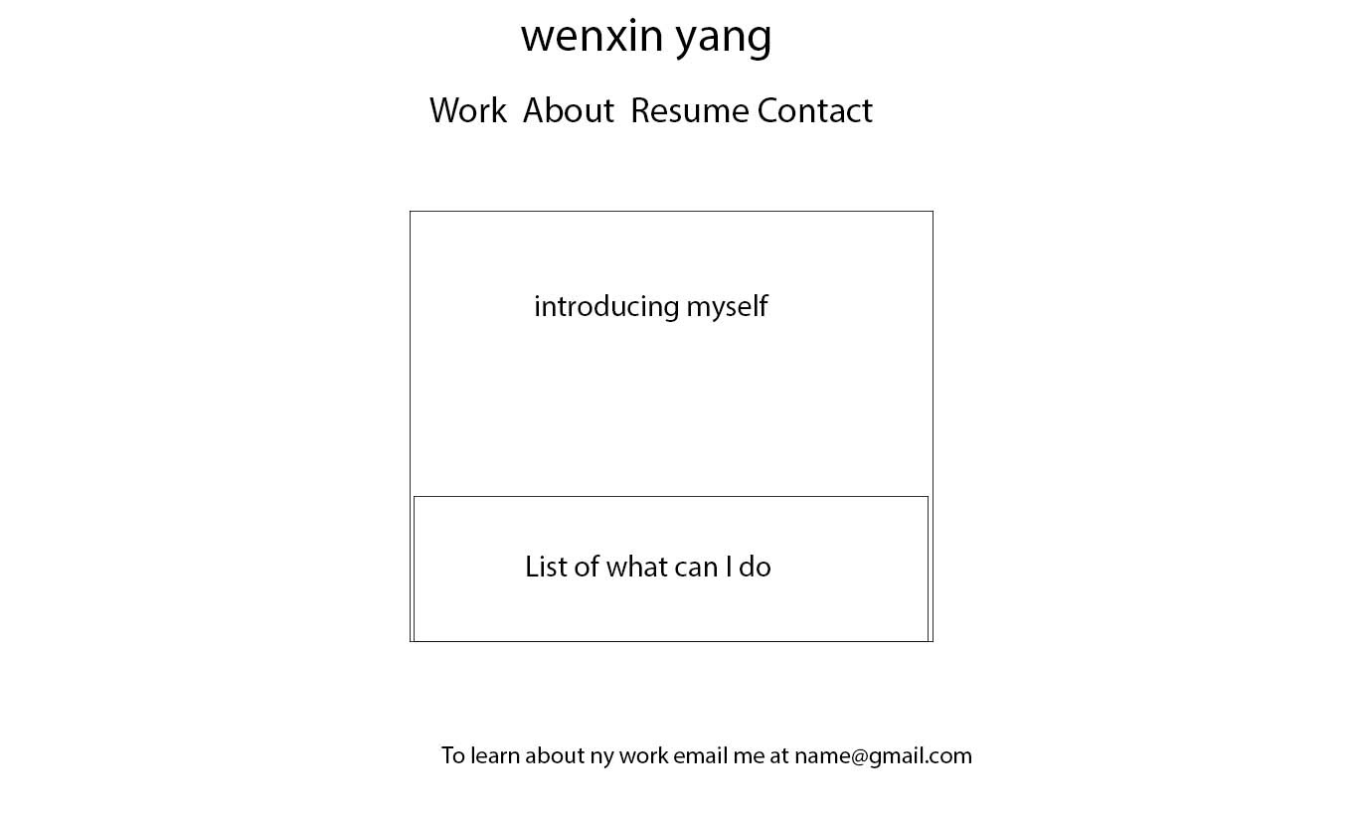 About Me

My name is WenXin Yang and I am a web designer. I like and want to create the highest quality and innovative products. My career goal is that increase my work experience, improve and learn more professional skills. Also, having a steady job and then increase my income.

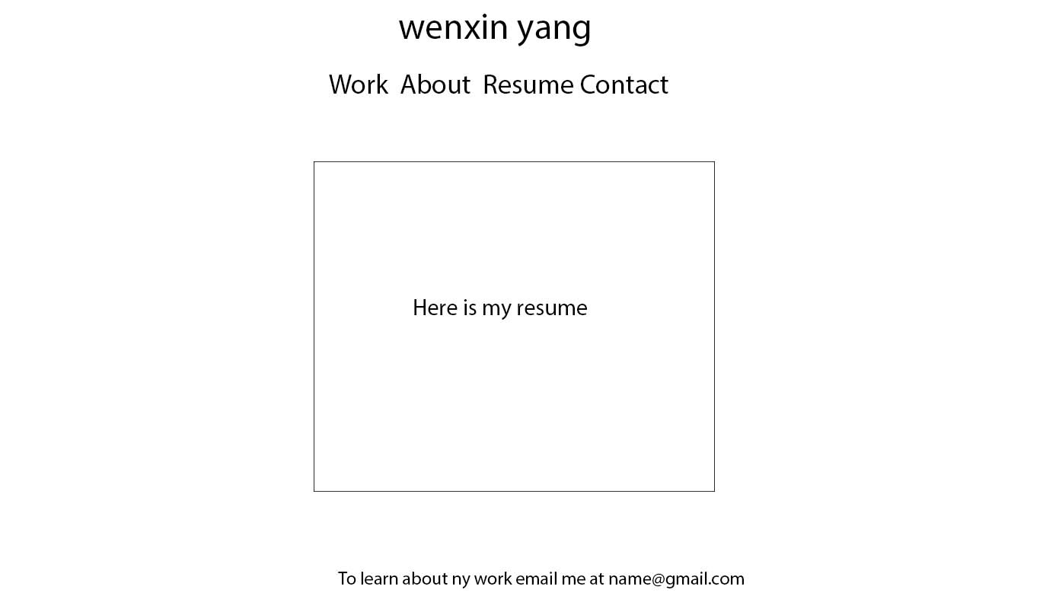

EDUCATION

Borough Manhattan Community College, New York, NY

Associate in Science in Multimedia Programming and Design

COURSEWORK

Foundations of Digital Graphic Design

Introduction to Multimedia

Multimedia Design

Typography and Layout

Visual Communication and Design

Digital Imaging for Graphic Design

SOFTWARE SKILLS

Adobe Photoshop, Illustrator, InDesign

Possess basic knowledge of HTML and CSS

VOLUNTEER EXPERIENCE

Doing a volunteer was about math tutoring in the math club