

**THE UNIVERSITY OF TEXAS AT ARLINGTON, TEXAS  
DEPARTMENT OF ELECTRICAL ENGINEERING**

**EE 5329**

**Distributed Decision and Control**

**HW # 4**

**ASSIGNMENT**

**by**

**SOUTRIK PRASAD MAITI**

**1001569883**

**Presented to**

**Dr. Frank Lewis**

**Feb 15, 2018**

**EE 5329 Distributed Decision and Control**

**Spring 2018**

**Homework Pledge of Honor**

On all homeworks in this class - YOU MUST WORK ALONE.

***Any cheating or collusion will be severely punished.***

***It is very easy to compare your software code and determine if you worked together***

***It does not matter if you change the variable names.***

Please sign this form and include it as the first page of all of your submitted homeworks.

.......................................................………………………………………………………………........

Typed Name: Soutrik Maiti

***Pledge of honor:***

"On my honor I have neither given nor received aid on this homework.”

e-Signature: Soutrik Maiti

Problem 1:

*MATLAB Code:*

%A matrix for third problem

a3= [0 0.5 0.5 0.5 0.5 0.5;

0.5 0 0 0 0 0;

0.5 0 0 0 0 0;

0.5 0 0 0 0 0;

0.5 0 0 0 0 0;

0.5 0 0 0 0 0];

%A matrix for seventh problem

a7= [0 0.5 0 0 0 0;

0.5 0 0.5 0 0 0;

0 0.5 0 0.5 0 0;

0 0 0.5 0 0.5 0;

0 0 0 0.5 0 0.5;

0 0 0 0 0.5 0];

%In degree matrix for third problem

d3= diag([sum(a3(1,:));sum(a3(2,:));sum(a3(3,:));sum(a3(4,:));sum(a3(5,:));sum(a3(6,:))]);

%In degree matrix for seventh problem

d7= diag([sum(a7(1,:));sum(a7(2,:));sum(a7(3,:));sum(a7(4,:));sum(a7(5,:));sum(a7(6,:))]);

%Graph aplacian matrix for third problem

l3= d3-a3;

%Graph aplacian matrix for seventh problem

l7= d7-a7;

%Random initial values for third problem

x3= (2)*rand(1,6)-1;

%Random initial values for seventh problem

x7= (2)*rand(1,6)-1;

for k=1:80

%for third problem

x3(k+1,:) = (eye(6)-(inv(eye(6)+d3))*l3)* x3(k,:)';

%for seventh problem

x7(k+1,:) = (eye(6)-(inv(eye(6)+d7))*l7)* x7(k,:)';

end

%plot for third problem

figure

plot(0:80,x3)

legend('1','2','3','4','5','6')

title('State vs. Time')

xlabel('Time');

ylabel('State');

%plot for seventh problem

figure

plot(0:80,x7)

legend('1','2','3','4','5','6')

title('State vs. Time')

xlabel('Time');

ylabel('State');

*Results:*

***For graph 3***

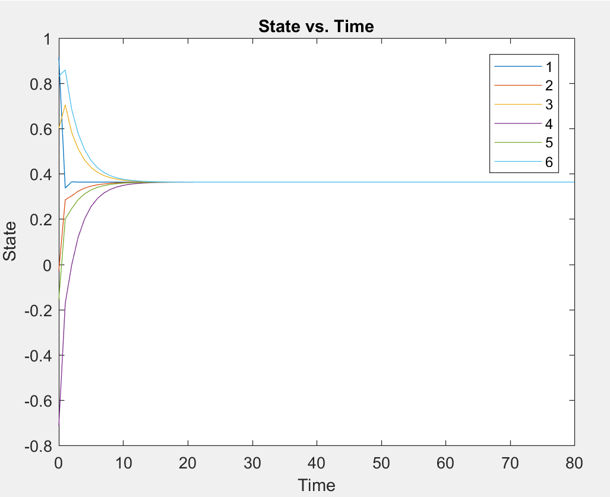

***For graph 7***

