

**THE UNIVERSITY OF TEXAS AT ARLINGTON, TEXAS  
DEPARTMENT OF ELECTRICAL ENGINEERING**

**EE 5329**

**Distributed Decision and Control**

**HW # 3**

**ASSIGNMENT**

**by**

**SOUTRIK PRASAD MAITI**

**1001569883**

**Presented to**

**Dr. Frank Lewis**

**Feb 6, 2018**

**EE 5329 Distributed Decision and Control**

**Spring 2018**

**Homework Pledge of Honor**

On all homeworks in this class - YOU MUST WORK ALONE.

***Any cheating or collusion will be severely punished.***

***It is very easy to compare your software code and determine if you worked together***

***It does not matter if you change the variable names.***

Please sign this form and include it as the first page of all of your submitted homeworks.

.......................................................………………………………………………………………........

Typed Name: Soutrik Maiti

***Pledge of honor:***

"On my honor I have neither given nor received aid on this homework.”

e-Signature: Soutrik Maiti

1. MATLAB CODE:

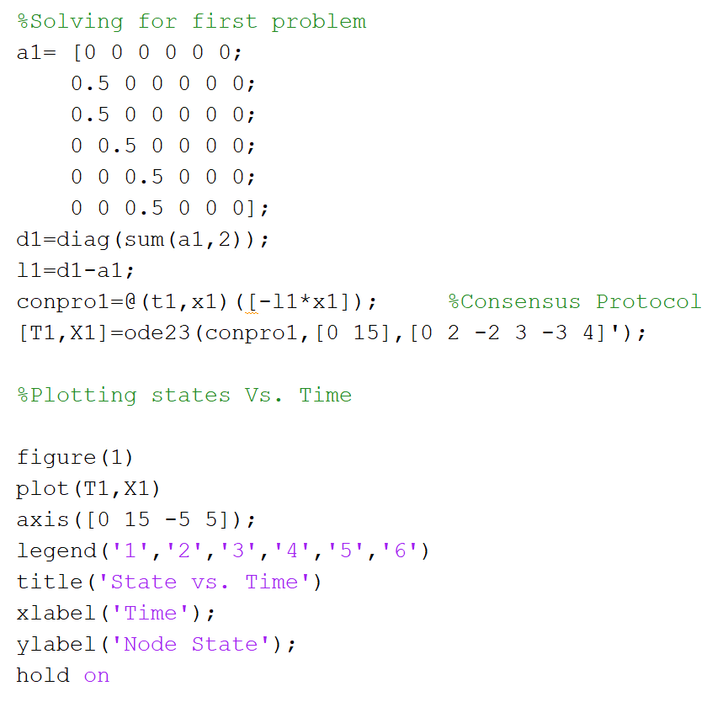

Result:

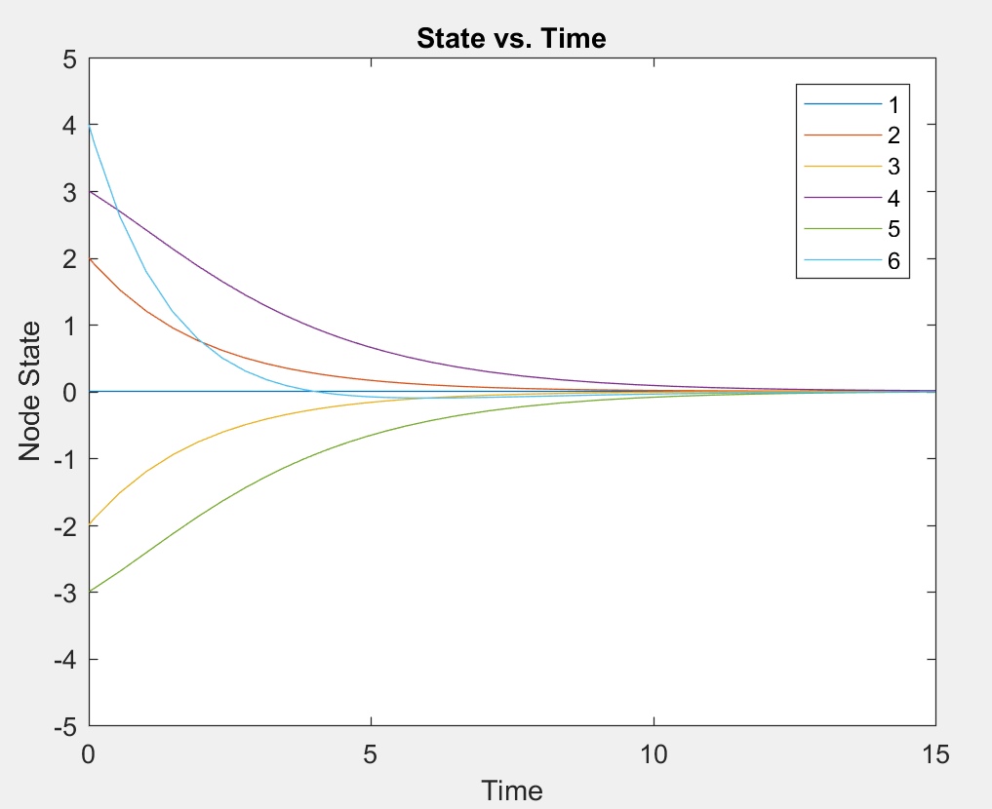

b)

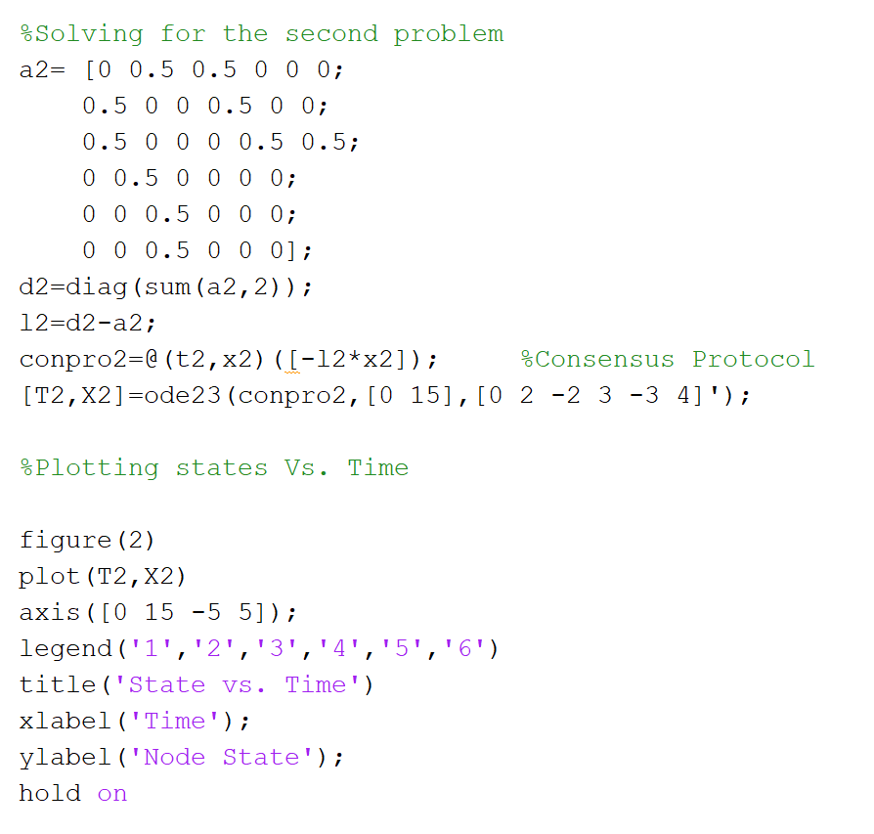

Result:

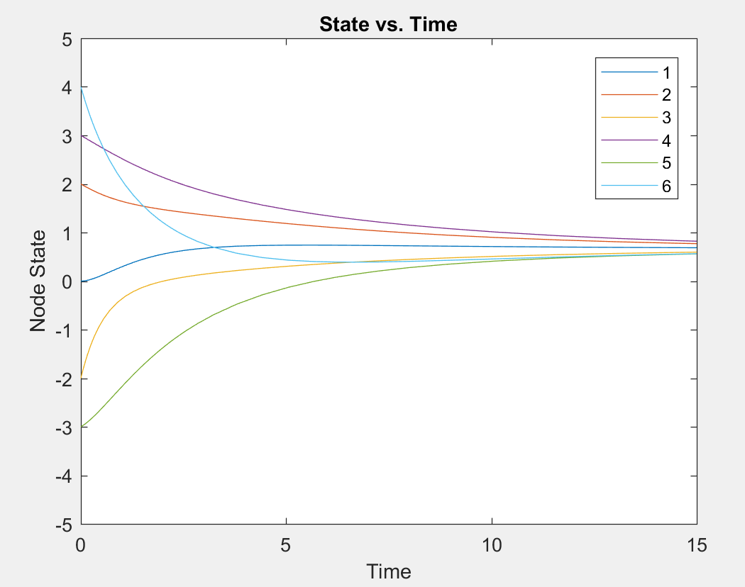

c)

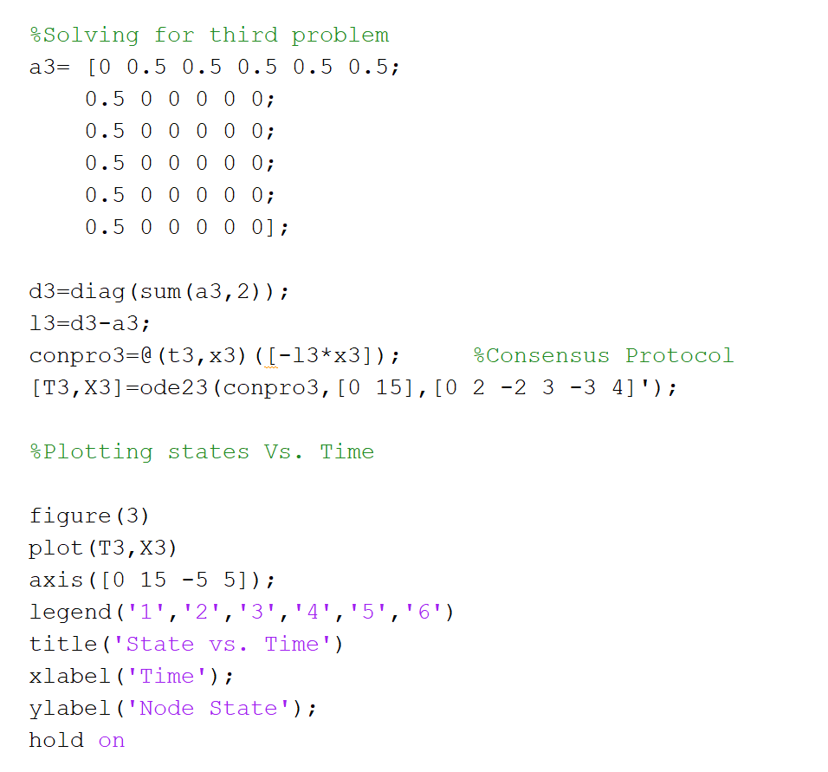

Result:

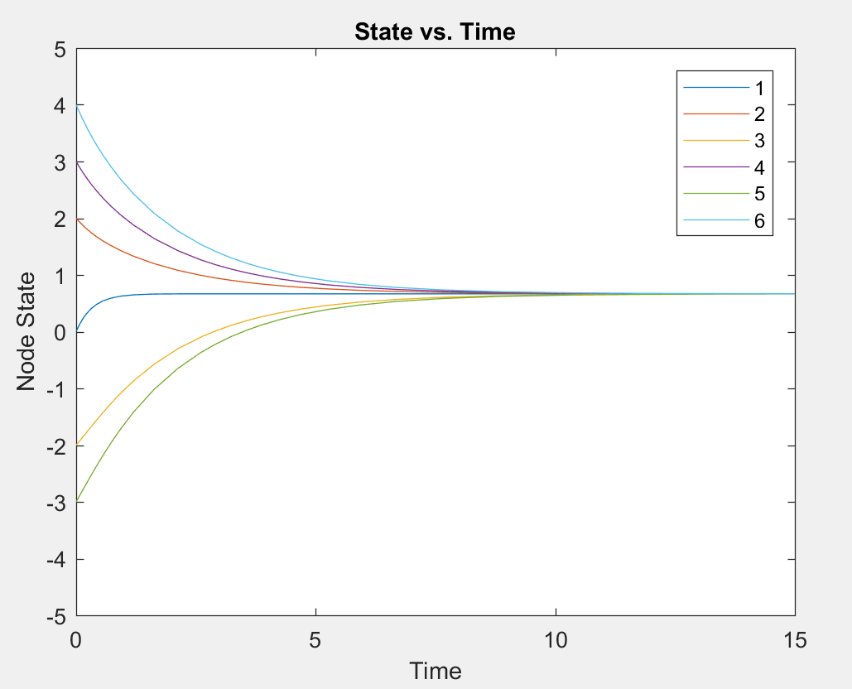

d)

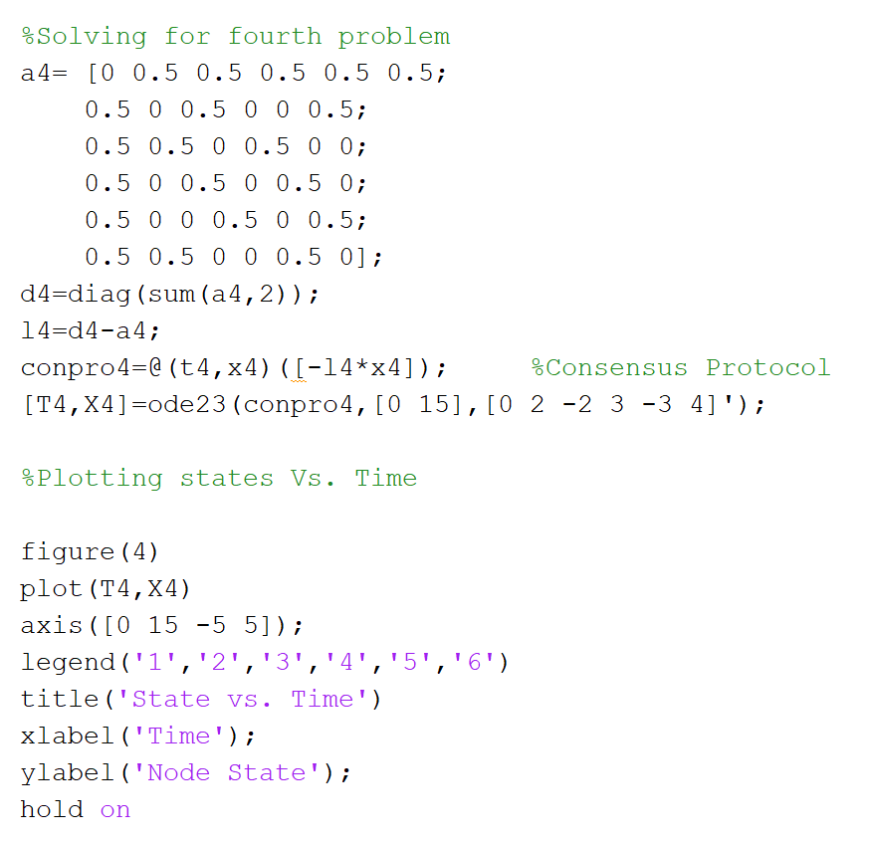

Result:

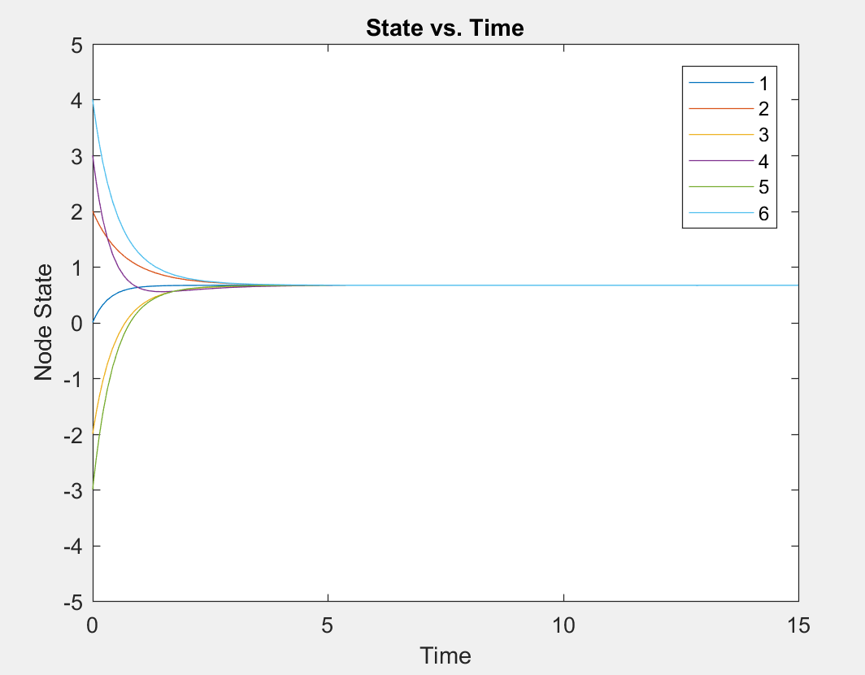

e)

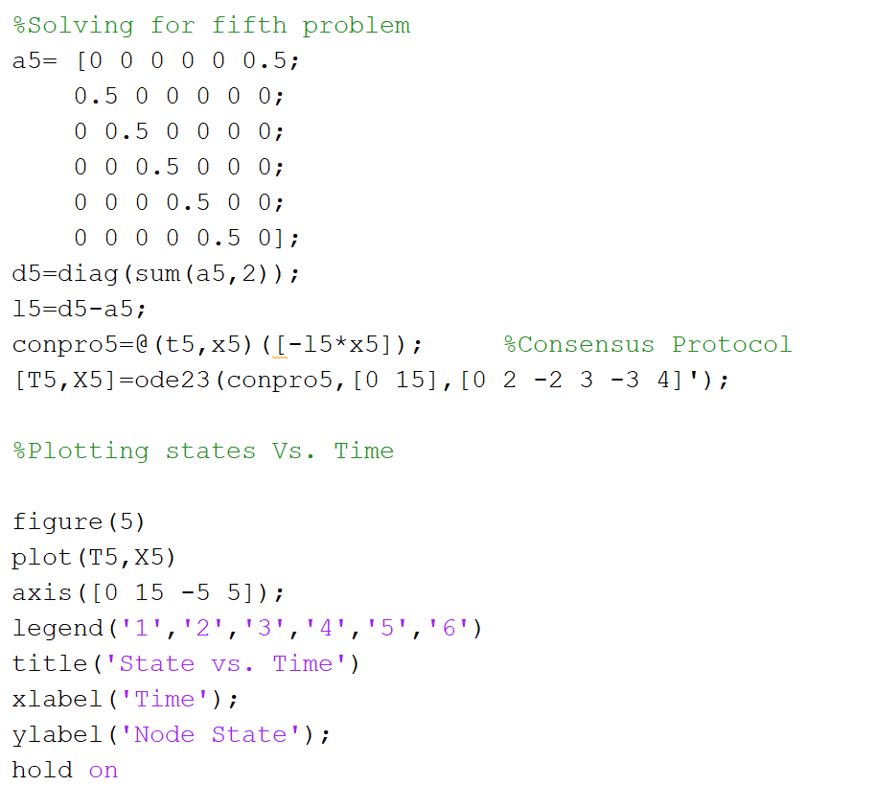

Result:

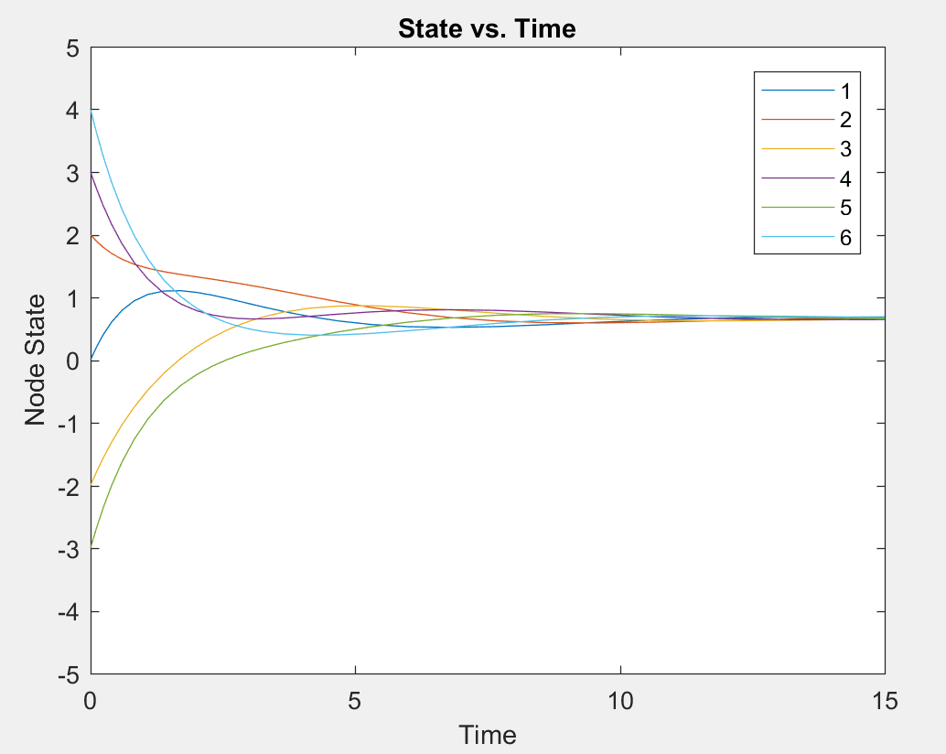

f)

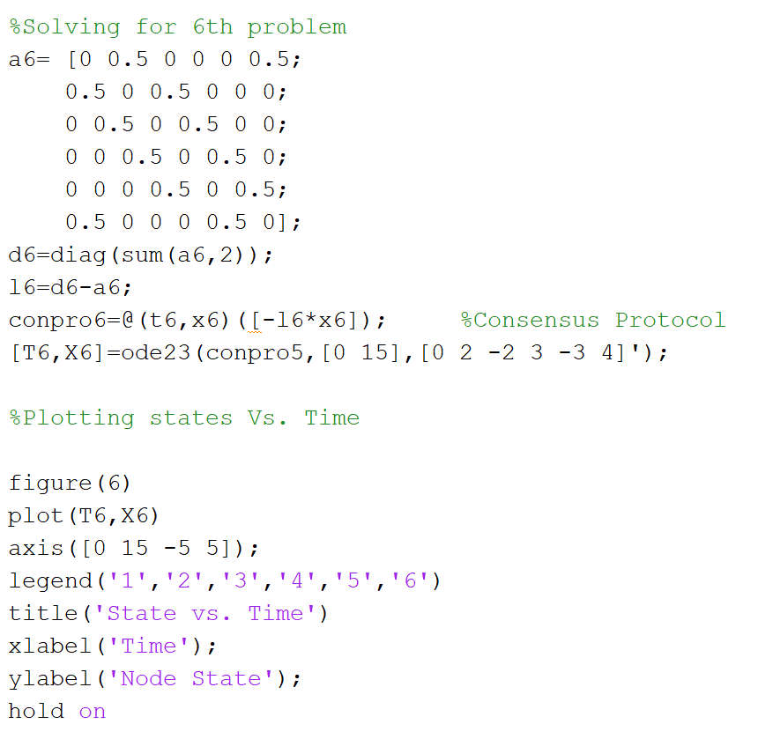

Result:

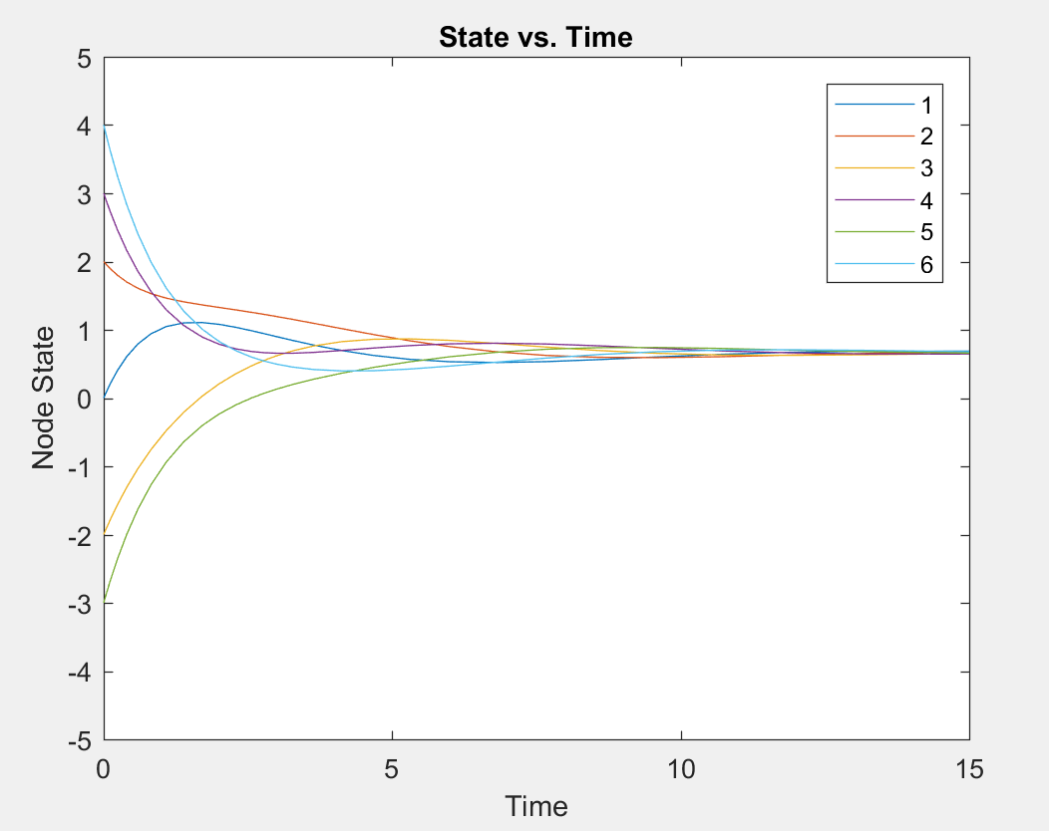

g)

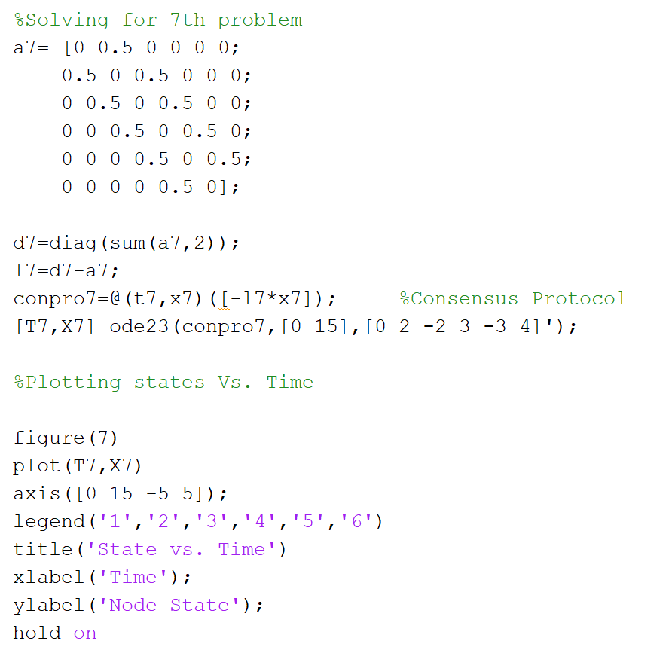

Result:

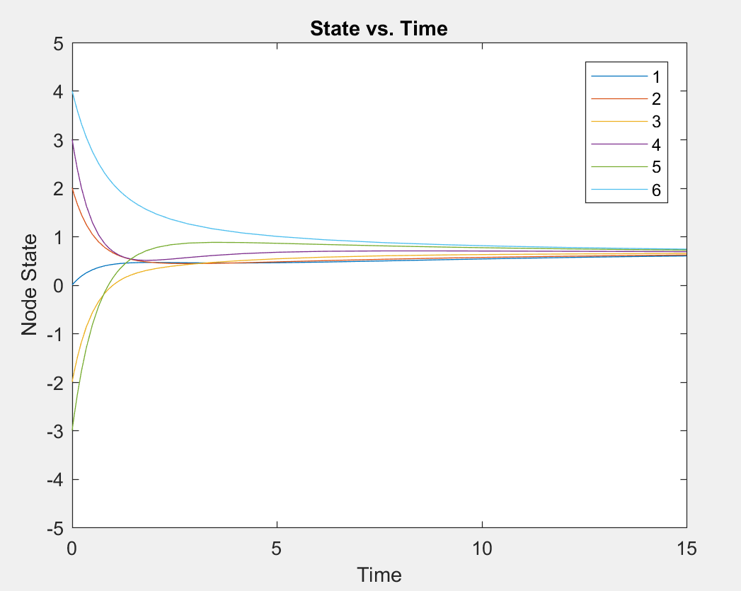

1. MATLAB CODE:

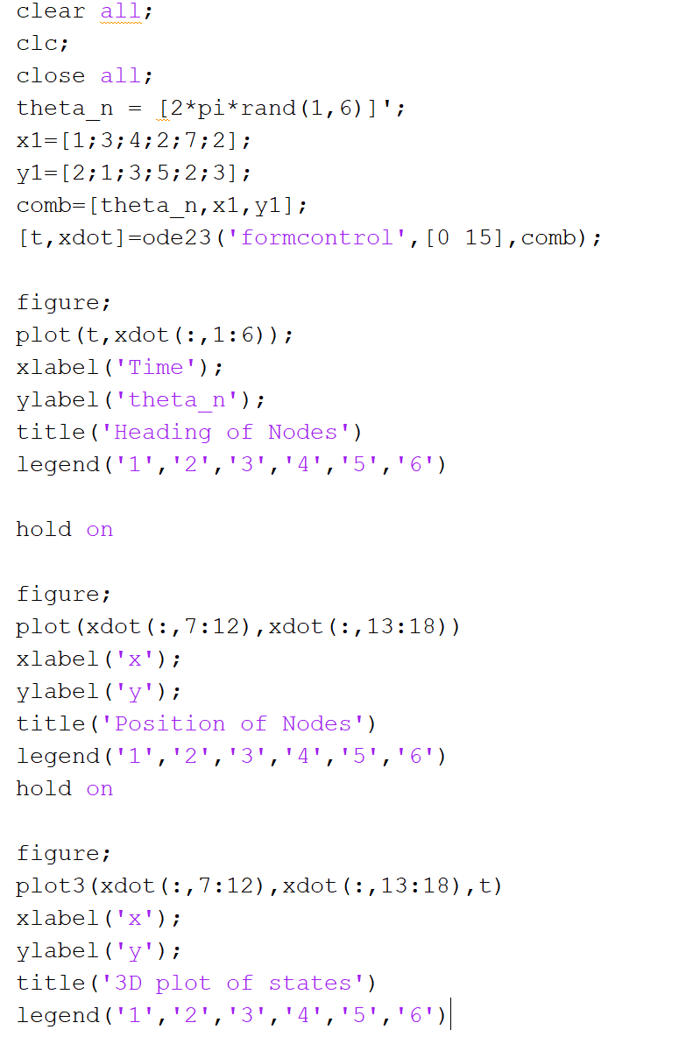

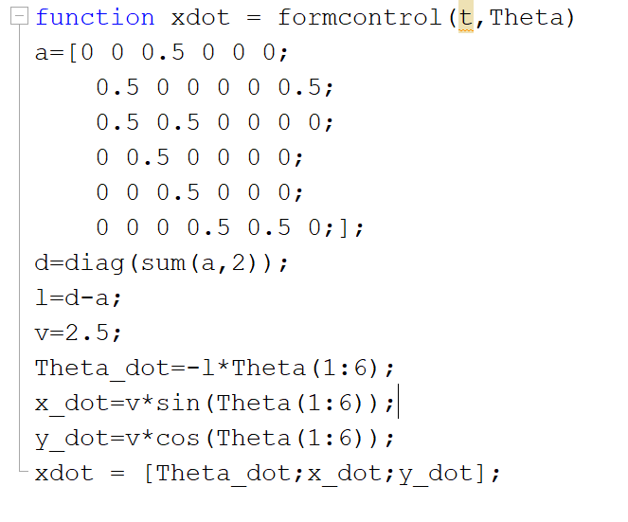

Result:

