

**THE UNIVERSITY OF TEXAS AT ARLINGTON, TEXAS  
DEPARTMENT OF ELECTRICAL ENGINEERING**

**EE 5329**

**Distributed Decision and Control**

**HW # 2**

**ASSIGNMENT**

**by**

**SOUTRIK PRASAD MAITI**

**1001569883**

**Presented to**

**Dr. Frank Lewis**

**Jan 23, 2018**

**EE 5329 Distributed Decision and Control**

**Spring 2018**

**Homework Pledge of Honor**

On all homeworks in this class - YOU MUST WORK ALONE.

***Any cheating or collusion will be severely punished.***

***It is very easy to compare your software code and determine if you worked together***

***It does not matter if you change the variable names.***

Please sign this form and include it as the first page of all of your submitted homeworks.

.......................................................………………………………………………………………........

Typed Name: Soutrik Maiti

***Pledge of honor:***

"On my honor I have neither given nor received aid on this homework.”

e-Signature: Soutrik Maiti

**Graph Laplacian Eigen Values**

**1.**

1. *Adjacent Matrix A and graph Laplacian L for the graph given in problem:*

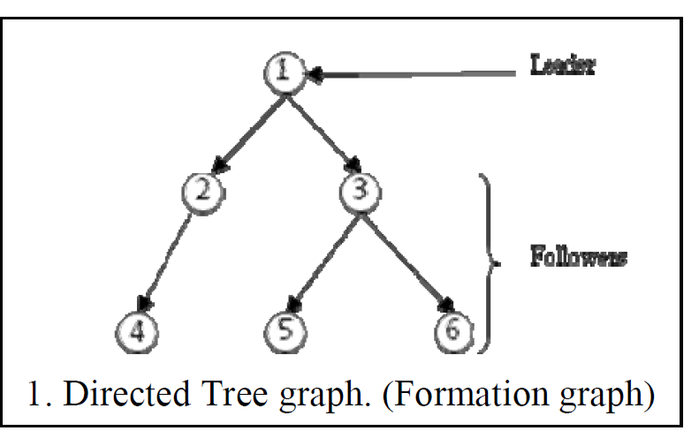

Adjacent Matrix:

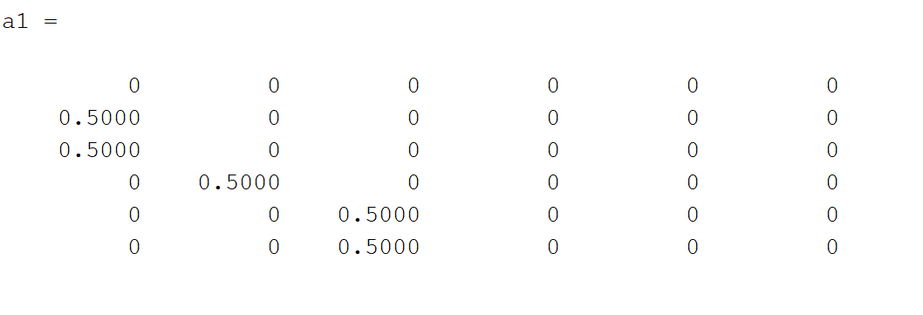

Laplacian Matrix:

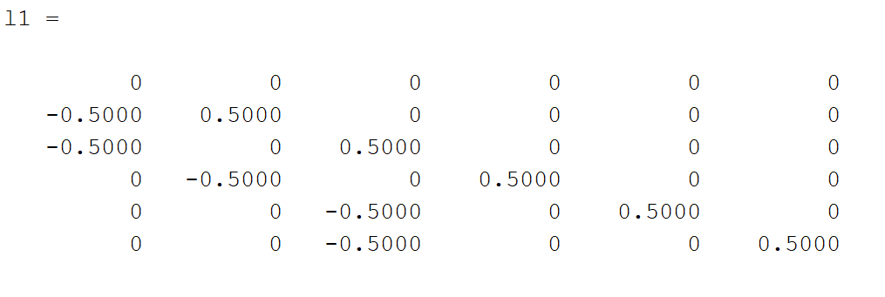

1. *Plotting the Eigen Values of L on the complex plane :*

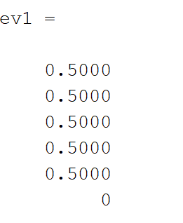

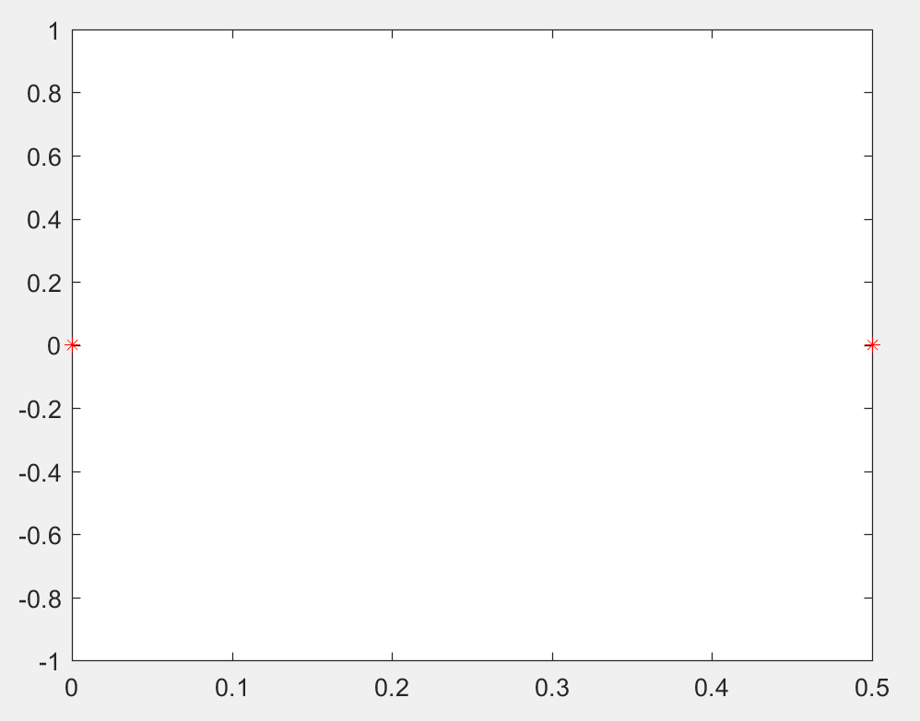

**2.**

1. *Adjacent Matrix A and graph Laplacian L for the graphs given in problem:*

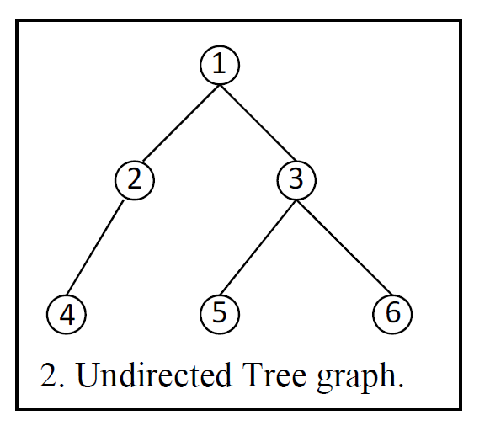

Adjacent Matrix:

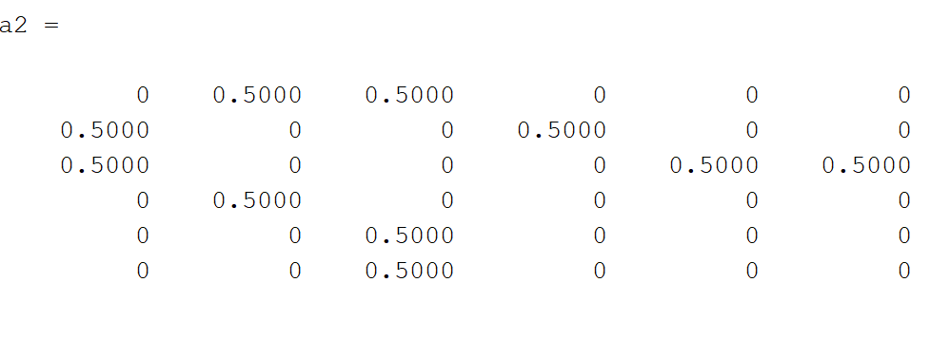

Laplacian Matrix: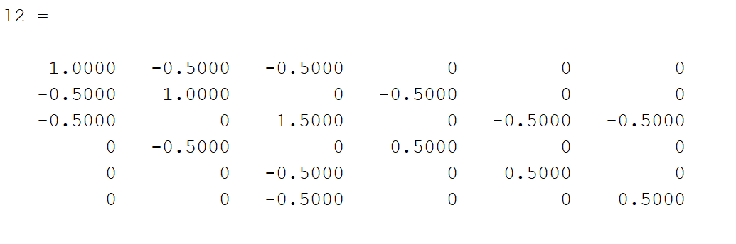

1. *Plotting the Eigen Values of L on the complex plane:*

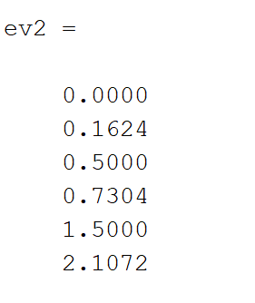

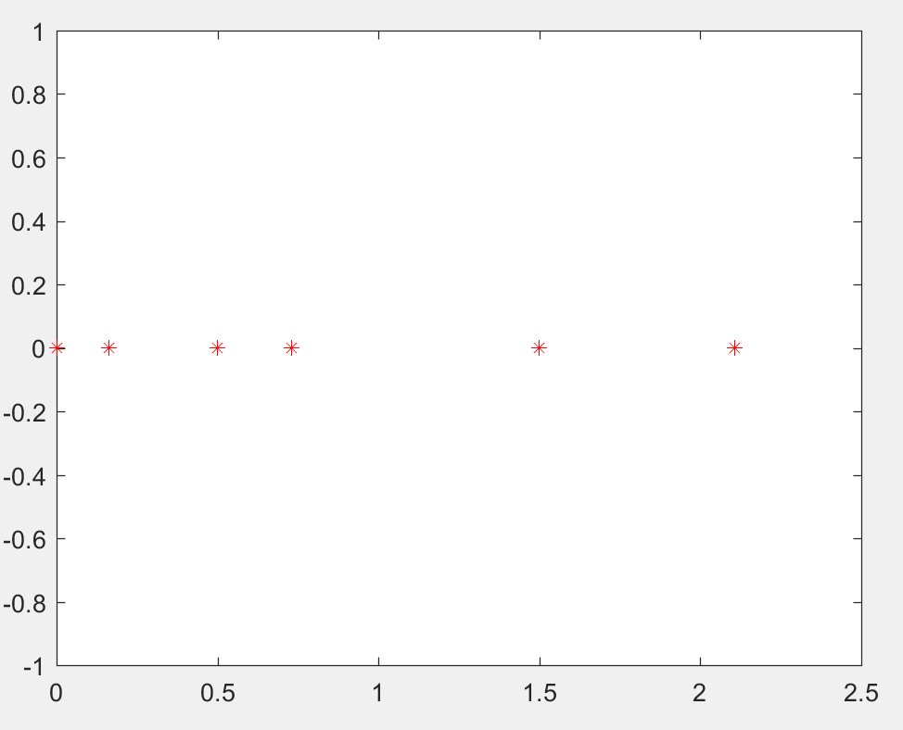

**3.**

1. *Adjacent Matrix A and graph Laplacian L for the graphs given in problem:*

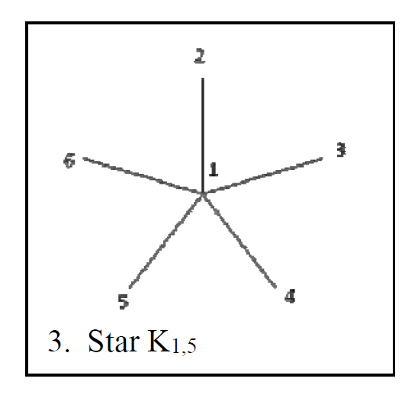

Adjacent Matrix:

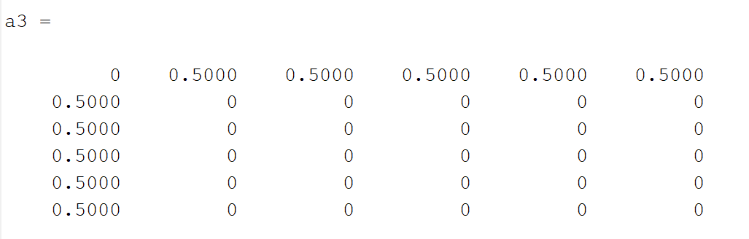

Laplacian Matrix:

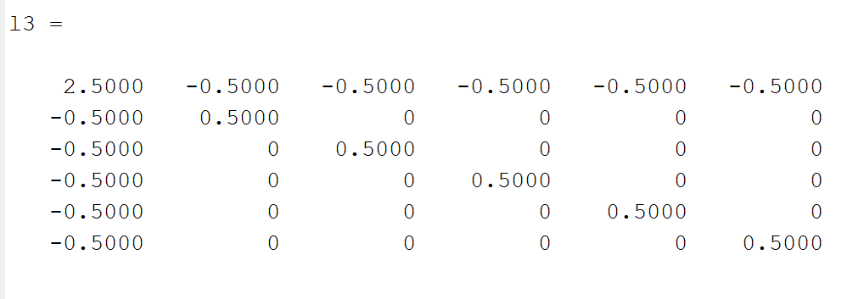

1. *Plotting the Eigen Values of L on the complex plane:*

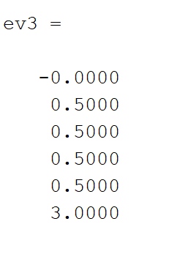

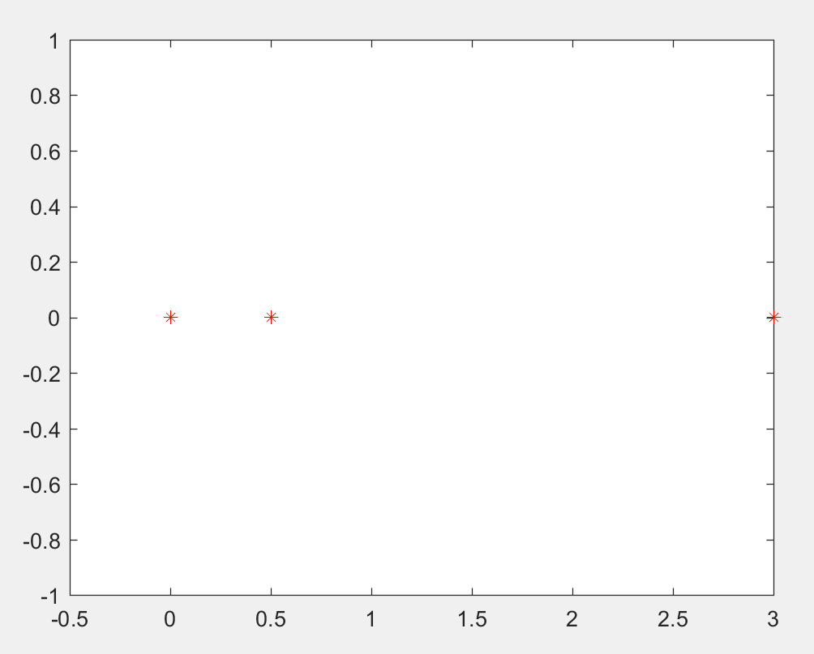

**4.**

1. *Adjacent Matrix A and graph Laplacian L for the graphs given in problem:*

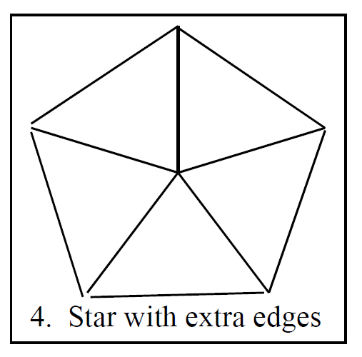

Adjacent Matrix:

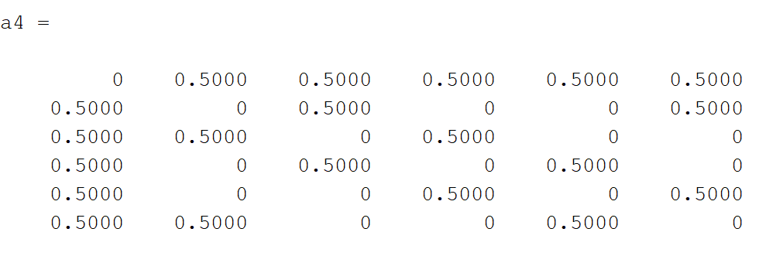

Laplacian Matrix:

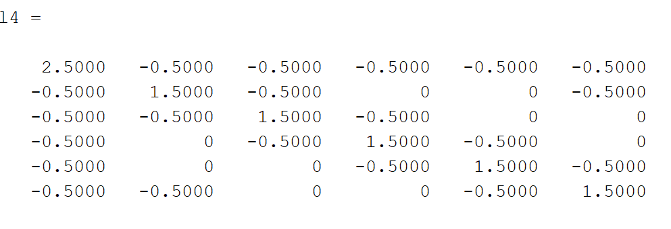

1. *Plotting the Eigen Values of L on the complex plane:*

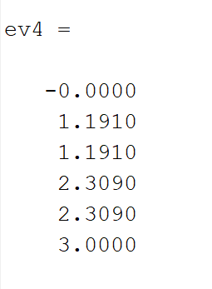

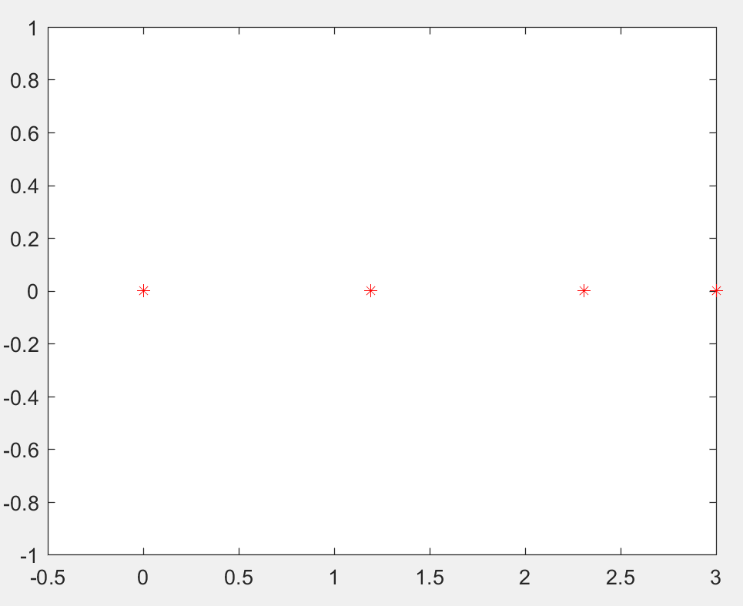

5.

*a) Adjacent Matrix A and graph Laplacian L for the graphs given in problem:*

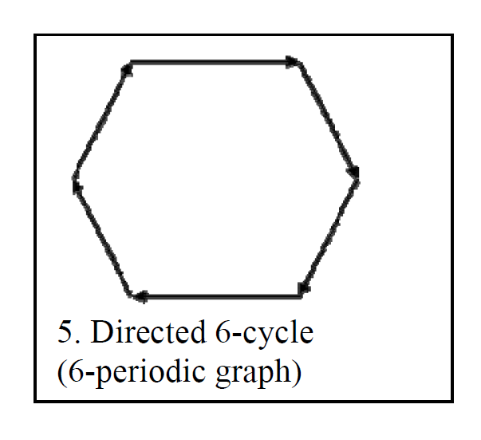

Adjacent Matrix:

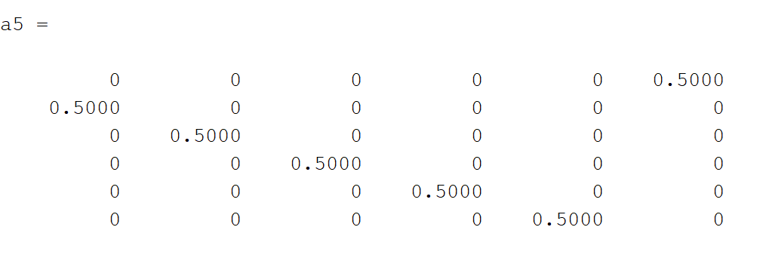

Laplacian Matrix:

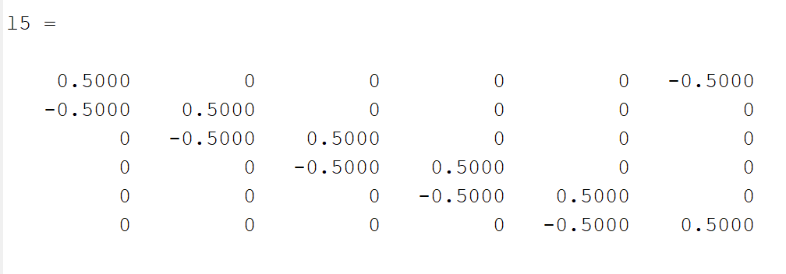

*b) Plotting the Eigen Values of L on the complex plane:*

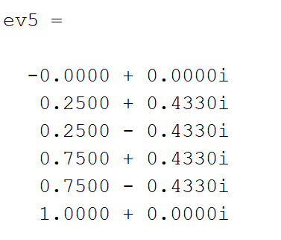

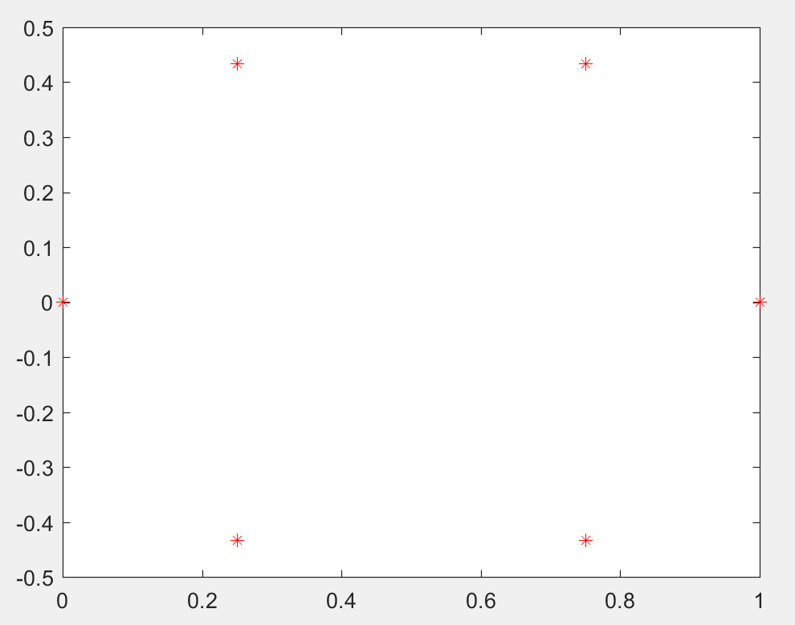

6.

*a) Adjacent Matrix A and graph Laplacian L for the graphs given in problem:*

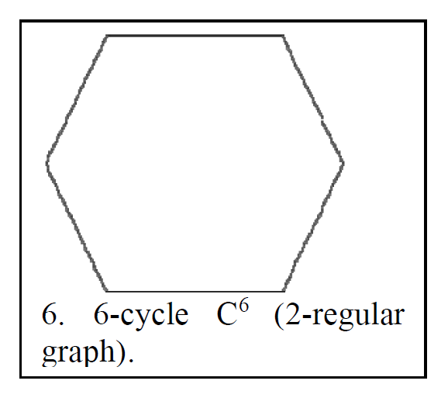

Adjacent Matrix:

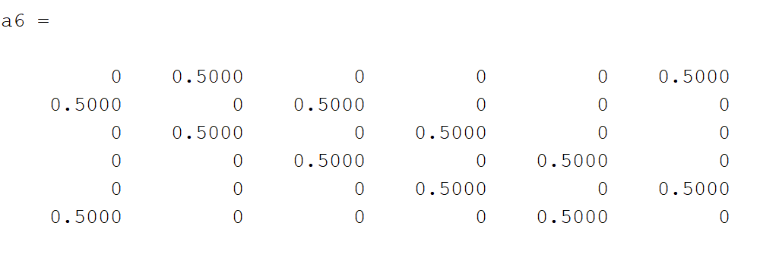

Laplacian Matrix:

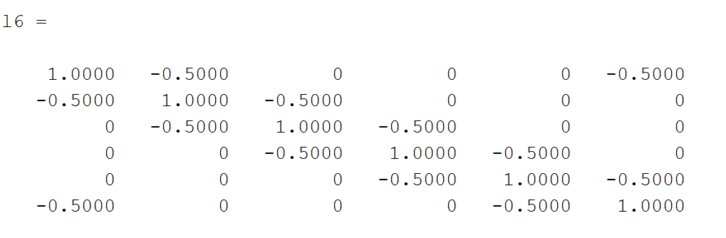

1. *Plotting the Eigen Values of L on the complex plane:*

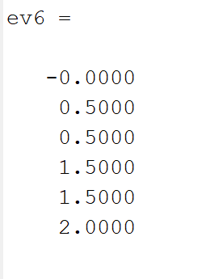

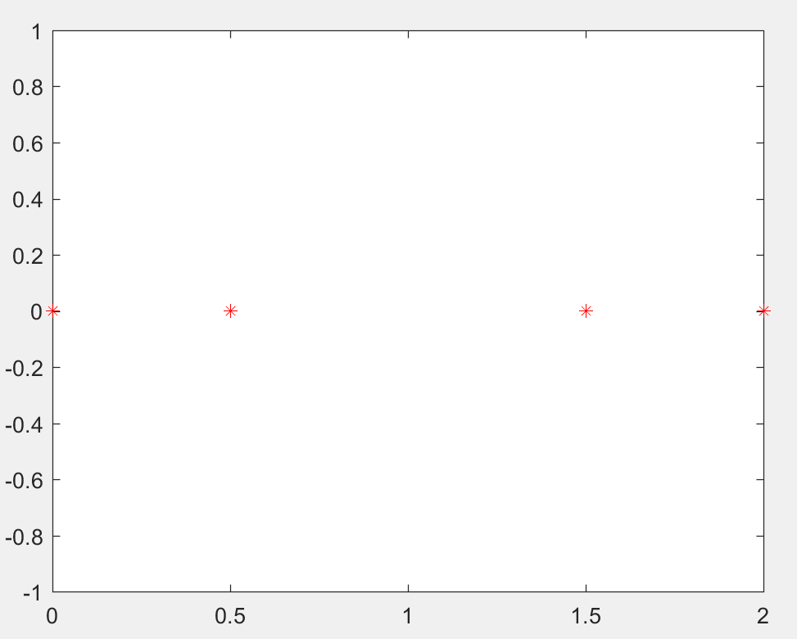

7.

*a) Adjacent Matrix A and graph Laplacian L for the graphs given in problem:*

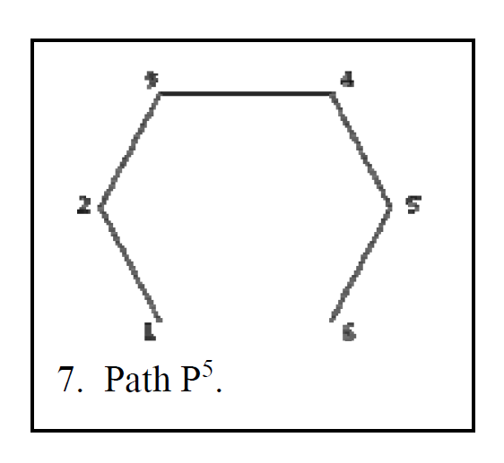

Adjacent Matrix:

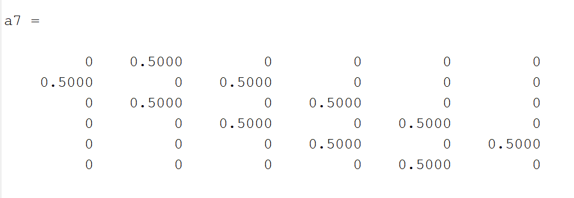

Laplacian Matrix:

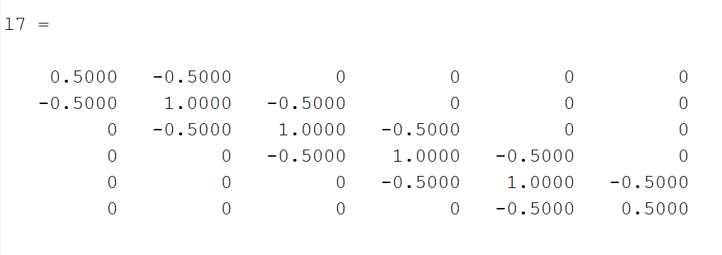

*b) Plotting the Eigen Values of L on the complex plane:*

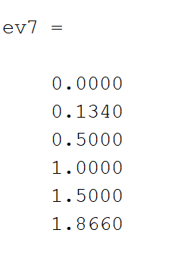

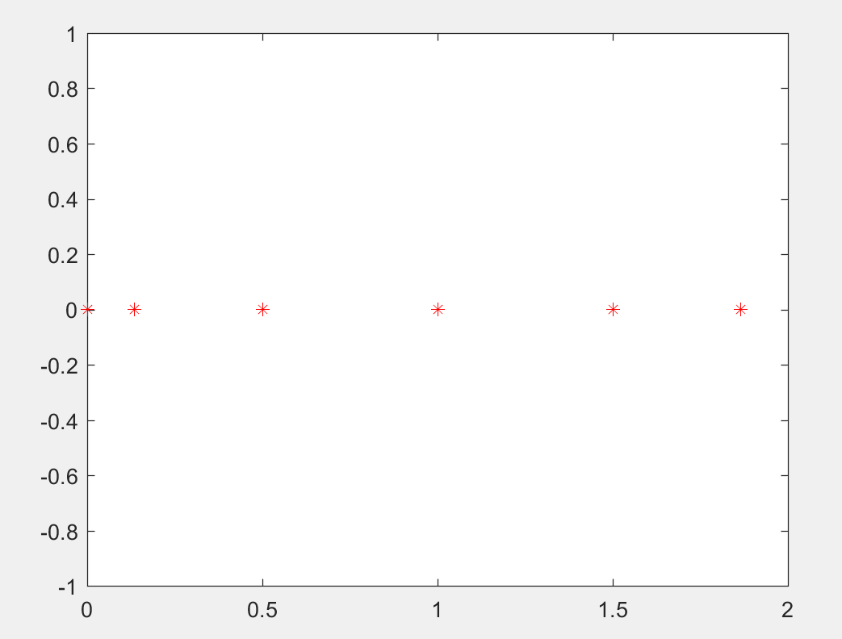

c)The Fiedler values of the corresponding graphs are:

*The Fiedler value represents the rate of convergence of the graph*

Graph 1 = 0.5000

Graph 2 = 0.1624

Graph 3 = 0.5000

Graph 4 = 1.1910

Graph 5 = 0.2500 + 0.4330i

Graph 6 = 0.5000

Graph 7 = 0.1340

The Fiedler value for the graph 4(1.1910) is the highest and hence this graph (star with extra edges) would converge the fastest.

1. The Left eigenvector w1 of L for λ1=0 for all the graphs are as follows :

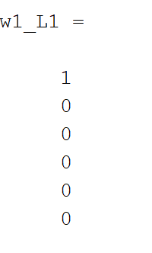

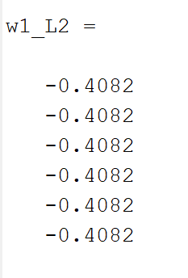

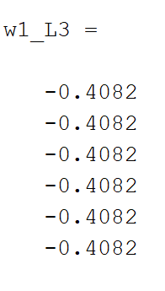

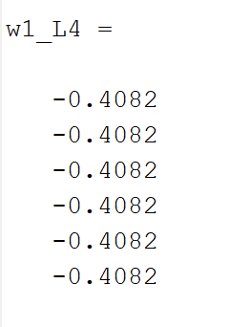

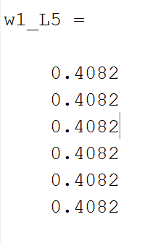

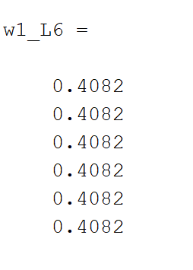

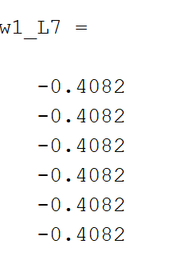

1. The Fiedler Eigen Vector v2 for the corresponding graphs are as follows:

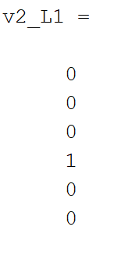

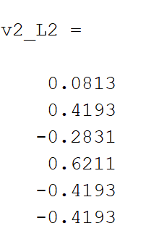

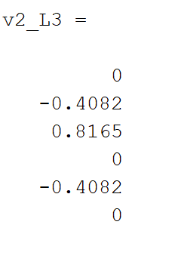

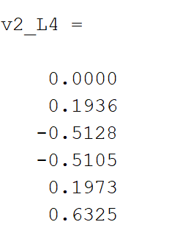

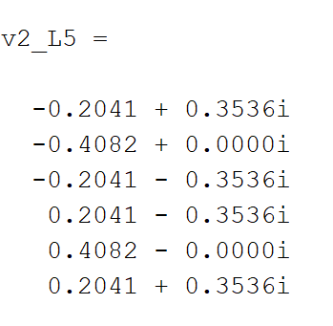

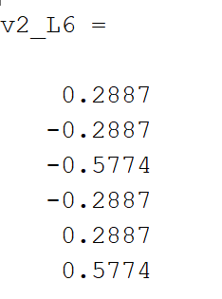

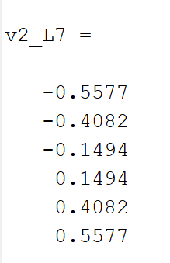

MATLAB CODE:

clear all

clc

close all

%A matrix for first problem

a1= [0 0 0 0 0 0;

0.5 0 0 0 0 0;

0.5 0 0 0 0 0;

0 0.5 0 0 0 0;

0 0 0.5 0 0 0;

0 0 0.5 0 0 0]

%A matrix for second problem

a2= [0 0.5 0.5 0 0 0;

0.5 0 0 0.5 0 0;

0.5 0 0 0 0.5 0.5;

0 0.5 0 0 0 0;

0 0 0.5 0 0 0;

0 0 0.5 0 0 0]

%A matrix for third problem

a3= [0 0.5 0.5 0.5 0.5 0.5;

0.5 0 0 0 0 0;

0.5 0 0 0 0 0;

0.5 0 0 0 0 0;

0.5 0 0 0 0 0;

0.5 0 0 0 0 0]

%A matrix for fourth problem

a4= [0 0.5 0.5 0.5 0.5 0.5;

0.5 0 0.5 0 0 0.5;

0.5 0.5 0 0.5 0 0;

0.5 0 0.5 0 0.5 0;

0.5 0 0 0.5 0 0.5;

0.5 0.5 0 0 0.5 0]

%A matrix for fifth problem

a5= [0 0 0 0 0 0.5;

0.5 0 0 0 0 0;

0 0.5 0 0 0 0;

0 0 0.5 0 0 0;

0 0 0 0.5 0 0;

0 0 0 0 0.5 0]

%A matrix for sixth problem

a6= [0 0.5 0 0 0 0.5;

0.5 0 0.5 0 0 0;

0 0.5 0 0.5 0 0;

0 0 0.5 0 0.5 0;

0 0 0 0.5 0 0.5;

0.5 0 0 0 0.5 0]

%A matrix for seventh problem

a7= [0 0.5 0 0 0 0;

0.5 0 0.5 0 0 0;

0 0.5 0 0.5 0 0;

0 0 0.5 0 0.5 0;

0 0 0 0.5 0 0.5;

0 0 0 0 0.5 0]

d1= diag([sum(a1(1,:));sum(a1(2,:));sum(a1(3,:));sum(a1(4,:));sum(a1(5,:));sum(a1(6,:))]);

d2= diag([sum(a2(1,:));sum(a2(2,:));sum(a2(3,:));sum(a2(4,:));sum(a2(5,:));sum(a2(6,:))]);

d3= diag([sum(a3(1,:));sum(a3(2,:));sum(a3(3,:));sum(a3(4,:));sum(a3(5,:));sum(a3(6,:))]);

d4= diag([sum(a4(1,:));sum(a4(2,:));sum(a4(3,:));sum(a4(4,:));sum(a4(5,:));sum(a4(6,:))]);

d5= diag([sum(a5(1,:));sum(a5(2,:));sum(a5(3,:));sum(a5(4,:));sum(a5(5,:));sum(a5(6,:))]);

d6= diag([sum(a6(1,:));sum(a6(2,:));sum(a6(3,:));sum(a6(4,:));sum(a6(5,:));sum(a6(6,:))]);

d7= diag([sum(a7(1,:));sum(a7(2,:));sum(a7(3,:));sum(a7(4,:));sum(a7(5,:));sum(a7(6,:))]);

l1= d1-a1

l2= d2-a2

l3= d3-a3

l4= d4-a4

l5= d5-a5

l6= d6-a6

l7= d7-a7

[V1,D1,W1]= eig(l1);

o=ones(6,1);

ev1=D1*o

r1=real(ev1);

i1=imag(ev1);

figure

plot(r1,i1,'r*')

hold on

[V2,D2,W2]= eig(l2);

ev2=D2*o

r2=real(ev2);

i2=imag(ev2);

figure

plot(r2,i2,'r*')

hold on

[V3,D3,W3]= eig(l3);

ev3=D3*o

r3=real(ev3);

i3=imag(ev3);

figure

plot(r3,i3,'r*')

hold on

[V4,D4,W4]= eig(l4);

ev4=D4*o

r4=real(ev4);

i4=imag(ev4);

figure

plot(r4,i4,'r*')

hold on

[V5,D5,W5]= eig(l5);

ev5=D5*o

r5=real(ev5);

i5=imag(ev5);

figure

plot(r5,i5,'r*')

hold on

[V6,D6,W6]= eig(l6);

ev6=D6*o

r6=real(ev6);

i6=imag(ev6);

figure

plot(r6,i6,'r*')

hold on

[V7,D7,W7]= eig(l7);

ev7=D7*o

r7=real(ev7);

i7=imag(ev7);

figure

plot(r7,i7,'r*')

hold on

% The left eigen vectors of the graphs corresponding to lamda = 0

w1_L1=W1(:,6)

w1_L2=W2(:,1)

w1_L3=W3(:,1)

w1_L4=W4(:,1)

w1_L5=W5(:,1)

w1_L6=W6(:,1)

w1_L7=W7(:,1)

%The Fiedler value v2 of the graphs are as follows:

v2_L1=V1(:,2)

v2_L2=V2(:,2)

v2_L3=V3(:,2)

v2_L4=V4(:,2)

v2_L5=V5(:,2)

v2_L6=V6(:,2)

v2_L7=V7(:,2)