

**THE UNIVERSITY OF TEXAS AT ARLINGTON, TEXAS  
DEPARTMENT OF ELECTRICAL ENGINEERING**

**EE 5327 - 001**

**SYSTEM IDENTIFICATION & ESTIMATION**

**HW # 3**

**ASSIGNMENT**

**by**

**SOUTRIK MAITI**

**1001569883**

**Presented to**

**Prof. Michael Niestroy**

**Oct 5th, 2017**

Problem 1:

*Simulink Diagram for aircraft dynamics*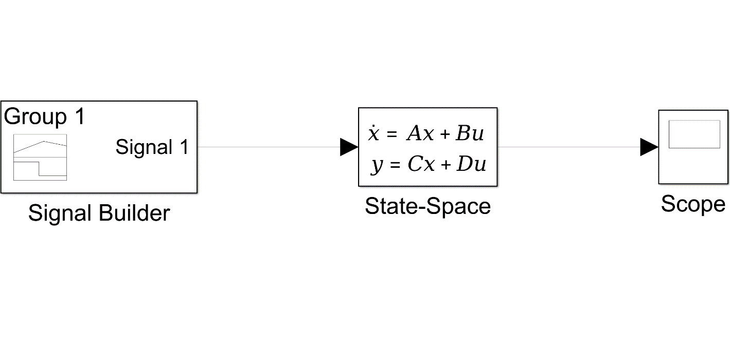

*Output response*

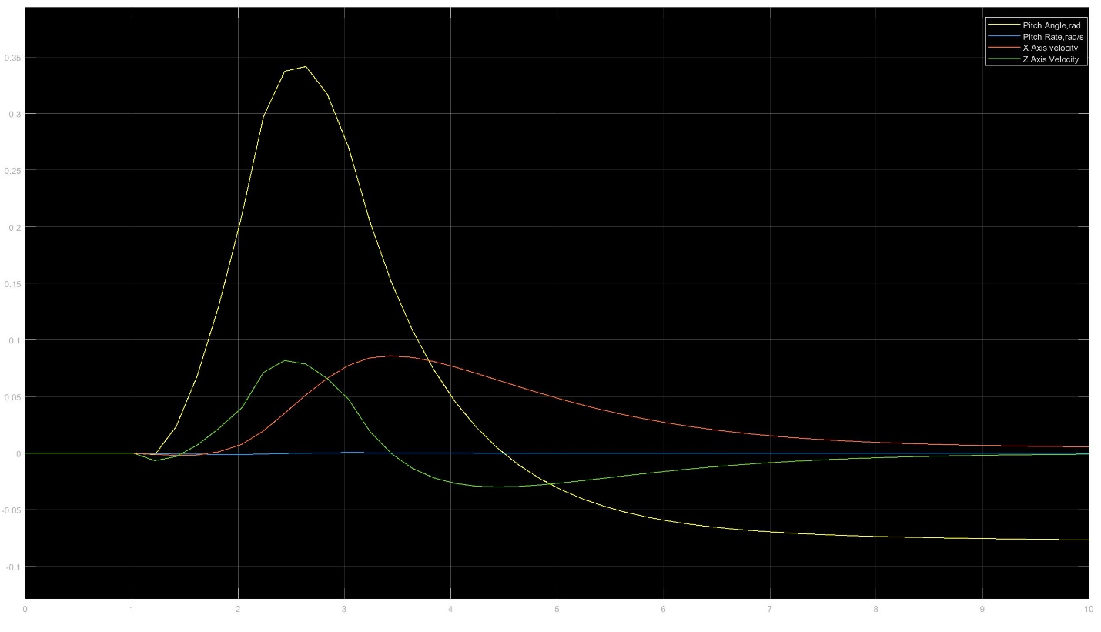

*States response*

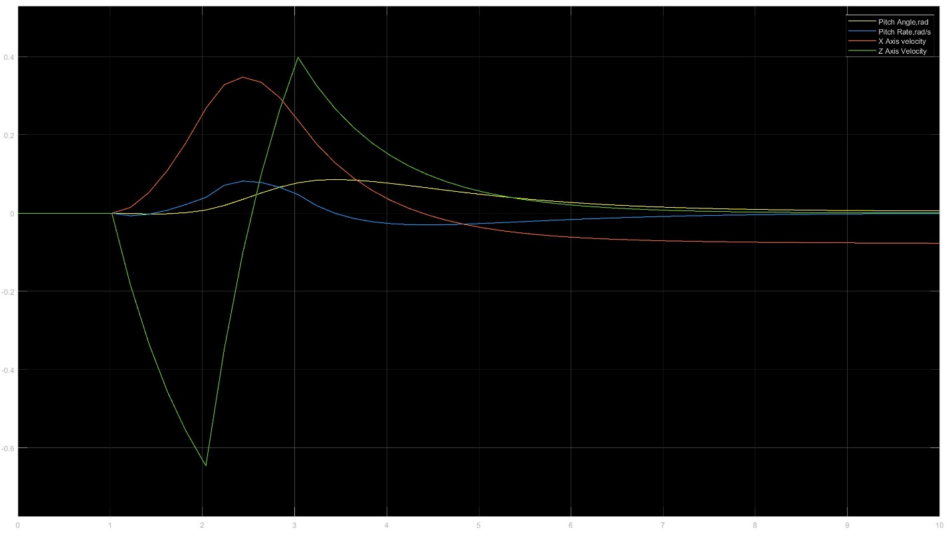

1. *Block diagram for adding noise to outputs*

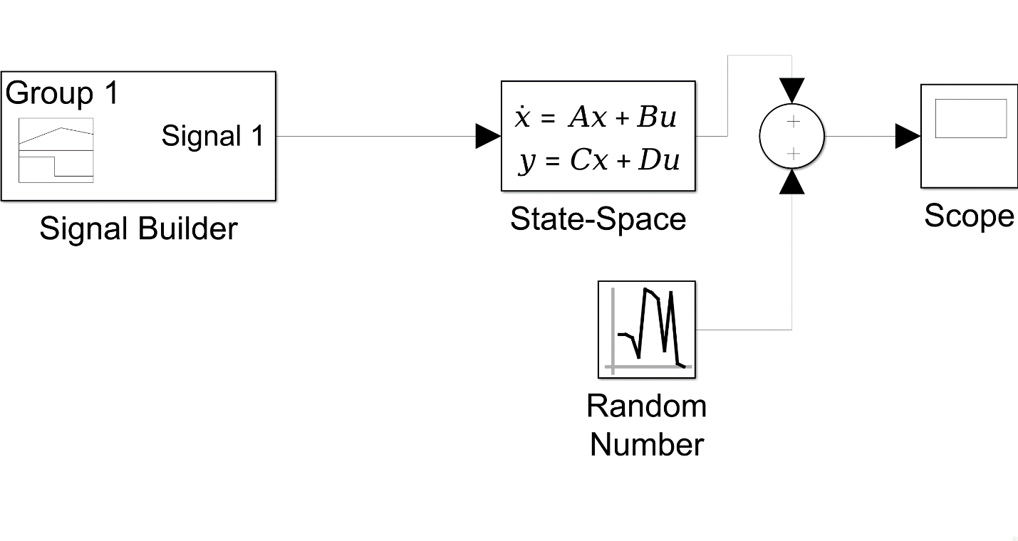

*Response after adding noise to the outputs.*

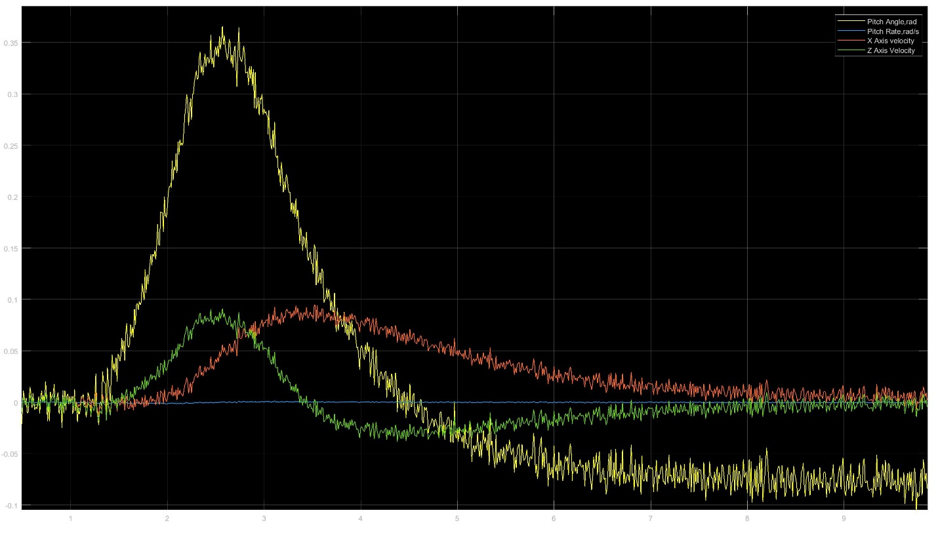

1. MLE function –

function [Px,Ht,Rin] = fcn

a =[0 1.0000 0 0;

0 -0.9965 0 -0.3000;

-0.3197 -0.5176 -0.0100 -0.7000;

0 0 -0.0005 -0.9924];

c =[0 0 0.9963 0.0862;

0 0 -0.0001 0.0017;

1.0000 0 0 0;

0 1.0000 0 0];

cov=[0.0001, 0.0000001, 0.00002, 0.00002];

R=diag(cov);

Rin=inv(R);

H=c;

Ht=H';

Px=inv(Ht*Rin*H);

*MLE function block in simulink*

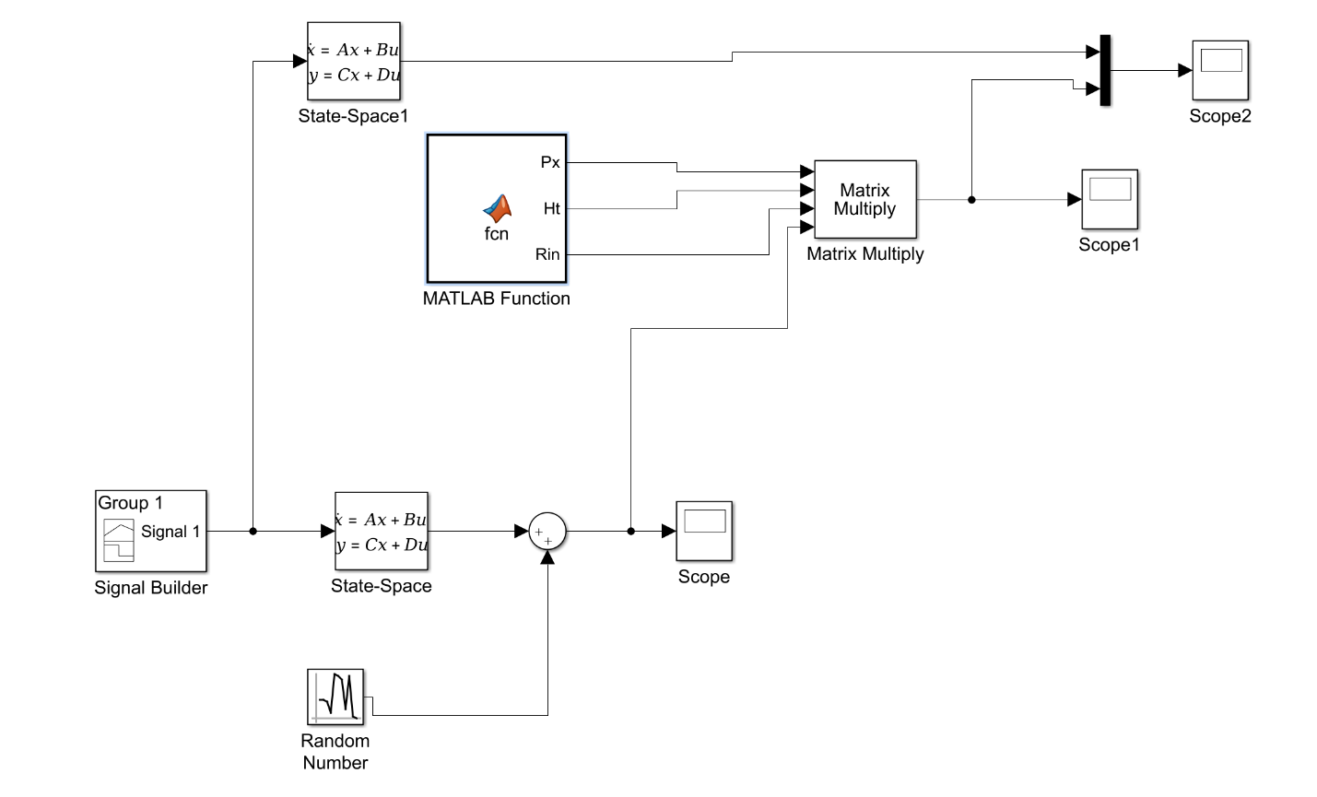

*Estimated states due to MLE*

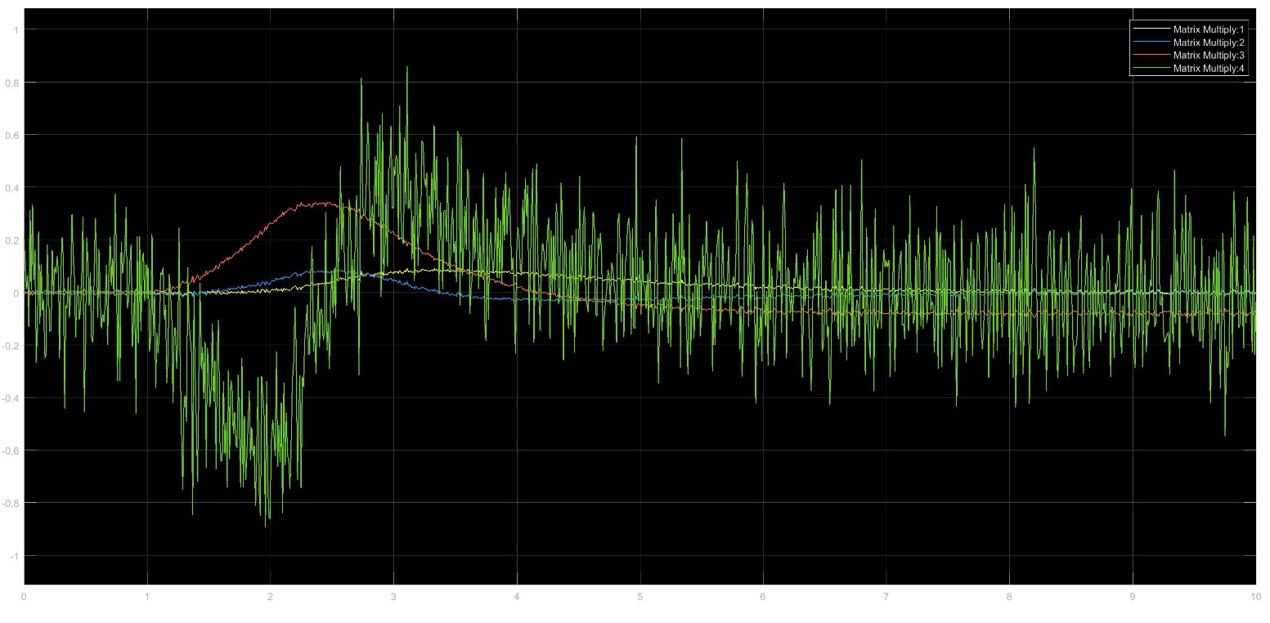

d)

*Estimated states and the actual states*

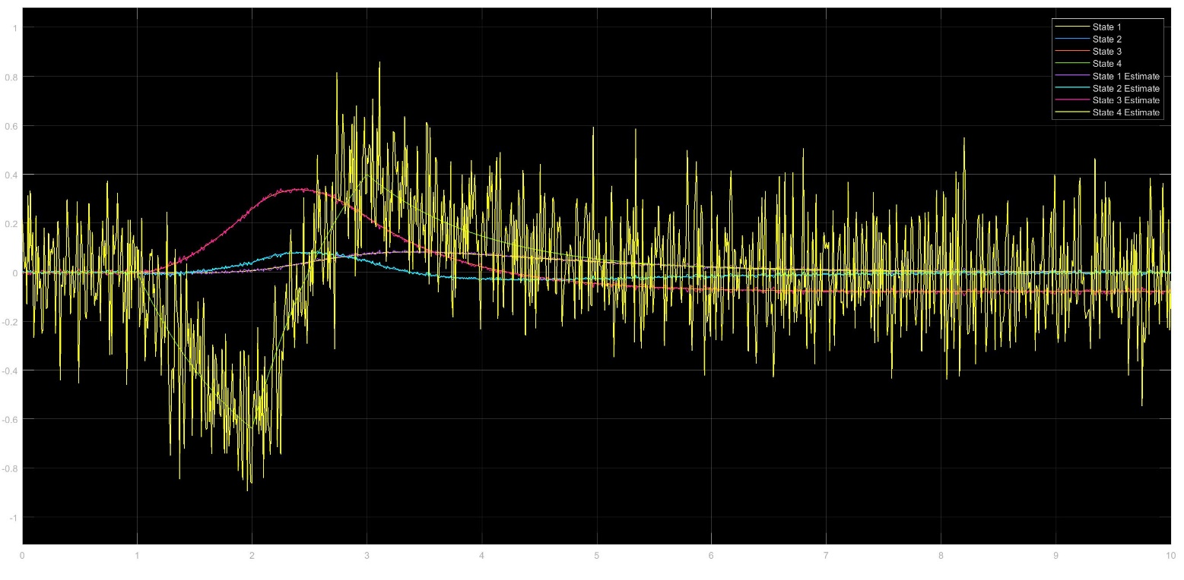

*Outputs Y and measurements Z*

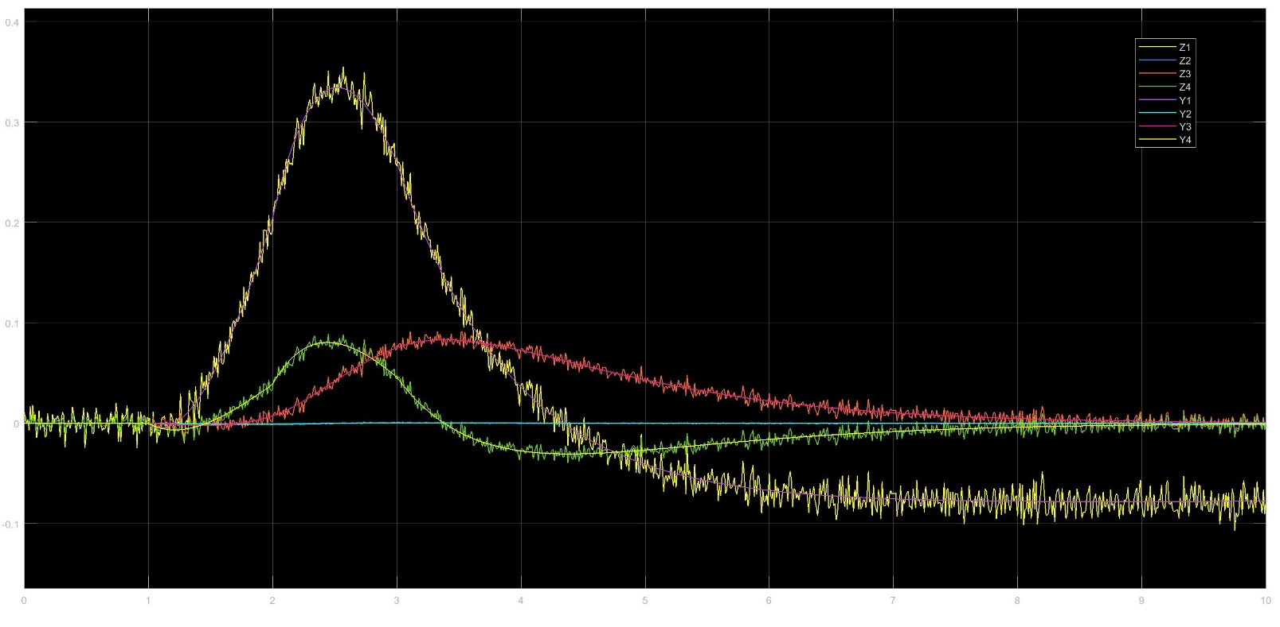

Problem 2 :

1. *Block Diagram for DKF*.

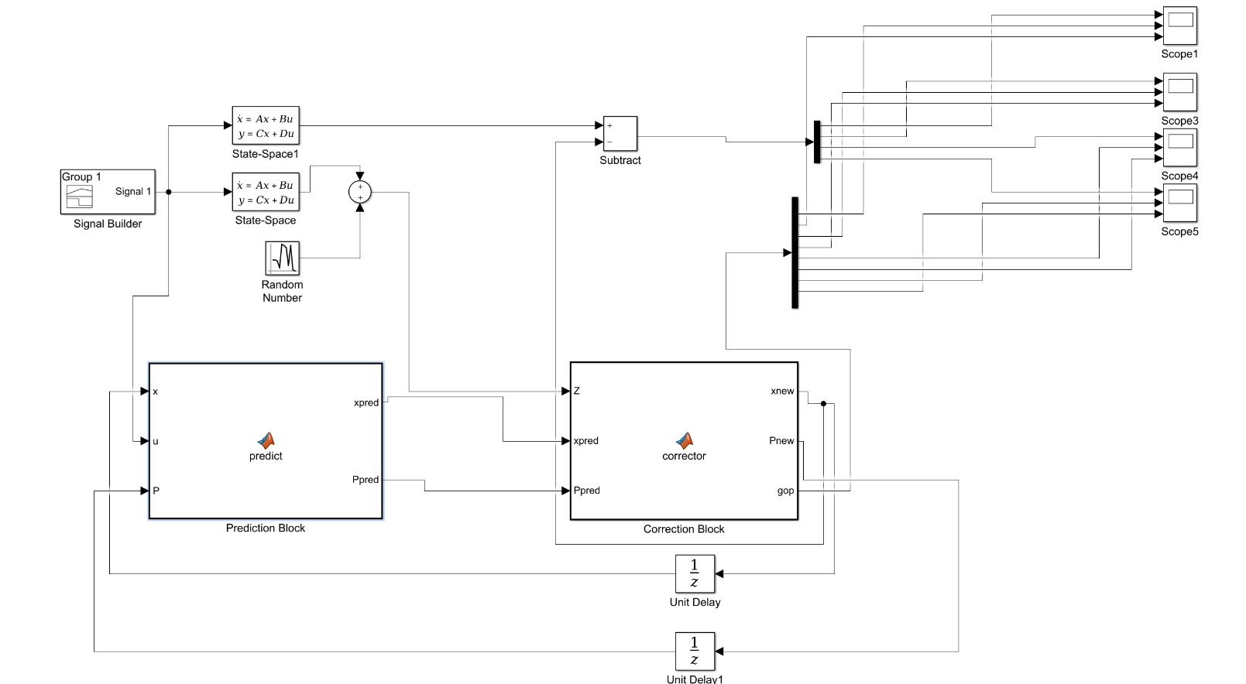

*Predictor Block* –

function [xpred, Ppred] = predict(x, u, P)

%xpred= A*x+B*U;

%Ppred=A*P*A'+Q;

xpred=zeros(4,1);

Ppred=zeros(4);

b = [ 0;-0.0013;0.0001;-0.0201];

a =[0 1.0000 0 0;0 -0.9965 0 -0.3000;-0.3197 -0.5176 -0.0100 -0.7000;0 0 -0.0005 -0.9924];

Q =100*eye(4);

P=eye(4);

Ad=expm(a*0.01);

Bd=inv(a)*(Ad-eye(4))*b;

F=[-a Q;zeros(4,4) a'];

G=expm(F*0.01);

GLr=G(5:8,5:8);

Gur=G(1:4,5:8);

Qd=GLr'*Gur;

xpred=Ad*x+Bd*u;

Ppred=Ad*P*Ad'+Qd;

Corrector Block –

function [xnew, Pnew,gop] = corrector(Z,xpred,Ppred)

%xpred= A*x+B*U;

%Ppred=A*P*A'+Q;

xnew=zeros(4,1);

Pnew=zeros(4);

gop=zeros(8,1);

R=diag([0.0001, 0.0000001, 0.00002, 0.00002]);

c = [0 0 0.9963 0.0862;

0 0 -0.0001 0.0017;

1.0000 0 0 0;

0 1.0000 0 0];

H=c;

K=Ppred*transpose(H)*inv(H*Ppred*(H)'+R);

Pnew=((eye(4)-K*H)*Ppred*transpose(eye(4)-K*H))+K*R*transpose(K);

xnew=xpred+K*(Z-H*xpred);

P44=Pnew(4,4)

gop(8,1)=sqrt(P44);

gop(7,1)=-sqrt(P44);

P33=Pnew(3,3)

gop(6,1)=sqrt(P33);

gop(5,1)=-sqrt(P33);

P22=Pnew(2,2)

gop(4,1)=sqrt(P22);

gop(3,1)=-sqrt(P22);

P11=Pnew(1,1)

gop(2,1)=sqrt(P11);

gop(1,1)=-sqrt(P11);

end

According to the response obtained from the DKF and the MLE, we can observe that the estimates are nearly similar in this case.

The following plot shows the estimates obtained from the DKF.

*Estimates obtained from DKF*.

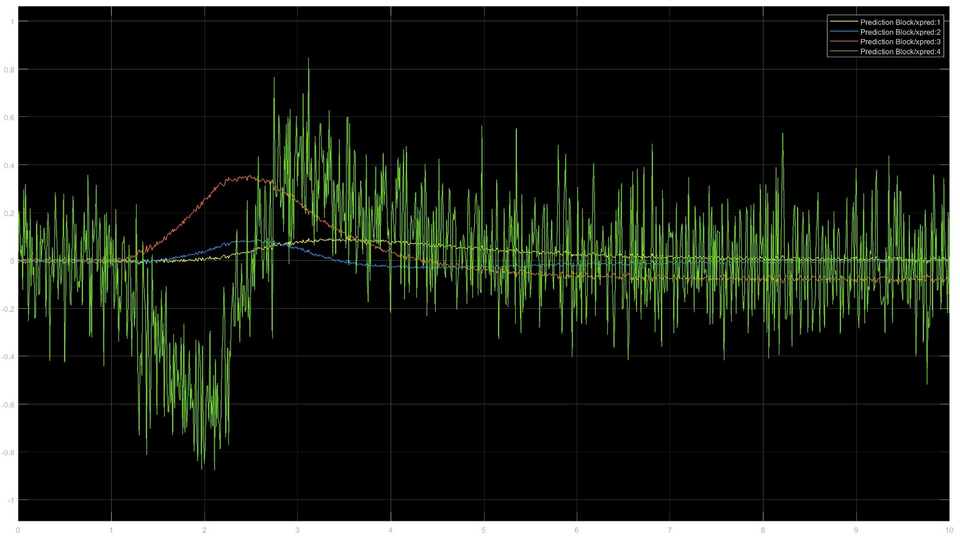

1. *Estimates obtained for state 4 within the square root value of the covariance matrix*

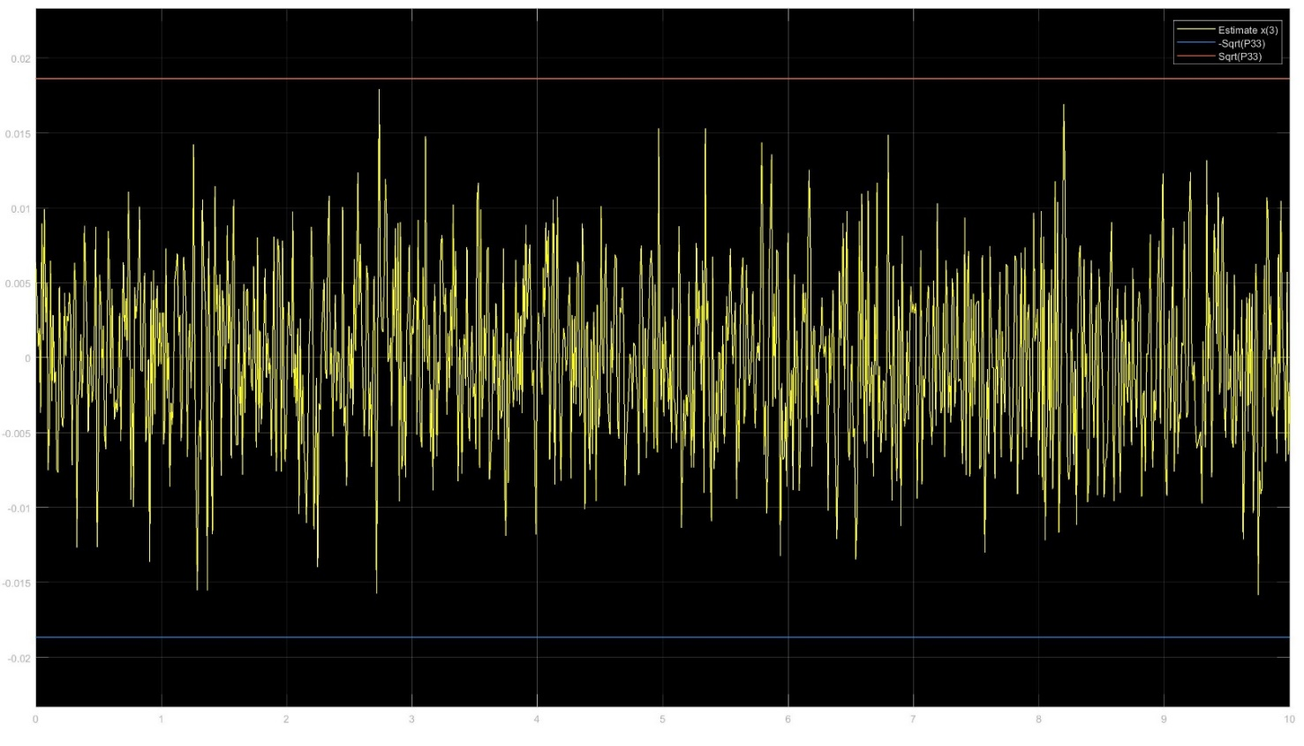

1. When Q=0.01*I, the response is as follows :-

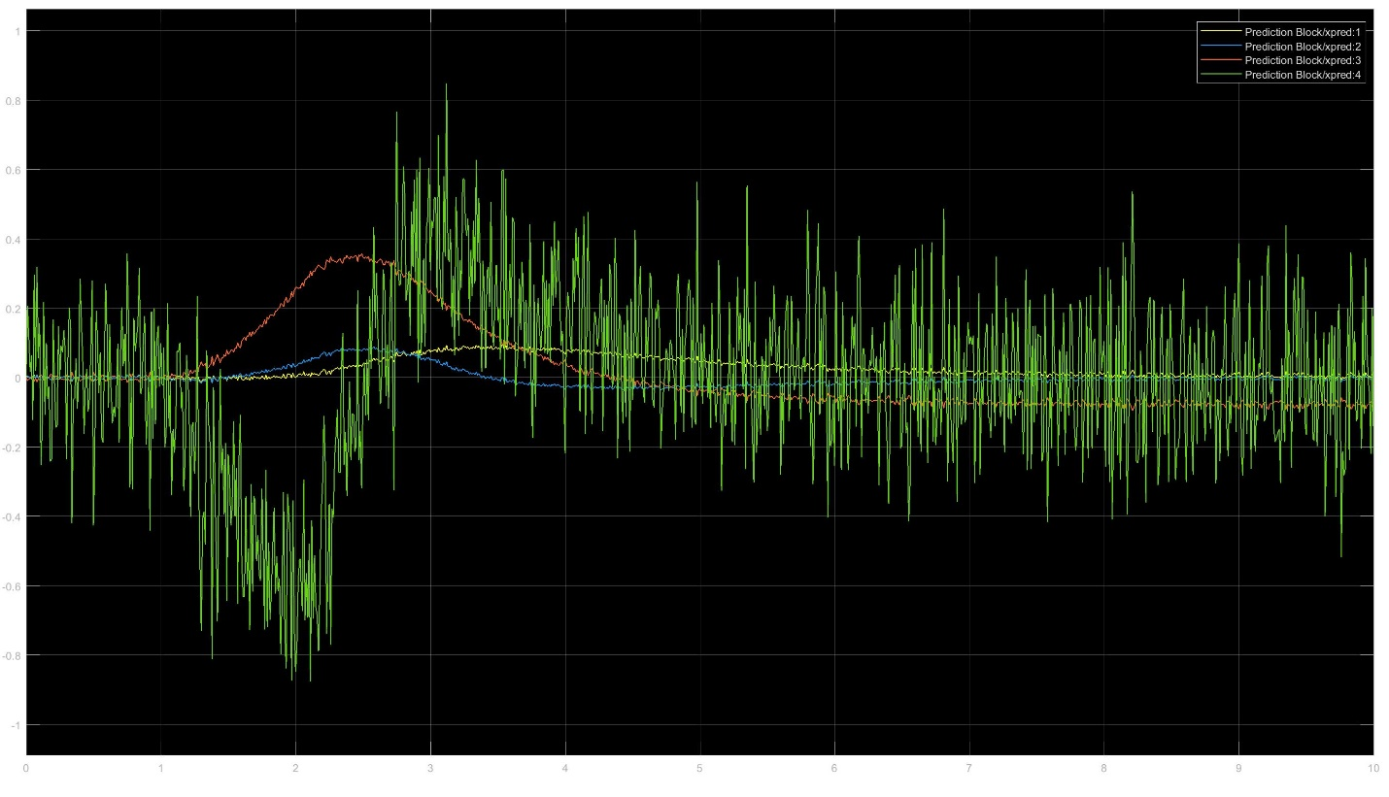

When Q=100*I, the response is as follows :-

