

**THE UNIVERSITY OF TEXAS AT ARLINGTON, TEXAS  
DEPARTMENT OF ELECTRICAL ENGINEERING**

**EE 5327 - 001**

**SYSTEM IDENTIFICATION & ESTIMATION**

**Project #2**

**EXAM**

**by**

**SOUTRIK MAITI**

**1001569883**

**Presented to**

**Prof. Michael Niestroy**

**Dec 15th, 2017**

According to the state space equations, the sub system containing the Van Der Pol Oscillator is as follows:

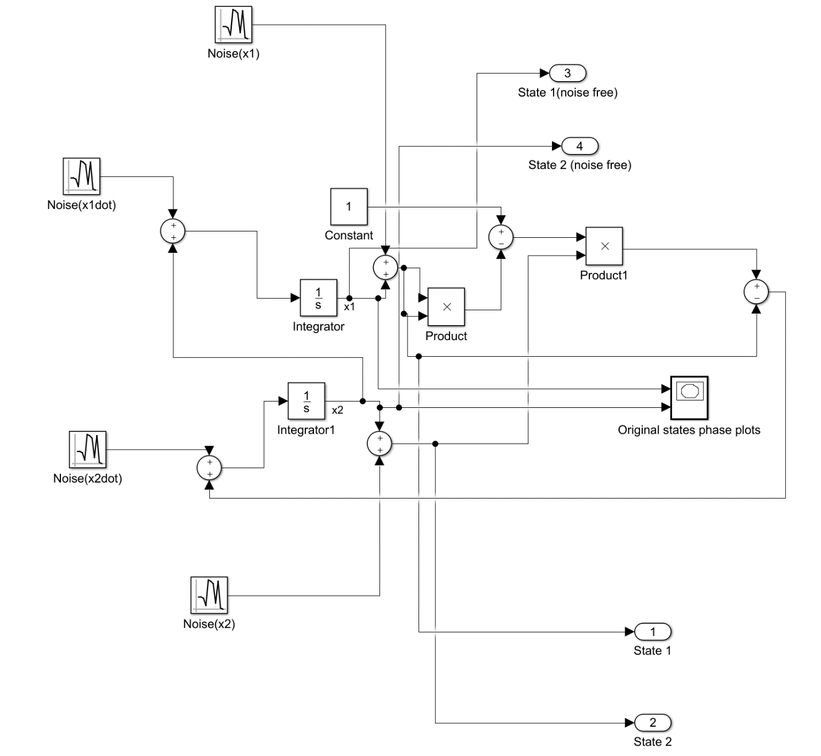

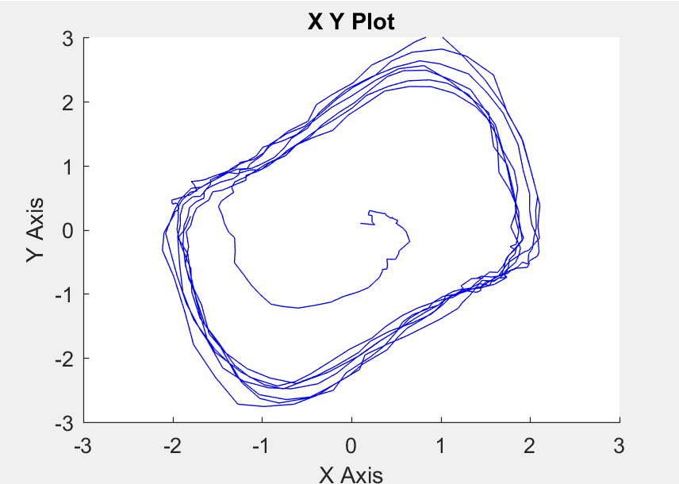The phase plot of the states when the above block runs is as follows:

The overall model with the extended Kalman Filter is as follows :

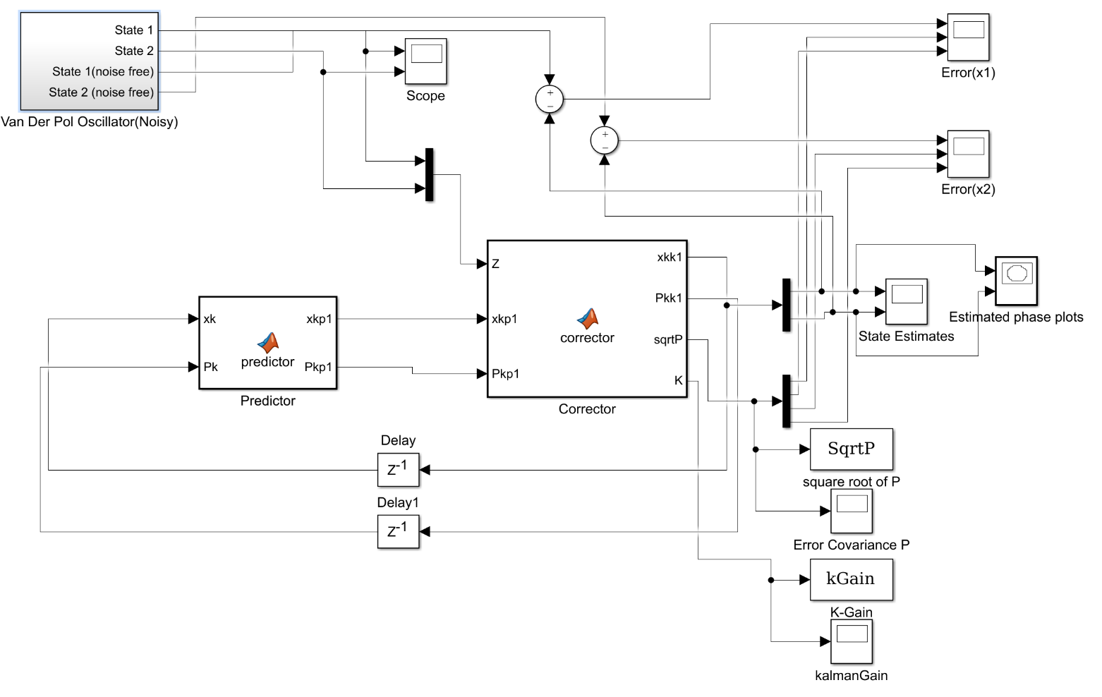

1. When R= diag([0.015 0.025])

Q=diag([2 1])

The phase plots for given condition looks like:

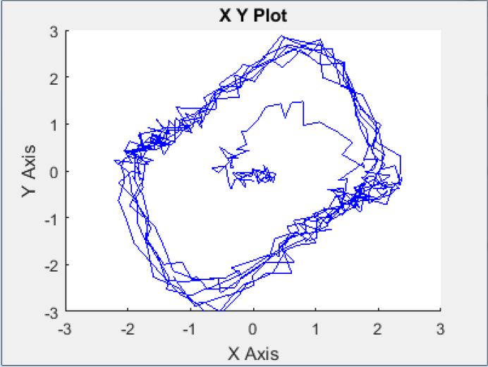

For error and covariance of state 1 and state 2:

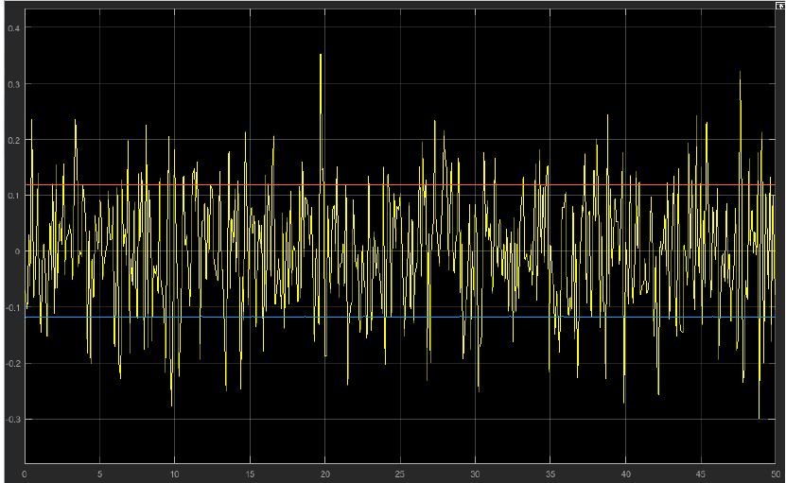

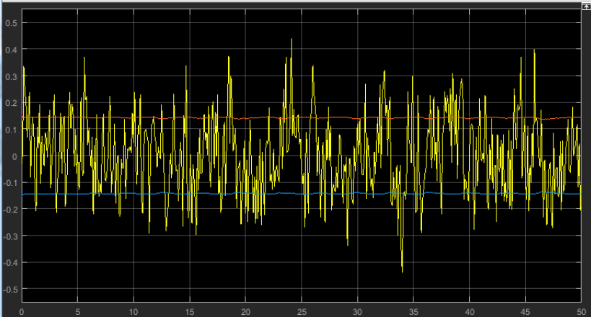

The values of Kalman gain k and error covariance, P:

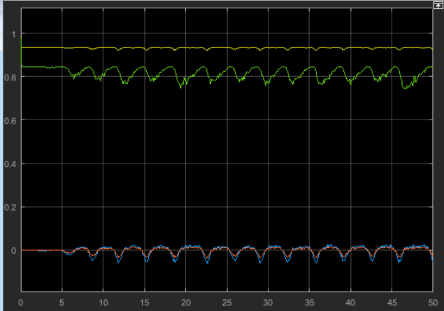

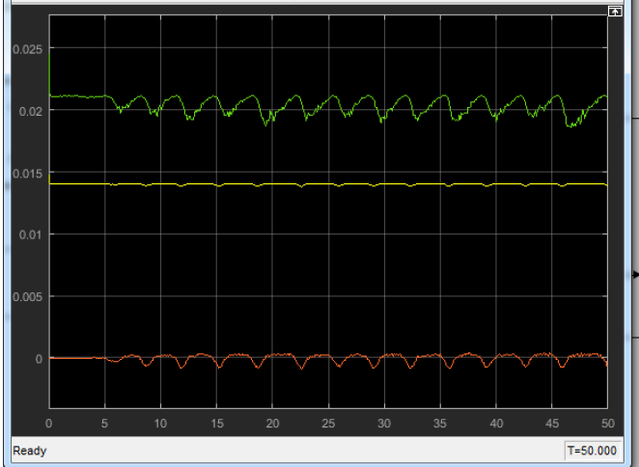

1. When Q = diag([0.2 0.1])

The phase plots for given condition looks like:

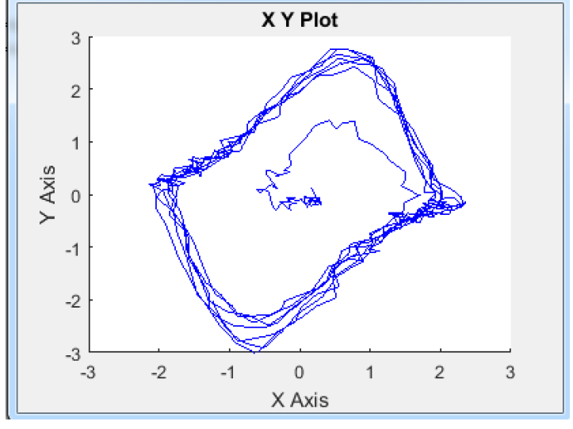

For error and covariance of state 1 and state 2:

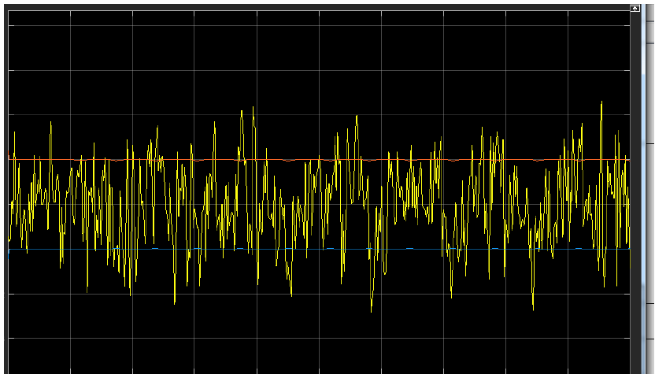

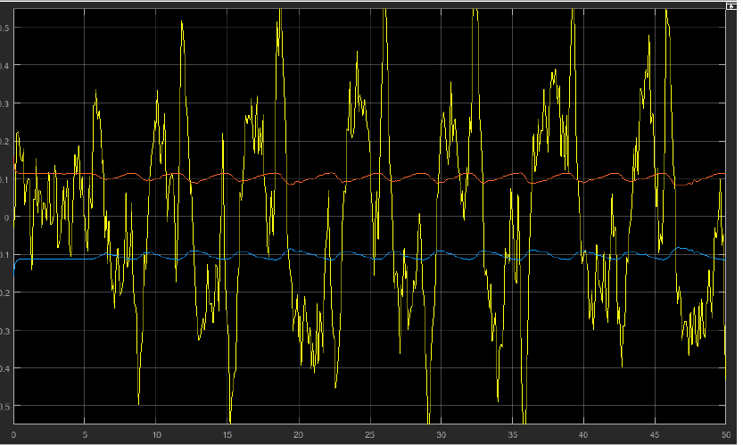

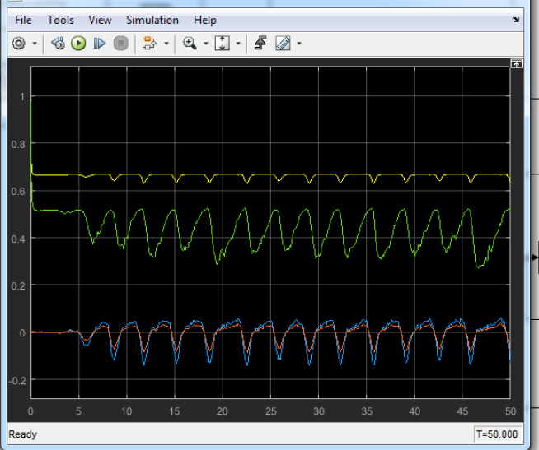

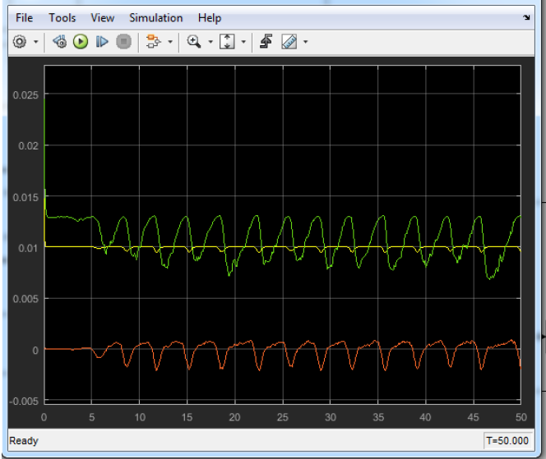

When Q = diag([4 2])

The phase plots for given condition looks like:

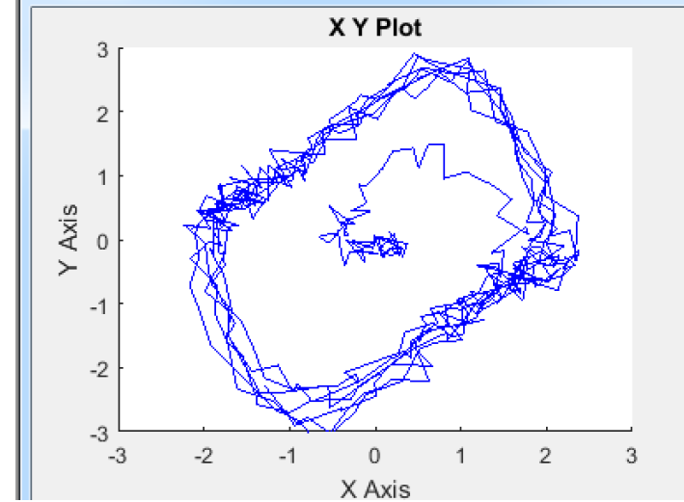

For error and covariance of state 1 and state 2:

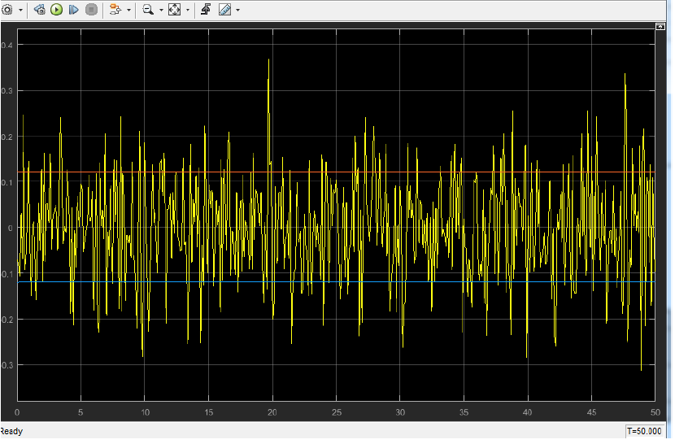

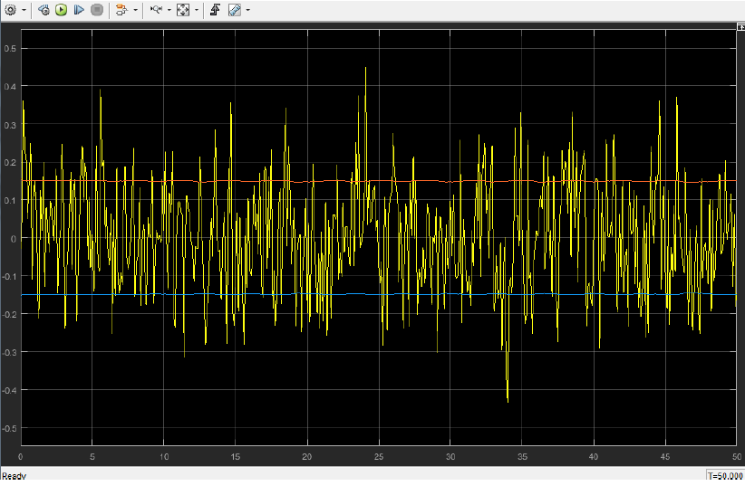

The values of Kalman gain k and error covarianc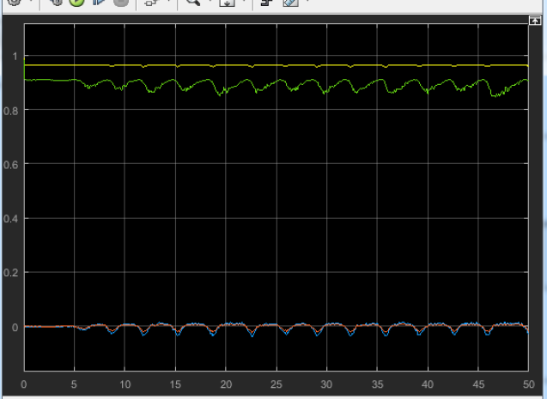e, P:

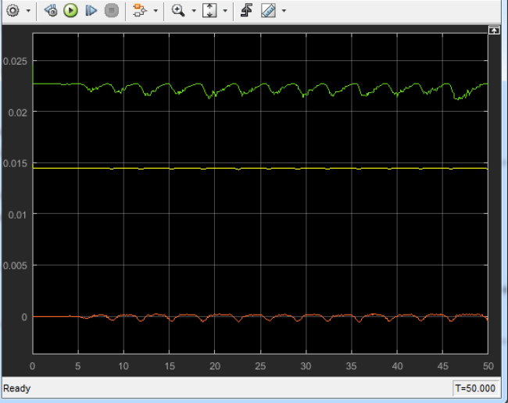

When Q is changed to diag([4 2]), the estimates are better for the states. There is considerably less spikes in error of state 2 as can be seen from the above plots.

1. When Q = dia([2 1]) and R = diag([0.15 0.25])

The phase plots for given condition looks like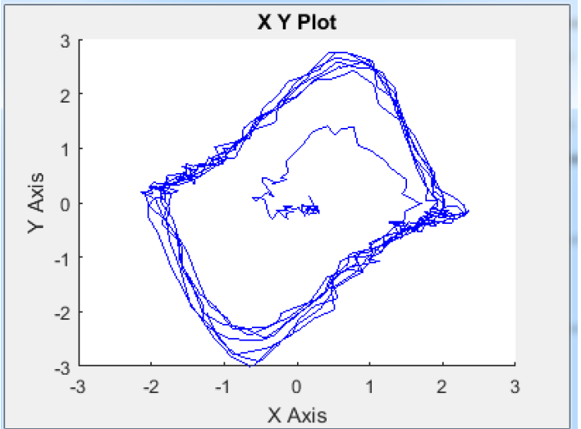:

For error and covariance of state 1 and state 2:

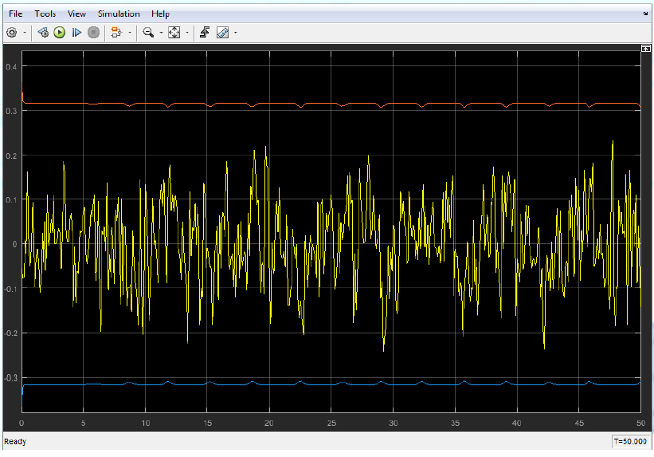

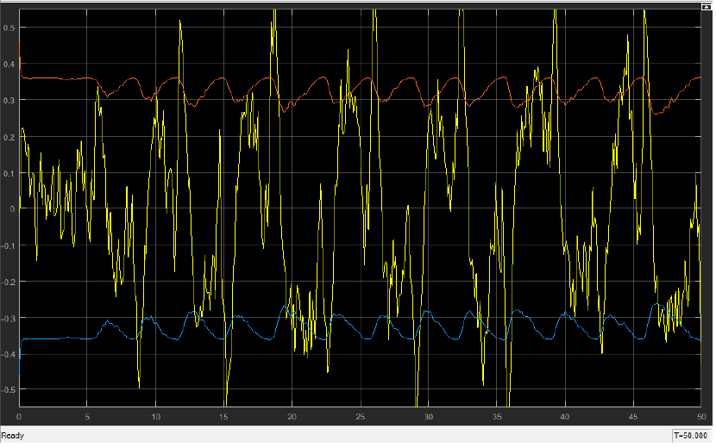

The values of Kalman gain k and error covariance, P:

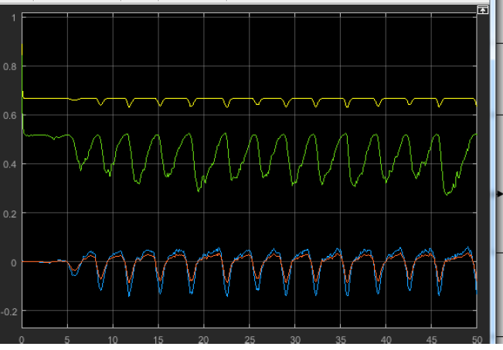

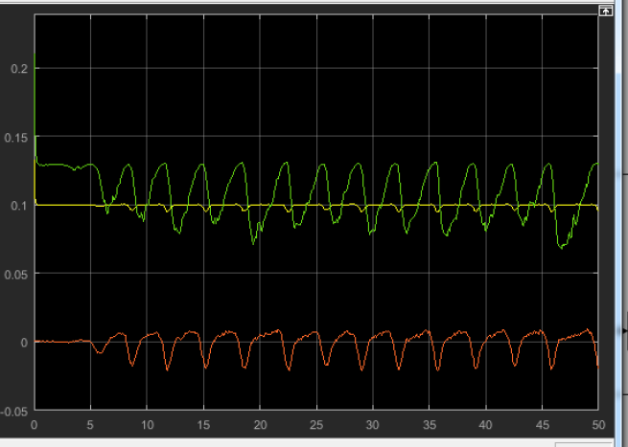

When R = diag([0.0015 0.0025])

The phase plots for given condition looks like:

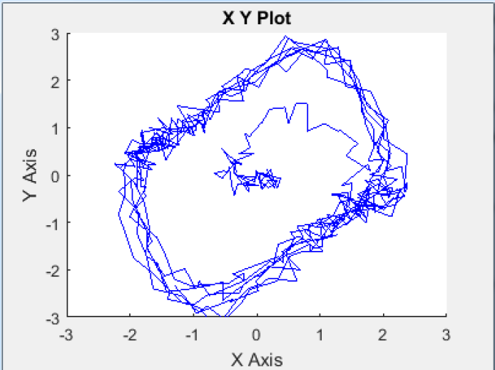

For error and covariance of state 1 and state 2:

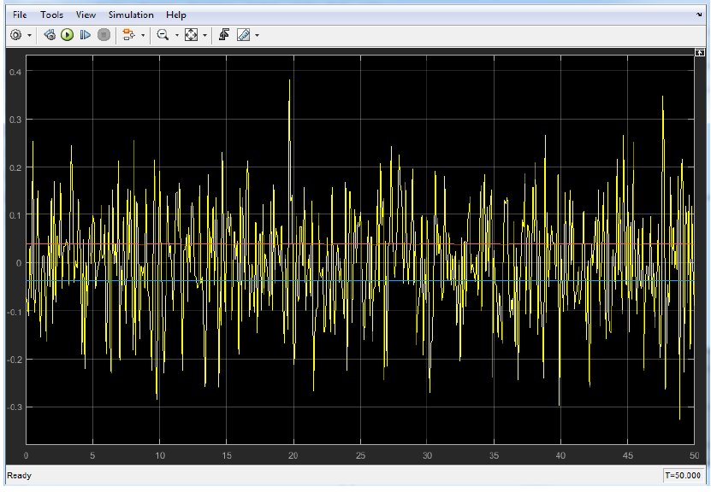

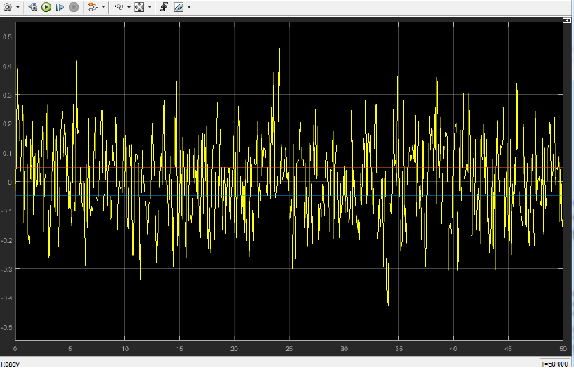

The values of Kalman gain k and error covariance, P:

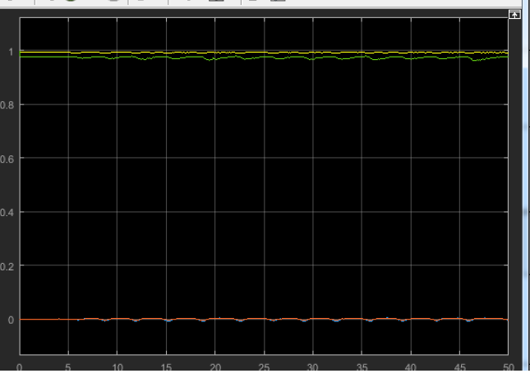

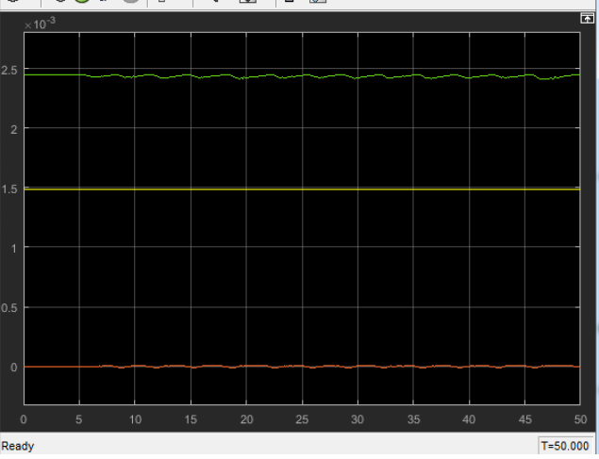

*If the value of Q is fixed and with a high value of R, error set to the covariance limit is maximum.*

1. When Q=diag([2 2]) and R =diag([0.4 0.2])

The phase plots for given condition looks like:

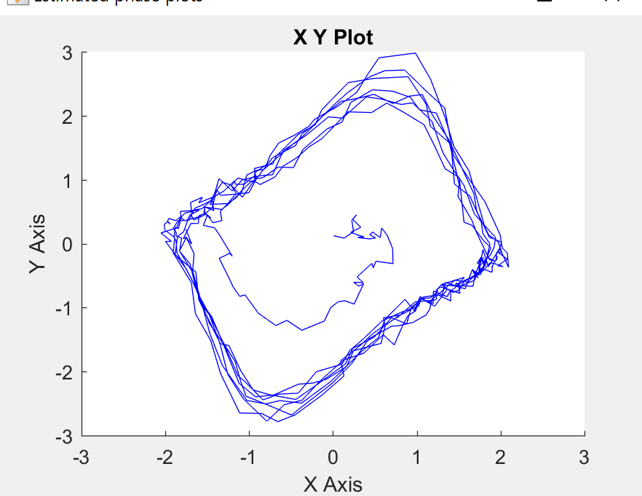

For error and covariance of state 1 and state 2:

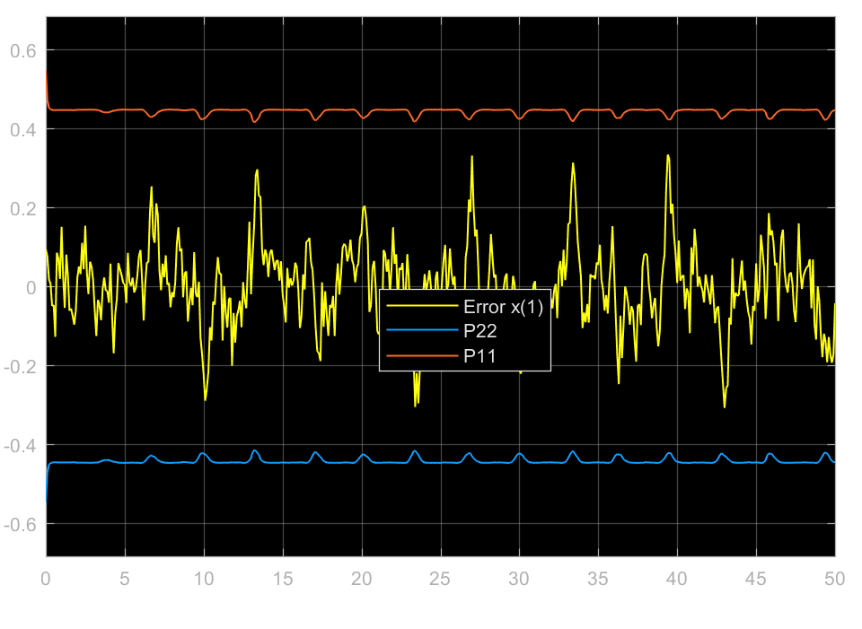

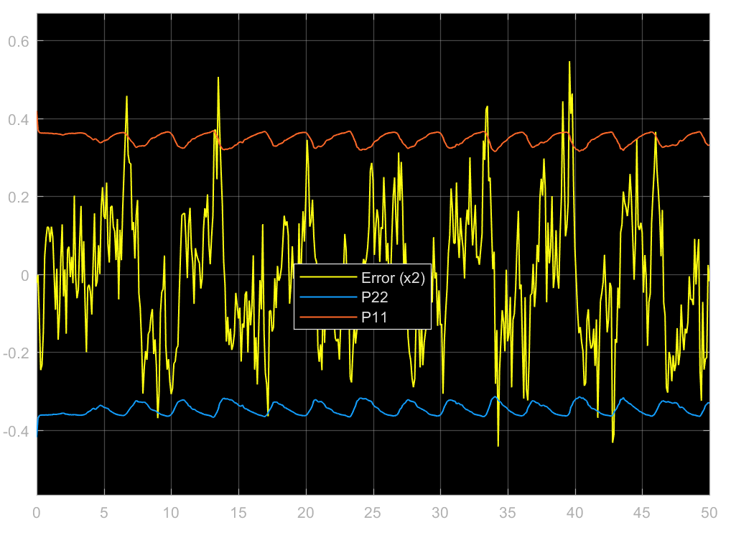

The values of Kalman gain k and error covariance, P:

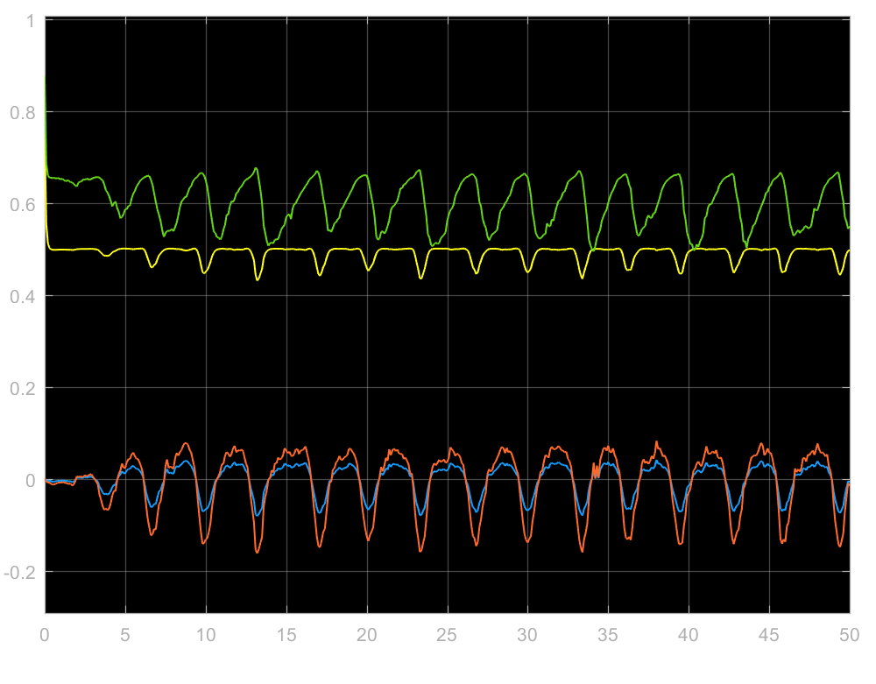

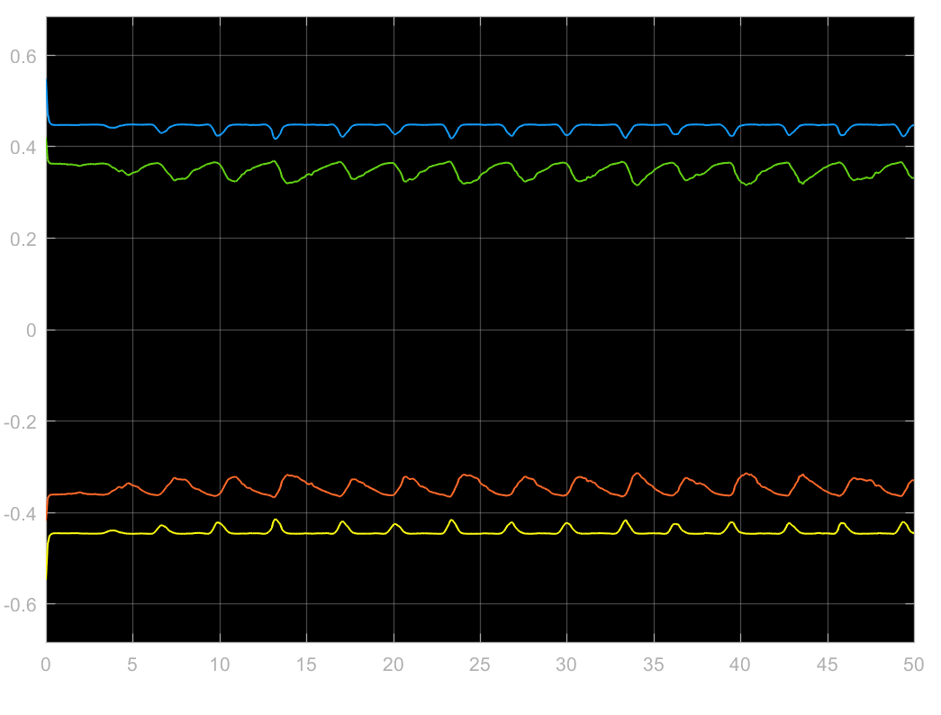

1. When the initial conditions of the predicted states is changed to [-0.5,0.5], The phase plots for given condition looks like:

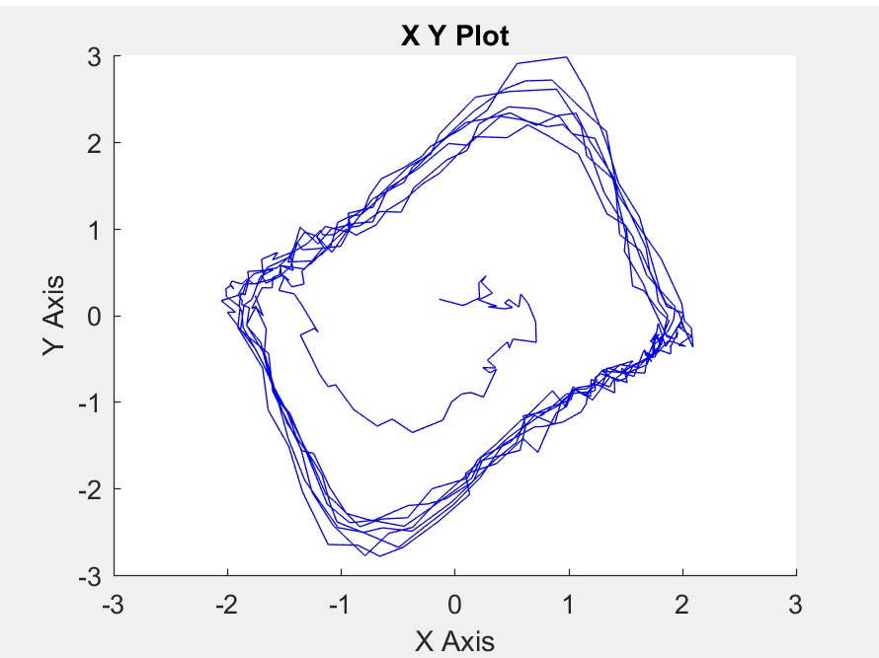

For error and covariance of state 1 and state 2:

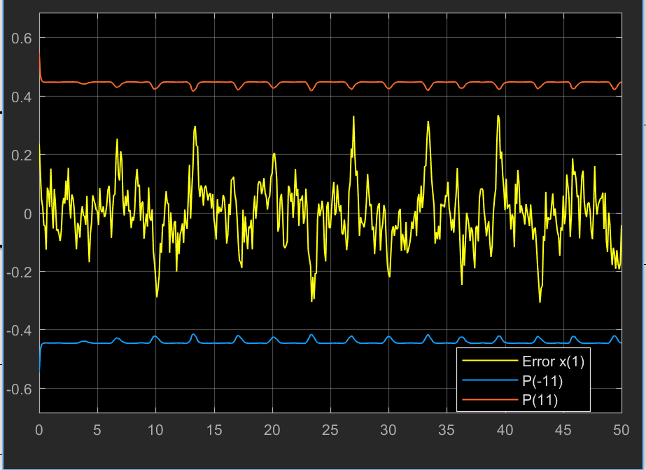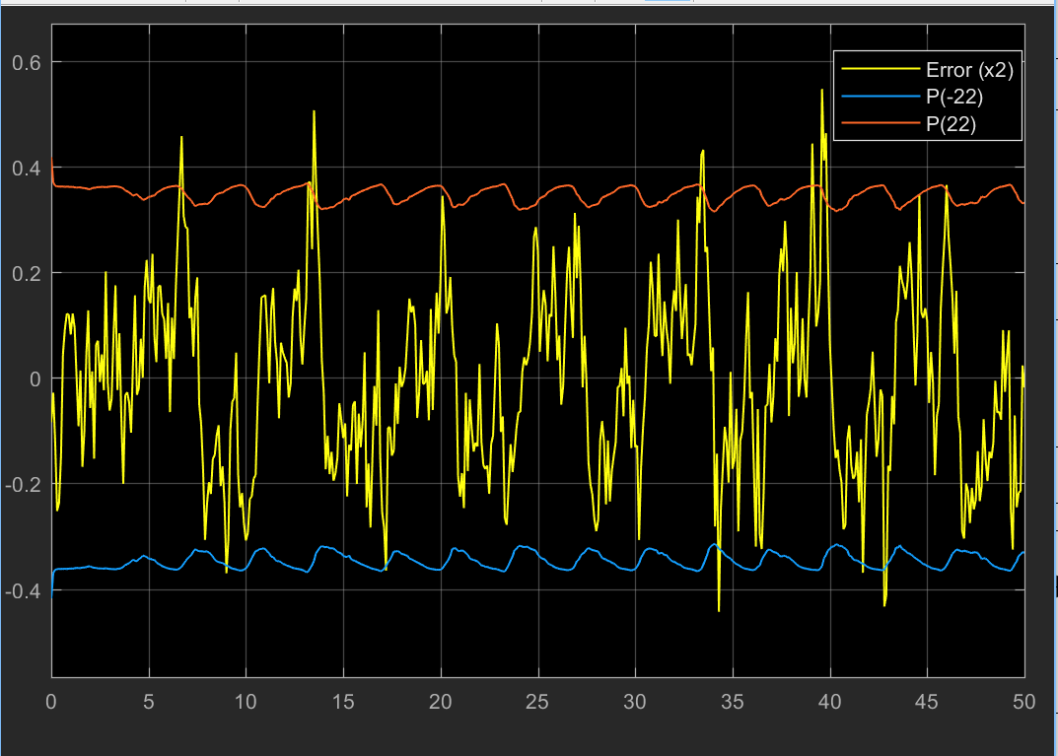

The values of Kalman gain k and error covariance, P:

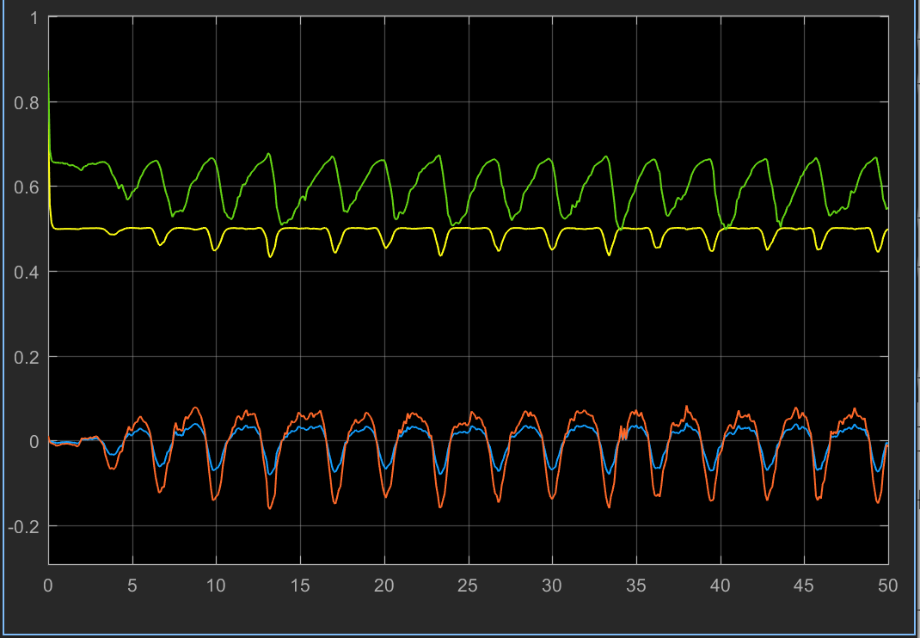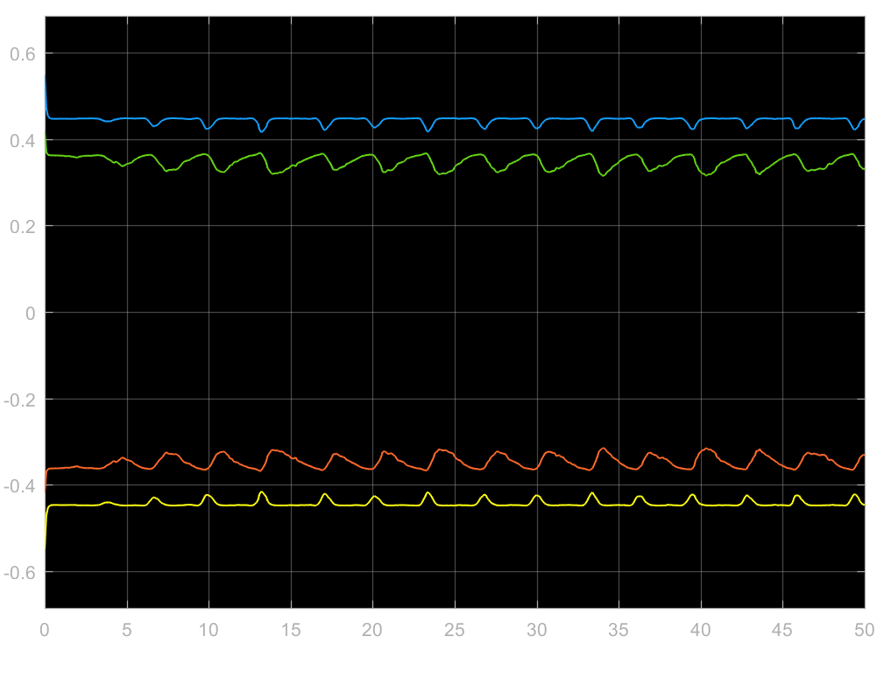

It can be seen from the previous part that the response for both the systems is similar although the initial conditions are changed for this part.

Therefore, there is no necessity to retune the filter if the initial conditions change for this dynamic system.

1. Predictor block MATLAB script

function [xkp1, Pkp1] = predictor(xk, Pk)

xkp1=zeros(2,1);

Pkp1=zeros(2);

x1=xk(1);

x2=xk(2);

a =[0 1; -2*x1*x2-1 1-x1*x1];

Q = diag([2 2]);

%Pk=eye(2);

T=0.1;

Ad=expm(a*T);

F=[-a Q;zeros(2,2) a'];

G=expm(F*T);

GLr=G(3:4,3:4);

Gur=G(1:2,3:4);

Qd=GLr'*Gur;

xkp1=Ad*xk;

Pkp1=Ad*Pk*Ad'+Qd;

end

Corrector block MATLAB script

function [xkk1, Pkk1,sqrtP,K] = corrector(Z,xkp1,Pkp1)

xkk1=zeros(2,1);

Pkk1=zeros(2);

sqrtP=zeros(4,1);

R=diag([0.4, 0.2]);

H=eye(2);

dh=eye(2);

K=Pkp1*dh'*inv(dh*Pkp1*(dh)'+R);

Pkk1=Pkp1- K*(dh*Pkp1*(dh)'+R)*K';

xkk1=xkp1+K*(Z-H*xkp1);

P22=Pkk1(2,2)

sqrtP(4,1)=sqrt(P22);

sqrtP(3,1)=-sqrt(P22);

P11=Pkk1(1,1)

sqrtP(2,1)=sqrt(P11);

sqrtP(1,1)=-sqrt(P11);

end

