August 2018

Report balabala

Group project

Jan Doe

John Doe

Table of Contents

1. Introduction 2

2. Literature Review 3

3. Construction 4

3.1. Brief introduction 4

3.2. Lalala 4

3.3. Dadada 4

4. Suggestions 5

5. Conclusions 6

6. Appendices 7

7. References 8

# Introduction

This is an introduction.

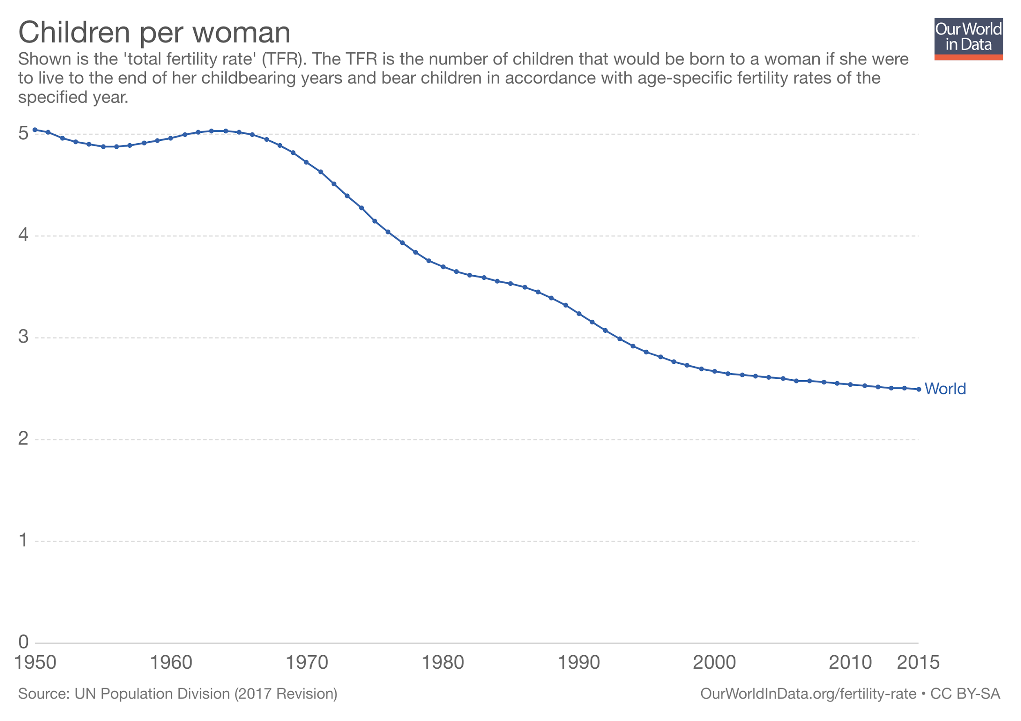

Figure 1‑1 Children per woman

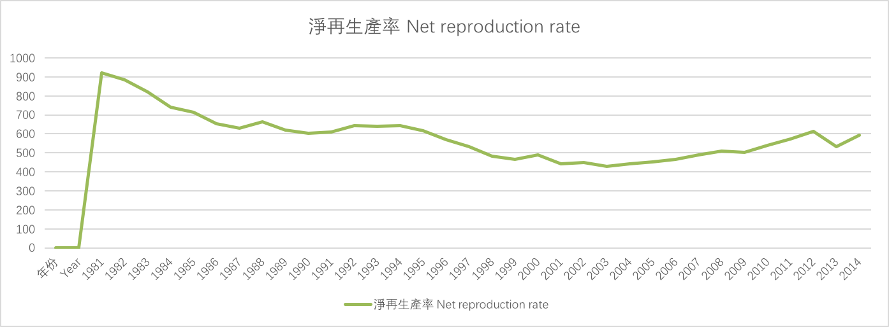

Figure 1‑2 Net reproduction rate in Hong Kong

Low fertility rate has already taken effect .

# Literature Review

Balabala

Reasons:

1. Control over people’s sexuality
2. Delayed marriage
3. Couple’s management of children’s number according to their financial outlook
4. Elite education on children
5. Development of contraceptive technology
6. Gender equality

# Construction[1][2]

## Brief introduction

AAAAA

## Lalala

BBBBB

## Dadada

DDDBBB

# Suggestions

Wa bei lei ji OK jau dak gak la…………

Let me tell you. It is OK. That’s all.

Wa bei lei ji OK jau dak gak la…………

Let me tell you. It is OK. That’s all.

Wa bei lei ji OK jau dak gak la…………

Let me tell you. It is OK. That’s all.

Wa bei lei ji OK jau dak gak la…………

Let me tell you. It is OK. That’s all.

Wa bei lei ji OK jau dak gak la…………

Let me tell you. It is OK. That’s all.

Wa bei lei ji OK jau dak gak la…………

Let me tell you. It is OK. That’s all.

Wa bei lei ji OK jau dak gak la…………

Let me tell you. It is OK. That’s all.

Wa bei lei ji OK jau dak gak la…………

Let me tell you. It is OK. That’s all.

Wa bei lei ji OK jau dak gak la…………

Let me tell you. It is OK. That’s all.

Wa bei lei ji OK jau dak gak la…………

Let me tell you. It is OK. That’s all.

Wa bei lei ji OK jau dak gak la…………

Let me tell you. It is OK. That’s all.

Wa bei lei ji OK jau dak gak la…………

Let me tell you. It is OK. That’s all.

Wa bei lei ji OK jau dak gak la…………

Let me tell you. It is OK. That’s all.

Wa bei lei ji OK jau dak gak la…………

Let me tell you. It is OK. That’s all.

# Conclusions

A+

A+

A+

A+

# Appendices

# References

Lalala

1. Footnote1
2. Footnote 2