How to use MS Work?

# How to write a good paragraph?

Hmm… I am not professional in this area, but some mistakes are very common among Chinese people.

* A blank space should be put after every punctuations and commas. (Oh, unless they are at the end of a lines)
* A blank space at the LHS of a left parenthesis and a blank space at the RHS of a right parenthesis, but not vice versa.
* A space between magnitude and unit, *even when writing Chinese document*.
* Use full-space square quotation mark when writing Chinese, unless you are writing *for* Mainland China government.
  + Example: 她竟然對你說「喵」？！
* Use Serif font （明體/宋体）, whenever your document is for printing.

Further reading:

* <https://github.com/sparanoid/chinese-copywriting-guidelines/blob/master/README.md>
* <https://github.com/mzlogin/chinese-copywriting-guidelines#%E6%95%B0%E5%AD%97%E4%B8%8E%E5%8D%95%E4%BD%8D%E4%B9%8B%E9%97%B4%E6%97%A0%E9%9C%80%E5%A2%9E%E5%8A%A0%E7%A9%BA%E6%A0%BC>
* <https://www.wikihow.com/Use-English-Punctuation-Correctly>

# Heading or Headache?

## Keep an elegant format

How do you make your page have a uniform text format? It would be good to always be careful. However, sometimes you need to combine your work with your teammates’ work into one document. This time, you have to use the format painter throughout your teammates’ part, which is very tedious.

What if you start your work before your tutor releasing the requirements for the document format? Still using format painter?

### Make use of the “styles” gallery

There are many pre-defined styles for your document, which can be picked up

If you want to tweak the style of some component, just change them by right-click the corresponding item.

### Separate content with style

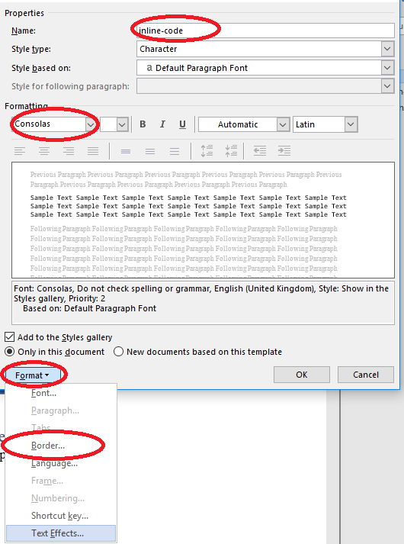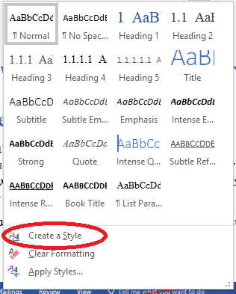It is possible that you want to include some special characters or program code in a document (such as MyClass.myStaticMethod(), but your team have yet decided what kind of format to use. To avoid using format painter everywhere throughout the document, you may create a new style and then just do some temporary formatting. After your teammates decide which format to use, you only need to change the format in one place.

Practice: change the background colour of the inline-code style to yellow (currently it is green).

### Wow, no need to re-structure!

Now, you can try to copy the content of example_1.docx into report.docx. As you can see, MS Office has do everything for you, and you do not need to further modify the format.

# MS Word will do everything for you

… Hmm… Except writing the contents, of course……..

## TOC, TOC, TOC, TOC

Suppose you want to have a decent report and want to add a table of contents. What should you do?

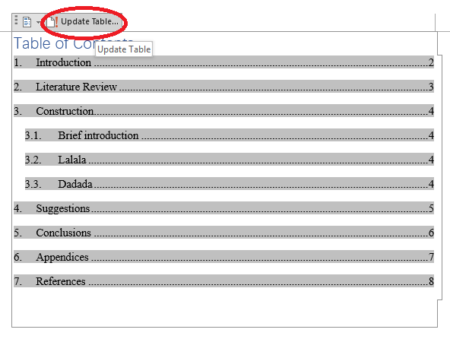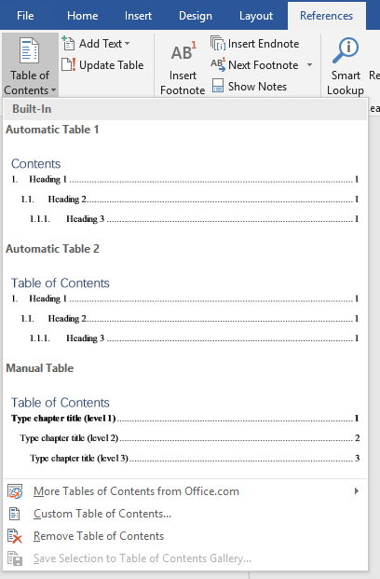If you format your headers using the means mentioned in the last section, you only need one step.

However, there may be one very important thing, after finalizing your content, you have to remember to click the Update Table button.

## Labelling

What? The tutor asked us to label every title and every figure? If you have to go through the document, this will be very exhausting. However, MS Word can also do everything for you. On windows, sometimes, you can just keep your cursor on one heading, and click the icon . On Mac OS, this can also be achieved by setting the “style” of the heading.

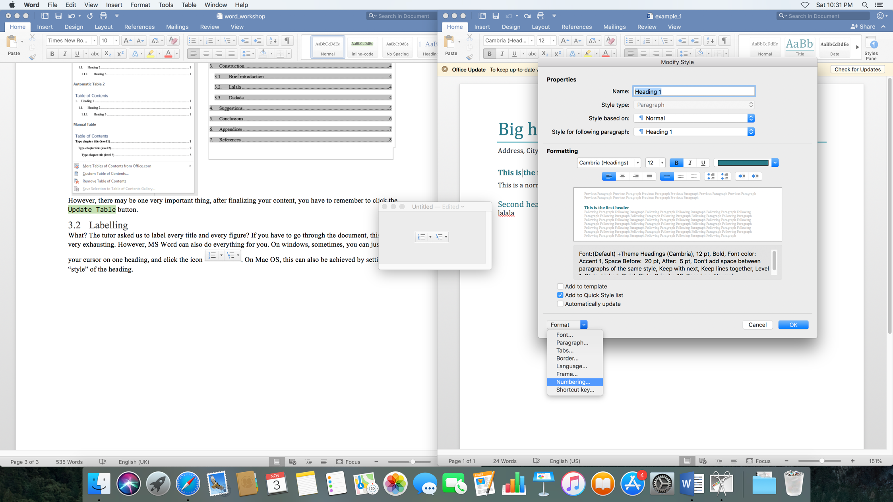

Practice: try to number the headings in example1.docx.

## Figure and equation

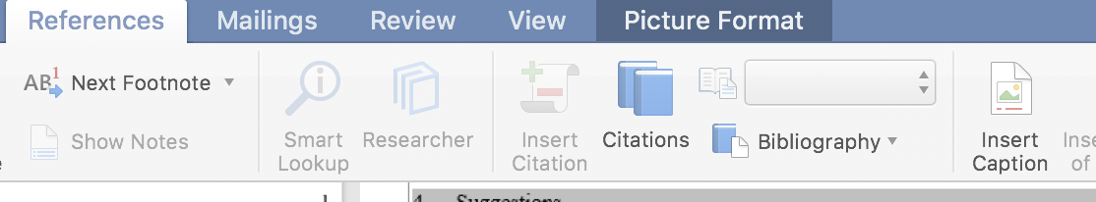

# How to find help?

Many times, you cannot find a way to resolve your question. You may think about asking your friends, however, this is time consuming. Finding help from MS word itself is much faster.

# Cooperation?

Many of the features cannot or can hardly be found on Google Drive. Then you may ask, what if I want to see what my teammates do on my document in time? Then, using OneDrive with SharePoint may be a good idea. When you want your friend to edit your document, you can just upload it to OneDrive. (By the way, CityU provides every student with a free 1 TB OneDrive for Business storage. Just Google it and use you [eid@ad.ctyu.edu.hk](mailto:eid@ad.ctyu.edu.hk) account to login.)

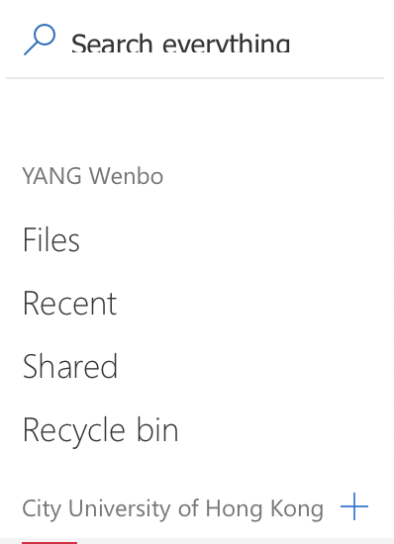

Click the “+” symbol, and then, you can create your site as you want. After the creation, you can add your friend onto this site, so that they can edit your documents.

Practice: form in group, create one site, and then try to upload and edit the documents on that site.