How to use MS Word? 如何使用 MS Word？

# How to write a good paragraph? 如何寫段落

Hmm… I am not professional in this area, but some mistakes are very common among Chinese people.

Hmmm，我並非此方面的專家，但是華人之中有很多共同的錯誤。

* A blank space should be put after every punctuations and commas (except the left half of two paired punctuation). (Oh, unless they are at the end of a lines) 在輸入英文時，標點之後要加空格，除非對於成對出現的標點符號的左半。
* A blank space at the LHS of a left parenthesis and a blank space at the RHS of a right parenthesis, but not vice versa. 輸入英文時，左半邊的符號左側和右半邊符號的右側需要加空格，而相反的地方則毋須。
* A space between magnitude and unit, *even when writing Chinese document*. 數字和單位之間加空格，無論文檔的語言是中文還是英文。
* Use full-space square quotation mark when writing Chinese, unless you are writing *for* Mainland China government. 輸入中文時，使用全角**方**括號，除非閣下是**為**中國政府工作。
  + Example: 她竟然對你說「喵」？！
* Use Serif font （明體/宋体）, whenever your document is for printing. 若文檔回被打印（列印）使用明體（宋體）或其他有襯線字體。
* Never use oblique font for Chinese. You can use Chinese emphasis mark (under-dot) if you want to emphasise a word, or use bold font if emphasis mark is not available. 中文不要加斜體。如需強調，可使用着重號（即文字之下加黑點），若無法使用着重號，則可考慮加粗文字（基於技術原因，本文檔以加粗代替着重號）。
* When using British English, add two blank space after a period. Use either British or American English in your writing, but not both; please remember to change the setting of your spell checker accordingly. 使用英式英語時，句號之後應加入兩個空格。寫作之時請使用繁體中文或者簡體中文，不可混用。請儘量使用來自一個地區的術語，如寫作使用繁體，則應使用**一個**來自繁體地區的術語，反之亦然。然而，請注意，即使時使用繁體的地區也會有用詞差異，即，港台用詞不同；同理，中國大陸與新加坡等地也有差異。
* It is a good practice to keep enough paragraph distance, especially in English writing, but do not insert a black line between paragraph! Use the instructions shown in later section to keep paragraph space.

Further reading: 拓展閱讀：

* <https://github.com/sparanoid/chinese-copywriting-guidelines/blob/master/README.md>
* <https://github.com/mzlogin/chinese-copywriting-guidelines#%E6%95%B0%E5%AD%97%E4%B8%8E%E5%8D%95%E4%BD%8D%E4%B9%8B%E9%97%B4%E6%97%A0%E9%9C%80%E5%A2%9E%E5%8A%A0%E7%A9%BA%E6%A0%BC>
* <https://www.wikihow.com/Use-English-Punctuation-Correctly>

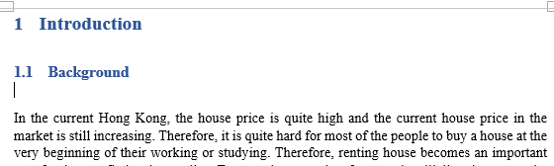

Figure 1 One counter example of keeping paragraph distance

# Heading or Headache? 標題？不要提了......

## Keep an elegant format

How do you make your page have a uniform text format? It would be good to always be careful. However, sometimes you need to combine your work with your teammates’ work into one document. This time, you have to use the format painter throughout your teammates’ part, which is very tedious.

如何保持閣下文章格式均一？你可以選擇編輯文檔時足夠小心。然而，有時閣下需要將閣下的文檔與其他人的合併。此時，閣下需要反覆使用複製格式（格式刷）以調整他人的部分的格式，此過程十分繁瑣。

What if you start your work before your tutor releasing the requirements for the document format? Still using format painter?

而且，閣下或許可能在導師發佈文檔格式要求之前着手功課，難道此時仍舊使用複製格式（格式刷）？

### Make use of the “styles” gallery 使用「樣式」

There are many pre-defined styles for your document, which can be picked up

MS Word 提供大量已提前設定的樣式認君選擇。

If you want to tweak the style of some component, just change them by right-click the corresponding item.

如需更改其中部分的格式，請右鍵進入之後修改。

### Separate content with style 將樣式與內容分隔

It is possible that you want to include some special characters or program code in a document (such as MyClass.myStaticMethod(), but your team have yet decided what kind of format to use. To avoid using format painter everywhere throughout the document, you may create a new style and then just do some temporary formatting. After your teammates decide which format to use, you only need to change the format in one place.

閣下或需於文章中加入特定格式的字符或代碼，如 MyClass.myStaticMethod()。在閣下團隊未有決定使用何種格式之前，為減少將來使用複製格式的機會，不妨創建一個新樣式，並臨時選取一些的字體樣式。在閣下團隊敲定使用何種樣式時，閣下僅需在一處調成。

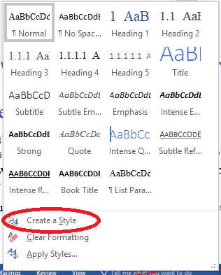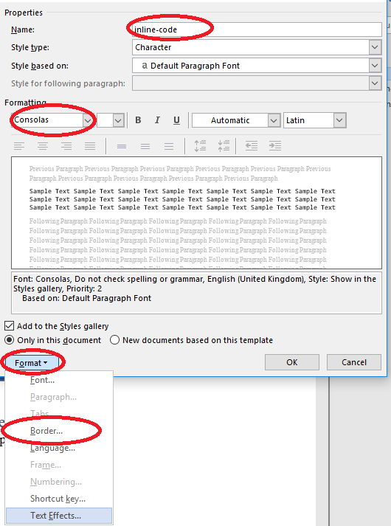

Practice: change the background colour of the inline-code style to yellow (currently it is green).

練習題：改變 inline-code 之背景顏色為綠。

### Wow, no need to re-structure! 哇，無需重新改格式！

Now, you can try to copy the content of example_1.docx into report.docx. As you can see, MS Office has do everything for you, and you do not need to further modify the format.

現在，閣下可以嘗試從 example_1.docx 複製內容至 report.docx。如你所見，MS Office會將所有樣式進行自動轉換/合併。

# MS Word will do everything for you MS Word 會為閣下做好一切

… Hmm… Except writing the contents, of course……..

……當然，不包括書寫文檔內容……

## TOC, TOC, TOC, TOC 目錄

Suppose you want to have a decent report and want to add a table of contents. What should you do?

倘使閣下需要製作一份整潔的報告文，並需加入目錄，子欲何為？

If you format your headers using the means mentioned in the last section, you only need one step.

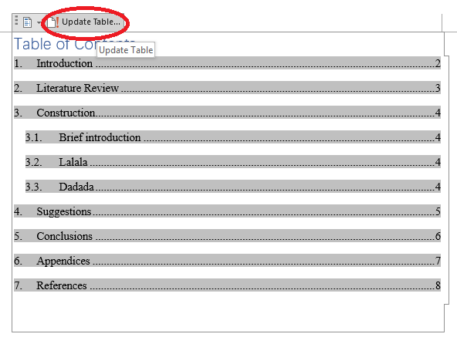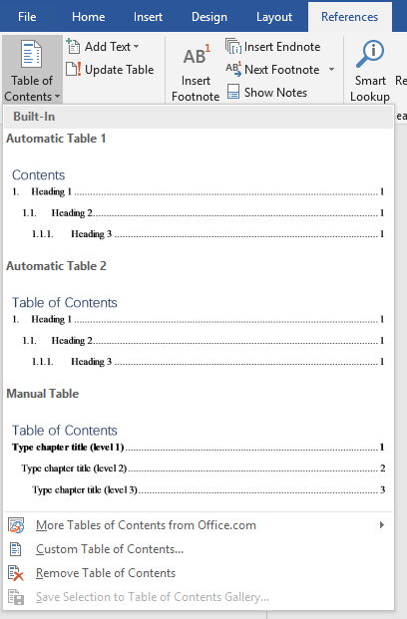只需一個步驟便可完成，假使閣下遵從上一章節所列明之操作。

However, there may be one very important thing, after finalizing your content, you have to remember to click the Update Table button, or Ctrl + A, then F9.

請注意，在上交或發佈文檔之前，請一定記得按下Update Table，或者先按 Ctrl + A 在按 F9。

## Labelling 標註圖片或編號標題

What? The tutor asked us to label every title and every figure? If you have to go through the document (and maintain their number), this will be very exhausting. However, MS Word can also do everything for you. On windows, sometimes, you can just keep your cursor on one heading, and click the icon . On Mac OS, this can also be achieved by setting the “style” of the heading.

如若導師要求我等標註所有圖片及表格，子欲何為？倘使閣下有足夠耐心，人手標註並人手更新其標籤數字，此則極其辛苦。然而，閣下可將此等任務交由MS Word 完成。請參照圖像之中內容操作。

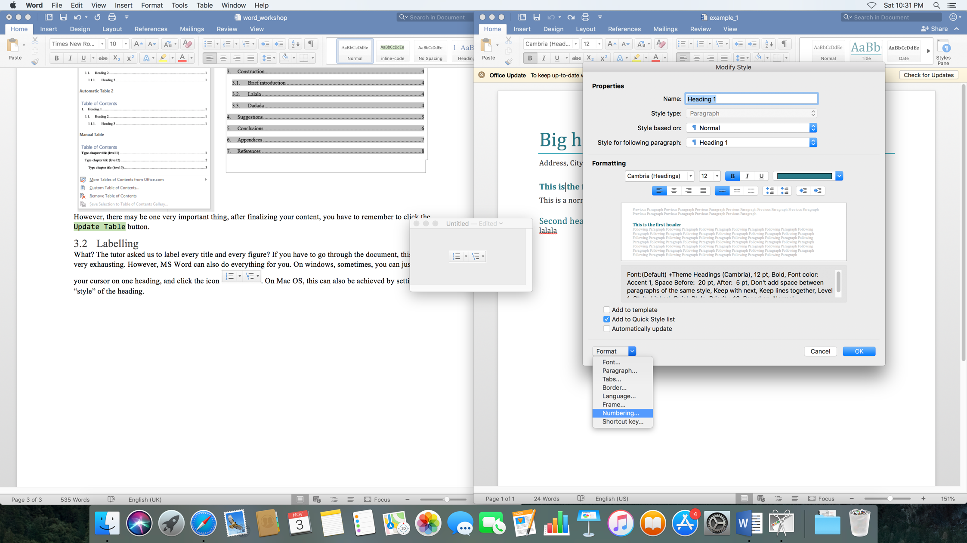

Practice: try to number the headings in example1.docx.

練習題：為 example1.docx 之中的標題編號。

## Figure and equation 圖或公式

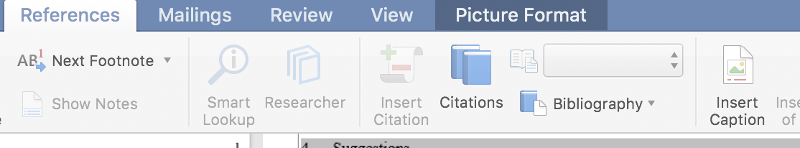

# How to find help? 何處尋求幫助？

Many times, you cannot find a way to resolve your question. You may think about asking your friends, however, this is time consuming. Finding help from MS word itself is much faster.

君或時常迷失於浩瀚功能之中。尋求閣下友人協助之前，或可考慮從 MS word 之文檔尋求答案。

# Cooperation? 協作？（不適用於中國大陸地區）

Many of the features cannot or can hardly be found on Google Drive. Then you may ask, what if I want to see what my teammates do on my document in time? Then, using OneDrive with SharePoint may be a good idea. When you want your friend to edit your document, you can just upload it to OneDrive. (By the way, CityU provides every student with a free 5 TB OneDrive for Business storage. Just Google it and use you [eid@ad.ctyu.edu.hk](mailto:eid@ad.ctyu.edu.hk) account to login.)

欲於 Google Drive 使用上述功能，甚難。如需協同操作，筆者建議使用 OneDrive 搭配SharePoint 。如閣下友人需編輯閣下文檔，可直接將其上載[1]至 OneDrive。

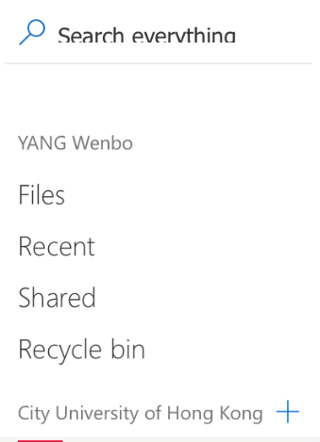

Please click ‘Open in Desktop App’ to open this file in native Windows/Mac OS app. Please do not use the web-based MS Word for editing.

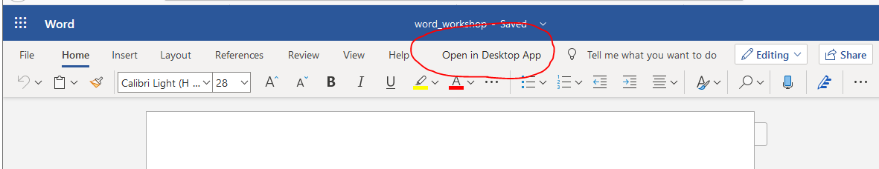

Click the “+” symbol, and then, you can create your site as you want. After the creation, you can add your friend onto this site, so that they can edit your documents.

按下加號，閣下便可創建一個 site。此後，君可邀請友人加入，並於此編輯文檔。

Practice: form in group, create one site, and then try to upload and edit the documents on that site.

練習題：組建團隊，創建一個 site。然後在其中放入本文檔並一起編輯。

1. 「上傳」為非正式翻譯。