TBS Test

Kunming Auto Show.jpg

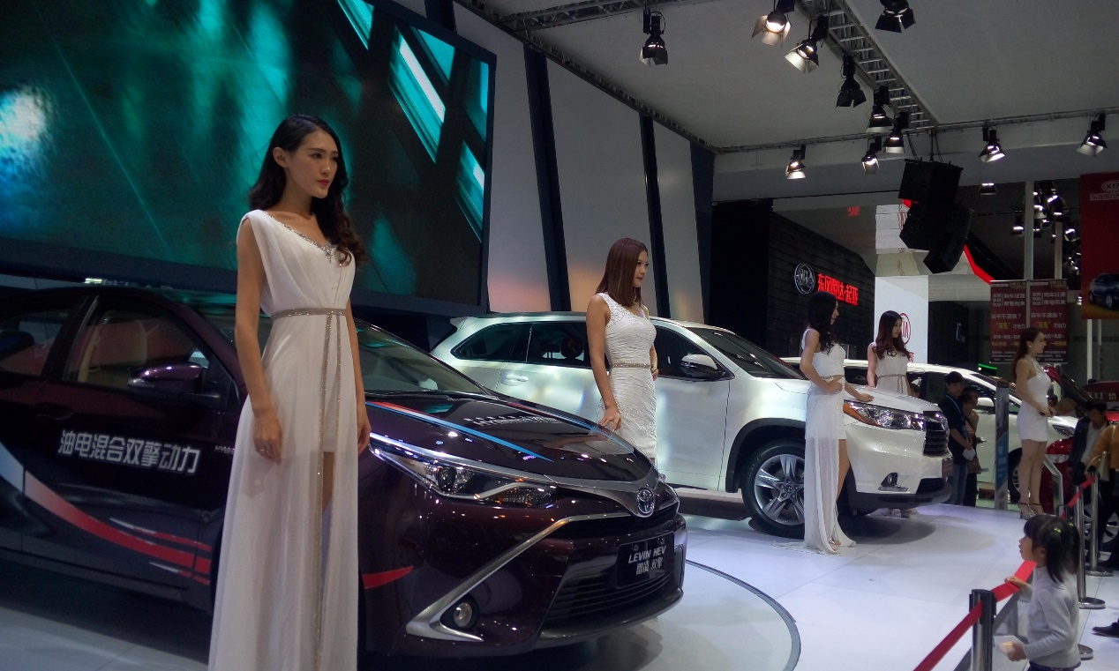

Yunnan Agricultural University.jpg

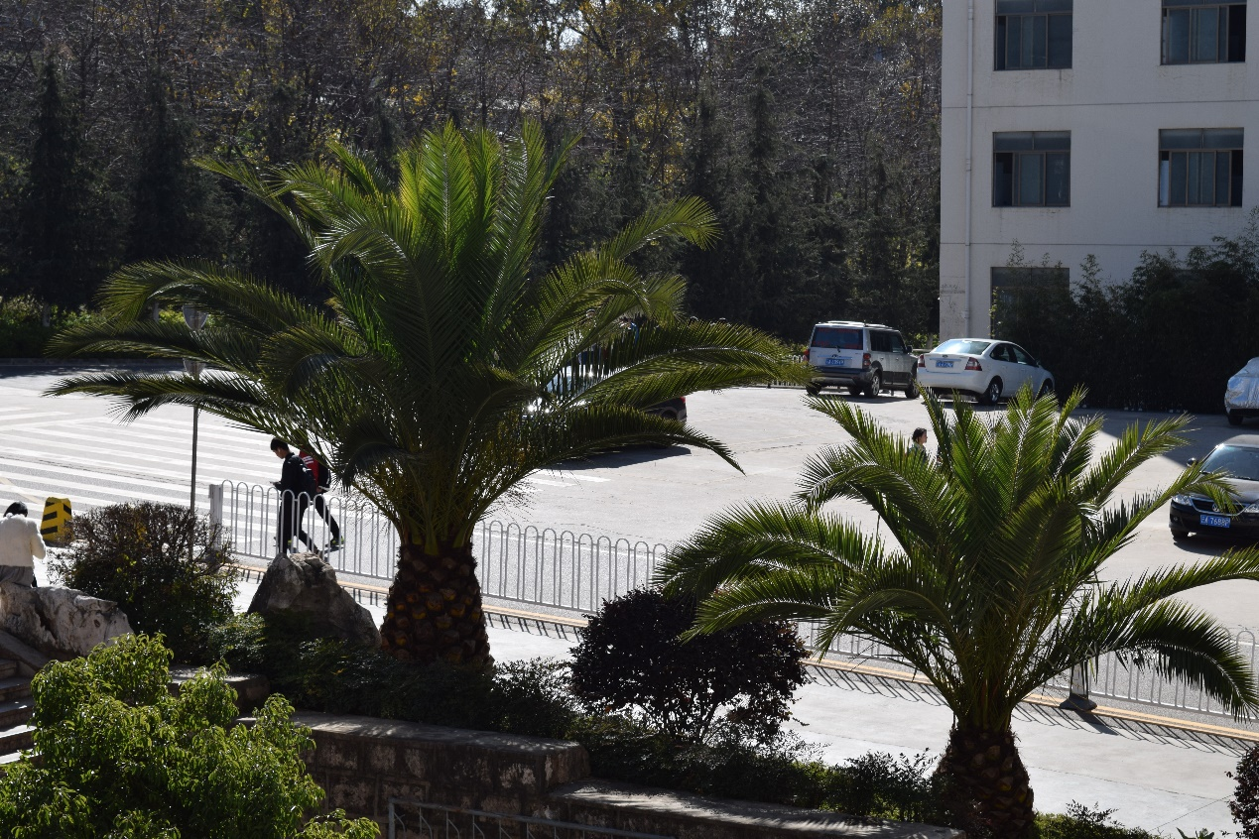

--xch